**Test case**

Test case name: Beta 4.0 LMS  
Test case type: Functional test case  
Requirement no: 1  
Module: Login through username/pw   
Status: XXXX  
Severity: Critical  
Release: Beta  
Version: 4  
Pre-condition: Requires proper login system   
Test data: Username (admin) =PranayeShrestha , password(admin)=1234, username(user)=ram, password(user)=135  
Summary: To check the functionality of login

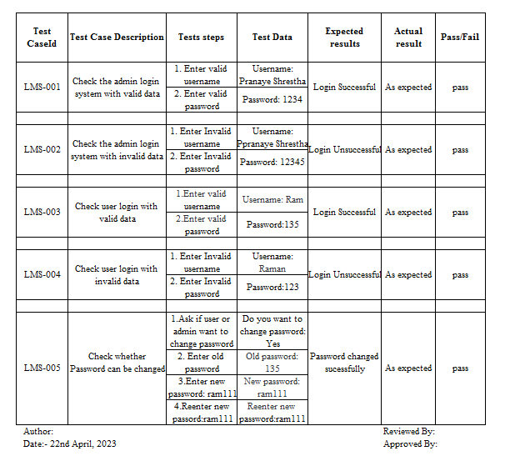

Test case name: Beta 4.0 LMS  
Test case type: Functional test case  
Requirement no: 2  
Module: Search books  
Status: XXX  
Severity: Major  
Release: Beta  
Version: 4  
Pre-condition: Requires valid book  
Test data: Book name= Software Engineering  
Summary: To check whether book can be searched

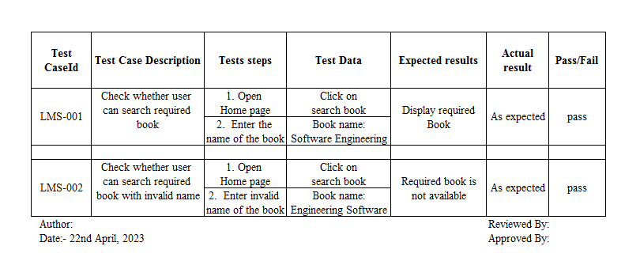

Test case name: Beta 4.0 LMS  
Test case type: Functional test case  
Requirement no: 3  
Module: View books  
Status: XXX  
Severity: Major  
Release: Beta  
Version: 4  
Pre-condition: Requires valid book  
Test data:   
Summary: To check whether user can view or read books

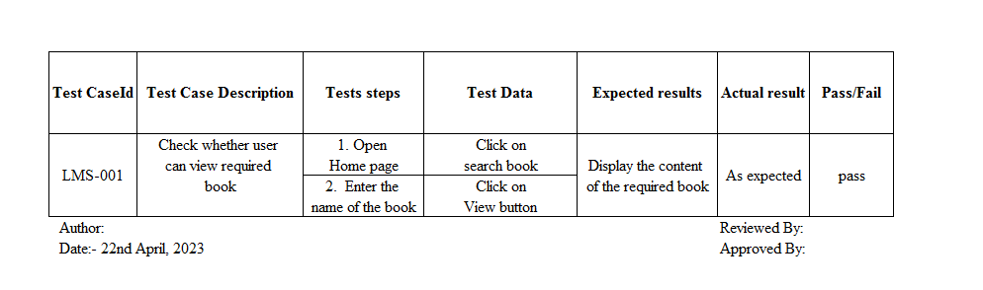

Test case name: Beta 4.0 LMS  
Test case type: Functional test case  
Requirement no: 4  
Module: Add books  
Status: XXX  
Severity: Major  
Release: Beta  
Version: 4  
Pre-condition: Admin must be logged in  
Test data: Book name= Software Engineering, bookid=0125, Author=Fred Brooks  
Summary: To check whether book can be added

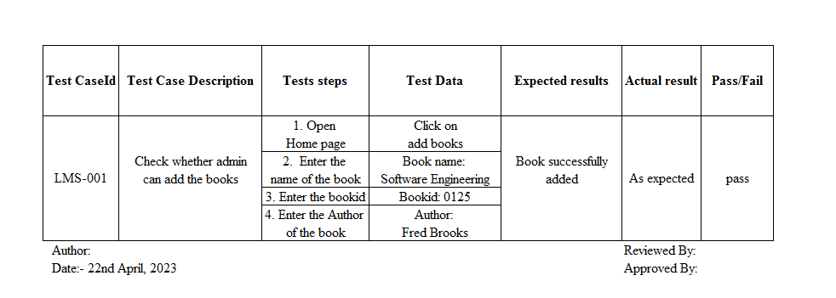

Test case name: Beta 4.0 LMS  
Test case type: Functional test case  
Requirement no: 5  
Module: Delete books  
Status: XXX  
Severity: Major  
Release: Beta  
Version: 4  
Pre-condition: Required valid book

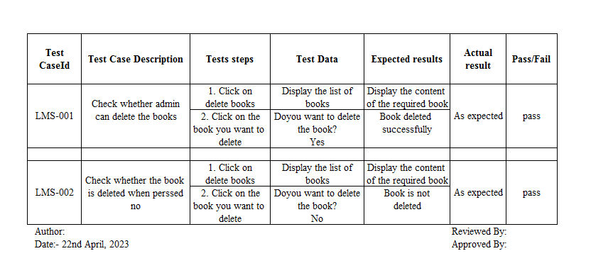

Test case name: Beta 4.0 LMS  
Test case type: Functional test case  
Requirement no: 6  
Module: Update books  
Status: XXX  
Severity: Major  
Release: Beta  
Version: 4  
Pre-condition: Requires valid book  
Test data: Book name= Operating System, bookid=0125, Author=Red Rooks  
Summary: To check whether book can be updated

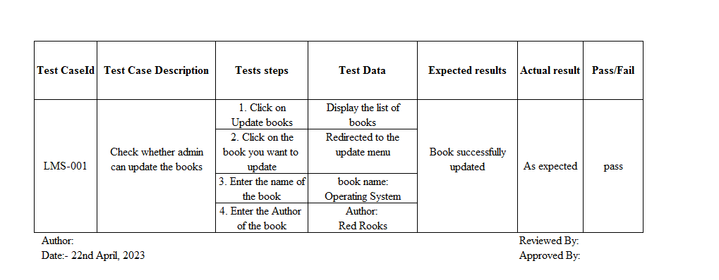

Test case name: Beta 4.0 LMS  
Test case type: Functional test case  
Requirement no: 7  
Module: Display books  
Status: XXX  
Severity: Major  
Release: Beta  
Version: 4  
Pre-condition: Requires valid books  
Test data: Click on display books  
Summary: To check whether list of book can be displayed

