TECHNOLOGY TRANFER SYSTEM
FOR
MINISTRY OF TECHNOLOGY AND RESEARCH

GUTHTHILA KAVIRAJ MUDHIYANSELAGE HEMAL HASHANTHA KAVIRAJ

M.Sc. 2007

TECHNOLOGY TRANFER SYSTEM
FOR
MINISTRY OF TECHNOLOGY AND RESEARCH

A PROJECT REPORT PRESENTED BY

G.K.M.H.H KAVIRAJ

To the Board of Study in Statistics & Computer Science of the

POSTGRADUATE INSTITUTE OF SCIENCE

in partial fulfillment of the requirements
for the award of the degree of

MASTER OF SCIENCE IN COMPUTER SCIENCE

of the

UNIVERSITY OF PERADENIYA

SRI LANKA

2007

DECLARATION

I do hereby declare that the work reported in this project report/thesis was exclusively carried out by me under the supervision of Dr. Roshan Darshana Yapa. It describes the results of my own independent research except where due reference has been made in the text. No part of this project report/thesis has been submitted earlier or concurrently for the same or any other degree.

Date: ……………………. …………………… ………………………
Signature of the Candidate

Certified by:

1. Supervisor (Name): Dr. Roshan Darshana Yapa Date: ………………..

(Signature): …………………………………

2. Supervisor (Name): ……………………………. Date: ………………..

(Signature): …………………………………

PGIS Stamp:

TECHNOLOGY TRANFER SYSTEM
FOR
MINISTRY OF TECHNOLOGY AND RESEARCH

G.K.M.H.H. Kaviraj
No 16, Samansirigama,
Ginigathena

Technology transfer taking the impotent place. But currently people haven’t easy and reliable way for browse required knowledge. Centralize and Publishing knowledge via internet able to resolve this issue. So implementing innovative web application for hosting technology transcript and manage solution database may helpful for remove the technology transfer barriers.

Acknowledgments

Table of Contents

CHAPTER 1 Introduction 01
1.1 Overview 01
1.2 Problem statement 02
1.3 Proposed solution 02
1.4 Report outline 02

CHAPTER 2 Literature review / Requirement Analysis 03
2.1 Institute overview 03
2.2 Vision 03
2.3 Mission 03
2.4 Registers Institute 03
2.5 Operational overview 04

CHAPTER 3 Methodology 07
3.1 Transferring Architecture 07
3.2 Application Architecture 07
3.3 Functional in system 08
3.3.1 Issues and Solution Management 08
3.3.2 Knowledge & Recourse Sharing 11
3.3.3 Programs and Participant 12
3.3.4 Task Management system 13
3.3.5 Client Information Database 15

CHAPTER 4 Result and discussion 16

CHAPTER 5 Conclusion and recommendations 17

List of Tables

Table 1.1 Key Events in VRC’s 02
Table 2.1 Members of Top level Management 06

List of Figures

Figure 2.1 -Provide solution for clients
Figure 2.2 -Technology Transfer process
Figure 2.3 -Task Management Process
Figure 3.1 -Transferring Architecture
Figure 3.2 - Submit Issues
Figure 3.3 -Authorize the submitted Issues
Figure 3.4 -Solution Centre
Figure 3.5- Publish Solutions
Figure 3.6 -Search solution
Figure 3.7 - Search Results
Figure 3.8 – Upload Recourses
Figure 3.9 Open Task
Figure 3.10 Not Complete Tasks
Figure 3.11 Transaction of tasks
Figure 3.12 Task open in mention date
Figure 2.13 Task By Name
Figure 2.14 Task details
Figure 3.15 Business registration Form
Figure 3.16 Business Registration

List of Abbreviations

MOST Ministry Of Science and Technology
VRC VIDHATHA recourse centre
GN Grama Niladari

CHAPTER 1

Introduction

  - Overview
In today’s usage of Science and Technology are highly increasing and innovative technologies are use in every sectors for develop their processes. In Sri Lanka There are higher number of Technical researches and also available many technical research institutes. And they introduce wide range of innovative technologies to stage with subject of new methodologies, new process, Invents and so on. According to the statistics of Sri Lanka Inventer’s commission, grass level peoples also introduce higher quality invents. But usage of these outcomes will not become to realize. One of the most weighted reason is available barrier of technology transfer. And unavailability of peoples top level requirement database is also taken higher rank. Hens researches unable to identify most required arias.

In 1994 Ministry of Science and Technology (MOST) is establish for develop and accelerate the Science & Technology sector. In year 2005 MOST start the new pilot project called “VIDHATHA” with theme of ‘Gamata Thakshanaya’. Under this project MOST established Recourse centers in every divisional secretariat called ‘Vidhatha Recourse Centre’ (VRC) for transferring technology to remote villages. Main task of this VRC’s is implement the outcomes of research project through island wide. MOST provide required facility to VRC’s for achieve this goal.

In today people who live in any where can collect information, knowledge, or facility which are available in research institute locate at capital city, by simply visit to VRC in own division.

During this project MOST start key events through VRC as follows.

Transferring the technology | Available and newly arise technology in research institute will transfer to rural community through VRC as request
Identify the recourses available in locally | Different Geographical areas has own recourses. Including physical recourses and so on.
Identify traditional technologies | During this, hope to protect with develop this traditional technologies.
Populate enterprises | Populate micro-small- and medium enterprises for finding self employment enhancing their income for poverty alleviation.
Engaging Information Database | VRC’s are separately manage their own database including mention things and more.
Table 1.1 key events in VRC’s

Currently MOST engage simple and traditional operational structure to manage mention tasks. And VRC’s handling their own information databases as their reference.VRC are locate in many geographical areas island wide and it is wide range network. Hence MOST face to difficulties for transferring information and browse data from seat. And VRC’s also has difficulties to share their information’s with others as well as knowledge. In present physical requirements are available in every VRC’s for going to innovative link. So this system will help to link all VRC’s as well as other research institutes together and then able to share and transferring knowledge in fast, reliability way.

  - Problem Statement

MOST has thirteen research and technology institutes and nearly 300 VRC’s. This every institute has owen knowledge bases. If we consider this knowledge bases together MOST has Higher capacity of technology knowledge base. But lake of facility to transferring the technology among the institutes. Hence arise following issues / barriers while operations.
- MOST spent lot of money and time for transferring knowledge.
- Identifying requirements is difficult.
- Officers face difficulties to answer the client questions on stage
- Implemented solutions for available issues may not spread

  - Proposed Solution

Sharing the own knowledge bases through web is ignore the limitation of knowledge sharing.
Introduce web base solution provide facility to sharing knowledge of institute as well as users who access this system. And it links all institute under MOST and also other external institutes or peoples. Hence user can browse latest technologies, information’s or solutions, from any geographical location. And it will help to centralize the available technology.

  - Report Outline
Chapters 2 is illustrating the institute overview and currently use technology transfer methodologies. Research methodology is discussed in chapter 3. Chapter 4 summarize and discuss outcome of system chapter 5 concludes the report.

CHAPTER 2

Literature review/ Requirement Analysis
This chapter presents the present process architecture and technology transfer methodologies
2.1Institute Overview

2.2Vision – Ministry of Technology and Research
(Past Ministry of science and Technology )
Sri Lanka becomes scientifically and technologically advanced country of the region by the year 2020...
2.3Mission

To formulate and implement policies pertaining to the advancement of science and technology ,including scientific research and development and transfer of technologies, to ensure improved quality and productivity and expand economic activities which are essential for the economic and social development of Sri Lanka.

2.4 Following Institutions come within the purview of the Ministry of Technology and Research
Arthur C. Clarke Centre for Modern Technologies (ACCIMT)
ACCIMT will endeavour to improve quality of life of our people with the help of Modern Technologies and research and development and will collaborate in national capability development through, Industry-Institute partnerships Research and Development Enhancing technological know-how in related areas Continuing Professional Development (CPD) activities Inputs for industrial development and educational reforms And enhance the image of the institute through collaborations globally, in scientific advancements.

Industrial Technology Institute (ITI)
The Industrial Technology Institute (ITI) is a Statutory Board, which came into existence as the successor to the Ceylon Institute of Scientific and Industrial Research (CISIR) on 01 April 1998 by virtue of the Science & Technology Development Act No. 11 of 1994. At present the ITI functions within the purview of the Ministry of Science and Technology. The CISIR?was one of the twin Institutes recommended by a World Bank mission of 1952 to promote industrial development in the country. The CISIR came into existence as an autonomous corporate institution under a special Parliamentary Act (Act No. 15 of 1955).
National Science & Technology Commission
To furnish the Government with policies, plans and mechanisms for building a national capability in S & T,and utilizing scientific personnel and institutions to promote national economic development with respect and regard for humanity and environment.
Sri Lanka Institute of Information Technology (SLIIT) and all Information Technology Centre Affiliated to SLIIT
To ensure that Sri Lanka profit from Information Technology, by providing education and training, conducting and promoting research and development, provide consultancy and software services, nurturing IT ventures, thus ensuring the availability of a rich pool of experts in IT.

National Engineering, Research and Development Centre (NERDC)
Sri Lanka Planetarium
National Science Foundation (NSF)
Institute of Policy Studies
National Research Council
Institute Of Fundamental Studies
Sri lanka Accreditation Board for Conformity Assessment
Sri lanka Standard Institute
Institute of Technical Science
Sri Lanka Inventor's Commission
Members of Top Level Management

Minister of Technology and Reserch | Hon. Prof. Tissa Vitarana
Deputy Minister | Mr. Lalith Disanayaka
Secretary | Mrs. Dhara Wijayatilake
Additional Secretary  Administration | Ms.Ranjanee de Alwis
Additional Secretary  Development | Mr.Nimal Athukorala
Chief Accountant | Mr.T.D.Alahapperuma
Senior Assistant Secretary  Administration | Mrs.Anurada Illeperuma
Senior Assistant Secretary  Development | Mr. M.K. Muhais
Table 2.1 Members of Top Level Management

2.5 Operational Overview

Currant Technology Transfer Process
Client
VRC
MOST
Research Institutes
Other External
Institutes
Other
VRC’s
Other External
Peoples

Figure 2.1 Provide solution to client issue
- Client can submit his issue to VRC or able to request information or technology training
- If that VRC able to fulfill it process can be complete
- If unavailable solution then VRC forward it MOST or other external institute
- Then MOST forward this to other VRC or research institute
- If available the solution it will send back through remaining path.

Figure 2.2Technology Transfer Process
MOST
Research Institutes
Other Institutes
VRC
Other SNT Officers
Client

- Research Institutes & other external institutes submit their results to MOST
- MOST select the officer’s work in VRC by analyzing previous data.
- Then Training those officer’s about remaining technology.
- Officer will transfer this technology to clients.
- Also this officer will transfer this technology to other VRC

Figure 2.3 Task Management Process
Client

Institute

This is the circulate request / Reply process. Managing task and monitoring the state is very important to client as well as institute.

CHAPTER 3
Methodology
This chapter describes the overall methodology of designing and implementing a web based System.

Web base technology transfer and knowledge sharing system is removing the barriers in currant process.

3.1 Transferring Architecture

Client
Admin

System
Upload
Monitoring
And Authorize
Download
Upload

Figure 3.1 Transferring Architecture

Front user is the client as same as server of knowledge. On other words both of operation upload and download are engage by user. Centralize administrator or client side authorized officers monitoring the system for smooth operations.

3.2 Application architecture

Front end
This is web base application. Hence it can be access via any common web browsers

Development Tools and Server
System runs on apache or IIS server. PHP use as script of programming, and it use for every programming task of out coming system.
Back End
Information and data handling of this system base on My-SQL server and it use as database tool.
Model of the Database
The database is designed to organize and store the data support to the run time functions. In attachment 01,02,03 shows the entity relationship diagrams and it shows connection between data stores.

3.3 Functions in Technology Transfer System

3.3.1 Issues and Solution Management
In this section system provide facility to submit user issues to system and system will publish it via application. Then any user able to reply or comment it. During the operation following process can be identify.

Submit the issues
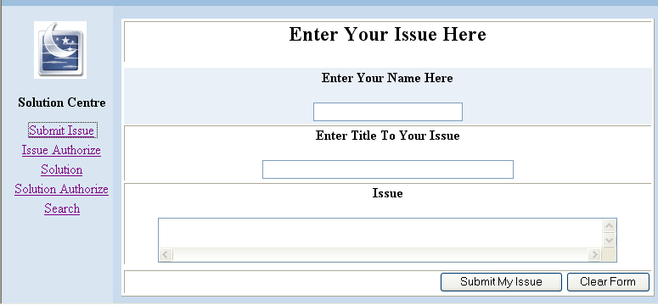
Figure 3.2 – Submit Issues
Entering core data and submit the form it will update the database. But it does not publish to public until admin given Authorize it.

Authorized the submitted issues for user access

Using screen in figure 3.3 provide facility to publish the user issue to public. This can be do by Authorize user or administrator by click on publish button.
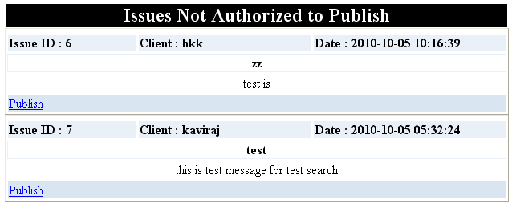

Figure 3.3 Authorize the submitted Issues

Provide Solution for submitted issues
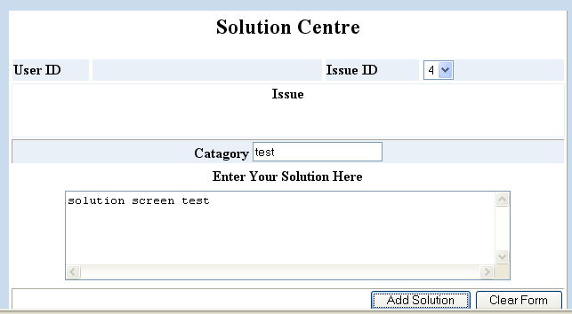
Figure 3.4 Solution Centre

Solution Centre form view in figure 3.3 is providing facility to given solution for submitted issues. This also will not publish until Authorize And figure 3.5will help to publish solutions.

Publish the solution
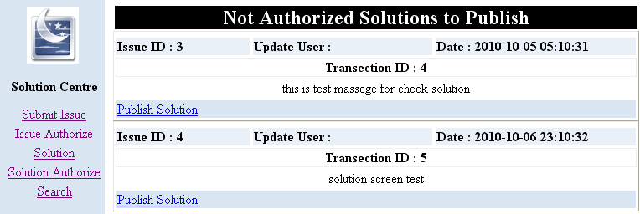

figure 3.3

Figure 3.5 Publish Solutions

Searching Issues and solutions
By using this screen ( figure 3.6) can search Issues in database. Text entering to this screen will tokenize and store in array. Search word by word in database and then system provide list of suggestions as in Figure 3.7.
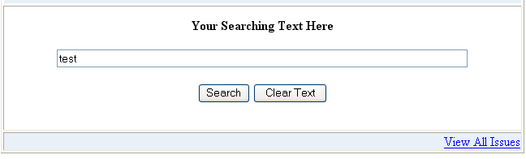

Figure 3.6 Search solution
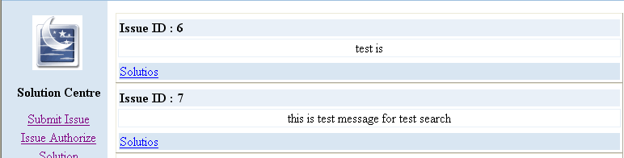
Figure 3.7 – Search Results

Click on suitable item then can view solutions submitted against it.

During this Issue / Solution operation Authorize users can view Authorized and Non Authorized Issues and Solutions And Other Users can view all authorized items.

3.3.2 Knowledge & Recourse Sharing
This Provide The facility to upload and Download file with different formats. Any Institute or person can upload items such as technical report, about research areas, Scientific Methods, New arrivals and so forth. Here also need to Authorize for publish. After Authorize uses can Download or view it.

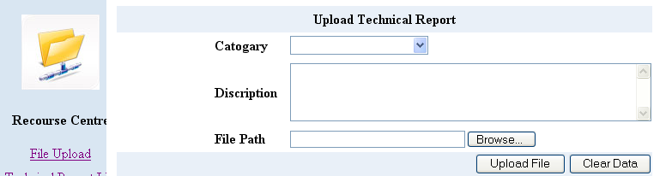
Figure 3.8 – Upload Recourses

Functions in Knowledge & Recourse Sharing function has following operations.

Upload Files
Images
Videos
Authorize Functions for Publish
View and Download Above mention Recourses.
View Resent Uploaded files, Authorize and Non Authorize files, List of Visited and Non Visited Files.
Search File by keywords in database.

3.3.3 Programs and Participant

In here VRC and other institute publish information about there training programs. MOST able to schedule the other programs, and able to manage action plan. And also client can register to required programs in any where.
Following functions are available under this event.
- VRC and other Institute able to publish their programs call to participants applications.
- Client can register via web to these training programs an any where, any time.
- Report can be generate.

3.3.4 Task Management system
Task Management is the important factor in any institute. In here provide monitoring and managing facility to institute administration.

Available factions
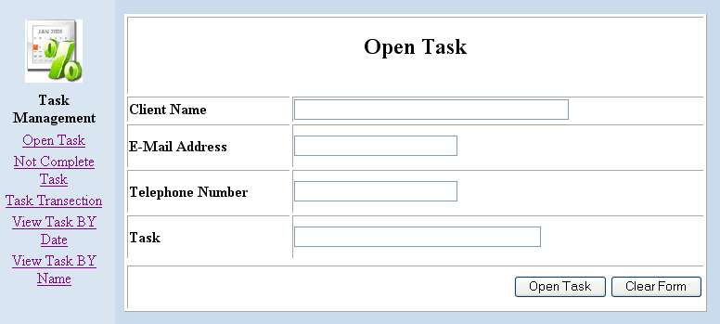
This section including open, Transact, and completing task as the data update level factions and generate report and search items as collect information screens.
Figure 3.9 Open Task
After submitting the task start a account in database according task ID. Then this event should follow until completing it. Not completed task will appear in Not Completed task screen shown in Figure 3.10
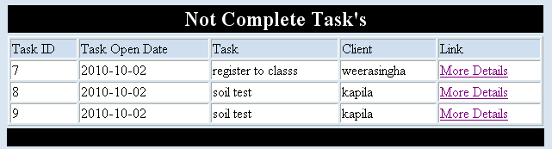

Figure 3.10 Not Complete Tasks

Using the Transaction of tasks screen in Figure 3.11 can be adding future tasks to opened events.
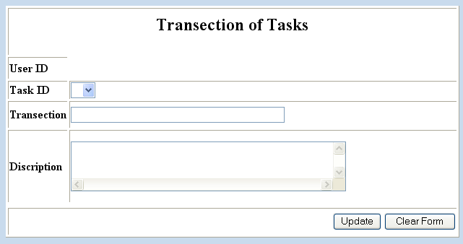

Figure 3.11 Transaction of tasks

System enables to view list of task by opening date, client name, task id. Screens are shown in bellow.
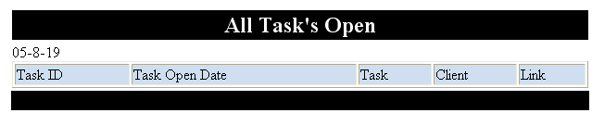

Figure 3.12 Task open in mention date

Search task by submitted user name
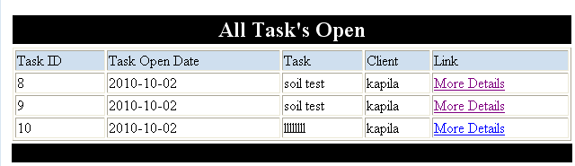

Figure 3.13 Task By Name

By click on the More Details link can View the details of task.
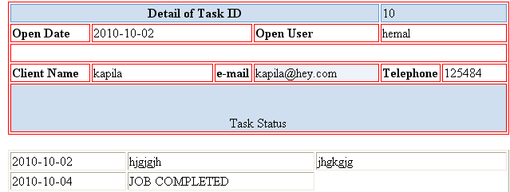
Figure 3.14 Task details

3.3.5 Client Information Database
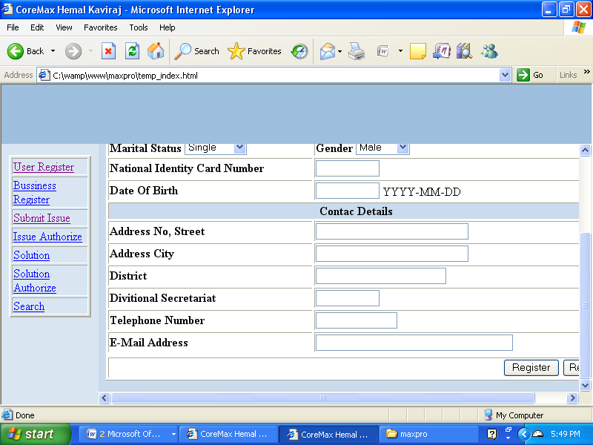
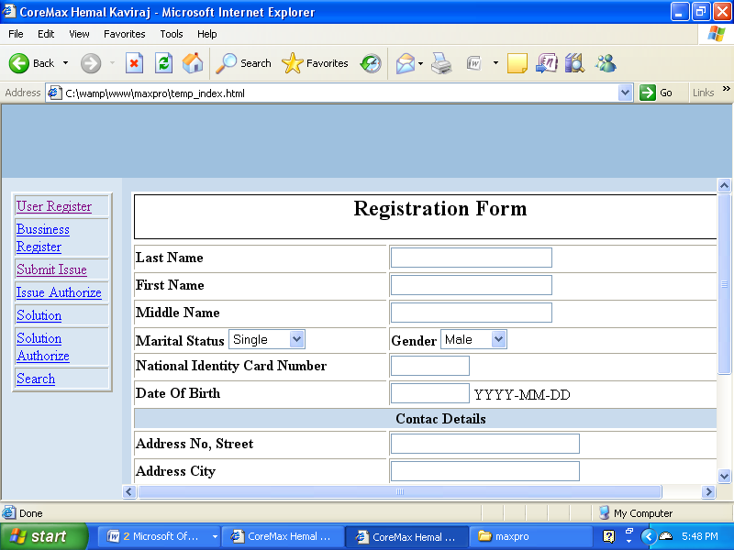
VRC establish the societies in every GN divisions. In here hope to update inform about them with there entrepreneurship.

Figure 3.15 Business registration Form

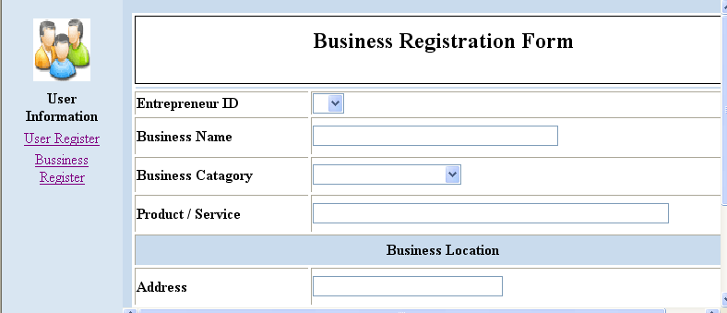
Figure 3.16 Business Registration

CHAPTER 4
Results and Discussion
This chapter illustrates the results obtained from system.

4.1 Testing
This system was test by known data set and it is function to all data sets of use. Testing was redirected to other functional requirements and it was helpful to ignore the data complicit.

4.2 Security
Web applications need good security and Authentication. This system use different user levels or user categories for access control. Every page in this system checks the logging information and after that it provides access rights for authorize peoples. And in the run time environment has different type of peoples. So all publications need authorize to public play. Uploading items will publish after authorize by officer.

4.3 Stability
Stability depends on use software and hardware. Technology transfer system run on Apache web server. It is most stable and realizable server in free software category. PHP is support for all known browses and My-SQL database also can smoothly run over expected data capacity.

4.4 Accuracy
System test with different type of datasets. And it generate expected outcomes.

CHAPTER 5
Conclusions and Recommendations
This chapter illustrates the achievements against to currant presses.

  - Conclusions
Functions of the web base technology transfer system could resolve the problems which bundle with traditional technology transfer system. This solution could fulfill the Identified issues during the feasibility study. Technology transfer system achieve it goals. Because of all the functional and non functional requirement of system are successfully implemented.

Technology transfer system achieves all the objectives have in beginning.

System provide advantages to MOST, VRC’s, Research institutes and other clients with following functions.

- Able to centralize the available knowledge in country.
- Required technology can be transfer to required person on required time.
- Able to improve the solution by comparing the different solutions coming from different place. And it direct to spiral research.
- Able to ready for technological issues in sector before the arise it.
- Technology usage in country may direct to economical development. Hence this will support to economical development.

REFERENCES

- Book PHP5, Apachi, MySQL web Development,Elizabeth Naramore, Jason Gerner, Yann Le Scouarnec, Jeremy Stolz,Michael K Glass – 2005
- http://en.wikipedia.org/wiki/Black-box_testing functional non functional software testing methods.
- Matheu N (2005) “Life Cycle Document Management System for Construction” Ph.D. thesis, Universitat Politecnica De Catalunya, SpainAvailable :http://www.tesisenxarxa.net/TESIS_UPC/AVAILABLE/TDX-0518105-155912//05Nfm05de12.pdf
- Website: data transferring and event handling functions. http://www-cs-students.stanford.edu/~wolfe/javascript/

reg_pro
date
user_id
Pro_name
Course_id
Trans_id
Belongs
1
1
apply
pro_schedule
Pro_loc_id
Pro_org
Pro_date
program
Pro_id
Trans_id
Pro_tp
Pro_email
varcant
user
date
status
Biz_register
Trans_id
Ent_id
Biz_name
Biz_cat
Biz_prod
Biz_add
Biz_tp
Biz_email
date
user
ent_info
nic
dob
add
dis
div
tp
gender
marital
name
no
email
user
date
Belong to
issues
Is_auth_id
Is_date
Is_issue
Is_title
Is_client
Is_id
Is_user
solution
date
user
Sol_cat
solution
Is_id
Trans_id
auth
has
1
N
submit
N
N
submit
N
N
Up_file
level
user
date
cat
discrip
file_id
access
N
N
Attachment 01

Pg_access
id
U_cat
Pg_id
user
user_pw
user_cat
user_id
User_cat
Cat_id
user_cat
has
1
1
N
1
contral
Task_open
date
user
email
clientn
task
task_id
statatus
tp
Task_trans
user
discrip
job
date
Task_id
Trans_id
has
1
N
Attachment 02

