Steps to host a Static webpage using Vercel

**Step 1:**

Create a Static Webpage with HTML, CSS, JavaScript. **Step 2:**

Upload the Website files into Github. **Step 3:**

Sign up to Vercel and login with it.

**What is Vercel:**

Vercel is a cloud platform for static sites and serverless functions. It allows developers to deploy web projects with ease, providing features like automatic deployments, custom domains, and serverless functions. Vercel supports a variety of frontend frameworks and static site generators, such as React, Next.js, Gatsby, and more. It's known for its simplicity and integration with popular version control systems like GitHub and GitLab. Developers often use Vercel to host their websites, web applications, and APIs.

**Step 4:**

1. Navigate to your project folder in github and click Import.
2. Configure Project.
3. Testin

**Create new user Name :**





**Already created users Id Then logIn and continue :**

**Set your avator :**



**Welcome page :**



**You entered the chart page :**

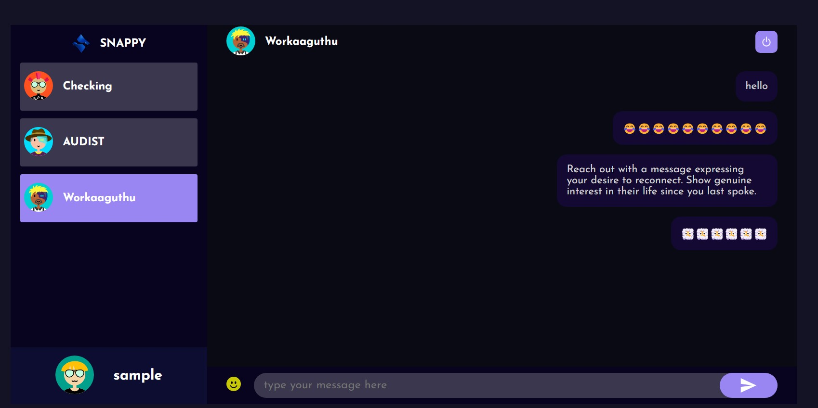

**Website link : https://cloud-front-end-fqab.vercel.app/**

**Kaviram R**

**2021115332**