PROJECT REPORT

SMART RADAR EQUIPMENT
HEALTH MONITORING SYSTEM
Based on STM32F103C8T6 and Proteus Simulation

Submitted by
Kavish Mari – 9925005020
Abdullah – 9925005049
Harshitha – 9925005045
Dedeepya – 9925005056

Department of Electronics and Communication Engineering
Kalasalingam Academy of Research and Education

ABSTRACT
The Smart Radar Equipment Health Monitoring System is a microcontroller-based project that demonstrates how equipment condition inputs can be monitored and how an alert can be produced when an input reaches a set limit. The prototype uses an STM32F103C8T6 microcontroller. Two potentiometers in the Proteus circuit represent temperature and vibration inputs. The microcontroller reads these analog signals through its ADC and compares the readings with a threshold value of 3000. If either reading reaches or exceeds the threshold, a red LED turns on and a buzzer beeps. If both readings remain below the threshold, the LED and buzzer stay off. The project is implemented as a software simulation using STM32CubeIDE and Proteus.

1. INTRODUCTION
Radar equipment is expected to operate reliably. Changes in operating conditions can indicate that equipment needs attention. Monitoring input values and providing an alert can help an operator notice an abnormal condition. This project demonstrates a basic monitoring and alert arrangement using an STM32 microcontroller.
In this prototype, actual temperature and vibration sensors are not used. Two potentiometers provide adjustable analog voltages to represent these inputs. This allows the monitoring logic to be tested in Proteus without physical sensors.

2. OBJECTIVES
- To use an STM32F103C8T6 microcontroller for monitoring analog inputs.
- To read two analog input channels using the built-in ADC.
- To compare the input readings with a fixed threshold value.
- To activate a red LED and buzzer when either input reaches the threshold.
- To test the circuit and program using Proteus simulation.

3. HARDWARE AND SOFTWARE REQUIREMENTS
Component / Tool | Use | Details
STM32F103C8T6 | Main controller | Reads analog inputs and controls alarm outputs
RV1 potentiometer | Temperature input simulation | Connected to ADC channel 0 / PA0
RV2 potentiometer | Vibration input simulation | Connected to ADC channel 1 / PA1
Red LED and 330 Ω resistor | Visual alert | Indicates an alarm condition
Buzzer / sounder | Audible alert | Beeps when an alarm condition is detected
3.3 V supply and ground | Circuit supply | Provides the supply reference
STM32CubeIDE | Programming tool | Used to develop and build the embedded C program
Proteus 8.17 | Simulation tool | Used to draw and simulate the circuit

4. CIRCUIT DIAGRAM
The following figure shows the Proteus circuit used for the project. RV1 and RV2 provide adjustable analog input signals to the STM32F103C8T6. The output section contains a red LED with a series resistor and a sounder.
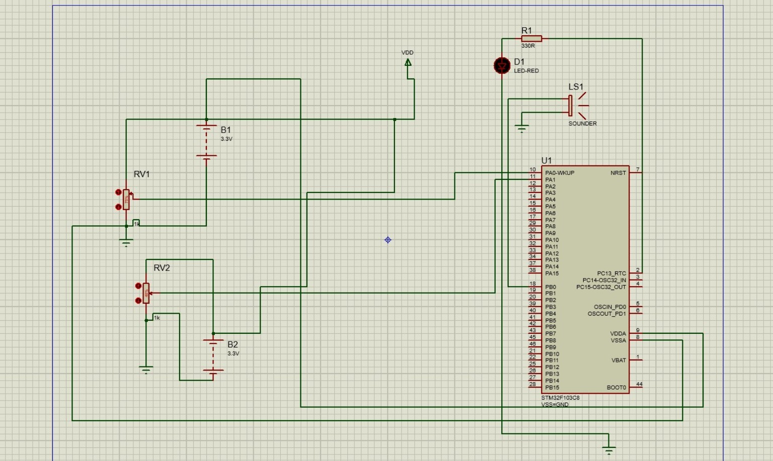
Figure 1: Proteus circuit diagram of the Smart Radar Equipment Health Monitoring System

5. PIN CONNECTIONS
STM32 pin | Connected component | Function
PA0 / ADC channel 0 | RV1 wiper | Temperature input simulation
PA1 / ADC channel 1 | RV2 wiper | Vibration input simulation
PC13 | Red LED control | Visual alarm output
PB0 | Buzzer control | Audible alarm output

6. WORKING PRINCIPLE
- The two potentiometers are adjusted to provide analog voltages to PA0 and PA1.
- The STM32 ADC reads PA0 as the temperature-related input.
- The ADC then reads PA1 as the vibration-related input.
- Each ADC reading is a 12-bit digital value between 0 and 4095.
- The program compares both readings with the threshold value 3000.
- If either reading is 3000 or higher, the program turns on the red LED and makes the buzzer beep.
- If both readings are below 3000, the program turns off the LED and buzzer.
- The process repeats continuously while the microcontroller is running.

7. PROGRAM DESCRIPTION

7.1 Header files and ADC handle
The program includes main.h for STM32 HAL definitions and stdint.h for fixed-width integer types. ADC_HandleTypeDef hadc1 is the handle used to configure and operate ADC1.

7.2 Threshold values
TEMP_ALARM_RAW and VIBRATION_ALARM_RAW are both set to 3000. These are raw ADC counts, not degrees Celsius or a physical vibration measurement.

7.3 Initialization
HAL_Init() initializes the HAL library. SystemClock_Config() configures the internal HSI clock. MX_GPIO_Init() configures the LED, buzzer and analog input pins. MX_ADC1_Init() configures ADC1. The program then starts ADC calibration.

7.4 ADC reading function
Read_ADC(channel) selects the requested ADC channel, starts conversion, waits for the conversion to finish, reads the digital result and stops the conversion. The returned value is used in the main loop.

7.5 Alarm control
The if condition uses the logical OR operator (||). Therefore, an alarm is activated when the temperature-related input reaches 3000 or the vibration-related input reaches 3000. The LED is set high and the buzzer is switched on and off with 200 millisecond delays. When neither input reaches the threshold, both outputs are set low.

7.6 Error handling
If an initialization or ADC operation fails, Error_Handler() disables interrupts and keeps the program in an infinite loop.

8. TESTING AND OBSERVATION
The input potentiometers can be adjusted in Proteus to test normal and alarm conditions. The following table shows the expected behaviour from the program.
Temperature input | Vibration input | LED | Buzzer
Below 3000 | Below 3000 | OFF | OFF
3000 or above | Below 3000 | ON | Beeping
Below 3000 | 3000 or above | ON | Beeping
3000 or above | 3000 or above | ON | Beeping
These are expected results based on the program logic. Actual test readings can be recorded separately when the simulation is run.

9. RESULT
The program monitors two analog input values using the STM32F103C8T6. When either ADC value reaches or exceeds 3000, the red LED is activated and the buzzer beeps. When both values are below 3000, the alarm outputs remain off. The circuit and firmware form a simulation-based prototype of an equipment condition monitoring system.

10. LIMITATIONS
- Potentiometers are used to simulate temperature and vibration inputs; actual sensors are not connected.
- The threshold values are raw ADC counts and have not been calibrated to real-world units.
- The prototype demonstrates local LED and buzzer alerts; it does not provide verified live radar equipment measurements.
- The project is a simulation prototype and is not presented as a field-tested radar monitoring device.

11. FUTURE ENHANCEMENTS
- Connect a suitable temperature sensor and calibrate its readings.
- Connect a suitable vibration sensor and process its output.
- Set threshold values based on sensor calibration and equipment requirements.
- Add a display to show measured values and alarm status.
- Develop a communication link for remote monitoring and data logging.

12. CONCLUSION
The Smart Radar Equipment Health Monitoring System demonstrates a simple method of monitoring two analog inputs with an STM32F103C8T6 microcontroller. The ADC converts the input voltages into digital values, and the program compares these values with fixed limits. A red LED and buzzer provide alerts when an input reaches the set threshold. The Proteus simulation helps demonstrate the operation of the circuit and embedded program. Using real sensors and calibrated measurements would be the next stage of development.

APPENDIX A – IMPORTANT PROGRAM VALUES
- Microcontroller: STM32F103C8T6
- ADC resolution: 12-bit (0 to 4095)
- Temperature input: PA0 / ADC channel 0
- Vibration input: PA1 / ADC channel 1
- Alarm threshold: 3000 for each input
- LED output: PC13
- Buzzer output: PB0
- Buzzer timing: 200 ms ON and 200 ms OFF

