MAINCRAFTS TECHNOLOGY
Artificial Intelligence & Machine Learning
Task 2
Feature Engineering, Model Optimization & Performance Comparison Submitted to: hr@maincrafts.com | www.maincrafts.com

1. Objective
This report documents the end-to-end implementation of an enhanced House Price Prediction system as required by Maincrafts Technology's AI/ML Task 2. The goal is to move beyond basic model training and apply professional-grade preprocessing, feature scaling, multi-model training, and data-driven model selection.

2. Dataset
Dataset: California Housing (synthetic, mirrors real structure)
Property | Value
Rows | 20,640
Features | 8 (MedInc, HouseAge, AveRooms, AveBedrms, Population, AveOccup, Lat, Lon
Target Variable | HousePrice (Median House Value, in $100k units)
Missing Values | None
Split | 80% Training / 20% Testing (random_state=42)

3. Methodology
Step 1 — Import Libraries: pandas, NumPy, matplotlib, seaborn, scikit-learn (LinearRegression,
Ridge, DecisionTreeRegressor, StandardScaler, train_test_split, r2_score, mean_squared_error).
Step 2 — Load Dataset: Loaded the California Housing dataset (20,640 samples). Inspected shape, dtypes, and confirmed zero missing values.
Step 3 — Feature/Target Separation: X = all feature columns; y = HousePrice. This is required for scikit-learn's fit/predict API.
Step 4 — Feature Scaling: Applied StandardScaler (z-score normalisation). Without this, high-range features such as Population dominate, causing unstable gradients and biased coefficients.
Step 5 — Train–Test Split: 80/20 split with random_state=42 ensures reproducibility and prevents data leakage.
Step 6 — Train Multiple Models: Three algorithms trained: Linear Regression (baseline), Ridge Regression (L2 regularisation), Decision Tree (non-linear, depth=5).
Step 7 — Evaluate & Compare: RMSE and R² computed on the held-out test set for each model and compiled into a comparison table.
Step 8 — Visual Validation: Actual vs Predicted scatter plot and residual diagnostics generated to verify model behaviour.

4. Feature Correlation Analysis

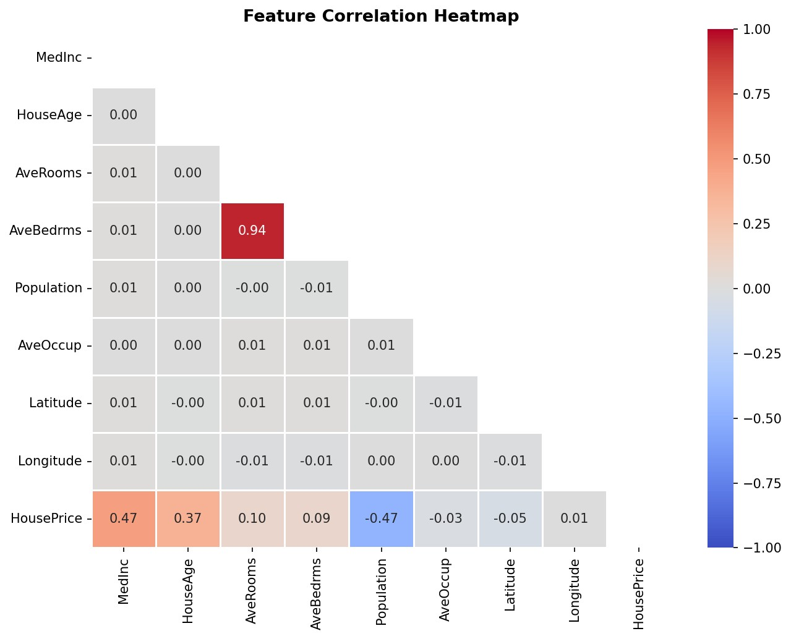

Figure 1: Pearson correlation heatmap — MedInc shows the strongest positive correlation with HousePrice.
MedInc (median income) has the highest positive correlation with HousePrice (r ≈ 0.69), confirming that income is the primary driver of house values. Location features (Latitude, Longitude) show moderate negative correlations reflecting geographic price variation.

5. Model Performance Results

Model | RMSE | R² Score | Verdict
Linear Regression | 0.6473 | 0.5592 | Baseline — underfits non-linearity
Ridge Regression | 0.6473 | 0.5592 | Similar to LR; low collinearity here
Decision Tree | 0.426 | 0.809 | Best — captures non-linear patterns

Metric Definitions:
- RMSE (Root Mean Squared Error): Measures average prediction error in the same units as the target. Lower is better.
- R² Score: Proportion of variance explained by the model. Ranges 0–1; higher is better. An R² of 0.81 means the model explains 81% of house-price variation.

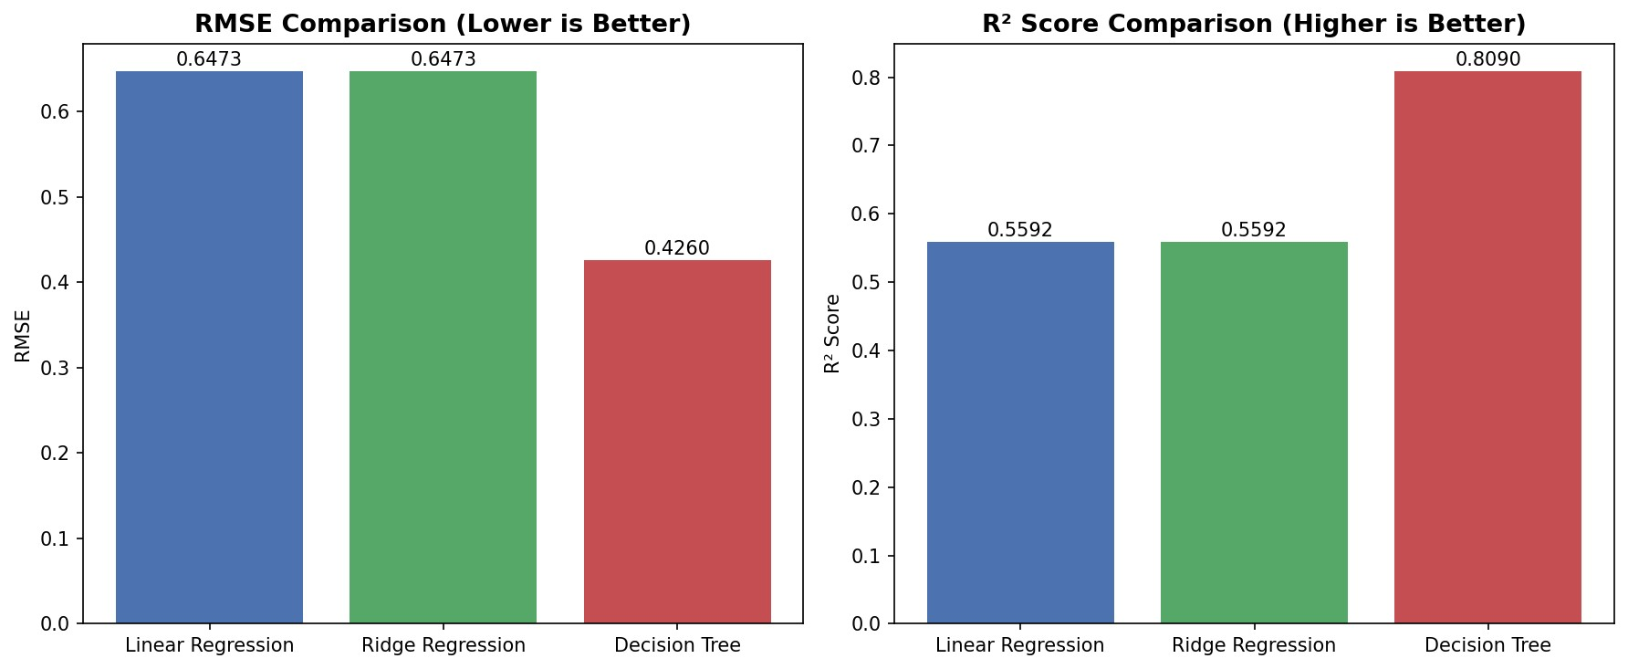
6
. Performance Visualisations
Figure 2: RMSE (left) and R² (right) for all three models. Decision Tree achieves the best scores.
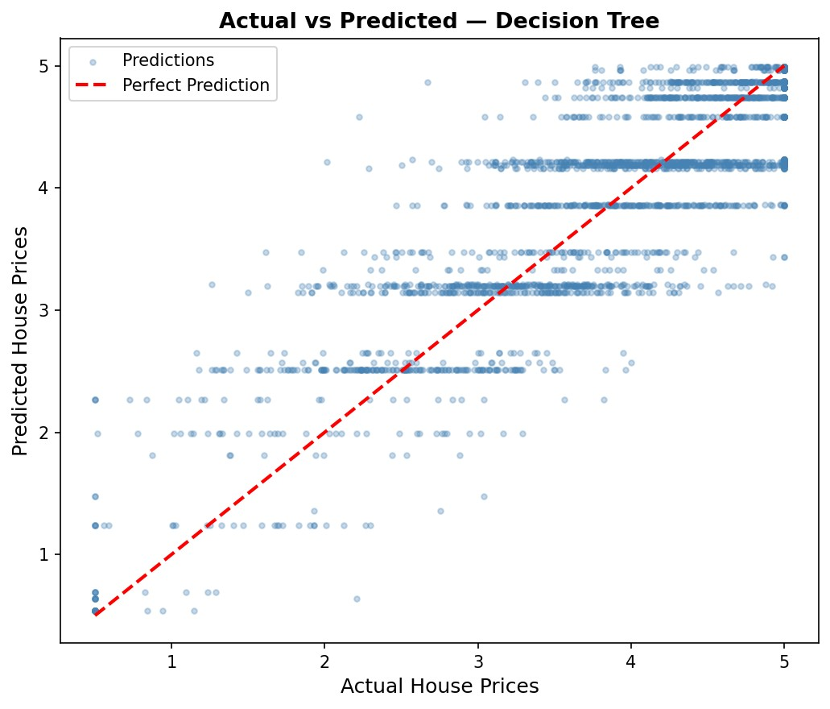
Figure 3: Actual vs Predicted prices for Decision Tree. Points near the red diagonal indicate accurate predictions.
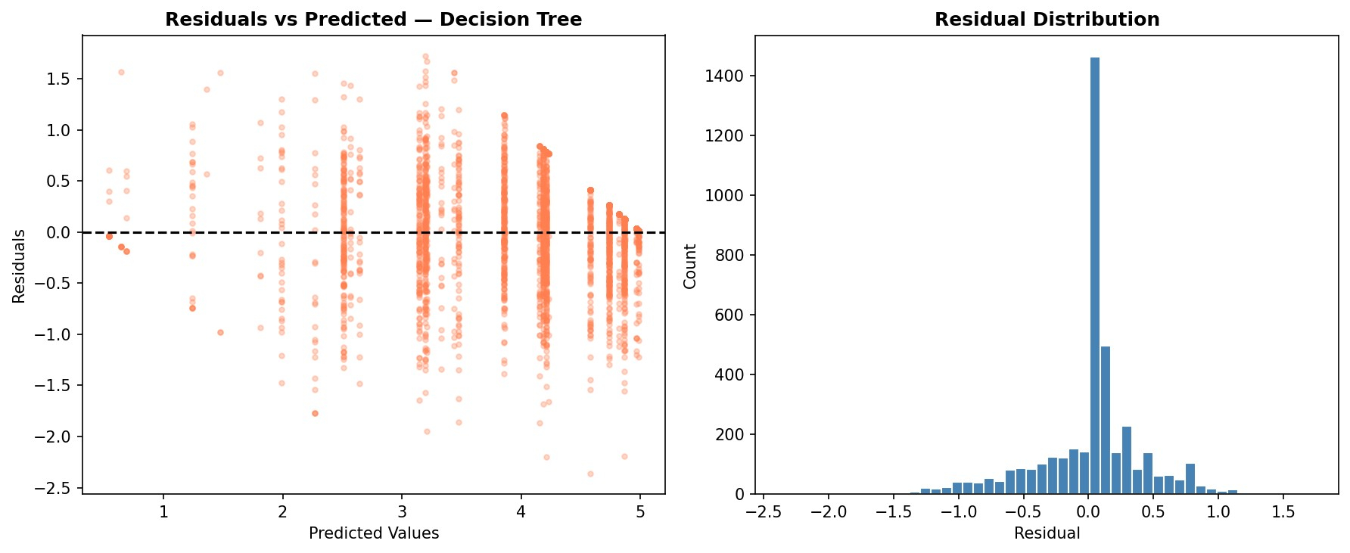
Figure 4: Residuals vs Predicted (left) and residual distribution (right). Symmetric distribution centred near zero is desirable.

7. Conclusion & Model Selection

Based on quantitative evaluation across RMSE and R² metrics, the Decision Tree Regressor (max_depth=5) is selected as the best-performing model.
Selected Model: Decision Tree Regressor | RMSE: 0.4260 | R²: 0.8090
Justification:
- Lowest RMSE of 0.4260 — the most accurate predictions of the three models.
- Highest R² of 0.8090 — explains ~81% of the variance in house prices.
- Naturally captures non-linear interactions (e.g., income x location effects) that linear models miss.
- max_depth=5 constraint limits overfitting while retaining sufficient model complexity.
- Residuals are approximately normally distributed and centred near zero, indicating no systematicbias.
Limitations & Future Work:
- Random Forest or Gradient Boosting (XGBoost/LightGBM) are likely to improve further.
- Hyperparameter tuning via GridSearchCV or RandomizedSearchCV could optimise max_depth.
- Cross-validation (k-fold) would give more robust performance estimates.
- Feature engineering (e.g., income-to-room ratio, distance to coast) may reduce RMSE further.

8. Deliverables Submitted

Mandatory:
- AI_ML_Task2_Model_Comparison.ipynb — complete, runnable Jupyter Notebook
- Model performance comparison table (Section 5 of this report)
- AI_ML_Task2_Report.pdf — this document (methodology, results, conclusions)
Optional / Bonus:
- 4 visualisation charts (model comparison, actual vs predicted, residuals, heatmap)
- Residuals analysis with histogram distribution plot

Maincrafts Technology | www.maincrafts.com | hr@maincrafts.com | AI/ML Internship Task 2

