**Capstone Project**

**Index**

|  |
| --- |
| 1. Project Modules |
| 1. Tools and Technologies |
| 1. Database and Fields Mappings |
| 1. Database Tables Screenshots |
| 1. Project Screenshots |

**Project Modules**

* + - * User Management-Role Based
      * Create/Place Order
      * Show All Orders
      * Confirmed Place Orders
      * Create Purchase Order
      * Show All Purchase Order
      * Create Invoice
      * Show All Invoice
      * Show All Reports Menu Wise
      * Report Microservice

**Tools and Technology**

* Programming Language: Java8
* Java Framework: Spring, Spring Boot
* Architecture: MVC Work Flow and Microservice
* Database: MySQL or Oracle
* ORM Frameworks: JPA, Hibernate
* Front End Technologies: HTML, CSS, Bootstrap, JavaScript
* Tools: Postman

**Database Table**

* User Table
* Role Table
* Order Table
* Purchase Order Table
* Item Table
* Invoice Table

**Database Table and Field Mapping**

* User Information Table with Roles Tables
* Place Order Table with Purchase Order Table
* Purchase Order Table with Invoice Table

**Database Table Screenshots**

1. Show All Database Tables

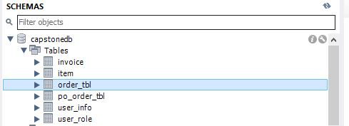

1. Show User Table

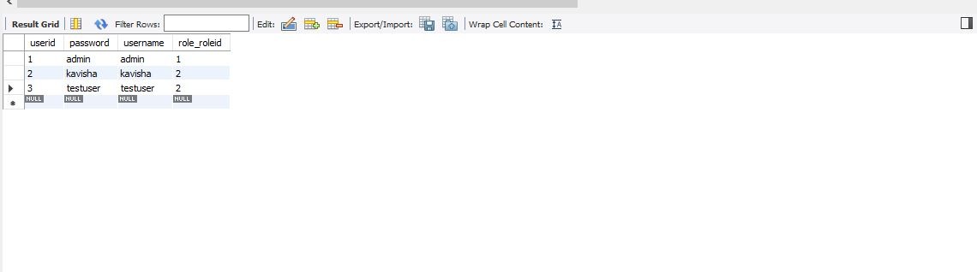

1. Show Role Table

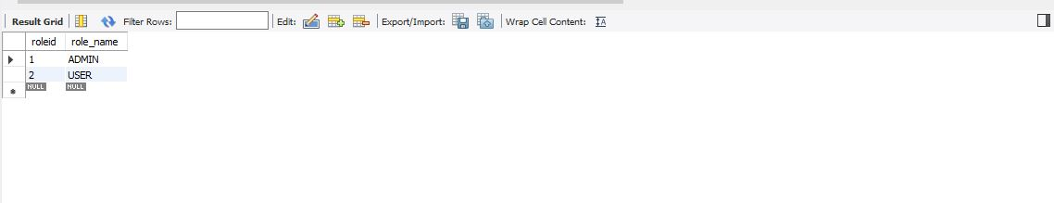

1. Show Placed Order Table

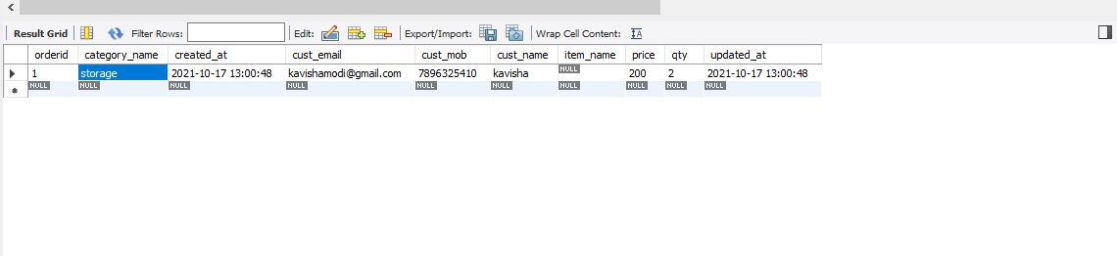

1. Show Purchase Order Table

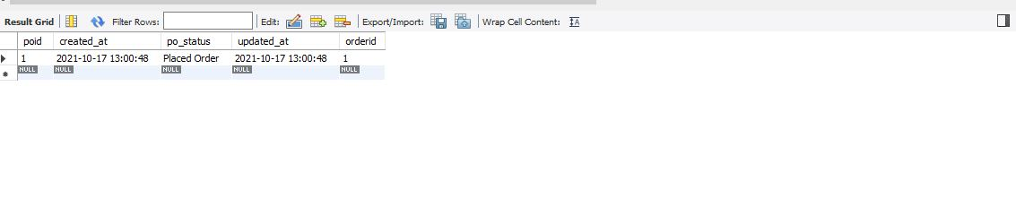

1. Show Item Table

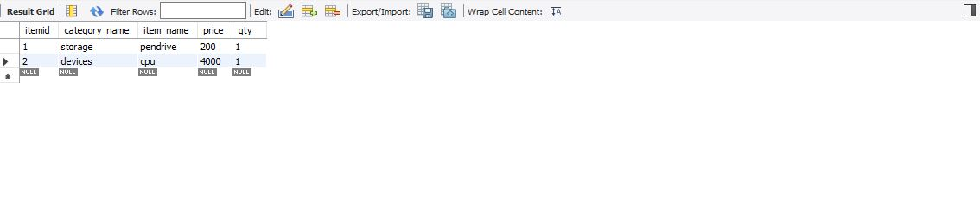

1. Show Invoice Table

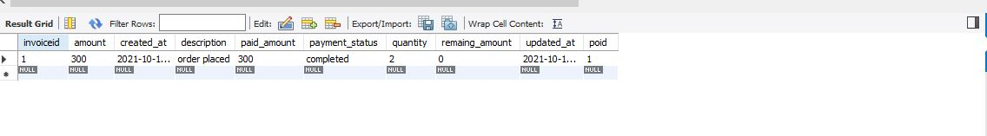

**Project Screenshots**

1. User Login Design

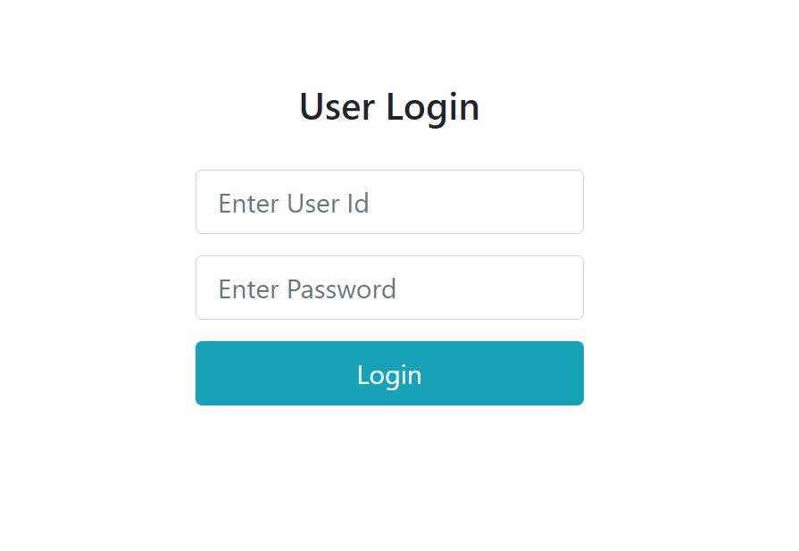

1. User Login Details

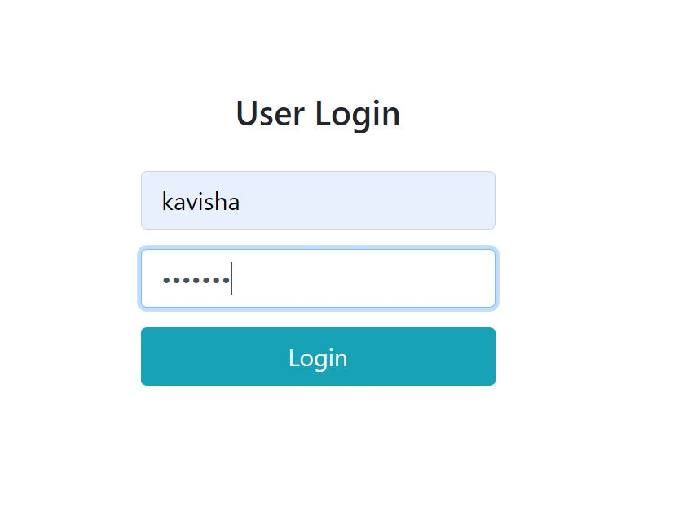

1. Create New User

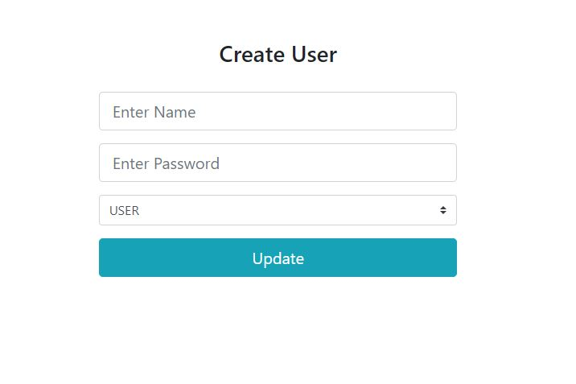

1. Show All User

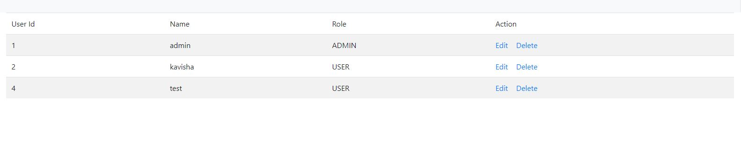

1. Edit User Details Design

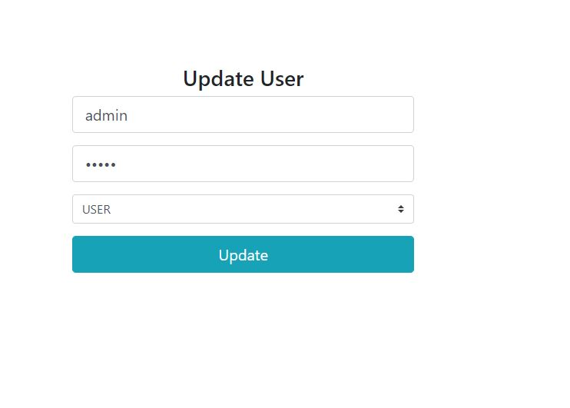

1. Updated User Details

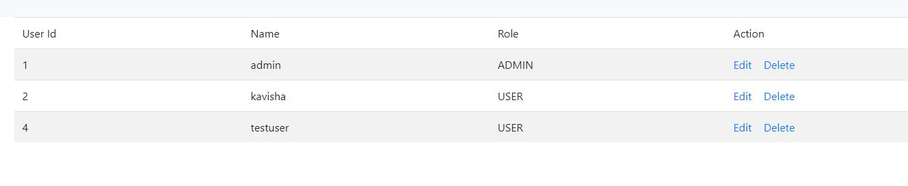

1. Delete User

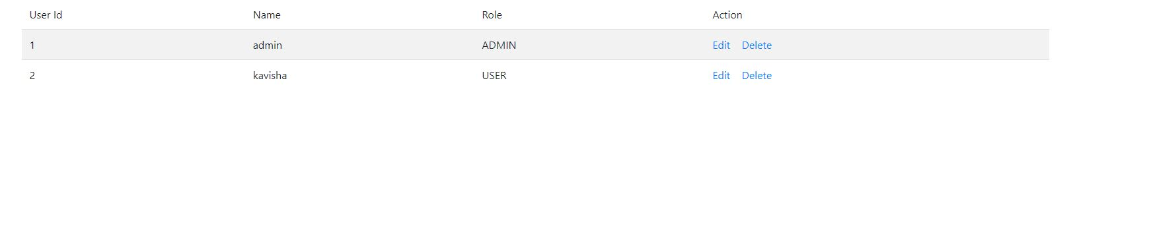

1. Show Menu for Admin Role

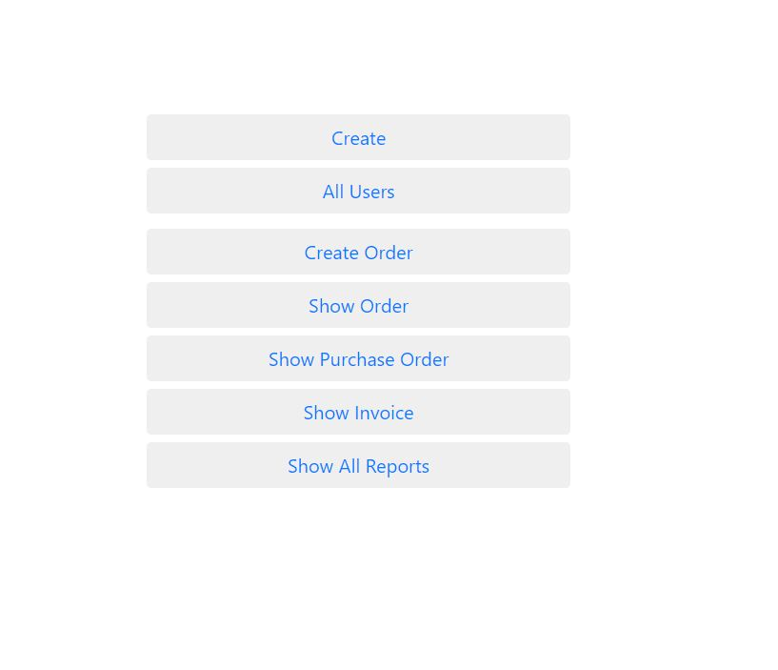

1. Show Menu for User Role

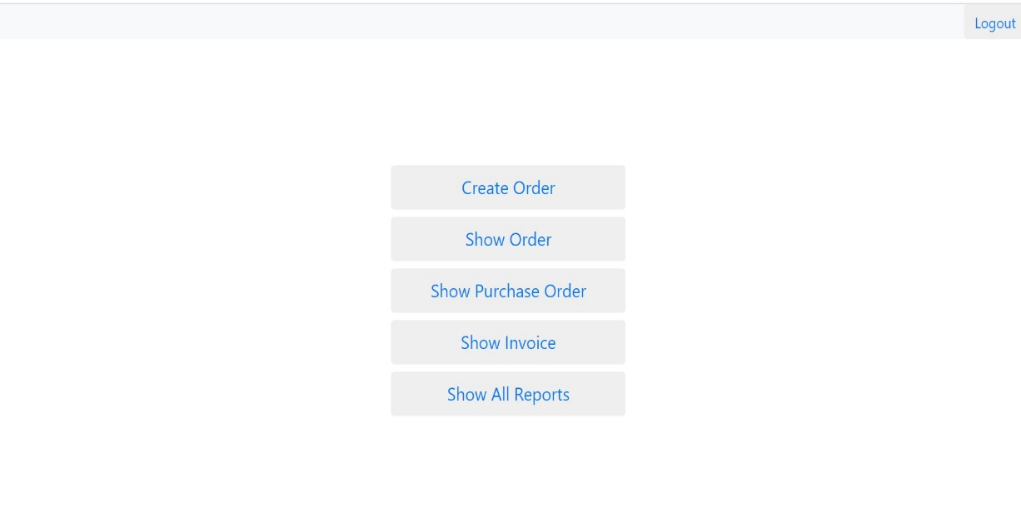

1. Create Order Form Design

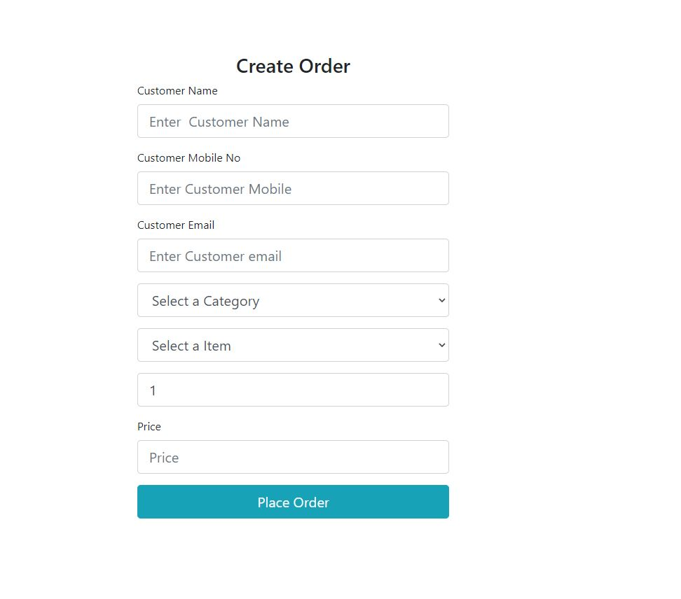

1. Create Order Form Validation

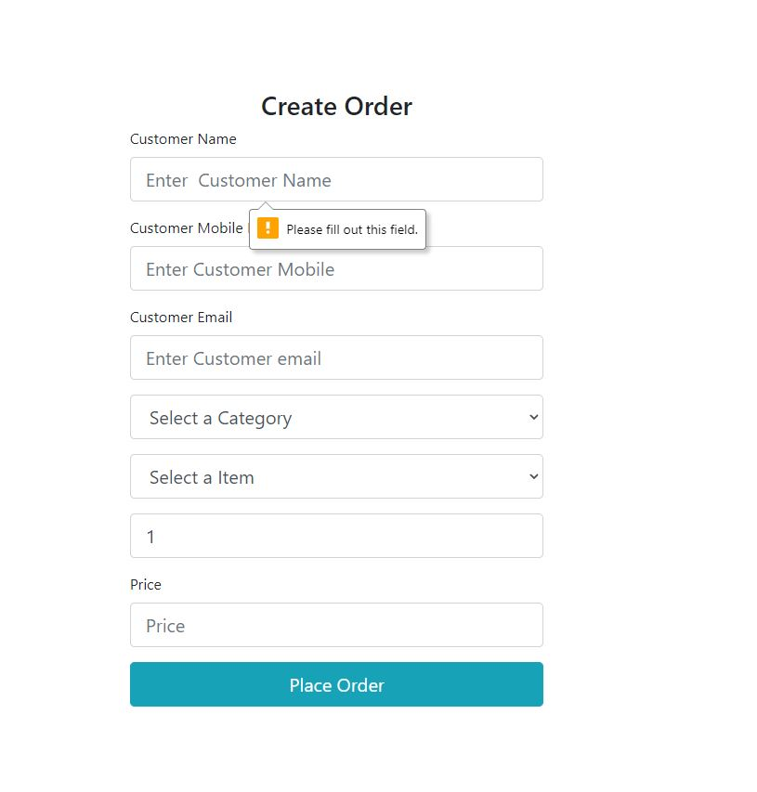

1. Show Orders- Customer Details

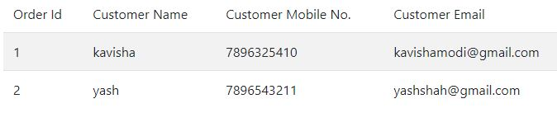

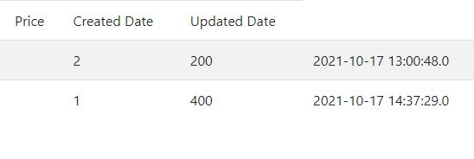

1. Purchase Order Details

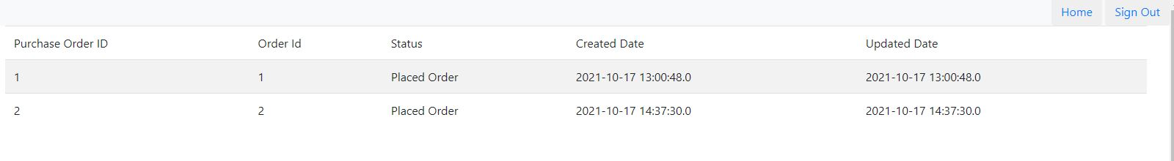

1. Show Confirmed Order

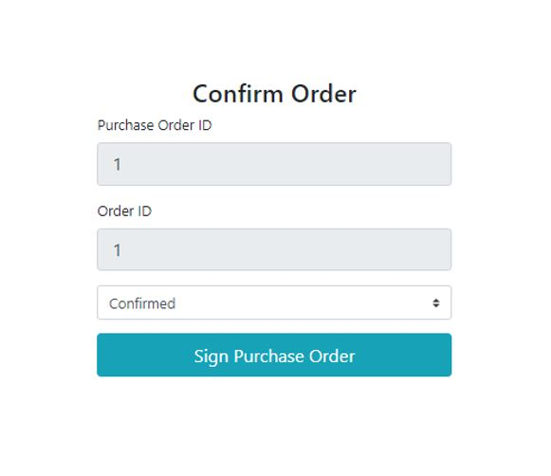

1. Show Invoice

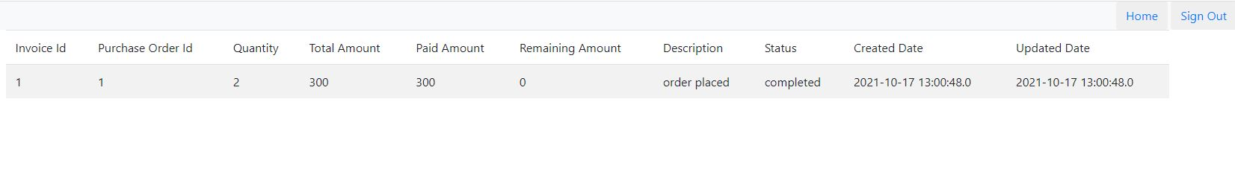

1. Show Menu for Reports

