CAPSTONE PROJECT IN DATA SCIENCE - DS2105
[Environment]
A PROJECT REPORT
[Rainfall Occurrence Modelling]

Submitted in partial fulfilment of the requirements for the award of the degree of
BACHELOR OF SCIENCE HONOURS
IN
DATA SCIENCE
By
GROUP 4
SEMESTER 3


DEPARTMENT OF DATA SCIENCE
FACULTY OF COMPUTING
SABARAGAMUWA UNIVERSITY OF SRI LANKA
BELIHULOYA
2025

Declaration
We hereby declare that this project report titled “Environment – Rainfall Occurrence Modeling, Disaster Prediction, Crop Yield Estimation.” is the result of our collective original work carried out for the fulfillment of the requirements of our degree program. This report does not contain any material previously submitted for any degree or diploma at any university or institution, except where proper acknowledgment has been made. All sources of information consulted during this project have been correctly cited and referenced.
We also grant the university the non-exclusive right to reproduce and distribute this report, in whole or in part, in print, electronic, or any other media format for academic purposes.

Index Number | Name of Student | Date | Signature of Student
22CDS0422 | N.K.C.S. Bandara | 2025.11.16
22CDS0425 | K.N. Hewawitharana | 2025.11.16
22CDS0433 | M.S.C. Bhawanthi | 2025.11.16
22CDS0435 | D.M. Avindu Kanishka | 2025.11.16
22CDS0438 | M.M. Saneeh | 2025.11.16
22CDS0442 | M. Thushan | 2025.11.16
22CDS0444 | Akshaya.V | 2025.11.16
22CDS0591 | K.T.D.D.M. Jayathissa | 2025.11.16
22CDS0596 | H.K. Warnabarana | 2025.11.16

Abstract
This study presents a comprehensive probabilistic analysis of daily rainfall patterns in four major Sri Lankan cities: Colombo, Galle, Kandy, and Jaffna. Using multi-year daily precipitation records, rainfall occurrence was examined under three thresholds (≥1 mm, ≥2.5 mm, ≥12.5 mm) to classify rainy and dry days. Classical probability tools—including Bernoulli trials, Binomial and Poisson distributions, Normal distribution fitting, and two-state Markov chains—were applied to quantify rainfall frequency, intensity, seasonal variation, and persistence. The findings highlight strong monsoon-driven differences among regions, with Colombo and Galle showing higher rain probabilities and stronger rainfall persistence. These probabilistic insights are valuable for agriculture, climate risk assessment, and water-resource planning.
Table of Contents
Declaration ii
Abstract iii
1. Introduction v
2. Problem Statement v
3. Objectives v
4. Theoretical Background vi
Z-Score (for probability calculations): vii
5. Data Collection and Pre-processing vii
6. Descriptive Statistics viii
8. Sensitivity to Rainfall Threshold ix
8. Seasonal and Monthly Variation x
9. Bernoulli and Binomial Probability Modeling x
10. Poisson Modeling of Monthly Rainy Days xi
11. Normal Distribution Fitting for Rainfall Amount xii
12. Markov Chain Modeling of Daily Rainfall Occurrence xiii
13. Results and Interpretation xiv
14. Limitations and Future Work xiv
15. Conclusion xv
16. References and Appendixes xv

1. Introduction
This report presents a probability-based analysis of daily rainfall occurrence in selected Sri Lankan cities (Colombo, Galle, Kandy, and Jaffna). The main objective is to model rainfall occurrence using classical probability tools such as Bernoulli and binomial models, Poisson processes, normal distribution fitting, and Markov chains.
Sri Lanka’s rainfall regime is strongly controlled by two monsoon systems:
- Southwest Monsoon (May–September), which mainly affects the southern and western regions including Colombo, Galle, and Kandy.
- Northeast Monsoon (October–January), which mainly affects the northern and eastern regions, including Jaffna.
Understanding the probability of rainfall occurrence is important for agriculture, disaster risk reduction, water resource management, and crop planning. In this study, we define a 'rainy day' primarily using the threshold of at least 2.5 mm of daily precipitation, which represents a day with meaningful wet conditions. We also examine alternative thresholds (1 mm and 12.5 mm) for sensitivity analysis.

2. Problem Statement
Although Sri Lanka has extensive climate datasets, limited research applies probabilistic models to characterize daily rainfall occurrence and persistence. This project fills this gap by using Bernoulli, Binomial, Poisson, Normal, and Markov models to better understand rainfall frequency and behavior.

3. Objectives
The main objectives of this study are:
- To calculate the probability of a rainy day for each city.
- To compare rainfall behaviour under different rainfall thresholds.
- To analyse monthly and seasonal rainfall variation.
- To apply classical probability models to understand rainfall distribution.
- To study rainfall persistence using a two-state Markov chain.
- To provide meaningful insights useful for planning and decision-making.

4. Theoretical Background
This project applies several key probability concepts.
- Bernoulli Trials
Daily rainfall (Rain = 1, Dry = 0) is modeled as a Bernoulli random variable:
- $P(X=1)=p$
- $P(X=0)=1-p$ This binary framework matches the nature of daily rainfall occurrence.
- Binomial Distribution
The number of rainy days in a fixed period (e.g., a week) follows:
$$X∼\text{Bin}(n,p)$$
PMF:
$$P(X=k)=({n \atop k})p^{k}(1-p)^{n-k}$$
Where:
- $n$= number of trials (days)
- $k$= number of rainy days
- $p$= probability of rain

Useful for event planning or weekly rainfall prediction.
- Poisson Distribution
Monthly rainy-day counts can be modeled as:
$$Y∼\text{Poisson}(λ)$$
PMF:
$$P(X=k)=\frac{e^{-λ}λ^{k}}{k!}$$
Where:
- $λ$= average number of events per time period
- $k$= number of events (rainy days)
- Normal Distribution
Rainfall intensity on rainy days is approximated by:
$$X∼N(μ,σ^{2})$$
PDF (Probability Density Function):
$$f(x)=\frac{1}{\sqrt{2πσ^{2}}}exp⁡(-\frac{(x-μ)^{2}}{2σ^{2}})$$
- $μ$= mean rainfall
- $σ^{2}$= variance

Z-Score (for probability calculations):
$Z=\frac{X-μ}{σ}$
This allows estimation of extreme rainfall probabilities.
- Markov Chains
Rainfall persistence across consecutive days is modeled using a two-state Markov chain:
- State 0: Dry
- State 1: Rainy
Transition matrix:
$$P=( \begin{matrix}P(D→D) & P(D→R) \\ P(R→D) & P(R→R)\end{matrix})$$
This captures monsoon-driven rainfall clustering.

5. Data Collection and Pre-processing
Daily weather data were obtained from an open-source dataset (Kaggle-style structure) for four Sri Lankan cities: Colombo, Galle, Kandy, and Jaffna. The dataset includes daily total precipitation (in mm), weather code, and date for a multi-year period. The key variable used is 'precipitation_sum', representing the total rainfall on each day.
Pre-processing steps included:
- Parsing dates and extracting year, month, and season.
- Defining several binary rainfall indicators based on thresholds: ≥1 mm, ≥2.5 mm, and ≥12.5 mm.
- Classifying each day into three seasonal regimes: Southwest Monsoon, Northeast Monsoon, and Inter-monsoon months.
- Removing unused columns and ensuring there are no missing values in the precipitation field.

6. Descriptive Statistics
- Total days: 4916 per city.
- Rain probabilities (≥2.5 mm): Colombo (0.613), Galle (0.568), Kandy (0.474), Jaffna (0.248).
- Colombo and Galle show strong wet-zone characteristics.
- Jaffna shows pronounced dry-zone behavior.
Table 1: Key rainfall occurrence matrix for threshold ≥ 2.5 mm.

7. Key Rainfall Occurrence Matrix (Threshold ≥ 2.5 mm)
City | Total Days | Rainy Days | Dry Days | Rain Probability | Dry Probability
Colombo | 4916 | 3015 | 1901 | 0.6133 | 0.38669
Galle | 4916 | 2790 | 2126 | 0.5675 | 0.43246
Jaffna | 4916 | 1221 | 3695 | 0.2484 | 0.75162
Kandy | 4916 | 2329 | 2587 | 0.4738 | 0.52624
Using the main threshold of 2.5 mm, a day is classified as Rainy if precipitation_sum ≥ 2.5 mm and Dry otherwise. Table 1 summarizes the total number of days, number of rainy days, and corresponding empirical probabilities for each city.
Figure 1 shows the comparative probability of a rainy day (≥2.5 mm) across the four cities.
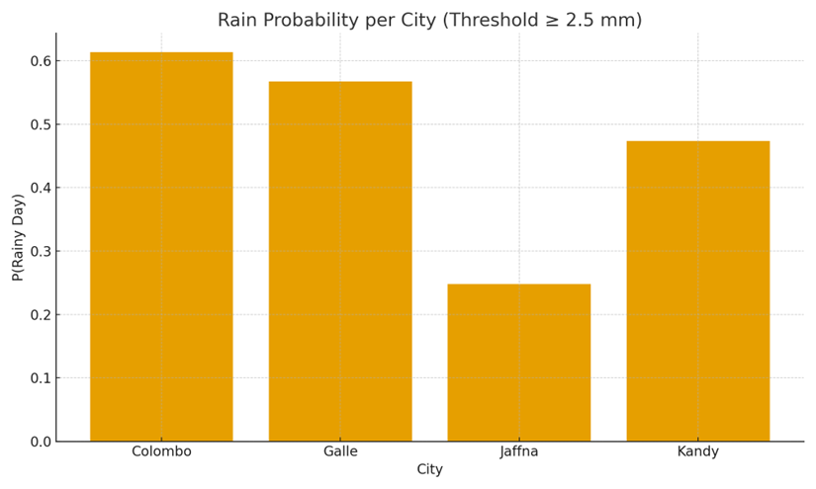

8. Sensitivity to Rainfall Threshold
To understand how the choice of 'rainy day' definition affects the results, three thresholds were tested: ≥1 mm, ≥2.5 mm, and ≥12.5 mm. Table 2 shows how the estimated probability of a rainy day changes with the threshold.
City | Threshold | Rainy Days | Rain Probability | Dry Probability
Colombo | ≥1 mm | 3774 | 0.7677 | 0.2323
Galle | ≥1 mm | 3715 | 0.7557 | 0.2443
Jaffna | ≥1 mm | 1807 | 0.3676 | 0.6324
Kandy | ≥1 mm | 3232 | 0.6574 | 0.3426
Colombo | ≥2.5 mm | 3015 | 0.6133 | 0.3867
Galle | ≥2.5 mm | 2790 | 0.5675 | 0.4325
Jaffna | ≥2.5 mm | 1221 | 0.2484 | 0.7516
Kandy | ≥2.5 mm | 2329 | 0.4738 | 0.5262
Colombo | ≥12.5 mm | 873 | 0.1776 | 0.8224
Galle | ≥12.5 mm | 601 | 0.1223 | 0.8777
Jaffna | ≥12.5 mm | 355 | 0.0722 | 0.9278
Kandy | ≥12.5 mm | 678 | 0.1379 | 0.8621

Table 2: Comparison of rainfall probabilities under different rainfall thresholds.

8. Seasonal and Monthly Variation

Monthly rainy-day frequency (the proportion of days in each month that are rainy) was computed for each city using the 2.5 mm threshold. Figure 2 displays the time series of monthly rainy-day frequency. Peaks correspond roughly to monsoon months, especially for Colombo, Galle, and Kandy during the Southwest Monsoon, and for Jaffna during the Northeast Monsoon.
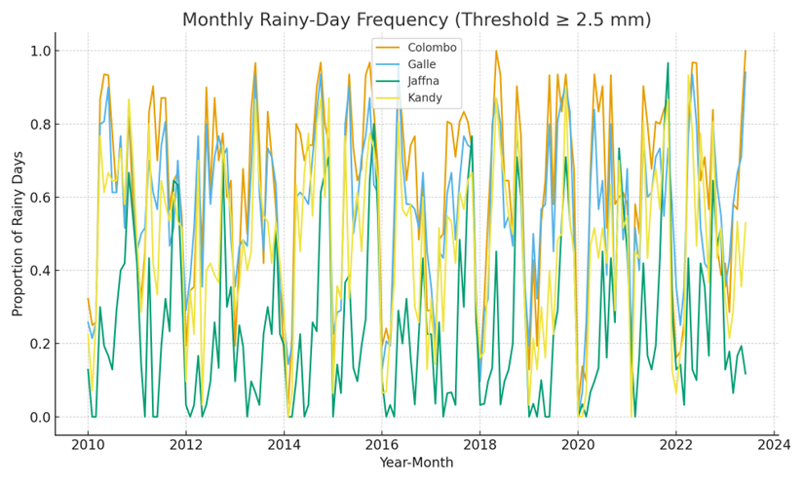

9. Bernoulli and Binomial Probability Modeling

For each city, daily rainfall occurrence (Rain/Dry) can be modeled as a Bernoulli trial with success probability p equal to the empirical rain probability from Table 1.
For example, for Colombo (threshold ≥2.5 mm), the estimated daily probability of rain is p ≈ 0.613. If we consider a 7-day week, the number of rainy days X in that week can be modeled as
X ~ Bin(n=7, p)
The probability of observing exactly k rainy days in a week is:
P(X = k) = C(7, k) p^{k} (1 - p)^{(7 - k)}
As an example, the Probability Colombo has ≥4 rainy days in a week
$$P(X≥4)=\sum_{k=4}^{7}{({7 \atop k})}p^{k}(1-p)^{7-k}$$
$$p=0.613$$
This type of calculation is important for planning outdoor events, farm activities, and water management.

10. Poisson Modeling of Monthly Rainy Days

The monthly counts of rainy days (≥2.5 mm) were computed for each city and used to fit a Poisson model. For a given city, let Y be the number of rainy days in a month. We assume Y ~ Poisson(λ), where λ is the average number of rainy days per month estimated from the data.
Table 3 lists the estimated λ (lambda) for each city.
City | Estimated λ (average rainy days/month)
Colombo | 18.61
Galle | 17.22
Jaffna | 7.54
Kandy | 14.38

For a city with parameter λ, the probability of having exactly k rainy days in a month is given by:
$$P(X=k)=\frac{e^{-λ}λ^{k}}{k!}$$
This model can be used, for example, to estimate the chance of experiencing more than 20 rainy days in a given month.

11. Normal Distribution Fitting for Rainfall Amount
For days classified as rainy (≥2.5 mm), the distribution of daily rainfall amounts was examined. For Colombo, the sample mean and standard deviation of daily rainfall on rainy days are:
• Mean μ ≈ 11.21 mm
• Standard deviation σ ≈ 11.49 mm
Under a normal approximation, R ~ N(μ, σ²), we can estimate probabilities such as the chance that daily rainfall exceeds 50 mm on a rainy day:
P(R > 50) = 1 - Φ((50 - μ) / σ)

where Φ is the cumulative distribution function of the standard normal distribution.
Figure 3 shows the histogram of daily rainfall amounts on rainy days in Colombo (≥2.5 mm).
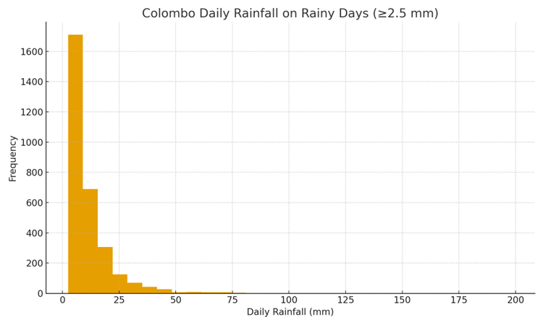

12. Markov Chain Modeling of Daily Rainfall Occurrence

Daily rainfall occurrence can exhibit persistence: a rainy day is often followed by another rainy day, especially during monsoon periods. To capture this dependence, a simple two-state Markov chain was fitted for each city, with states:
- State 1: Rainy day (≥2.5 mm)
- State 0: Dry day (<2.5 mm)
From the observed sequence of rainy and dry days, the following transition probabilities were estimated for each city:
City | P(R→R) | P(R→D) | P(D→R) | P(D→D)
Colombo | 0.810 | 0.190 | 0.302 | 0.698
Kandy | 0.734 | 0.266 | 0.240 | 0.760
Galle | 0.763 | 0.237 | 0.311 | 0.689
Jaffna | 0.676 | 0.324 | 0.107 | 0.893

Figure 4 illustrates the key transition probabilities P(R→R) and P(D→R) for each city. A high P(R→R) indicates that once it starts raining, there is a strong chance it will rain again the next day.
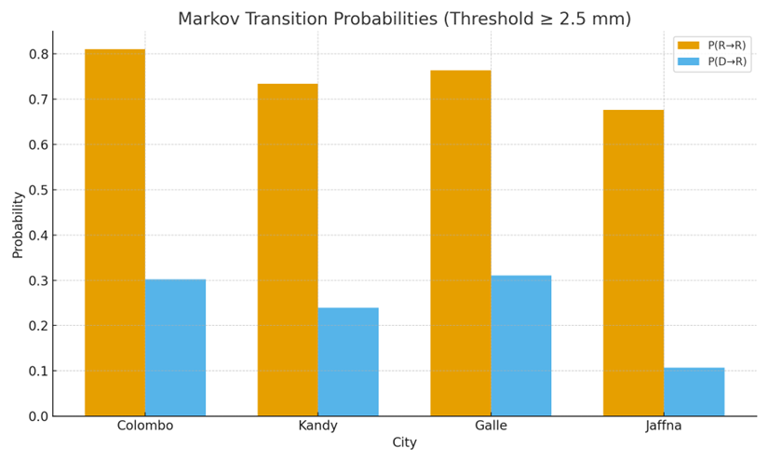

13. Results and Interpretation

The analysis leads to several important observations:
- Colombo and Galle have the highest daily rainfall probabilities for threshold ≥2.5 mm, reflecting the strong influence of the Southwest Monsoon.
- Jaffna shows a lower overall rain probability at this threshold but is more strongly influenced during the Northeast Monsoon months.
- Higher thresholds (e.g., ≥12.5 mm) significantly reduce the estimated probability of a rainy day, especially in Jaffna, which suggests that very heavy rainfall events are less frequent there compared to the wet zone.
- The Poisson model summarizes the expected number of rainy days per month and can be used for seasonal planning.
- The normal approximation for rainfall amounts on rainy days provides a way to quantify extreme rainfall risk (e.g., rainfall exceeding 50 mm).
- The Markov chain results show non-trivial persistence: rainy days tend to cluster during monsoon periods, which is reflected in relatively high P(R→R) values for wet-zone cities.

14. Limitations and Future Work
This study has several limitations:
- Only four cities were analyzed; including more stations would provide a more complete picture of Sri Lanka’s rainfall.
- The Bernoulli and binomial models assume independence between days, which is not strictly true due to monsoon dynamics.
- The Poisson and normal models are approximations and may not fully capture the tail behavior of extreme rainfall.
- The Markov chain used only two states (Rain/Dry); a multi-state model with separate categories for light, moderate, and heavy rain could provide richer insight.
Future work could include:
- Extending the Markov chain to more states and incorporating season as an additional factor.
- Applying generalized linear models (GLMs) or logistic regression to relate rainfall probability to large-scale climate indices.
- Using longer datasets and climate model projections to study potential changes in rainfall occurrence under climate change scenarios.

15. Conclusion
Using real daily rainfall data and classical probability models, this project quantified rainfall occurrence for four key Sri Lankan cities. The analysis demonstrates how Bernoulli, binomial, Poisson, normal, and Markov chain models can be applied in an integrated way to understand and predict rainfall behavior. Such probabilistic approaches are essential for evidence-based decision making in agriculture, water management, and disaster risk reduction in monsoon-driven climates.

16. References and Appendixes
Original Data set –
https://www.kaggle.com/datasets/rasulmah/sri-lanka-weather-dataset
Cleaned data set –
https://docs.google.com/spreadsheets/d/1b-lf6L3m6s94vkgS5WSzFgQvpt3Yqfi-M8zKdyzKtfw/edit?gid=942602400#gid=942602400

