GRAPH THEORY - RESEARCH-BASED ASSIGNMENT
A Greedy Local-Search Heuristic for Equal-Size Student Group Formation with Social Cohesion and Skill Balance
A Synthetic Benchmark Study
Student Name: ______________________________
Registration Number: ________________________
Module: Graph Theory
Submission Date: ____________________________
Research transparency note
No interviews, surveys, or real student records were used. All numerical findings and figures in this draft were generated by the included Python script from synthetic data. The report makes no claim that these simulations demonstrate real classroom learning outcomes.

1. Introduction
Forming effective study groups is a practical problem in education. A group should ideally bring together students with complementary skills while allowing members to communicate and collaborate effectively. Random assignment is easy to apply, but it may separate students who work well together or produce groups whose skill profiles differ substantially. Manual assignment may help, although it can be time-consuming and difficult to apply consistently.
Graph Theory provides a way to represent both kinds of information. Each student is represented as a vertex. An undirected weighted edge represents the strength of the social compatibility assumed between a pair of students, and each vertex has a skill vector such as programming, writing, and data analysis. The task is to partition the vertices into a fixed number of groups without assigning any student more than once.
Research on graph-based student group formation already exists, so this report does not claim that the general idea is new. Instead, it formulates a specific equal-size grouping benchmark that combines explicit synthetic social-compatibility weights with a measure of balance between group-level skill profiles. A simple greedy assignment heuristic followed by pairwise local search is evaluated computationally against three baseline approaches.

1.1 Aim and objectives
- Represent a classroom as an attributed, weighted graph and express equal group sizes as hard constraints.
- Define separate measures for retained social edge weight and between-group skill imbalance.
- Implement a greedy assignment heuristic followed by local search using pairwise swaps.
- Compare the proposed method with balanced random assignment, a social-only heuristic, and a skill-balance-only heuristic on reproducible synthetic data.
- Examine how changing the weight assigned to social cohesion affects the two metrics.

1.2 Research questions
- RQ1: How does the proposed heuristic trade off social cohesion and group-level skill balance compared with the selected baselines?
- RQ2: How much can pairwise local search improve the greedy assignment under the same objective?
- RQ3: How does the trade-off change as the importance assigned to social cohesion is varied?

2. Literature Review

2.1 Attribute-aware graph partitioning
Cao et al. (2025) proposed GP-DQN, a graph-partitioning approach using a GraphSAGE-style graph encoder and a Double Deep Q-Network. Their method considers graph structure, vertex attributes, partition load balance, and edge cuts in large social-network graphs. This work demonstrates that it would be inaccurate to claim that modern graph-partitioning research generally ignores node attributes. However, the meaning of load balance in distributed graph computation is different from balancing student skill profiles across groups.

2.2 Team formation in social networks
Lappas, Liu, and Terzi (2009) studied how to select a team whose members satisfy skill requirements while remaining connected through a social network with low communication cost. They showed that their team-formation variants are NP-hard and proposed algorithms for selecting one team for a task. This is relevant because the current report also represents compatibility through weighted edges. The problem considered here differs in scope: it partitions the complete student set into multiple disjoint groups of equal size rather than choosing one team.

2.3 Student grouping with skill diversity and constraints
Jenkins et al. (2023) formulated fair and skill-diverse student group formation as constrained k-way graph partitioning. Their approach derives skill representations from course-mark data, seeks diverse skill profiles within groups, applies group-size bounds and fairness constraints, and solves the resulting optimization with integer programming. A related article by Jenkins et al. appeared in IEEE Signal Processing Magazine in 2026. This is the closest work to the educational setting in this report. It means that student grouping through graph partitioning with skill and group-size constraints is not, by itself, a defensible research novelty claim.
The important distinction in the present computational exercise is its simplified problem formulation: it uses explicit synthetic pairwise social-compatibility weights, aims to balance group mean skill profiles around the overall cohort mean, enforces exactly equal group sizes, and evaluates a lightweight greedy-plus-local-search heuristic. This is a narrower implementation and benchmarking contribution, not a claim to outperform the integer-programming method of Jenkins et al.; no direct implementation-level comparison with that method has been conducted.

2.4 Review of graph-based team-formation methods
Saeedi et al. (2025) survey graph-based expert team-formation research and distinguish search-based and learning-based approaches. The survey is useful for placing heuristic optimization within a broader field, but expert team formation is not identical to distributing an entire class into equal-sized groups. The present report therefore uses it as contextual literature rather than as evidence that the educational grouping problem has not been studied.

2.5 Summary of related work
Study | Main focus | Relevance and distinction
Cao et al. (2025) | Attributed graph partitioning; edge cuts and computing-load balance. | Shows that attribute-aware partitioning already exists; target is distributed computation.
Lappas et al. (2009) | Selecting one skilled, socially connected team. | Combines skills and social ties, but selects a team rather than partitioning the full class.
Jenkins et al. (2023; 2026) | Fair and skill-diverse student groups under size/fairness constraints. | Closest educational work; requires a careful, narrow contribution claim.
Saeedi et al. (2025) | Survey of graph-based expert team formation. | Provides taxonomy and context for search-based heuristics.

3. Research Gap and Proposed Problem
The literature establishes that graph methods can represent relationships among people, that team formation can jointly consider skills and compatibility, and that constrained graph partitioning has already been applied to skill-diverse student groups. Accordingly, the broad claim that earlier work does not combine student skills with graph partitioning would be incorrect.
The narrower problem examined here is whether a computationally simple heuristic can produce an understandable trade-off between (i) retaining synthetic social-compatibility weight within groups and (ii) keeping group-average skill profiles close to the overall cohort profile, while assigning exactly the same number of students to each group. The evaluation is a controlled synthetic benchmark, not a real-world classroom validation.

3.1 Proposed contribution
- A transparent mathematical formulation with hard equal-size constraints.
- A deterministic-seed Python implementation of greedy assignment and pairwise local search.
- A reproducible comparison with three simple baselines over 30 synthetic graph instances, including a sensitivity analysis of the objective weight.

3.2 Research questions and hypotheses
The experiment is descriptive and exploratory. The expected trade-off is that a method prioritizing social cohesion will retain more internal edge weight, while a method prioritizing skill balance will make group means more similar. The experiment tests these expectations under the stated synthetic generator; it does not test student satisfaction, educational achievement, or actual friendship quality.

4. Methodology

4.1 Graph and skill representation
Let G = (V, E, W, A) be an undirected attributed graph, where V is the set of n students, E is the set of observed synthetic compatibility links, W = [wᵢⱼ] is a symmetric, non-negative adjacency matrix, and A = [aᵢ] is the skill matrix. Each vector aᵢ contains three normalized synthetic scores in [0, 1]: programming, writing, and data analysis. A zero matrix entry means no synthetic link was generated for that pair.
Let K be the number of groups and xᵢₖ ∈ {0, 1} indicate whether student i belongs to group k. Every student must be assigned exactly once, and all groups must have size n/K; therefore n must be divisible by K.
∑ₖ xᵢₖ = 1 for every student i; ∑ᵢ xᵢₖ = n/K for every group k

4.2 Objective metrics
Social cohesion C is the proportion of all graph edge weight that lies within groups:
C = [∑ₖ ∑ᵢ<ⱼ wᵢⱼ xᵢₖ xⱼₖ] / [∑ᵢ<ⱼ wᵢⱼ]
Higher C means that more of the synthetic compatibility weight is retained inside assigned groups. It is undefined if the graph has no edges; the generator used here produces nonzero edge weight.
Let μ be the whole-class mean skill vector and μₖ be the mean skill vector of group k. The skill-imbalance measure B is the between-group sum of squares divided by the total sum of squares:
μ = (1/n)∑ᵢ aᵢ; μₖ = (1/|Gₖ|)∑ᵢ∈Gₖ aᵢ
B = [∑ₖ |Gₖ| ‖μₖ − μ‖²] / [∑ᵢ ‖aᵢ − μ‖²]
If the denominator is zero, B is defined as zero. Otherwise B lies between zero and one for a complete partition. Lower B means that group-average skill profiles are closer to the overall cohort profile. This metric measures balance between groups; it does not directly measure diversity within each individual group or guarantee that every group has a student strong in every skill.
The combined objective is:
Maximize J = αC − (1 − α)B, 0 ≤ α ≤ 1
The two metrics are normalized to interpretable fractions. α = 0.50 is used for the main proposed method. α = 1.00 creates the social-only objective; α = 0.00 creates the skill-balance-only objective. These are chosen modelling weights, not empirically learned values.

4.3 Synthetic dataset and experiment design
No interviews, surveys, or real student records were collected. The benchmark uses 30 independently generated synthetic instances, each with 30 synthetic students, six groups, and five students per group. Each student receives three synthetic skill scores. A student is given a randomly selected primary-strength dimension, which is increased before noise is added; scores are clipped to [0, 1]. These values are artificial and should not be interpreted as actual student ability.
For the weighted social graph, six latent communities of five vertices are generated and shuffled. A potential edge is included with probability 0.62 for a pair in the same latent community and 0.11 for a pair in different communities. Present edges receive a random weight uniformly drawn from [0.20, 1.00]. The latent communities are merely part of the synthetic data-generating process. They are not supplied to the grouping algorithms.
The base random seed is 20261016, and replicate r uses seed 20261016 + r for r = 0, …, 29. This setup makes the experiment repeatable. For each instance, the random baseline is the average over 20 independently generated balanced random partitions. The other methods use greedy assignment followed by best-improvement pairwise local search.

4.4 Methods compared
- Balanced random: assign a random permutation of students into six groups of five; average its metrics across 20 random partitions per instance.
- Social-only: greedy assignment and pairwise local search with α = 1, optimizing internal edge weight without considering skill balance.
- Skill-balance-only: greedy assignment and pairwise local search with α = 0, minimizing between-group skill imbalance without considering the social graph.
- Proposed combined heuristic: greedy assignment that considers both metrics followed by pairwise local search with α = 0.50.

4.5 Algorithm
- Calculate each synthetic student’s weighted degree and distance of their skill vector from the cohort mean.
- Order students by weighted degree for the social-only method, by skill-profile distance for the skill-only method, and by a combined rank for the proposed method.
- Process students in that order. For every group that has not reached capacity, temporarily place the student there and calculate the partial objective. Select the feasible group with the highest value.
- Evaluate swaps between students in different groups. Accept the best swap that improves the full objective. Repeat until no pairwise swap improves it.
- Calculate C, B, group sizes, accepted swaps, and runtime. For α sensitivity, repeat the combined heuristic at α ∈ {0.20, 0.35, 0.50, 0.65, 0.80}.
The local-search result is a local optimum with respect to one-for-one swaps under the chosen objective. The method is heuristic and does not guarantee the globally optimal partition.

4.6 Reproducibility and software
The supplied file replicate_experiment.py generates the synthetic instances, applies all methods, exports CSV tables, and produces the network visualizations. Install the packages listed in requirements.txt, then run python replicate_experiment.py. Output files are written to the outputs folder next to the script. The exact configuration is also saved in experiment_config.json.

5. Findings and Results
The following results were produced by executing the included Python experiment. They summarize 30 independently generated synthetic instances; they are not measurements from real students. Values are reported as the mean and sample standard deviation across instances. For the Random row, each instance first averages 20 random balanced partitions, then those instance-level averages are summarized.

5.1 Main comparison
Method | Cohesion C (mean ± SD) | Imbalance B (mean ± SD) | Median runtime (s) | Mean accepted swaps
Random | 0.1364 ± 0.0082 | 0.1749 ± 0.0104 | — | 0.00
Social-only | 0.5174 ± 0.0439 | 0.1780 ± 0.0620 | 0.0448 | 10.30
Skill-only | 0.1493 ± 0.0356 | 0.0035 ± 0.0013 | 0.0418 | 10.40
Proposed α=0.50 | 0.4737 ± 0.0545 | 0.0442 ± 0.0147 | 0.0544 | 12.87
Table 1. Results across 30 synthetic graph instances. Runtime is environment-dependent; the random baseline uses 20 partitions per instance.
All methods produced exactly six groups of five students in every complete partition; the maximum group-size variance was zero. The social-only heuristic achieved the highest mean cohesion (C = 0.5174), but its mean skill imbalance was also high (B = 0.1780). The skill-only heuristic achieved the lowest imbalance (B = 0.0035) but retained much less social edge weight (C = 0.1493).
The proposed combined heuristic achieved mean cohesion C = 0.4737 and mean imbalance B = 0.0442. Compared with the social-only heuristic, its cohesion was lower by about 0.0437, while the imbalance measure was about 75.2% lower. Compared with the random baseline, the combined heuristic retained more internal edge weight (0.4737 versus 0.1364) and had lower imbalance (0.0442 versus 0.1749). These comparisons describe this generator and objective; they do not establish superiority on real classrooms or against all published algorithms.

5.2 Network and partition visualizations
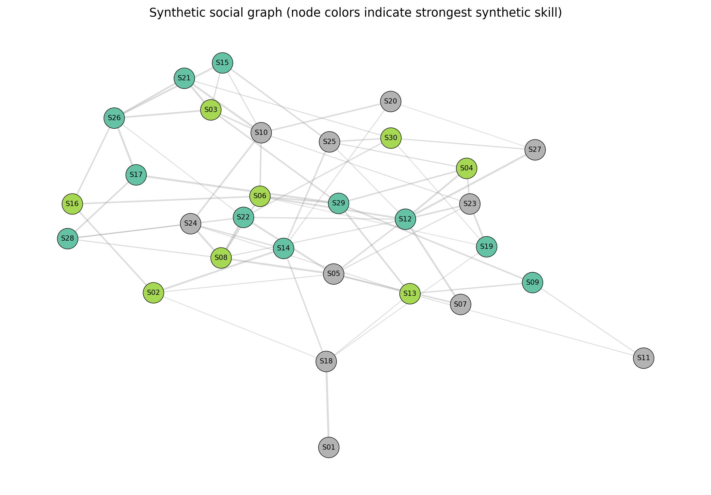
Figure 1. Example synthetic weighted social graph. Node color indicates the strongest generated skill dimension; edge width is proportional to synthetic compatibility weight.
Figure 1 shows only the first synthetic instance (seed 20261016). The layout and relationships are generated by the code and do not represent actual classmates or observed friendships.
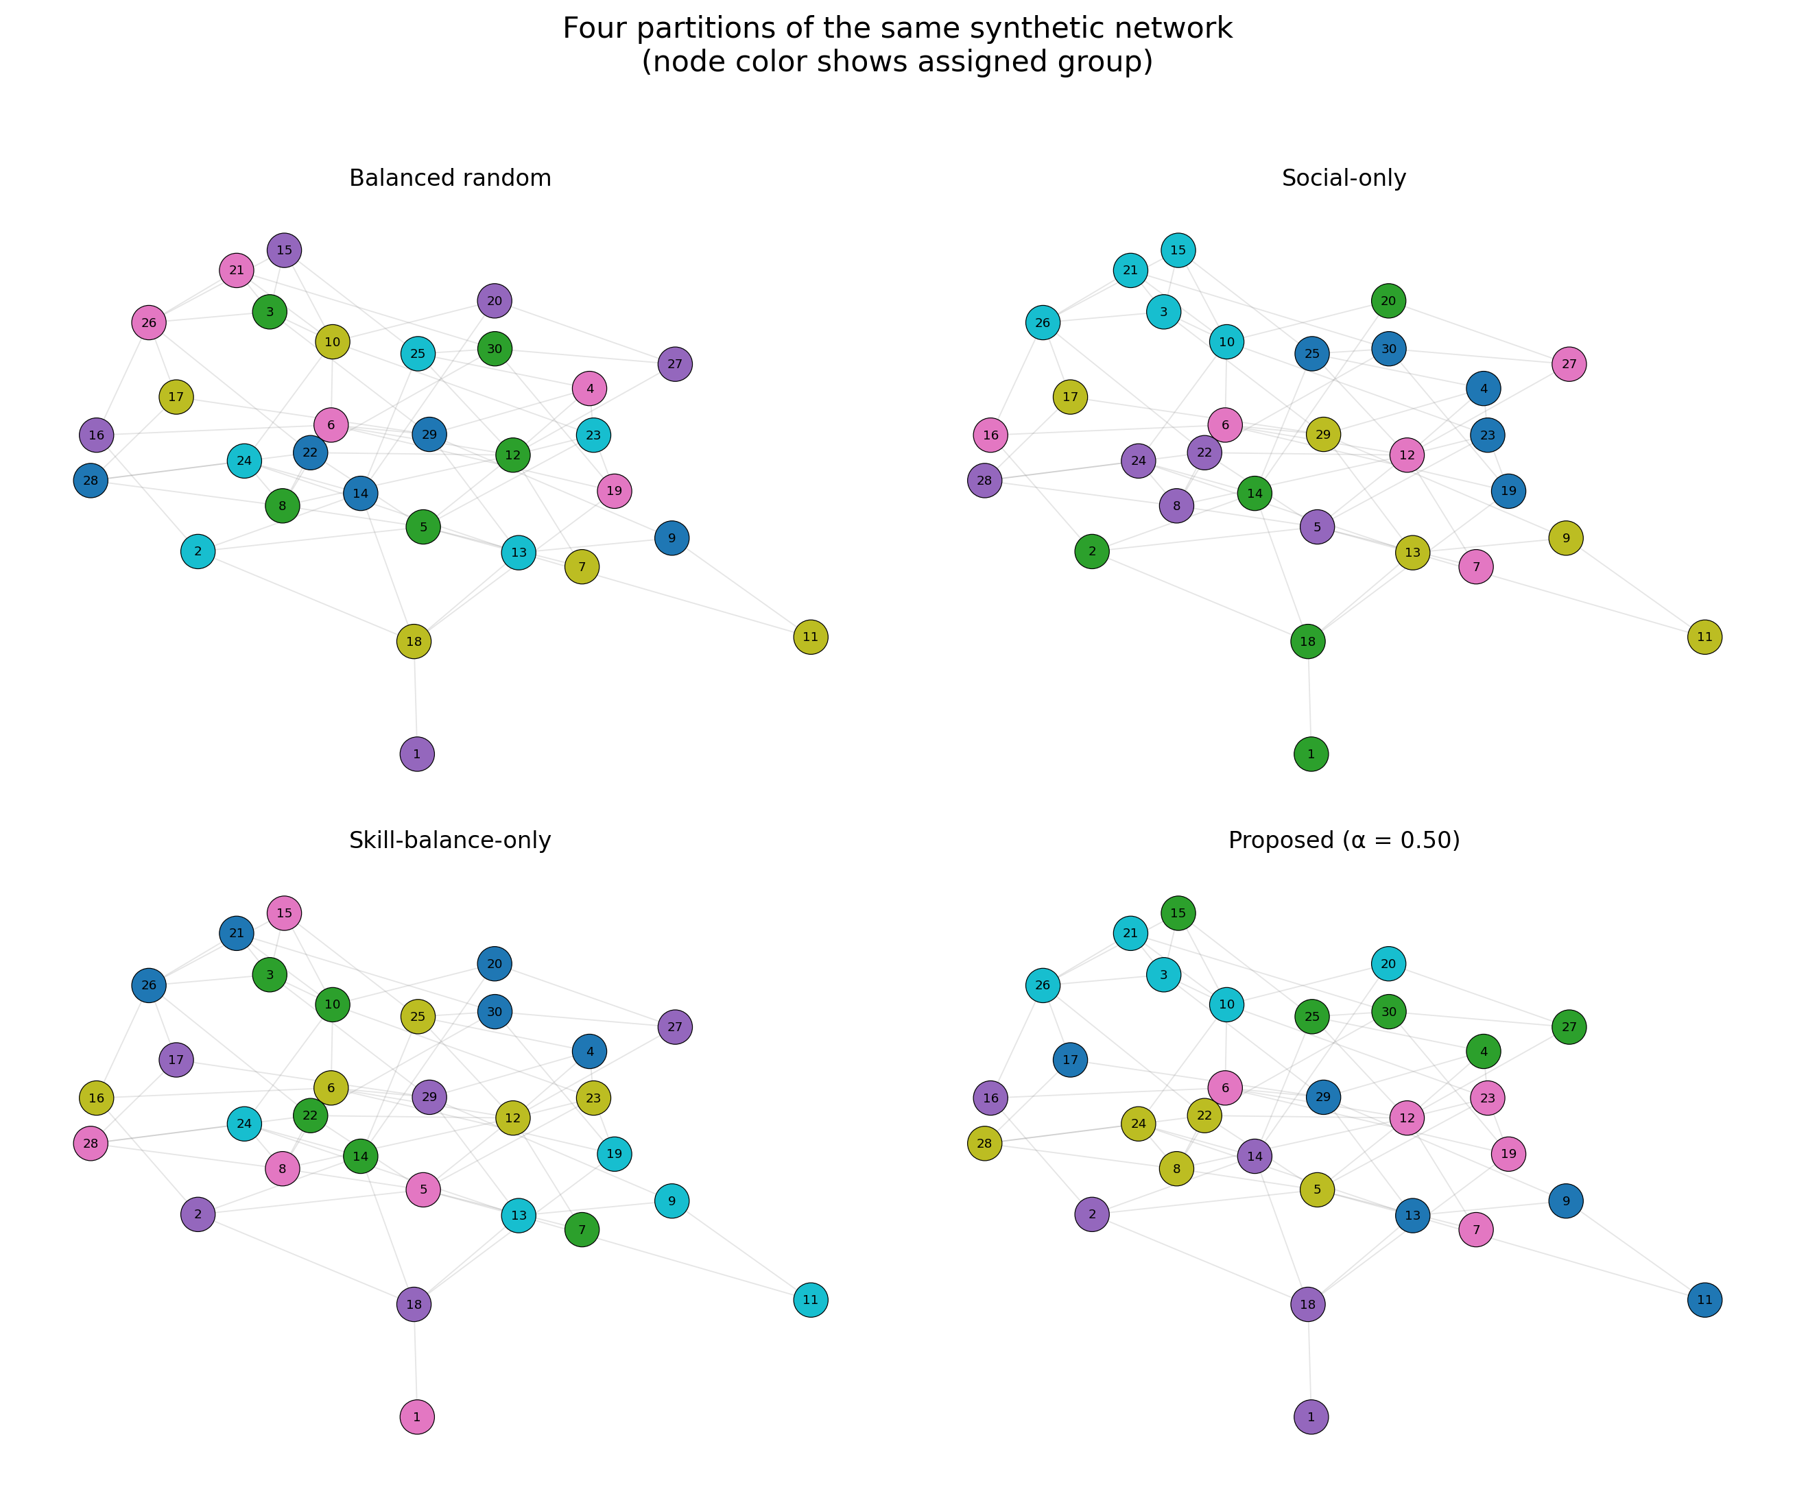
Figure 2. Four group assignments of the same synthetic graph. Node color indicates assigned group, not skill. Each method assigns five nodes to every group.
The partitions in Figure 2 illustrate the trade-off visually. Social-only optimization tends to keep connected nodes together. Skill-balance-only optimization focuses on group-average skill profiles. The combined method attempts to preserve substantial internal edge weight while avoiding large differences between group skill means.

5.3 Metric comparison chart
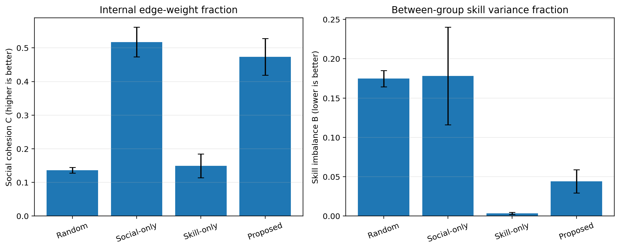
Figure 3. Mean cohesion and skill imbalance; error bars show one sample standard deviation across the 30 synthetic instances.

5.4 Sensitivity to α
Social weight α | Cohesion C (mean ± SD) | Imbalance B (mean ± SD)
0.20 | 0.3928 ± 0.0446 | 0.0129 ± 0.0046
0.35 | 0.4319 ± 0.0539 | 0.0220 ± 0.0078
0.50 | 0.4737 ± 0.0545 | 0.0442 ± 0.0147
0.65 | 0.4869 ± 0.0517 | 0.0624 ± 0.0198
0.80 | 0.5068 ± 0.0558 | 0.1045 ± 0.0420
Table 2. Sensitivity results for five values of α, averaged over the same 30 synthetic instances.
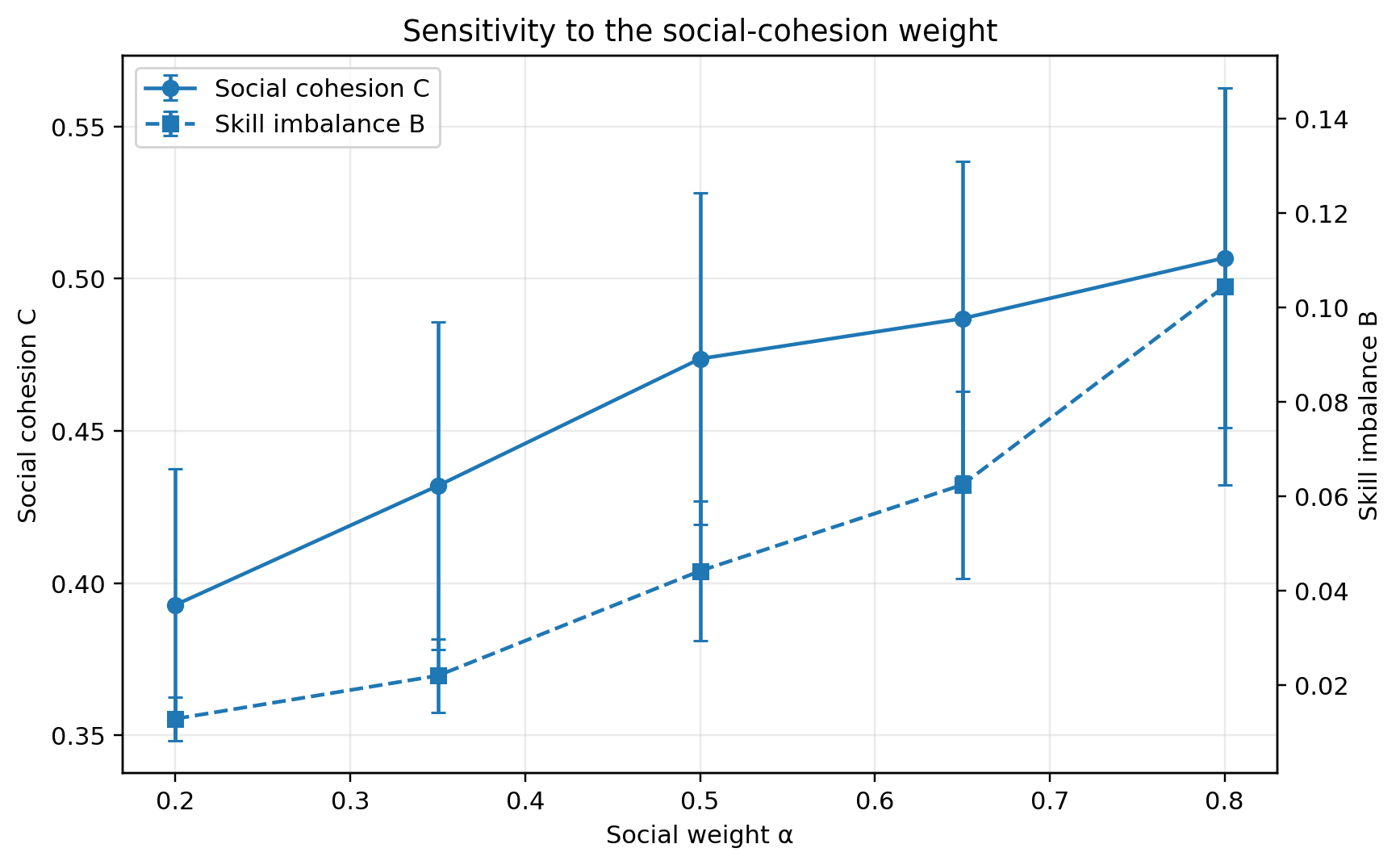
Figure 4. Effect of increasing the weight α assigned to social cohesion. Error bars show one sample standard deviation.
As α increased from 0.20 to 0.80, mean cohesion increased from 0.3928 to 0.5068, while mean imbalance increased from 0.0129 to 0.1045. This pattern is consistent with the defined objective: stronger emphasis on social compatibility allows larger differences in group-average skill profiles. The selected value α = 0.50 is a transparent benchmark setting, not a proven optimal value for education.

6. Discussion

6.1 Interpretation
The synthetic experiment demonstrates that the objective weight controls a measurable trade-off. Optimizing cohesion alone retained the most edge weight but did not balance group-average skill profiles. Optimizing skill balance alone produced very similar group means but did not preserve substantially more social edge weight than random assignment. The combined objective found an intermediate outcome on the generated instances.
The results support the limited computational claim that this implementation can produce equal-size partitions with a tunable cohesion–balance trade-off under the selected synthetic data assumptions. They do not show that the generated groups would collaborate better, receive higher grades, or report greater satisfaction. Such conclusions require real-world validation and suitable measures of learning or collaboration.

6.2 Limitations
- Synthetic data only: the graph and skills were generated from assumptions chosen for this assignment. No student interviews, surveys, marks, friendship records, or classroom trials were used.
- Generator dependence: a different graph density, community structure, skill distribution, or relationship between skills and social ties could change the ranking of methods.
- Metric scope: B measures balance of group-average skill profiles around the cohort mean. It does not directly maximize within-group diversity, measure fairness, or ensure minimum coverage of every skill.
- Heuristic optimality: greedy assignment and pairwise local search may stop at a local optimum. The experiment does not compare against an exact integer-programming solution or directly reproduce the Jenkins et al. method.
- Baseline scope: the methods are simple baselines implemented for this benchmark, not a comprehensive comparison with state-of-the-art partitioning algorithms.
- External validity: runtime depends on the computing environment, and 30 synthetic instances are sufficient for an initial coursework benchmark but not broad empirical generalization.

6.3 Ethical considerations
If this method were developed for actual classrooms, skill estimates and social-compatibility data would require informed consent, privacy protection, careful handling of sensitive attributes, and a way for instructors to override recommendations. Friendship data should not be inferred or disclosed without a clear legitimate purpose. A grouping algorithm should assist instructors rather than make unreviewable decisions about students.

6.4 Future improvements
- Compare against an integer-programming formulation or a constraint-programming solver on small instances where an exact or near-exact result can be obtained.
- Test multiple graph densities, community strengths, skill correlations, class sizes, and group sizes, reporting sensitivity and uncertainty.
- Add a separate within-group diversity or minimum-skill-coverage metric if that is the intended educational objective.
- If an appropriate ethical and institutional process is available, evaluate anonymized real data and report whether the synthetic findings transfer to actual class settings.

7. Conclusion and Future Work
This report formulates equal-size student grouping as a weighted, attributed graph partitioning problem and defines a composite objective that rewards within-group social edge weight while penalizing differences between group-average skill profiles. A greedy assignment method with pairwise local search was implemented and evaluated on 30 synthetic graph instances, each containing 30 students partitioned into six groups of five.
On the synthetic benchmark, the combined heuristic produced an intermediate result between the social-only and skill-balance-only heuristics: its mean cohesion was 0.4737 and its mean imbalance was 0.0442. Sensitivity analysis showed the expected trade-off as α changed. These are reproducible computational findings, not field-study results. The broader concept of graph-based skill-diverse student grouping is already present in the literature, so the defensible contribution of this coursework is the clearly specified heuristic and its transparent synthetic benchmark, not a claim to have invented student group formation through graph theory.
Future work should test the method against exact or established optimization baselines and explore the effect of alternative synthetic assumptions before considering any ethically approved real-world evaluation.

8. References
Cao, J., Wang, H., Jiao, J., Hu, K., & Qi, P. (2025). A social network graph partitioning algorithm based on double deep Q-Network. Scientific Reports, 15, Article 34339. https://doi.org/10.1038/s41598-025-16768-x
Jenkins, A., Jaimoukha, I., Stankovic, L., & Mandic, D. (2023). Fair and skill-diverse student group formation via constrained k-way graph partitioning. arXiv:2301.09984. https://arxiv.org/abs/2301.09984
Jenkins, A., Rainbow, E., Jaimoukha, I., Ng, F. S., Stankovic, L., Dakovic, M., Mandic, D., & Mandic, D. (2026). Fair and skill-diverse student group formation: A graph-theoretic approach. IEEE Signal Processing Magazine, 43(1), 83–97. https://doi.org/10.1109/MSP.2025.3627096
Lappas, T., Liu, K., & Terzi, E. (2009). Finding a team of experts in social networks. Proceedings of the 15th ACM SIGKDD International Conference on Knowledge Discovery and Data Mining, 467–476. https://doi.org/10.1145/1557019.1557074
Saeedi, M., Hosseini, H., Wong, C., & Fani, H. (2025). A survey of subgraph optimization for expert team formation. ACM Computing Surveys, 57(12), Article 314, 1–40. https://doi.org/10.1145/3737455

Appendix A. Reproducing the computational results
1. Use Python 3.10 or newer.
2. From the project folder, install dependencies with: pip install -r requirements.txt
3. Run the experiment with: python replicate_experiment.py
4. Check outputs/results_summary.csv for the main results, results_by_instance.csv for individual instances, the two alpha-sensitivity CSV files for the sensitivity analysis, and the PNG files for figures. Fixed random seeds are recorded in the script and experiment_config.json; changing the code or settings can change the results.

