MID TERM REVIEW REPORT
Car and Rental Equipment Management System (CREMS)
Semester 2, 2026

CARPENTERS FIJI PTE LIMITED
CS400 Industry Experience Project
Academic supervisor: Dr Ravneil Nand
16 September 2026

Group 10
Name | Student ID
Kavish Chandra | S11219143
Shoneel Kumar | S11219651
Sudhansu Jayshil Kisun | S11219520
Rahul Chand | S11219885

Table of Contents
EXECUTIVE SUMMARY 1
1.0 PROJECT CONTEXT AND SCOPE 2
2.0 FUNCTIONAL REQUIREMENTS 3
3.0 QUALITY AND ETHICAL REQUIREMENTS 4
4.0 SYSTEM ARCHITECTURE AND DATA MODEL 5
5.0 USER RESPONSIBILITIES AND WORKFLOW DESIGN 6
6.0 MILESTONES AND ENGINEERING EVIDENCE 7
7.0 PLAN CHANGES AND ISSUES RESOLVED 8
8.0 RISK MANAGEMENT UPDATE 9
9.0 REMAINING DELIVERY PLAN 10
10.0 TEAMWORK AND PROJECT CONTROL 11
11.0 CONCLUSION AND REFERENCES 12
APPENDIX A REQUIREMENTS SPECIFICATION 13

EXECUTIVE SUMMARY
We are developing CREMS for Carpenters Motors and Carptrac to bring customer requests, asset records, quotations, approvals and hire operations into one system. During the first half of the project, we established the application and database, implemented the main customer and staff interfaces, and began integrating the full rental workflow.
Our current build supports customer and staff access, branch-based permissions, booking workspaces, configurable approvals and guided pickup and return. Recent testing identified problems with inspection uploads, saving inspection records, session expiry and catalogue images. We corrected these problems and added targeted checks to reduce the chance of recurrence.
Our next priority is to complete and test the vehicle and equipment hire journeys from booking through return. Maintenance, equipment-specific requirements, reporting and client acceptance testing remain in the delivery plan. We are working towards the planned completion date of 30 October 2026.

1.0 PROJECT CONTEXT AND SCOPE

Business problem
Carpenters Fiji manages rental vehicles and equipment with different operating rules. Vehicle hire involves licence eligibility, fuel and odometer readings. Equipment may require capacity checks, operators, transport, engine-hour tracking and additional approval. Separate operational records make it harder to establish availability, reconstruct condition at handover and relate asset income to maintenance costs.
CREMS provides a shared record across the hire lifecycle. A booking connects the customer, branch, asset and hire period. Inspections and agreements remain associated with that booking, while the asset register provides the longer-term asset history. A general asset inspection therefore does not establish the condition of a particular customer hire.

Objectives
Our objectives are to provide secure access, accurate availability and booking records, configurable pricing and approval, reliable inspection evidence and useful operational reports. We will assess these objectives through complete user tasks, including checking that records are saved and accessible only to authorized users.
Included in the delivery scope | Outside the MVP or separately controlled
Motors vehicles and Carptrac equipment; configurable branches, categories and attributes. | Additional divisions require operational validation and their own acceptance work.
Customers, assets, availability, quotes, bookings, approvals and hire documents. | Full accounting/ERP replacement, payroll and banking reconciliation.
Inspection evidence, handover, return, maintenance and expenditure. | Live telematics, advanced route optimization and native offline applications.
Operational reports, audit, notifications and profitability measures. | Production payment gateway, third-party identity and large historical migration unless approved.

Stakeholders and expected value
Customers need clear charges and booking status. Rental officers need reliable queues; managers need scoped oversight and approval evidence. Maintenance staff need service and condition history. Client sponsor Amit Kumar and academic supervisor Dr Ravneil Nand provide business and academic review.
We expect the system to reduce duplicate records, clarify responsibility during handover and improve visibility of asset use and maintenance costs. We will evaluate these benefits through client testing once the complete workflow is ready.

2.0 FUNCTIONAL REQUIREMENTS
We have grouped the main requirements below to show what is implemented and what still needs verification. Final acceptance will depend on completing the relevant user scenario, checking the saved records and confirming access restrictions.
ID and requirement | Current position | Required acceptance evidence
FR01 Identity and access | Implemented; wider security verification remains. | Customer sees own records only; staff role and branch restrictions hold at API level.
FR02 Customer records | Portal and staff administration demonstrable. | Create and update customer; retrieve permitted documents and reject unauthorized access.
FR03 Assets and catalogue | Implemented; image recovery verified locally. | Persist attributes, branch and status; display catalogue photos correctly.
FR04 Availability and requests | Booking and quote flows implemented and refining. | Reject unavailable hire; retain dates, branch and request reference.
FR05 Pricing and quotations | Pricing workspace and quote decisions implemented. | Charges, tax, deposit and revisions match agreed examples.
FR06 Configurable approvals | Ordered stages and scoped decisions implemented. | Triggered hire completes required stages before confirmation.
FR07 Pre-hire and checkout | Guided flow and independent saving implemented; targeted tests pass. | Save and reopen photos/checklist without checkout; complete handover separately.
FR08 Return and post-hire | Return and comparison implemented; browser payload checks completed. | Retain evidence; apply correct asset status and damage referral.
FR09 Maintenance and costs | Foundation exists; operational completion remains. | Record job costs and downtime; verify return-to-service control.
FR10 Reports and notifications | Partial; reconciliation and delivery verification remain. | Reconcile reports to transactions; verify delivery outcome and audit history.

Traceability and change control
For the remaining tests, we will record the requirement, test data, expected outcome and actual result. Where a client rule changes, we will update the requirement and its test together.

3.0 QUALITY AND ETHICAL REQUIREMENTS

Quality targets
Our quality targets are two seconds for routine interactions and five seconds for longer operations, with at least 80 percent unaided completion of core tasks during usability testing. We will measure these targets during integration testing and client user acceptance testing.
Area | Required control and verification
Access and sessions | Enforce role and branch scope on the server. Test expiry, active renewal, logout and prohibited access using separate accounts.
Integrity | Validate dates, meters, payments and lifecycle transitions. Verify persistence after reload and conflicting operations.
Files and privacy | Restrict photo types and sizes; protect private documents and signatures. Verify download authorization and agree retention rules.
Recovery | Maintain migrations and recoverable configuration. Rehearse backup restoration and clean setup before handover.
Usability | Use labelled controls, clear errors and consistent navigation. Verify keyboard access, responsive layouts and representative tasks.

Handling personal information and condition evidence
The system handles identity documents, photographs and signatures, so we need to limit collection and access to what is necessary for a hire. Inspection images should focus on the asset and avoid unrelated personal information. OWASP recommends validating file types, limiting upload size and checking upload permissions [1]. We have added image validation and size controls; retention and private-access checks remain part of our security review.
Inspection records may be used when reviewing damage and charges. We therefore keep the evidence linked to the booking and responsible staff member. A saved pre-hire inspection is separate from final handover, and a recorded damage concern must still be reviewed before a charge is confirmed.

Transparency and professional responsibility
We need to present rental charges, additional services and refundable bonds clearly so customers understand the quotation. Staff access must reflect their responsibilities, and approval decisions must remain traceable. We will use non-sensitive demonstration data and follow the client’s confidentiality requirements when sharing project material.

Fairness and accessibility
We also need to consider users with limited technical experience or unreliable access to devices. Clear labels, visible error messages and keyboard-accessible controls are part of our usability work. Approval rules should apply consistently to similar requests, and staff should record reasons for exceptions so decisions can be reviewed.

4.0 SYSTEM ARCHITECTURE AND DATA MODEL
The web application uses React 19, TypeScript, Vite and Material UI. An ASP.NET Core API on .NET 10 applies business rules, and Entity Framework Core persists records in SQL Server. The development database runs in Docker.
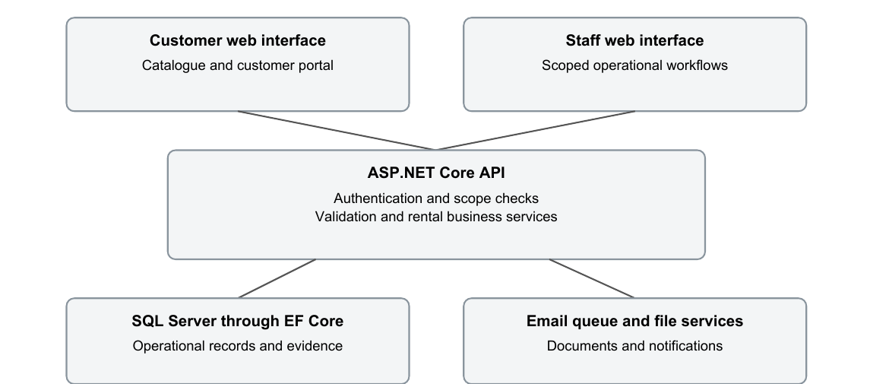
Figure 1 Logical architecture of the development system
Our API checks the user, permitted scope and business state before making protected changes. This follows the distinction between establishing a user’s identity and deciding what that user may access in ASP.NET Core authorization [2]. Browser checks provide immediate feedback, while the server enforces the rules.
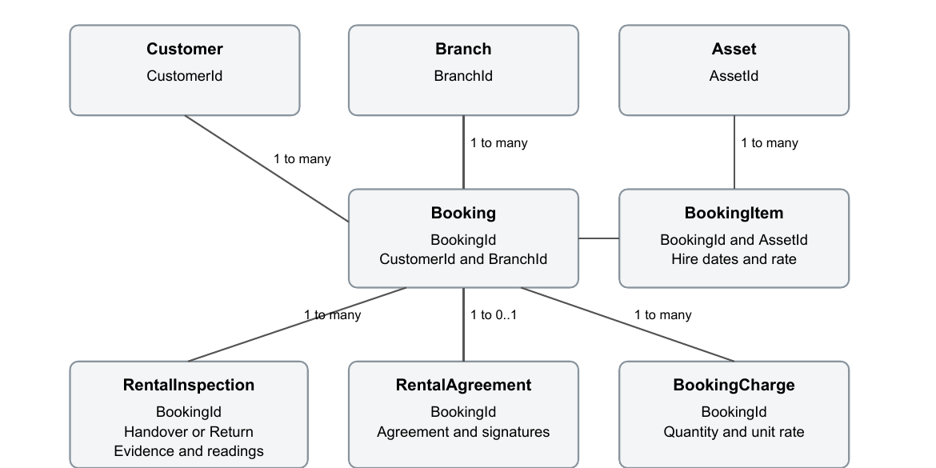
Figure 2 Selected rental entities and relationships
BookingItem connects each asset and hire period to a booking. RentalInspection stores handover and return evidence. A booking can have several items. The diagram shows the main rental relationships; approval, payment and user-access entities support these records.

5.0 USER RESPONSIBILITIES AND WORKFLOW DESIGN
Actor | Principal use cases
Visitor and Customer | Browse rentals; request booking or quotation; manage own profile and monitor own requests and documents.
Rental Officer | Review requests, prepare pricing, allocate assets and perform authorized pickup, inspection and return.
Branch Manager | Review branch activity and decide assigned approval stages within permitted scope.
Maintenance Officer | Review asset condition and carry out authorized maintenance and service updates.
Administrator and Super Administrator | Manage permitted accounts and configuration; reserve system-wide governance for appropriate authority.

We removed separate Driver or Operator and Finance Officer login roles from the current scope. Driver and operator requirements remain part of rental planning and charges. This keeps the login model focused on the users who need to operate the system.

Pickup and inspection sequence
A confirmed booking opens the existing Pickups & returns workflow from Bookings & quotations. Staff confirm the customer, scan the asset, verify documents, record meter and fuel, complete the pre-hire inspection, review the agreement, obtain the customer signature and perform agent checkout. Authorized operational staff conduct the inspection.
The pre-hire step saves a preparation record independently. Reopening should restore checklist, photos and readings. Saving must not change the booking into an active hire; checkout is a separate action with its own readiness checks. General Asset register inspections remain asset records. Rental pre-hire and post-hire evidence belongs to the booking workflow.

Return and equipment variations
At return, staff record condition and readings, compare pre-hire evidence and record damage and accessories. The next asset state depends on the result and maintenance needs. Vehicle-specific licence and meter fields must not block equipment where they do not apply. Equipment acceptance also requires appropriate operator, engine-hour and safety scenarios.

Project-specific design contribution
We designed one hire workflow with configurable asset categories and inspection templates. For example, a vehicle can require licence and odometer checks while a forklift uses equipment-specific checks. Configurable approval stages let an ordinary rental follow a shorter review path while a higher-risk hire receives additional approval. Saving inspection preparation separately also lets staff record condition before completing handover. These choices adapt the system to the client’s different operations without duplicating entire workflows.

6.0 MILESTONES AND ENGINEERING EVIDENCE
Our project schedule runs from 10 August to 30 October 2026. We are in Week 6 at this review. Some approval and rental functions have been developed earlier than planned, allowing us to identify integration problems before the scheduled lifecycle demonstrations.
Baseline milestone | Position at review
M1 Week 1 Scope and foundation | Plan, repository, API, web application and database available. Approval records remain part of project governance.
M2 Week 2 Secure sign-in | Authentication and sessions implemented; active-session renewal corrected during testing.
M3 Week 3 Access isolation | Role and branch scope implemented; full isolation regression remains required.
M4 Week 5 Asset register | Asset/category interfaces and catalogue available; targeted image checks completed.
M5 Week 7 Quotation to booking | Booking and staged approvals implemented; complete notification and agreement demonstration remains.
M6 Week 8 Motors lifecycle | Guided pickup/return implemented early; targeted defects corrected and tests added.
M7 Week 10 Carptrac lifecycle | Equipment foundation available; personnel and engine-hour acceptance remains.
M8 Week 12 Handover | Deployment, final acceptance, guides and closure remain planned.

Completed development verification
Our latest backend test run passed all 31 tests. We also checked that an inspection could be inserted with photo and checklist evidence, retrieved after clearing the database context, and updated without changing the booking status. We rolled back the test transaction after verification.
We tested photo selection, resizing, invalid-file errors, previews and the pickup and return forms. These component tests used mocked API writes, so full authenticated workflow tests remain necessary. We also checked all 32 restored catalogue image URLs and confirmed that 12 visible photos loaded in headless Chrome.

7.0 PLAN CHANGES AND ISSUES RESOLVED

Changes from the baseline
We brought configurable approvals and parts of the hire workflow forward because they affect booking confirmation and asset handover. This helped us find integration problems early. We also simplified customer handling and removed unnecessary login roles to keep the initial scope manageable. Our remaining schedule keeps time for testing and handover rather than adding further optional features.
Observed issue | Engineering response | Verification and remaining work
Inspection could not save | Register new inspections explicitly for insertion; reuse the preparation record on subsequent saves. | Regression tests and rolled-back SQL insert/read/update passed; user workflow retest remains.
Photo attachment unreliable | Shared picker with decoding, resizing, limits, previews and processing status. | Browser checks cover valid and corrupt files; real device and camera checks remain.
Save could lead to login | Renew server session during active use while retaining inactivity expiry. | Controlled-clock tests cover active/idle behaviour; full session regression remains.
Catalogue images broken | Restore missing bundled seed images and avoid stale failed-image cache responses. | 32 URLs passed; 12 visible photos decoded.
Booking inspection entry confusing | Redirect to existing Pickups & returns with the selected booking. | Focused booking and preparation checks added; no separate inspection page needed.
Equipment pickup had vehicle assumptions | Allow non-applicable driver/meter fields while retaining applicable readiness checks. | Targeted request and workflow tests; full equipment acceptance remains.

Lessons and unresolved work
These issues showed us that checking a form on screen is not enough. We now check whether its data survives a reload and whether errors are handled clearly. We still need to complete broader integration tests and resolve remaining administration issues before the release.

Response to workflow feedback
During development review, the inspection entry point was found to be confusing and saving did not reliably preserve the record. We changed the booking action to open the existing Pickups & returns page and added independent inspection saving. This feedback changed both navigation and persistence testing; the resulting workflow still needs formal client acceptance.

8.0 RISK MANAGEMENT UPDATE
We review risks using probability and impact scores from 1 to 5. The table retains our baseline ratings and shows the actions taken or still required. New technical risks from inspection saving, session expiry and media handling are described below.
Risk and baseline score | Mitigation and current position | Accountable role
Scope/capacity R1/R3 20 High | Maintain initial division boundary; defer optional scope before reducing verification time. | Project Leader
Client availability R2 16 High | Book focused reviews early; log assumptions and request explicit operational decisions. | Project Leader
Scope leakage R4 15 High | Scoped queries and API policies exist; cross-branch negative tests remain necessary. | Backend lead
Invalid booking state R5 15 High | Validate transitions and persistence; test concurrency and duplicate submission. | Backend lead
Pricing R6 15 High | Reconcile decimal calculations and line items against client-approved examples. | Backend lead
Photo privacy R7 12 Medium | Type/size controls implemented; review private access, retention and storage growth. | Quality lead
Late mismatch R12 15 High | Demonstrate complete journeys; block handover on unresolved critical defects. | Project team
Test backlog R21 12 Medium | Targeted tests added; extend integration coverage before optional features. | Quality lead

Additional risks identified
The inspection fault showed that similar save operations could fail if new related records are not inserted correctly. Long forms also create a risk of session expiry, while missing image files can make the catalogue unusable. We will extend persistence tests, test realistic form durations and verify media files during deployment checks. The backend and quality leads will review these risks at the next checkpoint.

9.0 REMAINING DELIVERY PLAN
We have retained the original completion date and the planned maintenance, equipment and handover milestones. The remaining work focuses on completing the operational journeys, resolving defects and preparing for client testing.
Period | Deliverable and lead | Exit evidence
16–18 Sep | Stabilize rates, quotes and inspection saving. Backend and Quality leads. | Record survives reload; pricing matches examples; defects triaged.
21–25 Sep | Quotation-to-booking, approvals, agreements and notifications. Project and Backend leads. | Standard and triggered requests complete with correct references, documents and delivery outcome.
28 Sep–2 Oct | Motors lifecycle validation. Frontend and Quality leads. | Booking completes pre-hire, QR handover, return and post-hire with correct evidence and state.
5–9 Oct | Maintenance, damage and expenditure. Backend lead. | Job costs, downtime, referral and return-to-service restrictions verified.
12–16 Oct | Carptrac variations and UAT preparation. Backend and Frontend leads. | Operator, engine-hour, transport and safety cases pass; UAT scripts ready.
19–23 Oct | Reports and integrated UAT. Quality lead and client reviewers. | Reports reconcile; critical journeys pass; feedback corrected or formally deferred.
26–30 Oct | Stabilization and handover. Project Leader and all members. | Blocking defects resolved; restore/setup proven; guides, release and final assessment materials delivered.

Critical dependencies
Our reports depend on accurate rental and expenditure records, and return-to-service depends on inspection and maintenance outcomes. We will finish and test these transactions before validating the dashboards. If a delay affects this sequence, we will review scope and escalate the impact to the client.

Release criteria
Before handover, we will require critical business-rule and API tests to pass, agreed browser journeys to work, and significant security issues to be resolved or formally addressed. We will also complete client feedback review, performance checks and a backup restoration exercise.

10.0 TEAMWORK AND PROJECT CONTROL

Responsibility baseline
We have divided the main responsibilities as follows. These roles give each work area a clear owner, while testing, documentation and presentation preparation remain shared tasks.
Member | Primary responsibility
Kavish Chandra | Project Leader/client liaison: scope, decisions, coordination, integration and submission.
Shoneel Kumar | Backend/data lead: API and domain model, database, migrations and authorization.
Sudhansu Jayshil Kisun | Frontend/UX lead: journeys, interface integration, accessibility and UI verification.
Rahul Chand | Quality/DevOps lead: tests, builds, environments, release, backup and documentation.

Communication and participation
Our communication plan uses weekly reviews to connect client feedback with requirements and the next development increment. This is consistent with the Scrum Guide’s approach of reviewing outcomes with stakeholders and adapting subsequent work [3]. We will keep the remaining reviews focused on complete rental scenarios and decisions that affect delivery.
We have prepared requirements, technical models and workflow explanations to communicate the project to both technical and non-technical reviewers. For the next demonstrations, each member will explain the work in their area and help test the related parts of the system.

Change and knowledge control
We will record the reason and schedule impact of any material change before adding it to the remaining work. We use the repository to retain implementation history and will keep setup guidance and technical decisions available to all members. This is especially important for the security, pricing and inspection logic.

Use of AI assistance
We used AI as a supporting reference for selected technical explanations, prototype debugging and suggestions for report wording and structure. AI suggestions were used alongside project requirements, source documentation and testing. We remain responsible for checking the material we submit and understanding and explaining the implementation.

11.0 CONCLUSION AND REFERENCES
We have completed the main application foundation and implemented the customer, asset, booking and approval interfaces. We have also made progress on pickup and return, including correcting the inspection and image problems identified during testing. The project is now moving from individual feature development towards complete workflow verification.
Our focus for the second half is to complete the Motors and Carptrac hire journeys, finish maintenance and reporting, and work through client acceptance testing. We will keep optional changes under control so that testing, documentation and handover can be completed by 30 October 2026.

References
[1] OWASP Foundation. File Upload Cheat Sheet. OWASP Cheat Sheet Series. Available online: https://cheatsheetseries.owasp.org/cheatsheets/File_Upload_Cheat_Sheet.html. Accessed 16 September 2026.
[2] Microsoft. Introduction to authorization in ASP.NET Core. Microsoft Learn. Available online: https://learn.microsoft.com/en-us/aspnet/core/security/authorization/introduction?view=aspnetcore-10.0. Accessed 16 September 2026.
[3] K. Schwaber and J. Sutherland. The Scrum Guide. November 2020. Available online: https://scrumguides.org/scrum-guide.html. Accessed 16 September 2026.

APPENDIX A REQUIREMENTS SPECIFICATION
This specification expands the requirements in Section 2 into the business rules we will use for acceptance. The current status of each requirement remains as recorded in that section.
Requirement | Business rule and acceptance condition
FR01 Access control | Customers may access only their own records. Staff operations require the appropriate role and assigned branch or division. Unauthorized direct API requests must be rejected, even if the interface hides the action.
FR02 Customer records | Authorized users can create and update customer details. Identification requirements depend on the hire. Required fields must be validated, and personal documents must not be exposed in public catalogue responses.
FR03 Asset records | Each asset retains its branch, category, identifying details, status, applicable attributes and photographs. Saving an update must preserve these values after reload. Customer pages show only public asset information.
FR04 Availability | A request records the customer, asset, branch and hire dates. Invalid date ranges and conflicting confirmed hire must be rejected. Successful requests retain a reference that staff and customers can use.
FR05 Quotations | Quotes retain itemized rental and additional charges, tax, deposit and validity. Acceptance must lead to the associated booking without losing the agreed pricing or quote history.
FR06 Approval | Configured conditions determine the required approval stages. Only an assigned, authorized decision maker may act. A booking must not bypass unfinished stages; rejection and decision notes remain recorded.
FR07 Pickup | The pre-hire checklist, photos, condition and applicable meter/fuel readings can be saved and reopened before checkout. Checkout requires the applicable customer, asset, document, payment and signature checks.
FR08 Return | Return evidence remains linked to the hire and can be compared with pre-hire condition. Applicable readings, accessories and damage are retained. The resulting asset state must reflect any maintenance restriction.
FR09 Maintenance | A maintenance job records the asset, work, costs and downtime. An asset requiring maintenance must not be returned to available status until the relevant work and authorization are complete.
FR10 Reporting and audit | Operational totals must reconcile with booking and cost records. Important decisions retain an audit history. Notification success or failure must be visible to authorized staff.

Cross-cutting acceptance also includes the security, privacy, performance, recovery and accessibility requirements in Section 3. Final tests will cover both Motors and Carptrac scenarios.

