
CARPENTERS RENTAL & ASSET MANAGEMENT SYSTEM
PROJECT MANAGEMENT PLAN
Initial Divisions: Carpenters Motors • Carptrac • Selected Carpenters Shipping Hire Services
Asset tracking • Pre-hire and post-hire inspections • Maintenance management

Document item | Details
Client organization | Carpenters Fiji Limited
Course | CS400 Industry Experience Project — Semester 2, 2026
Project duration | 10 August 2026 – 30 October 2026 (12 weeks)
Prepared by | Kavish Chandra; Shoneel Kumar; Sudhansu Jayshil Kisun; Rahul Chand
Group / student IDs | To be inserted before submission
Document version | Version 1.0 — Project planning baseline
Document date | 12 August 2026

Planning status Week 1 is limited to client consultation, requirements gathering, domain research, and scope finalisation. Development activities shown later are planned future work and are not presented as completed.

Document Control
Version | Date | Prepared by | Purpose / change
0.1 | 10 Aug 2026 | Project team | Initial structure following client consultation
0.2 | 11 Aug 2026 | Project team | Scope refined for Motors, Carptrac and selected Shipping services
1.0 | 12 Aug 2026 | Project team | Planning baseline for review and approval

Approvals and distribution
Recipient | Role | Action
Client representative | Project sponsor / business subject-matter expert | Review scope, assumptions and priorities
Academic supervisor | CS400 supervisor | Assess plan and provide academic guidance
Project team | Delivery team | Use as the execution and reporting baseline

AI-use declaration
AI-assisted tools were used to help structure the document and improve clarity. The project team remains responsible for checking the content against client discussions, validating assumptions, rewriting where required, and acknowledging use in accordance with CS400 requirements.

Confidentiality
This plan contains only project-level information currently available to the student team. Client data, internal pricing, customer information, security configuration and operational records must not be added to public repositories or reports without authorization.

Table of Contents
Section | Page
1. Executive Summary | 4
2. Business Context and Problem Definition | 4
3. Domain Analysis and Proposed Solution | 5
4. Project Objectives and Success Criteria | 6
5. Scope Baseline | 7
6. Functional Requirements | 8
7. Division Workflows | 10
8. Non-Functional Requirements | 11
9. Proposed Technical Architecture | 12
10. Deliverables and Acceptance | 13
11. Schedule Baseline: Twelve One-Week Sprints | 14
12. Work Breakdown Structure and Responsibility | 15
13. Resources and Budget | 16
14. Communication and Stakeholder Management | 17
15. Risk Management Plan | 18
16. Quality Management and Test Strategy | 19
17. Change, Configuration and Scope Management | 20
18. Deployment, Data and Handover Plan | 21
19. Requirements Traceability Matrix | 22
20. Assumptions, Constraints and Open Decisions | 23
21. System Analysis Diagrams | 24
Appendix A — Team Charter | 28
Appendix B — Project Acceptance | 29

Page numbers refer to this Version 1.0 planning baseline.

1. Executive Summary
The Carpenters Rental & Asset Management System (CREMS) is proposed as a modular web-based platform for managing rentable assets across selected Carpenters Fiji divisions. The first implementation scope covers Carpenters Motors, Carptrac, and a deliberately limited part of Carpenters Shipping: large bins, scaffolding and portable toilets. The common business thread is the complete asset rental and maintenance lifecycle rather than the broader operations of each division.
CREMS will provide a shared control point for registering and locating assets, checking availability, managing customers and bookings, recording pre-hire and post-hire inspections, logging damage, scheduling preventive and corrective maintenance, and reporting revenue and expenditure at asset level. Division, branch and role boundaries will ensure users see only the work relevant to them while common modules can be configured for future divisions.
The project will be delivered through twelve one-week sprints from 10 August to 30 October 2026. Week 1 is devoted only to requirements gathering, domain research, client consultation and scope finalisation. Incremental design, implementation and testing begin after the baseline is accepted. The team will demonstrate working increments regularly and keep a requirements traceability matrix so that every approved business requirement has design, implementation and test evidence.
Proposed value A reliable “single view of the asset” connecting availability, hire activity, inspection condition, maintenance expenditure and profitability, while remaining simple for occasional vehicle-rental customers and operationally useful for staff.

2. Business Context and Problem Definition

2.1 Context
Carpenters Fiji operates multiple divisions with different asset types and rental practices. Motors primarily deals with vehicles; Carptrac hires industrial and construction equipment that may require qualified operators; selected Shipping hire services involve transportable assets such as bins, scaffolding and portable toilets. Although the assets differ, each division must know what it owns, where the asset is, whether it is safe and available, who is responsible for it, what income it generates, and what it costs to maintain and deliver.

2.2 Problem statement
Without a consistent cross-division lifecycle, availability, handover condition, meter readings, damage responsibility, maintenance costs and profitability can become fragmented across spreadsheets, paper forms or separate systems. This creates risks of double booking, incomplete inspection evidence, delayed maintenance, unclear asset status, weak auditability and poor decisions about whether an asset should be retained, repaired or replaced.

2.3 Opportunity
A configurable platform can standardize the common process while allowing division-specific asset attributes, charging units, approval stages, operators and logistics costs. This balances enterprise consistency with practical workflows for each business unit.

3. Domain Analysis and Proposed Solution

3.1 Common rental lifecycle
Stage | Business activity | Evidence captured
1. Register | Create asset identity and ownership record | Asset number, division, branch, category, serial/VIN, acquisition and warranty
2. Prepare | Confirm status, rate and upcoming service | Availability, meter, pricing, insurance/licence and maintenance due dates
3. Reserve | Customer enquiry, quotation and approval | Dates, asset/service, charges, deposit, approvers and revision history
4. Pre-hire | Inspect before release | Checklist, photos, damage map, fuel/meter, accessories and signatures
5. Check-out | Allocate and release asset | QR scan, agreement, operator/driver, delivery and time stamp
6. On hire | Track usage and exceptions | Status, extensions, meter readings, alerts, operator time and incidents
7. Return | Receive and compare condition | Post-hire checklist, fuel/meter, missing items, photos and signatures
8. Recover / maintain | Assess damage and perform work | Liability, parts, labour, contractor, downtime and maintenance cost
9. Close / analyse | Invoice and evaluate performance | Revenue, expenses, utilization, profit and audit history

3.2 Modular solution concept
The proposed solution uses a shared platform with configurable divisions, branches, asset categories, checklist templates, rate units, charge types, approval workflows and access policies. The same asset, booking, inspection and maintenance services are reused; division-specific rules are stored as configuration rather than embedded as separate applications.

3.3 Creative and differentiating aspects
• A QR/barcode identity links field staff directly to the correct asset record, inspection, check-out or check-in task.
• Pre-hire and post-hire evidence is compared to support fair damage assessment and reduce disputes.
• Revenue and all attributable expenses are combined into an asset-level profit-and-loss view.
• Configurable charges support daily, hourly, per-unit, transport, labour, operator, fuel and maintenance recovery without redesigning the application.
• Optional approval workflows can vary by division, booking value or customer type.

4. Project Objectives and Success Criteria
Objective | Measurable success criterion
Create a dependable asset register | 100% of UAT sample assets have unique identity, ownership, location, category and status fields.
Prevent allocation conflicts | The system blocks overlapping confirmed bookings and maintenance outages for the same asset in all test cases.
Strengthen handover evidence | Every completed check-out and check-in in UAT has the applicable checklist, meter/fuel readings, staff identity and time stamp.
Improve maintenance control | Preventive and corrective jobs record reason, status, parts/labour/contractor costs and return-to-service decision.
Show asset economics | Authorized managers can view rental/service revenue, recorded expenditure, gross profit and margin for an individual asset and reporting period.
Support three initial business areas | Motors, Carptrac and the scoped Shipping asset services use shared modules with configured variations.
Protect information | Role, division and branch access tests pass; sessions expire according to the approved security policy; critical changes are audited.
Be usable by non-technical staff | At least 80% task completion in moderated UAT without facilitator intervention for defined core tasks.

4.1 Expected benefits
• More reliable availability and fewer booking conflicts.
• Faster asset identification and handover through QR/barcode scanning.
• Better safety and accountability through consistent inspections and maintenance records.
• Improved branch and division decisions using utilization, downtime, revenue, expenditure and profit evidence.
• A reusable foundation for other Carpenters divisions after the MVP is proven.

5. Scope Baseline

5.1 In-scope divisions and services
Division / area | Assets and services in the initial scope | Division-specific considerations
Carpenters Motors | Rental vehicles, including passenger and commercial vehicles | Vehicle registration, odometer, fuel, driver details, vehicle inspection and daily rates
Carptrac | Forklifts, cranes, excavators, generators and related hire equipment | Engine hours, qualifications, operator assignment, overtime, safety checks and hourly/daily rates
Carpenters Shipping — selected hire services only | Large metal bins, scaffolding and portable toilets | Quantity/per-unit charging, delivery and collection, transport/labour costs, cleaning/condition checks

5.2 In-scope shared capabilities
• Secure customer and staff authentication with role-, division- and branch-based access.
• Customer registration, corporate/individual profiles, contacts and approved renters.
• Asset master data, location/status history, QR/barcode, meter readings and lifecycle events.
• Availability search, quotation, booking/reservation, configurable charges, deposit and optional approvals.
• Rental agreement generation, customer acceptance, staff approval, invoice/quotation delivery by email.
• Allocation, delivery/collection where applicable, operator assignment and return processing.
• Template-driven pre-hire and post-hire checklists, photos, signatures and damage reports.
• Preventive and corrective maintenance, reminders, parts/labour/contractor costs and downtime.
• Dashboards and reports for availability, rentals, overdue items, utilization, maintenance and asset profitability.
• Audit logging and configurable business notifications.

5.3 Out of scope for the MVP
• Shipping vessels, freight forwarding, port operations, cargo manifests and container-line operations.
• Carpenters Property, MH, hardware/retail and other divisions not named in the initial scope.
• Full accounting/ERP replacement, payroll, human-resources management and banking reconciliation.
• Live telematics/GPS vendor integration, advanced route optimization and native offline mobile applications.
• Production payment gateway and third-party identity integration unless separately approved.
• Historical data migration beyond an agreed representative pilot dataset.

6. Functional Requirements

6.1 Identity, customers and access
ID | Requirement | Priority
FR-01 | Staff authenticate securely and are assigned one or more approved roles, divisions and branches. | Must
FR-02 | Customers authenticate to submit and track bookings; public visitors may browse services, prices and indicative availability. | Must
FR-03 | Administrators manage users, password resets, access status, division/branch assignment and audit review. | Must
FR-04 | The system supports individual and corporate customers, contacts, purchase orders and agreed credit/rate information. | Should

6.2 Asset tracking and availability
ID | Requirement | Priority
FR-05 | Maintain a unique asset record with identifiers and flexible category-specific attributes. | Must
FR-06 | Record current division, branch, location, operational status and full status/location history. | Must
FR-07 | Generate and scan QR/barcodes to open the asset and permitted check-out/check-in workflow. | Must
FR-08 | Record odometer, engine-hour, day, fuel or quantity measurements appropriate to the asset. | Must
FR-09 | Calculate availability across bookings, inspections, maintenance, transfers and out-of-service periods. | Must
FR-10 | Track acquisition, commissioning, warranty, registration/insurance and disposal or sale where applicable. | Should

6.3 Quotation, booking and hire
ID | Requirement | Priority
FR-11 | Create quotations and bookings for one or more assets/services and preserve revisions. | Must
FR-12 | Resolve configurable hourly, daily or per-unit rates plus operator, driver, transport, labour, fuel, deposit, discount and tax charges. | Must
FR-13 | Support optional configurable approval stages, assigned roles/persons, limits, rejection reasons and escalation. | Should
FR-14 | Generate customer-facing quotation, agreement and invoice documents and send them through the configured email service. | Must
FR-15 | Allow authorized extensions, cancellations and returns while retaining history. | Must

6.4 Inspections, damage and maintenance
ID | Requirement | Priority
FR-16 | Use configurable checklists by asset category for pre-hire, post-hire and maintenance inspections. | Must
FR-17 | Capture checklist responses, notes, meter/fuel, accessories, photos, signatures, staff and timestamps. | Must
FR-18 | Compare pre/post condition and create a linked damage report with responsibility and recovery status. | Must
FR-19 | Create preventive/corrective maintenance jobs with priority, dates, meter triggers and return-to-service approval. | Must
FR-20 | Record internal labour, operator, parts, supplier, contractor, transport and other attributable costs. | Must
FR-21 | Measure downtime and preserve repeat-failure and maintenance history for each asset. | Should

6.5 Reporting, alerts and audit
ID | Requirement | Priority
FR-22 | Role dashboards show relevant availability, pickups/returns, approvals, maintenance, overdue rentals and alerts. | Must
FR-23 | Report rental history, utilization, maintenance, overdue rentals, revenue, expenditure, profit and customer rental history. | Must
FR-24 | Calculate asset gross profit and margin from recorded revenue and attributable expenditure for a selected period. | Must
FR-25 | Send configurable booking, overdue, approval, document and maintenance notifications. | Must
FR-26 | Log critical user, booking, asset, inspection, maintenance and administrative transactions. | Must
FR-27 | Export agreed reports to CSV and PDF; Excel export is a should-have if time permits. | Should

7. Division Workflows

7.1 Carpenters Motors
1. Customer browses vehicle classes, price guidance and availability, then signs in to request a booking.
2. Rental officer verifies customer/driver details, confirms asset and prepares quotation or booking.
3. Required approvals are completed; agreement and pickup instructions are issued.
4. At pickup, staff scan the vehicle QR, record odometer, fuel, accessories, photos and pre-hire condition; both parties acknowledge the handover.
5. At return, staff repeat the inspection and meter/fuel capture; variances create excess-usage, refuelling or damage items.
6. The vehicle becomes available only after return inspection and any required maintenance clearance.

7.2 Carptrac
7. Customer selects equipment category, site/dates and whether a qualified operator is required.
8. Staff verify equipment and operator availability, delivery needs, rate basis and minimum hire period.
9. Quotation combines equipment, operator, overtime, transport and other approved charges.
10. Pre-hire safety inspection records engine hours, attachments, consumables, photos and operator assignment.
11. Usage/time is recorded during hire; return captures final hours, condition and damage or maintenance needs.

7.3 Selected Carpenters Shipping hire services
12. Customer requests bin, scaffolding or portable-toilet quantity, site, dates, delivery and collection.
13. Staff confirm inventory, serviceability, transport capacity, labour and charge type (daily, per unit or trip).
14. Delivery evidence records items, location, photos, customer acceptance and driver/team details.
15. Collection/post-hire inspection records condition, missing quantity, cleaning, damage and recovery charges.
Scope boundary No vessel, cargo, port, freight-forwarding or shipping-line workflow is included in this project phase.

8. Non-Functional Requirements
Area | Requirement / target
Security | Least-privilege RBAC; division/branch isolation; secure password hashing; HTTPS in staging/production; CSRF protection for cookie-authenticated changes; secure, HttpOnly and SameSite cookies; secrets outside source control.
Session control | Configurable idle timeout and absolute session lifetime; sensitive actions require a valid session; sign-out revokes the window session. Exact multi-window/browser policy will be validated with the client and browser constraints documented.
API protection | Authenticated endpoints by default, authorization per operation, request validation, rate limiting, bounded request timeouts, consistent errors and no sensitive details in responses.
Performance | For the agreed pilot dataset, 95% of ordinary page/API interactions should complete within 2 seconds on the test network; reports within 5 seconds where practical.
Availability and recovery | Health checks, structured logs, tested backup/restore procedure and documented recovery steps for the staging deployment.
Usability | Responsive layouts, plain-language labels, consistent breadcrumbs/navigation, clear status badges and validation messages; core flows tested with representative users.
Maintainability | Layered modular design, no mutable global business state, small reusable functions/services, dependency injection, configuration-driven rules, code review and automated tests.
Data integrity | Database constraints, transactions for multi-record operations, UTC timestamps with Fiji display rules, immutable audit history for critical actions.
Privacy | Collect only required personal data; authorize downloads; validate file type/size; define retention and access auditing before production.
Compatibility | Current major versions of Chrome and Edge; responsive use on common staff laptop/tablet and customer mobile widths.

9. Proposed Technical Architecture
Layer | Selected baseline | Purpose
Customer and staff web apps | React, TypeScript, Vite and Material UI | Responsive public/customer and protected staff experiences using shared design tokens
Application/API | ASP.NET Core Web API on .NET 10 | Authentication, authorization, business rules, workflows, document generation and integrations
Data access | Entity Framework Core | Validated domain persistence and migrations
Database | Microsoft SQL Server | Transactional data, indexes, constraints and reporting views/queries
Infrastructure | Docker for local dependencies; environment-based configuration | Repeatable team setup and staging preparation
Email | SMTP or approved email API (provider to be confirmed) | Transactional confirmations, documents, reminders and password reset messages
Engineering tools | Git/GitHub, Postman, VS Code/Visual Studio, issue board | Version control, collaboration, API testing and work tracking

9.1 Architectural principles
• Modular monolith for the semester: clear domain modules without premature distributed-system complexity.
• Shared core entities for division, branch, customer, asset, booking, inspection, maintenance and financial transaction.
• Configuration tables for categories, checklist templates, rates, charge types, approval stages and notifications.
• Authorization enforced in the API and database query scope, not only hidden in the interface.
• External services behind interfaces so email, storage and future accounting integrations can be replaced safely.

9.2 Data domains
Organization and access; customers and contacts; assets and meters; availability; quotations/bookings/agreements; inspections/damage; maintenance and costs; operators/logistics; invoices/payments; notifications; audit and reporting. A detailed logical schema and data dictionary are planned after Week 1 scope approval.

10. Deliverables and Acceptance
Deliverable | Contents | Acceptance evidence
D1 — Approved scope baseline | Problem, stakeholders, requirements, assumptions, exclusions and priorities | Client/supervisor review record and signed or emailed approval
D2 — Solution design | Architecture, data model, UX flows, security model, API contract and test strategy | Design review actions resolved
D3 — Working CREMS MVP | Customer and staff web interfaces, API, database and configured initial divisions | Sprint demonstrations and traceability to Must requirements
D4 — Asset lifecycle module | Tracking, QR, availability, pre/post inspections, damage and status history | End-to-end scenario evidence for all three scoped business areas
D5 — Maintenance and profitability | Maintenance work/costs, downtime, revenue/expense and asset profit reporting | Verified calculations using agreed sample data
D6 — Quality and security evidence | Test cases/results, access isolation, session/API checks and defect register | No unresolved critical defect; UAT sign-off or documented exceptions
D7 — Deployment and handover package | Setup guide, user guide, admin guide, database/deployment instructions and presentation | A new team member can follow setup; final demonstration completed
D8 — Project records | Plan, charter, meeting minutes, sprint reports, risk/change logs and retrospective | Complete and version-controlled submission set

10.1 MVP completion definition
A feature is done only when its acceptance criteria are met, code is reviewed, automated tests appropriate to risk pass, role/division/branch access is checked, the interface has usable empty/error/loading states, migration and API documentation are updated, and the increment is demonstrated in the shared environment.

11. Schedule Baseline: Twelve One-Week Sprints
The schedule uses weekly increments so client feedback can refine the solution without losing control of scope. Each sprint ends with a review, evidence update and prioritized backlog. Week 1 is a discovery and scope week only.
Week / dates | Primary focus | Planned outputs / milestone
1 • 10–14 Aug | Requirements gathering and scope finalisation only | Client meeting notes; domain research; stakeholder map; agreed initial divisions; draft scope, risks and plan. M1: scope baseline ready for review.
2 • 17–21 Aug | Requirements validation and solution design | Prioritized requirements; use cases; process maps; UX wireframes; architecture; logical database schema; security and test approach. M2: design baseline.
3 • 24–28 Aug | Technical foundation and access control | Repository/environment baseline; database migrations; staff/customer authentication; roles; division and branch isolation; audit foundation.
4 • 31 Aug–4 Sep | Asset master, lifecycle and identification | Configurable categories/attributes; branch/location/status history; meter records; QR/barcode; asset search and detail views. M3: asset register demo.
5 • 7–11 Sep | Customers, availability, quotation and booking | Individual/corporate profiles; service catalogue; conflict-aware availability; booking and flexible charge foundation.
6 • 14–18 Sep | Agreement, allocation and return controls | Agreement workflow; pre-hire checklist; QR check-out; allocation; post-hire inspection; damage initiation. M4: Motors lifecycle demo.
7 • 21–25 Sep | Maintenance and asset expenditure | Preventive/corrective jobs; triggers; downtime; labour/parts/contractor/transport costs; return-to-service decision.
8 • 28 Sep–2 Oct | Carptrac equipment and personnel workflow | Engine-hour charging; operator qualifications/availability; assignments; timesheets; overtime and safety evidence. M5: Carptrac demo.
9 • 5–9 Oct | Selected Shipping hire workflow | Bins, scaffolding and portable toilets; quantity/per-unit hire; delivery/collection; transport/labour; condition/cleaning. M6: Shipping-scope demo.
10 • 12–16 Oct | Approvals, notifications, dashboards and profitability | Configurable approval stages; email documents/alerts; role dashboards; revenue/expense/profit reports and audit views.
11 • 19–23 Oct | Integration, security, performance and UAT | End-to-end tests; authorization isolation; session/API timeout tests; calculations; migration tests; UAT and defect prioritization. M7: UAT exit decision.
12 • 26–30 Oct | Stabilisation, handover and closure | Critical fixes; deployment/runbook; user/admin guides; final report/presentation; client acceptance and retrospective. M8: final handover.

12. Work Breakdown Structure and Responsibility
WBS | Work package | Lead | Supporting members | Key output
1.0 | Project governance, client liaison and scope | Kavish Chandra | All | Plan, backlog, meeting records, change/risk control
2.0 | Domain research and requirements | Kavish Chandra | All | Process models, requirements and acceptance criteria
3.0 | Architecture, database and security | Sudhansu Jayshil Kisun | Kavish, Shoneel | Architecture, schema, migrations and security controls
4.0 | Asset tracking, QR and maintenance | Shoneel Kumar | Sudhansu, Rahul | Asset lifecycle, inspections, damage and maintenance
5.0 | Customer, booking and interface experience | Rahul Chand | Kavish, Shoneel | Public/customer flows, availability, booking and documents
6.0 | Carptrac/operator and Shipping hire variations | Shoneel Kumar | Rahul, Sudhansu | Division configurations, personnel and logistics charges
7.0 | Reporting, profitability and notifications | Sudhansu Jayshil Kisun | Kavish, Rahul | Dashboards, calculations, exports and email workflows
8.0 | Quality assurance and release | Rahul Chand | All | Test evidence, UAT, guides, deployment and presentation

Leads coordinate the work package; they do not work alone. Every production change requires at least one peer review, and all members participate in requirements, sprint reviews, testing and documentation. Assignments may be rebalanced through the weekly planning meeting.

12.1 Weekly sprint cadence
Event | Timing | Purpose
Planning | Monday | Agree sprint goal, tasks, owners, acceptance criteria and risks
Team checkpoint | At least twice weekly | Surface blockers, integrate work and update board
Client clarification | As agreed / when required | Resolve business questions without inventing policy
Code/design review | Before merge | Check correctness, security, maintainability and consistency
Sprint review and demo | Friday | Show working evidence or completed planning artifact
Retrospective | After review | Record one or two improvements for the next sprint

13. Resources and Budget

13.1 Human and technical resources
Resource | Quantity / access | Use
Student project team | 4 members across 12 weeks | Requirements, design, development, testing, documentation and presentation
Client representative(s) | Scheduled review access | Business rules, examples, decisions, feedback and acceptance
Academic supervisor | Scheduled review access | Academic guidance, assessment and escalation
Development computers | 4 suitable Windows/macOS devices | Local development and testing
Software/tooling | Education/free tiers where practical | .NET, React, SQL Server, Docker, GitHub, Postman, IDE and document tools
Staging environment | One controlled environment, subject to approval | Integrated client demonstrations, UAT and release rehearsal
Representative test data | Sanitized or synthetic dataset | Scenario testing without exposing confidential production data

13.2 Planning budget
Student labour is treated as an academic/in-kind contribution and is not invoiced to the client. The following is a planning allowance, not a client quotation. Paid services will be activated only with approval.
Cost item | Estimated semester allowance (FJD) | Basis / control
Development software | 0 | Open-source, education or existing licensed tools
Local database and containers | 0 | Runs on team development machines
Staging hosting / database | 0–300 | Free tier where suitable; paid resource only if reliability requires it
Transactional email testing | 0–100 | Sandbox/free tier initially; production sending requires approved account/domain
Domain / TLS | 0–80 | Use client or institution subdomain where possible; TLS is free where supported
Contingency | 100 | Approved only for an essential, evidenced project need
Maximum planning allowance | 580 | Excludes in-kind student labour and client staff time

The project manager will keep a simple cost log. Any purchase requires team agreement and client/academic approval where applicable. No team member should enter personal payment details into a shared account.

14. Communication and Stakeholder Management
Stakeholder | Interest / influence | Engagement approach
Client sponsor / representative | High / high | Confirm scope and policy, provide examples, review increments and accept deliverables
Motors rental staff | High / high | Validate vehicle booking, pickup, return, inspection and maintenance flow
Carptrac staff / operators | High / high | Validate equipment attributes, meters, safety, operator and charging rules
Selected Shipping hire staff | High / high | Validate bins, scaffolding, portable toilets, delivery, labour and return condition
Branch/division managers | High / high | Validate data boundaries, approvals, dashboards and profitability
Customers (individual/corporate) | High / medium | Validate simple discovery, booking, document and tracking experience
Academic supervisor | High / high | Review plan, progress, professional conduct and assessment evidence
Project team | High / high | Plan, deliver, test, document and escalate openly

14.1 Communications matrix
Communication | Frequency | Participants | Format / output | Owner
Team sprint planning | Weekly | All team members | Meeting + sprint board | Project lead
Team checkpoint | Twice weekly | All team members | Short meeting / action updates | Rotating facilitator
Client progress review | Weekly or agreed cadence | Client representative + team | Demo, decisions and minutes | Project lead
Academic progress update | As scheduled | Supervisor + team | Status, evidence and issues | Project lead
Risk/change review | Weekly | Team; client for material items | Registers and decision log | Project lead
Urgent blocker/escalation | Within 1 business day | Affected owner, lead, sponsor as needed | Message/email with impact and options | Issue owner

14.2 Meeting conduct
Agendas are circulated before planned client meetings. Minutes record decisions, assumptions, owners and due dates—not verbatim discussion. The client confirms material requirements and scope changes in writing. Confidential information is shared only through approved channels.

15. Risk Management Plan
Risks are identified continuously, scored for probability and impact on a 1–5 scale, and ranked using probability × impact. Scores 15–25 are high, 8–14 medium and 1–7 low. The owner reviews triggers and actions weekly. Issues that have already occurred are moved to the issue log rather than left as risks.
ID | Risk / trigger | P×I | Rating | Response / mitigation | Owner
R1 | Requirements remain unclear or expand across divisions | 4×5=20 | High | Baseline MVP and exclusions; decision log; prototypes; formal change control | Kavish
R2 | Limited client/user availability delays validation | 4×4=16 | High | Book reviews early; send focused questions; document assumptions and expiry dates | Kavish
R3 | 12-week scope exceeds four-person capacity | 4×5=20 | High | Must/Should/Could priorities; vertical slices; protect testing/closure weeks | All
R4 | Division/branch data leaks through weak authorization | 3×5=15 | High | API-level policies, query scoping, isolation tests, peer security review | Sudhansu
R5 | Conflicting bookings or invalid asset status | 3×5=15 | High | Transactional conflict checks, status rules and concurrency tests | Shoneel
R6 | Incorrect pricing/profit calculations undermine trust | 3×5=15 | High | Approved examples, decimal arithmetic, traceable line items and calculation tests | Sudhansu
R7 | Inspection photos/signatures create privacy/storage risk | 3×4=12 | Med | Restricted types/sizes, private storage design, authorization and retention rules | Rahul
R8 | Team environment differences block integration | 3×3=9 | Med | Docker/setup guide, pinned versions, clean-machine validation and shared config example | Sudhansu
R9 | Email provider/domain is not ready | 3×3=9 | Med | Sandbox testing, provider abstraction, queue/log, controlled fallback evidence | Rahul
R10 | Data loss or destructive migration | 2×5=10 | Med | Versioned migrations, backups, restore rehearsal and non-production test first | Sudhansu
R11 | Team availability or uneven workload | 3×4=12 | Med | Small reviewed tasks, shared ownership, weekly rebalancing and early escalation | All
R12 | UAT discovers major workflow mismatch late | 3×5=15 | High | Weekly demonstrations, end-to-end prototypes and acceptance criteria from Week 2 | All

16. Quality Management and Test Strategy
Quality area | Method | Exit threshold / evidence
Requirements | Review, acceptance criteria and traceability | All Must requirements approved or explicitly deferred
Code quality | Small modules/functions, dependency injection, linting, peer review and secure configuration | No unreviewed production merge; no secrets committed
Unit testing | Pricing, status transitions, availability, approvals and profitability | All critical business-rule tests pass
API integration | Authentication, authorization, validation, database transactions and error contracts | All critical API scenarios pass; no cross-division/branch leakage
Database | Migration apply/rollback rehearsal where supported; constraints and indexes | Clean database can be created; upgrade path documented
Browser end-to-end | Customer booking and staff asset lifecycle scenarios | Critical paths pass on agreed Chrome/Edge versions
Security | Session timeout, CSRF, access control, rate limit, file validation and dependency scan | No open critical/high issue without sponsor-approved treatment
Performance | Representative pilot data and timed API/page checks | 95% ordinary interactions within agreed targets
Usability/UAT | Moderated tasks with representative users | At least 80% unaided completion for defined core tasks; feedback triaged
Documentation | Setup performed by a member who did not write the guide | Successful clean setup and corrected guide

16.1 Core end-to-end acceptance scenarios
• Motors: customer availability → booking → agreement → pre-hire → QR check-out → return → post-hire → revenue/cost view.
• Carptrac: equipment and qualified operator availability → hourly quotation → approval → meter capture → timesheet → return → profit view.
• Shipping scope: quantity hire → delivery/transport/labour → acceptance → collection → cleaning/damage → closure.
• Security: role/division/branch isolation, expired session, unauthorized request, audit trail and admin access change.

17. Change, Configuration and Scope Management

17.1 Change control
16. Request: stakeholder records the business reason, requested outcome and urgency.
17. Log: project lead assigns an identifier and clarifies the affected requirement.
18. Assess: team estimates scope, schedule, risk, quality and technical impact.
19. Decide: client representative decides business priority; academic supervisor is consulted where the semester plan or assessment is affected.
20. Plan: approved change is added to the backlog and baseline; displaced work is explicitly deferred.
21. Verify: acceptance criteria and traceability are updated; the decision is communicated.
Emergency security or data-integrity fixes may be implemented immediately to contain harm, but must be documented and reviewed afterward. Silence or informal conversation does not constitute scope approval.

17.2 Configuration management
• Protected main branch with short-lived feature branches and pull-request review.
• Meaningful commits linked to backlog work; no credentials, production data or personal secrets in Git.
• Environment-specific configuration through documented settings and secret stores.
• Versioned database migrations and tagged demonstration/release points.
• Decision, risk, issue and change registers stored with project documentation.

17.3 Scope verification
At each review, the team demonstrates acceptance evidence against requirement IDs. Final scope acceptance is based on approved Must requirements, test results, agreed documentation, known limitations and the client’s recorded decision—not on the number of screens produced.

18. Deployment, Data and Handover Plan

18.1 Environments
Environment | Purpose | Data rule
Local development | Individual coding and automated tests | Synthetic or sanitized seed data only
Shared integration/staging | Integrated demos, email testing and UAT | Controlled sample data; access limited to project participants
Production candidate | Release rehearsal or client-hosted target if approved | No deployment until security, backup, configuration and acceptance gates pass

18.2 Data preparation
The team will define a data dictionary and agree which fields are mandatory for each asset category. Initial data will be representative and traceable to a source. Any client-provided dataset must be minimized, protected, validated and imported only into an authorized environment. A reconciliation report will count accepted, rejected and corrected records.

18.3 Handover
• Installation and environment setup guide for macOS and Windows team/client users.
• Administrator guide for divisions, branches, users, roles, categories, rates, checklists and workflows.
• Staff guide for booking, inspection, check-out/check-in, damage and maintenance.
• Customer guide for registration, booking, quotation/agreement and tracking.
• Architecture, API, database, migration, backup/restore and troubleshooting documentation.
• Known limitations, deferred backlog, support ownership and recommended next phase.

19. Requirements Traceability Matrix
Requirement group | Design / module | Planned sprint(s) | Verification
FR-01–04 Identity/customers | Identity, access policy and customer modules | 2–3, 5 | Authorization, isolation and customer workflow tests
FR-05–10 Asset tracking | Asset, meter, location/status and QR modules | 2, 4 | Asset CRUD, history, scan and availability tests
FR-11–15 Booking/hire | Pricing, quote, booking, approval and documents | 5–6, 10 | Calculation, conflict, approval and document tests
FR-16–21 Inspection/maintenance | Checklist, damage, maintenance and cost modules | 6–7 | Pre/post comparison, job, trigger and cost tests
FR-22–27 Reporting/alerts/audit | Dashboard, reporting, email and audit modules | 10–11 | Role dashboard, report totals, delivery and audit tests
Motors scenario | Vehicle configuration and lifecycle | 4–7 | End-to-end vehicle rental scenario
Carptrac scenario | Equipment, operator and hourly charging configuration | 8 | End-to-end equipment/operator scenario
Shipping-scope scenario | Quantity, delivery, labour and collection configuration | 9 | End-to-end bin/scaffold/toilet scenario
NFR security/performance/usability | Cross-cutting architecture and QA | 2–12 | Security, performance, accessibility/usability and recovery evidence

20. Assumptions, Constraints and Open Decisions

20.1 Assumptions
• The client will nominate representatives who can validate Motors, Carptrac and selected Shipping hire workflows.
• The MVP may use representative synthetic/sanitized data and does not require a complete production migration.
• All three scoped business areas can share the core asset, booking, inspection and maintenance lifecycle with configuration differences.
• The client will approve branding, legal agreement wording, tax rules, rates, retention and security policy before production use.

20.2 Constraints
• Fixed 12-week academic window ending 30 October 2026 and a four-member student team.
• Client availability, confidential data access and external service accounts may be limited.
• The system cannot replace legal, accounting, safety or operational approval by authorized Carpenters personnel.

20.3 Decisions required from the client
Decision | Why needed | Target
Authoritative division/branch list and asset categories | Defines organizational and access model | Week 2
Roles, approval thresholds and delegation rules | Defines authorization and workflow | Week 2–3
Mandatory asset fields and inspection checklists by category | Defines data model and safe handover evidence | Week 2–4
Rate, tax, deposit, operator and transport rules | Defines pricing calculations | Week 5
Maintenance triggers, cost categories and return-to-service authority | Defines maintenance workflow | Week 6–7
Session timeout, browser/window policy and email provider | Defines security and notification configuration | Week 3 / 10
Legal text, signature validity and retention | Defines agreements and evidence storage | Week 6
UAT participants and acceptance authority | Protects final review schedule | Week 9

21. System Analysis Diagrams

21.1 Use-case diagram
The use-case view separates public browsing and customer self-service from protected operational and administrative work. Access to each use case remains subject to the role, division and branch policies described in the requirements.
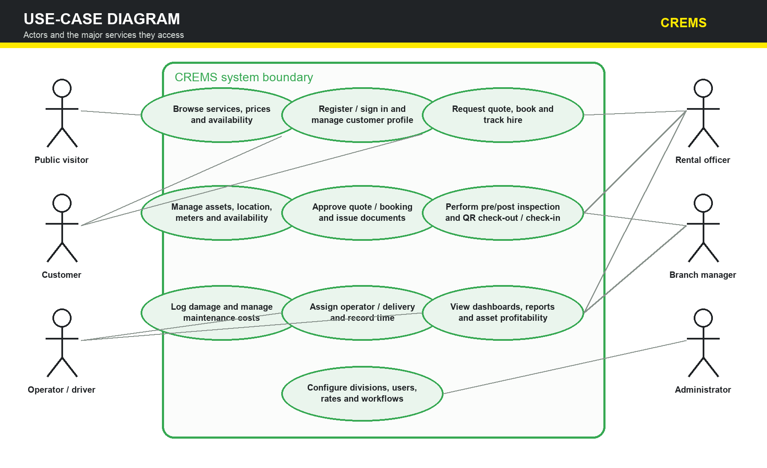
Figure 1. CREMS actors and major use cases
Interpretation Customers can browse, register, request bookings and track hire. Rental officers manage day-to-day transactions; branch managers approve and monitor performance; administrators configure organization-wide controls; operators and drivers complete assigned field activities.

21.2 Data flow diagram — context (Level 0)
The context diagram treats CREMS as one process and shows the information exchanged with its principal external entities. It defines the system boundary without committing to screen or database implementation details.
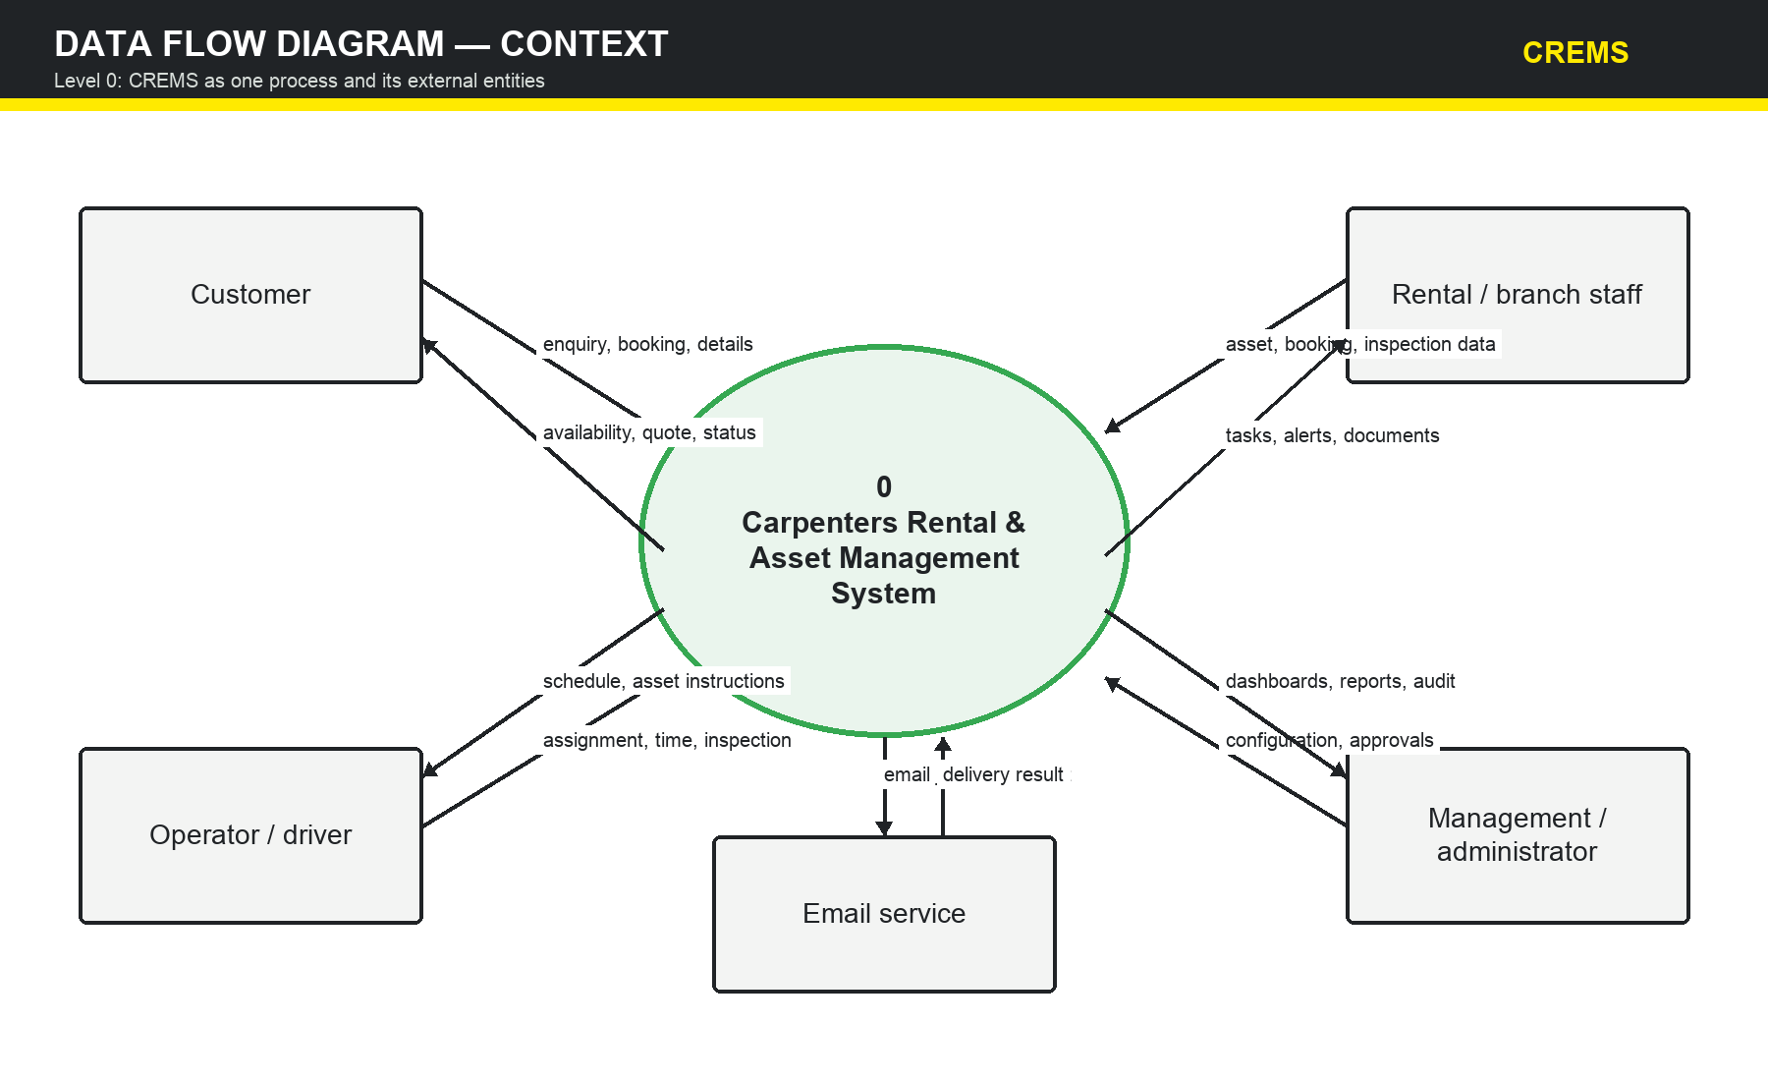
Figure 2. Context-level data flow diagram for CREMS
Boundary note The email service is external to CREMS. The application submits approved messages and documents and records delivery results; the email provider does not decide booking, maintenance or approval outcomes.

21.3 Data flow diagram — Level 1
The Level 1 DFD decomposes CREMS into six cooperating business processes. Arrows show representative information movement, while the data stores identify the main persistent records used across processes.
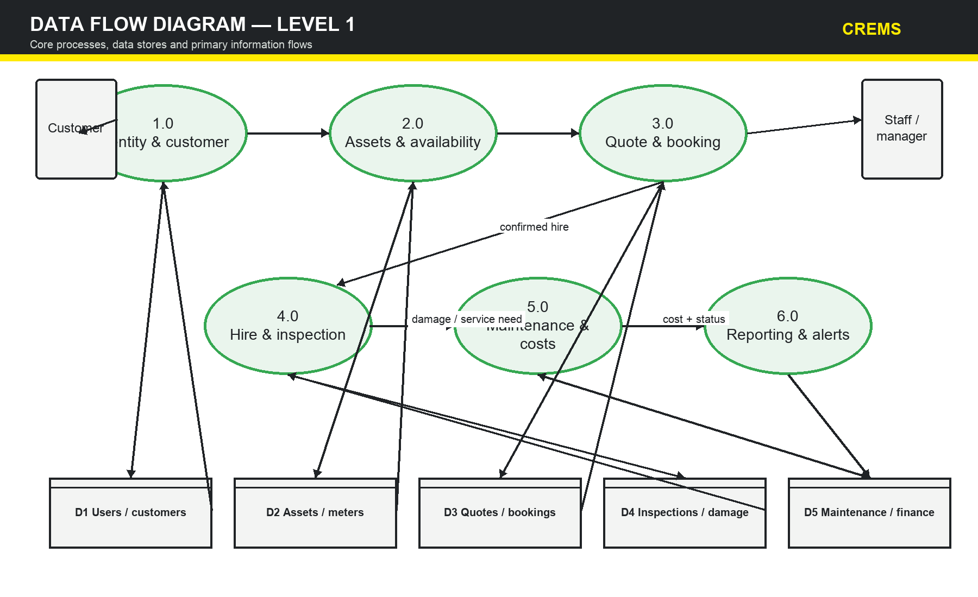
Figure 3. Level 1 data flow between core CREMS processes and stores
• Identity and customer management establishes authenticated actors and customer records.
• Asset and availability management supplies serviceable assets and meter/status information to quoting and hire processes.
• Hire, inspection and maintenance processes return condition, damage, cost and availability information for reporting and alerts.

21.4 Conceptual entity–relationship diagram
The conceptual ERD identifies the minimum shared data model needed to support division and branch ownership, customers, bookings, assets, inspections, maintenance, personnel and attributable costs. It is a planning model rather than the final physical schema.
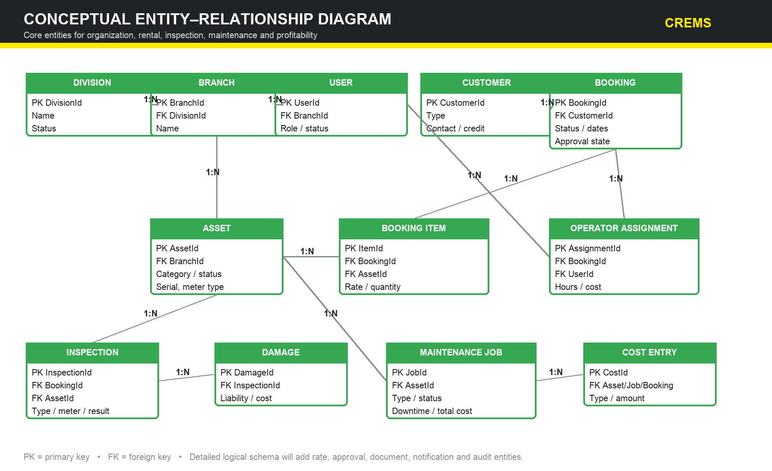
Figure 4. Conceptual CREMS entity–relationship diagram
Design note Rate cards, approval stages, documents, notification jobs, audit events, detailed checklist templates and asset-category attributes will be normalized into additional entities during the Week 2 logical data-model exercise.

Appendix A — Team Charter

A.1 Team purpose
The team will collaboratively plan, design, implement and validate a professional, modular rental and asset-management MVP that reflects approved client requirements and CS400 learning outcomes. Team success is measured by verified value and professional conduct, not by individual screen or commit counts.

A.2 Team members and initial responsibilities
Member | Initial coordination responsibility | Shared obligations
Kavish Chandra | Project coordination, client liaison, requirements and integration | Attend meetings; deliver assigned work; review peers; test; document; raise risks early
Shoneel Kumar | Asset lifecycle, inspections, maintenance and division workflows | Same shared obligations
Sudhansu Jayshil Kisun | Architecture, database, security and reporting | Same shared obligations
Rahul Chand | Customer/staff experience, booking documents, notifications and QA | Same shared obligations

A.3 Working agreements
• Be prepared, punctual and respectful; critique the work, not the person.
• Record decisions and action owners; do not rely on memory or private messages for material project decisions.
• Ask for help early. A blocker older than one working day is raised to the project lead and team.
• No production-like code is merged without peer review and evidence appropriate to its risk.
• Protect client confidentiality, personal data and credentials at all times.
• Credit contributions honestly and document AI assistance according to course policy.
• Disagreement is resolved using requirements, evidence, feasibility and client value. Unresolved material issues are escalated to the supervisor/client.

A.4 Decision and conflict process
Routine technical decisions are made by the work-package owner after consultation. Decisions affecting scope, policy, security, schedule or client operations require team review and, where appropriate, client or supervisor confirmation. If consensus is not reached, options and impacts are documented and the project lead facilitates an escalation rather than imposing an undocumented decision.

A.5 Participation and accountability
Tasks are visible on the shared board with owner, acceptance criteria and due date. The team reviews workload weekly and redistributes work where necessary. Repeated missed commitments are discussed privately first, then recorded and escalated according to university procedures if unresolved.

Appendix B — Project Acceptance
Approval of this document confirms agreement with the planning baseline and initial scope. It does not certify that the software has been completed or authorize production use. Changes after approval follow the change-control process in Section 17.
Approval role | Name | Signature / confirmation | Date
Client representative | To be confirmed
Academic supervisor | To be confirmed
Project leader | Kavish Chandra
Team member | Shoneel Kumar
Team member | Sudhansu Jayshil Kisun
Team member | Rahul Chand

References and evidence sources
Carpenters Fiji client consultation notes and requirements supplied to the project team, August 2026 (confidentiality restrictions apply).
The University of the South Pacific. (2026). CS400 Industry Experience Project, Assignment #1 — Project Plan specification and marking rubric.
ProjectManagementDocs.com. Project Management Plan Template (used as a visual and structural reference; template example content replaced).
Microsoft. ASP.NET Core, .NET, Entity Framework Core and SQL Server documentation (technical feasibility reference).
OWASP Foundation. Application Security Verification Standard and web application security guidance (security planning reference).

