PowerWise Deployment Report
Energy Monitoring & Management System

1. Deployment Overview
This document describes the deployment configuration for the PowerWise full-stack application. The backend REST API is deployed on Render and the React frontend is deployed on Vercel.

Project | PowerWise – Smart Domestic Electricity Management System
Backend Platform | Render (render.com)
Frontend Platform | Vercel (vercel.com)
Backend Live URL | https://YOUR-APP-NAME.onrender.com
Frontend Live URL | https://power-wise-theta.vercel.app
Database | MongoDB Atlas (Cloud)
Deployment Date | April 2026

2. Backend Deployment — Render

2.1 Platform
The Express.js backend is deployed as a Web Service on Render. Render automatically detects the Node.js runtime and handles process management, health checks, and HTTPS.

2.2 Setup Steps
The following steps were followed to deploy the backend:

- Pushed the repository to GitHub at github.com/kavishkasandaruwan2002/PowerWise
- Logged into Render and created a new Web Service
- Connected the GitHub repository to Render
- Configured the service with the following settings:

Root Directory | backend
Build Command | npm install
Start Command | node server.js
Environment | Node
Instance Type | Free

- Added all required environment variables in the Render dashboard
- Clicked Deploy and waited for the build to complete

2.3 Environment Variables
The following environment variables were configured in the Render dashboard. Actual secret values are not shown here.

Variable | Description
MONGODB_URI | MongoDB Atlas connection string
PORT | Set automatically by Render
NODE_ENV | production
FRONTEND_URL | https://power-wise-theta.vercel.app
JWT_ACCESS_SECRET | Secret key for signing JWT tokens
JWT_EXPIRE | 7d
ADMIN_SECRET_KEY | Secret key for admin registration

2.4 Live Backend URL
https://powerwise.onrender.com/api/health
Note: The free tier on Render spins down after periods of inactivity. The first request after idle may take 30–60 seconds while the service restarts. This is expected behaviour on the free plan.

2.5 Deployment Screenshot
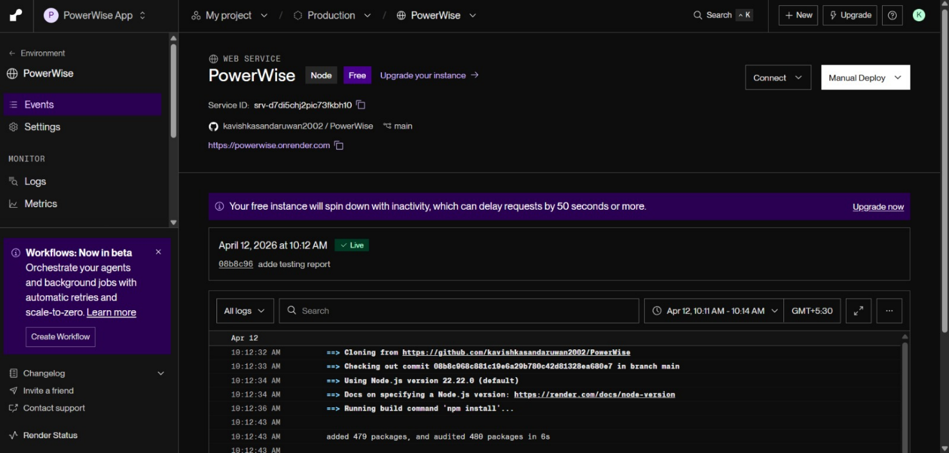

3. Frontend Deployment — Vercel

3.1 Platform
The React frontend (built with Vite) is deployed on Vercel. Vercel provides automatic deployments on every push to the main branch, global CDN, and HTTPS out of the box.

3.2 Setup Steps
The following steps were followed to deploy the frontend:

- Logged into Vercel and created a new project
- Imported the GitHub repository (kavishkasandaruwan2002/PowerWise)
- Configured the project with the following settings:

Root Directory | frontend
Framework Preset | Vite
Build Command | npm run build
Output Directory | dist

- Added the VITE_API_URL environment variable pointing to the Render backend
- Clicked Deploy — Vercel built and deployed the app successfully

3.3 Environment Variables
The following environment variable was configured in the Vercel dashboard:

Variable | Description
VITE_API_URL | Deployed Render backend base URL

3.4 Live Frontend URL
https://power-wise-theta.vercel.app

3.5 Deployment Screenshot
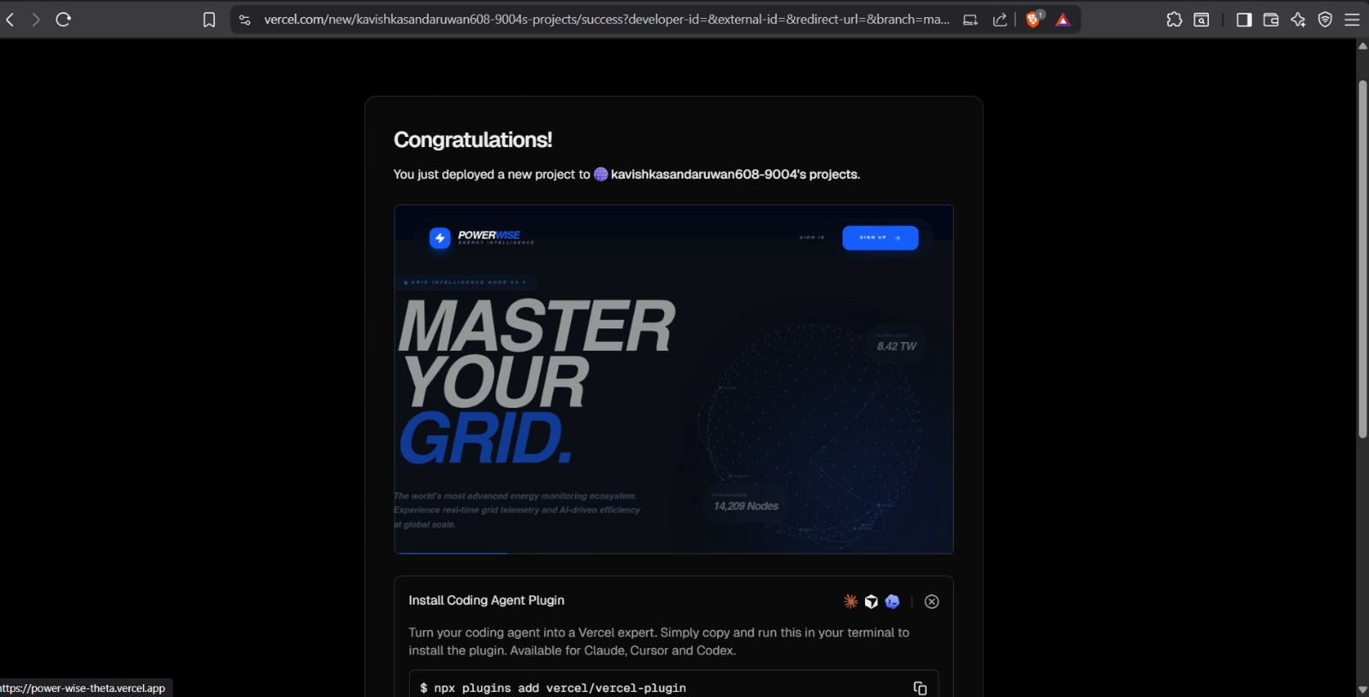

4. Live URLs Summary

Deployed Backend API | https://powerwise.onrender.com
Deployed Frontend App | https://power-wise-theta.vercel.app
API Health Check | https://powerwise.onrender.com/api/health
GitHub Repository | https://github.com/kavishkasandaruwan2002/PowerWise

5. Additional Notes
- Both frontend and backend are deployed from the main branch of the GitHub repository.
- Automatic deployments are enabled — any push to main will trigger a new deployment on both platforms.
- The MongoDB database is hosted on MongoDB Atlas and is accessible from the Render backend via the MONGODB_URI environment variable.
- CORS is configured on the backend to only accept requests from the deployed Vercel frontend URL.
- All secrets and API keys are stored as environment variables on the respective platforms and are never committed to the repository.
- The .env file is listed in .gitignore and is not tracked by version control.

