Develop collaborative recommendation for following utility matrix.

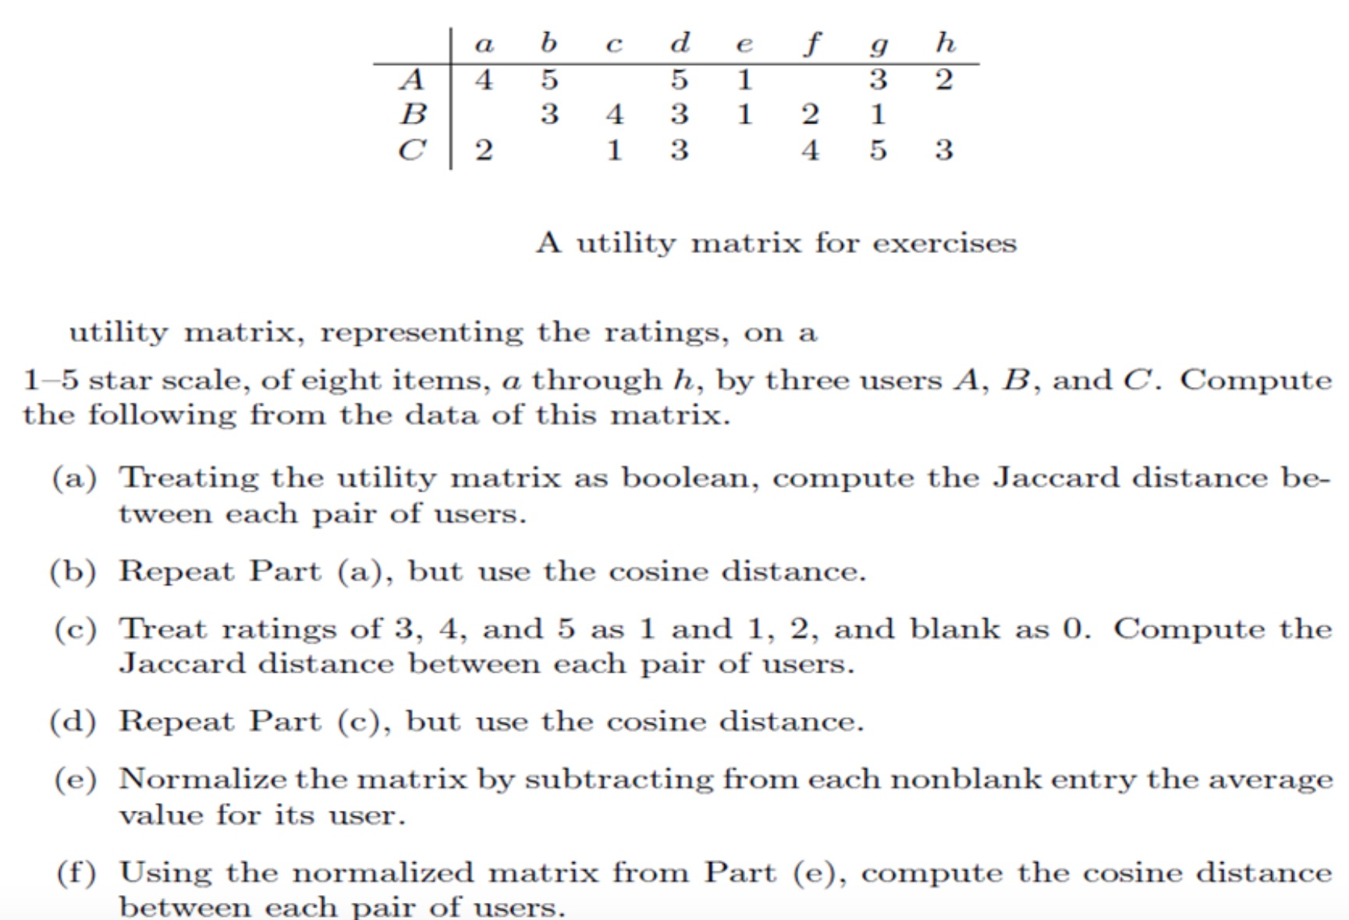
Solution:
The output of program is as follows:
Given matrix is:
===================================================
a | b | c | d | e | f | g | h
===================================================
A |4.000 | 5.000 | 0.000 | 5.000 | 1.000 | 0.000 | 3.000 | 2.000
B |0.000 | 3.000 | 4.000 | 3.000 | 1.000 | 2.000 | 1.000 | 0.000
C |2.000 | 0.000 | 1.000 | 3.000 | 0.000 | 4.000 | 5.000 | 3.000

----------------------------------------------------------------------------------------------------------------------
The boolean matrix is:
===================================================
a | b | c | d | e | f | g | h
===================================================
A |1.000 | 1.000 | 0.000 | 1.000 | 1.000 | 0.000 | 1.000 | 1.000
B |0.000 | 1.000 | 1.000 | 1.000 | 1.000 | 1.000 | 1.000 | 0.000
C |1.000 | 0.000 | 1.000 | 1.000 | 0.000 | 1.000 | 1.000 | 1.000

The Jaccard distance of all pairs is:
('A', 'B') Jaccard Similarity: 0.500 Jaccard Distance: 0.500
('A', 'C') Jaccard Similarity: 0.500 Jaccard Distance: 0.500
('B', 'C') Jaccard Similarity: 0.500 Jaccard Distance: 0.500

The Cosine distance of all pairs is:
('A', 'B') Cosine Distance: 0.667
('A', 'C') Cosine Distance: 0.667
('B', 'C') Cosine Distance: 0.667

----------------------------------------------------------------------------------------------------------------------
The rounded data matrix is:
===================================================
a | b | c | d | e | f | g | h
===================================================
A |1.000 | 1.000 | 0.000 | 1.000 | 0.000 | 0.000 | 1.000 | 0.000
B |0.000 | 1.000 | 1.000 | 1.000 | 0.000 | 0.000 | 0.000 | 0.000
C |0.000 | 0.000 | 0.000 | 1.000 | 0.000 | 1.000 | 1.000 | 1.000

The Jaccard distance of all pairs is:
('A', 'B') Jaccard Similarity: 0.400 Jaccard Distance: 0.600
('A', 'C') Jaccard Similarity: 0.333 Jaccard Distance: 0.667
('B', 'C') Jaccard Similarity: 0.167 Jaccard Distance: 0.833

The Cosine distance of all pairs is:
('A', 'B') Cosine Distance: 0.577
('A', 'C') Cosine Distance: 0.500
('B', 'C') Cosine Distance: 0.289

--------------------------------------------------------------------------------------------------------------------
The normalized matrix is:
==================================================
a | b | c | d | e | f | g | h
==================================================
A |0.667 | 1.667 | 0.000 | 1.667 | -2.333 | 0.000 | -0.333 | -1.333
B |0.000 | 0.667 | 1.667 | 0.667 | -1.333 | -0.333 | -1.333 | 0.000
C |-1.000 | 0.000 | -2.000 | 0.000 | 0.000 | 1.000 | 2.000 | 0.000

The Cosine distance of all pairs is:
('A', 'B') Cosine Distance: 0.584
('A', 'C') Cosine Distance: -0.115
('B', 'C') Cosine Distance: -0.740

---------------------------------------------------------------------------------------------------------------------

Created a program in python that reads the input utility matrix from ratings.txt file. This file has space separated values in three columns viz. User, item, and rating. The file is as follows:

#ratings.txt
#User|Item|Rating
A a 4
A b 5
A c 0
A d 5
A e 1
A f 0
A g 3
A h 2
B a 0
B b 3
B c 4
B d 3
B e 1
B f 2
B g 1
B h 0
C a 2
C b 0
C c 1
C d 3
C e 0
C f 4
C g 5
C h 3

The python program to calculate jaccard and cosine distance is as follows:

#!python3
"""
Module to find jaccard distance and cosine distance of given utility matrix. The input is given in file ratings.txt.
A '0' rating means no rating has been given by user for that item
"""
from collections import OrderedDict
from itertools import combinations
import math

# configuration parameters
HIGEST_RATE = 5
LOWEST_RATE = 1
FILE_NAME = "ratings.txt"
HIGH_RATINGS = [3,4,5]
LOW_RATINGS = [1,2]
SEP = 135
fformat = '.3f'

def printJD(res):
print("The Jaccard distance of all pairs is:")
for grp in res:
print(grp, "Jaccard Similarity:", format(float(res[grp][0]/res[grp][1]), fformat),
"Jaccard Distance:", format(float((res[grp][1] - res[grp][0])/res[grp][1]), fformat), sep='\t')
print('\n')

def printCD(res):
print("The Cosine distance of all pairs is:")
for grp in res:
print(grp, "Cosine Distance:", format(res[grp], fformat), sep='\t')
print('\n')

def printMat(mat):
ratings = OrderedDict()

for user in mat:
ratings['cols'] = [item for item in mat[user]]
ratings['cols'] = ' \t|\t '.join(ratings['cols'])
break

for user in mat:
#ratings[user] = [str(format(mat[user][item], fformat)) if mat[user][item] is not 0 else ' ' for item in mat[user]]
ratings[user] = [str(format(mat[user][item], fformat)) for item in mat[user]]
ratings[user] = '\t|\t'.join(ratings[user])

print('='*SEP)
print('\t', ratings['cols'])
print('='*SEP)
for row in ratings:
if row is not 'cols':
print(row, '|' + ratings[row], sep='\t')
print('\n')

def getMatrix(filename):
f = open(filename, 'r')
mat = OrderedDict()
for line in f:
if not line.startswith('#'):
data = line.strip().split(' ')
if data[0] not in mat.keys():
mat[data[0]] = OrderedDict()
mat[data[0]][data[1]] = int(data[2])

return mat

def getBoolmat(mat, highrate=range(1, HIGEST_RATE+1)):
boolMat = OrderedDict()
for user in mat:
if user not in boolMat.keys():
boolMat[user] = OrderedDict()
for item in mat[user]:
if mat[user][item] in highrate:
boolMat[user][item] = 1
else:
boolMat[user][item] = 0
return boolMat

def getNormalizedMat(mat):
normMat = OrderedDict()
for user in mat:
if user not in normMat.keys():
normMat[user] = OrderedDict()
count = 0
sumi = 0
for item in mat[user]:
if mat[user][item] > 0:
count += 1
sumi += mat[user][item]

for item in mat[user]:
if mat[user][item] > 0:
normMat[user][item] = float(float(mat[user][item]) - float(sumi/count))
else:
normMat[user][item] = 0

# if mat[user][item] in highrate:
# boolMat[user][item] = 1
# else:
# boolMat[user][item] = 0
return normMat

def getJaccardD(mat):

grps = combinations(mat.keys(),2)
res = OrderedDict()
for grp in grps:
interset = 0
union = 0
for item in mat[grp[0]]:
if mat[grp[0]][item] and mat[grp[1]][item]:
interset += 1
if mat[grp[0]][item] or mat[grp[1]][item]:
union += 1
res[grp] = (interset, union)

return res

def getCosineD(mat):

grps = combinations(mat.keys(),2)
res = OrderedDict()
for grp in grps:
num = 0
den1 = 0.00
den0 = 0.00
for item in mat[grp[0]]:
num += mat[grp[0]][item] * mat[grp[1]][item]
den0 += mat[grp[0]][item]*mat[grp[0]][item]
den1 += mat[grp[1]][item]*mat[grp[1]][item]

den0 = math.sqrt(den0)
den1 = math.sqrt(den1)
res[grp] = float(num/(den0*den1))

return res

def main():
uMat = getMatrix(FILE_NAME)
print("Given matrix is:")
printMat(uMat)
print('-'*SEP)

boolMat = getBoolmat(uMat)
boolJd = getJaccardD(boolMat)
boolCd = getCosineD(boolMat)
print("The boolean matrix is:")
printMat(boolMat)
printJD(boolJd)
printCD(boolCd)
print('-'*SEP)

customBoolMat = getBoolmat(uMat, HIGH_RATINGS)
customBoolJd = getJaccardD(customBoolMat)
customBoolCd = getCosineD(customBoolMat)
print("The rounded data matrix is:")
printMat(customBoolMat)
printJD(customBoolJd)
printCD(customBoolCd)
print('-'*SEP)

normMat = getNormalizedMat(uMat)
#normJd = getJaccardD(normMat)
normCd = getCosineD(normMat)
print("The normalized matrix is:")
printMat(normMat)
#printJD(normJd)
printCD(normCd)
print('-'*SEP)

if __name__ == '__main__':
main()

The Screenshots:
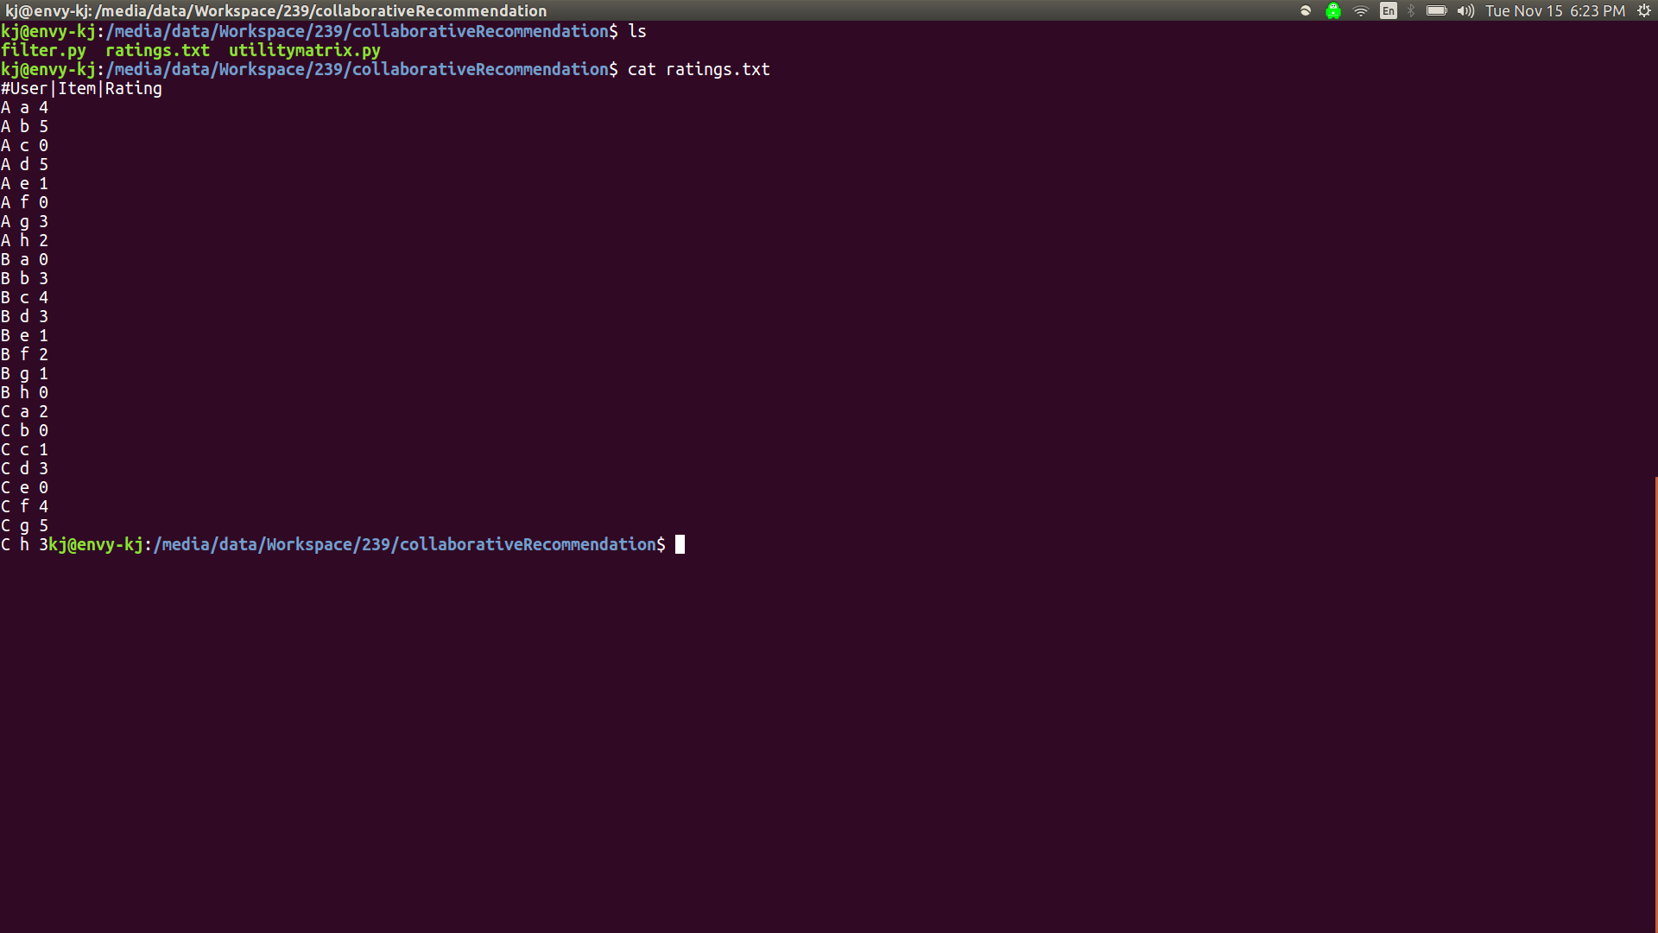

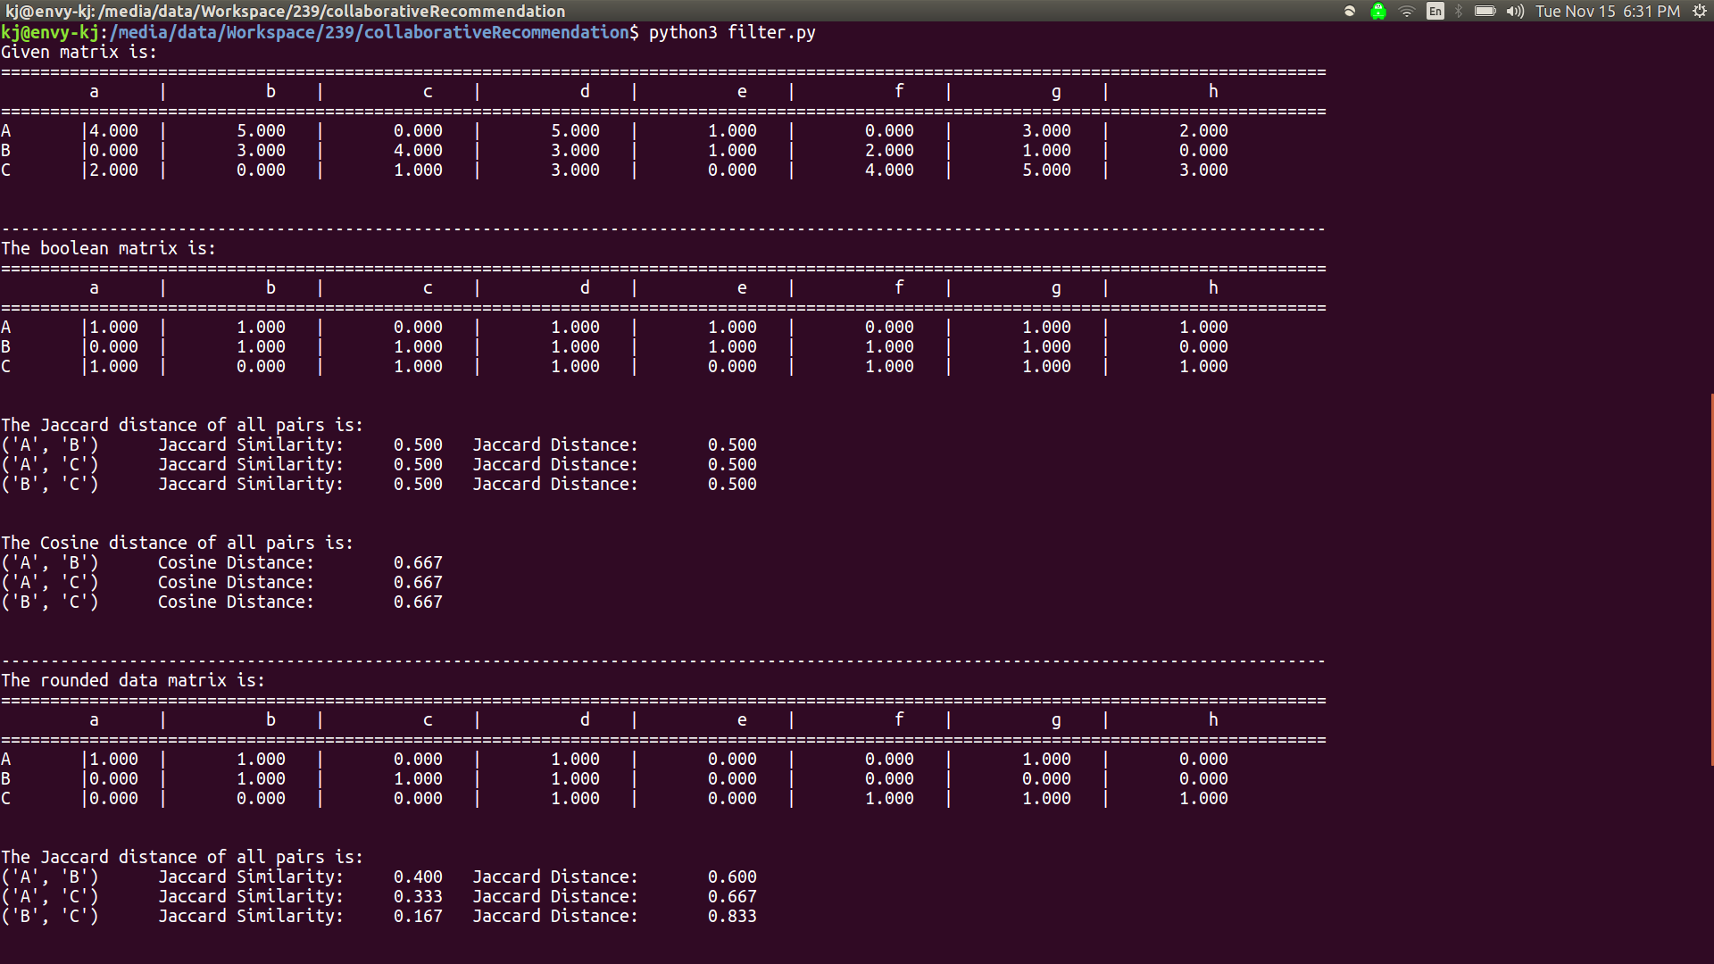
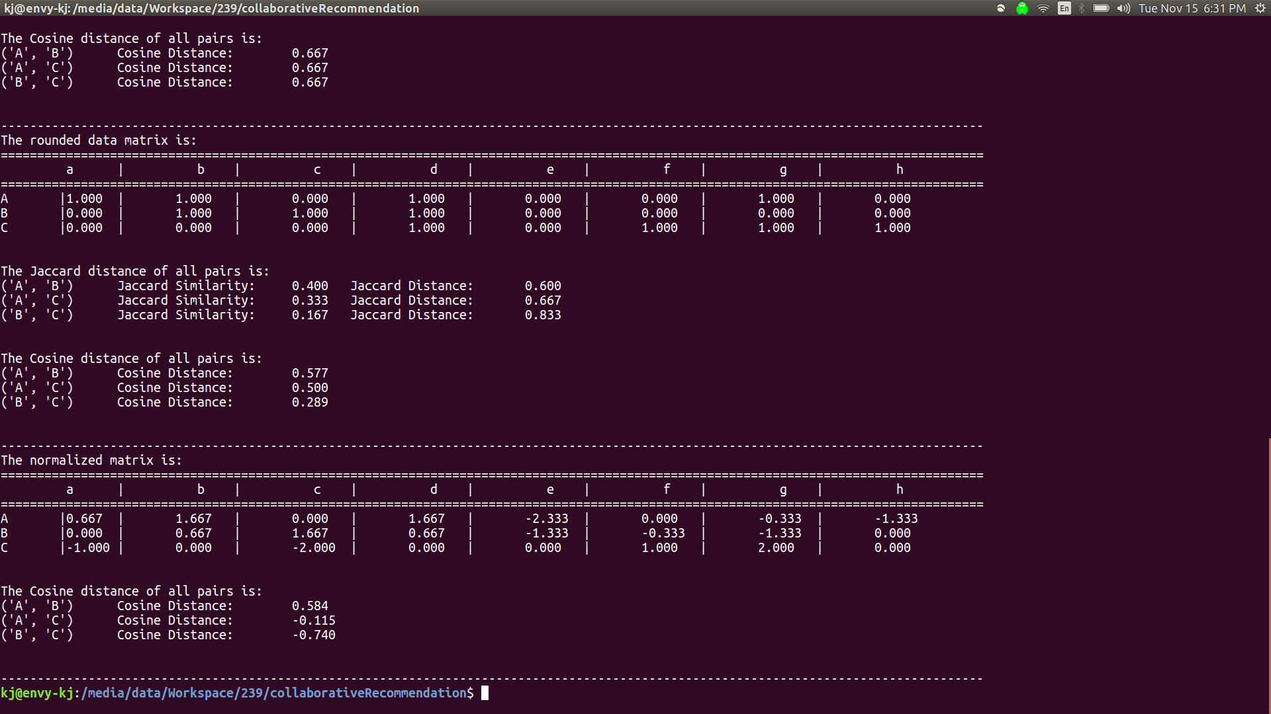
Github link:

https://github.com/kavishme/CollaborativeFiltering

