Apply TF-IDF and develop Spam Filter mode for the enclosed documents.

Solution:
Output of program:

-------------------------------------------------------------------------------------------------------------------------------------------------------------------------------------------
***Spam dictionary***

free,click here,visit,open attachment,call this number,money,out,extra,offer,available,pension,opportunity,chance,investment,pension
--------------------------------------------------------------------------------------------------------------------------------------------------------------------------------------------
***Word frequency table***

document1.txt 0 1 0 0 0 1 0 0 0 1 0 0 0 0
document2.txt 1 0 1 0 0 0 0 0 0 0 0 0 0 0
document3.txt 1 0 0 0 0 0 1 0 0 0 2 0 0 0
document4.txt 2 1 0 0 0 0 0 0 0 0 0 0 0 0
document5.txt 0 0 0 0 0 1 0 2 0 0 0 1 1 0
document6.txt 0 0 0 0 0 0 0 0 1 0 0 0 0 1
--------------------------------------------------------------------------------------------------------------------------------------------------------------------------------------------
***IDF***

0.368 0.544 0.845 0.000 0.000 0.544 0.845 0.845 0.845 0.845 0.845 0.845 0.845 0.845 0.845
--------------------------------------------------------------------------------------------------------------------------------------------------------------------------------------------
***TF table***

document1.txt 0.000 1.000 0.000 0.000 0.000 1.000 0.000 0.000 0.000 1.000 0.000 0.000 0.000 0.000
document2.txt 1.000 0.000 1.000 0.000 0.000 0.000 0.000 0.000 0.000 0.000 0.000 0.000 0.000 0.000
document3.txt 1.000 0.000 0.000 0.000 0.000 0.000 1.000 0.000 0.000 0.000 1.114 0.000 0.000 0.000
document4.txt 1.114 1.000 0.000 0.000 0.000 0.000 0.000 0.000 0.000 0.000 0.000 0.000 0.000 0.000
document5.txt 0.000 0.000 0.000 0.000 0.000 1.000 0.000 1.114 0.000 0.000 0.000 1.000 1.000 0.000
document6.txt 0.000 0.000 0.000 0.000 0.000 0.000 0.000 0.000 1.000 0.000 0.000 0.000 0.000 1.000
--------------------------------------------------------------------------------------------------------------------------------------------------------------------------------------------
***TF-IDF table***

document1.txt 0.000 0.544 0.000 0.000 0.000 0.544 0.000 0.000 0.000 0.845 0.000 0.000 0.000 0.000
document2.txt 0.368 0.000 0.845 0.000 0.000 0.000 0.000 0.000 0.000 0.000 0.000 0.000 0.000 0.000
document3.txt 0.368 0.000 0.000 0.000 0.000 0.000 0.845 0.000 0.000 0.000 0.942 0.000 0.000 0.000
document4.txt 0.410 0.544 0.000 0.000 0.000 0.000 0.000 0.000 0.000 0.000 0.000 0.000 0.000 0.000
document5.txt 0.000 0.000 0.000 0.000 0.000 0.544 0.000 0.942 0.000 0.000 0.000 0.845 0.845 0.000
document6.txt 0.000 0.000 0.000 0.000 0.000 0.000 0.000 0.000 0.845 0.000 0.000 0.000 0.000 0.845
--------------------------------------------------------------------------------------------------------------------------------------------------------------------------------------------

The program expects the spam dictionary in file dict.txt and spam emails in folder mails in txt files.
The program is as follows:

#!python3

import os
from math import log
from collections import OrderedDict

DICTFILE = 'dict.txt'
MAILFOLDER = './mails/'
SEP = 150
fformat = '.3f'

def getSpamDictionary(filename):
f = open(filename, 'r')
words = f.read()
words = [word.strip().lower() for word in words.split('\n')]
return words

def main():

sdict = getSpamDictionary(DICTFILE)

docs = OrderedDict()
idf = OrderedDict()

for fi in os.listdir(MAILFOLDER):
if fi.endswith(".txt"):
f = open(MAILFOLDER + fi, 'r')
docs[fi] = OrderedDict()
docs[fi]['data'] = f.read().strip().lower().replace('-', ' ').replace('\n', ' ')

for word in sdict:
for doc in docs:
data = docs[doc]['data'].split(' ')
count = []
for w in word.split(' '):
count.append(data.count(w))

if 'count' not in docs[doc].keys():
docs[doc]['count'] = OrderedDict()

docs[doc]['count'][word] = min(count)

for doc in docs:
if 'tf' not in docs[doc].keys():
docs[doc]['tf'] = OrderedDict()
for word in sdict:
count = docs[doc]['count'][word]
if count:
docs[doc]['tf'][word] = 1 + log( 1 + log(count, 10), 10)
else:
docs[doc]['tf'][word] = 0

for word in sdict:
freq = 0
for d in docs:
if docs[d]['count'][word] > 0:
freq += 1
if freq:
idf[word] = log((1+len(docs))/freq, 10)
else:
idf[word] = 0

for doc in docs:
if 'tfidf' not in docs[doc].keys():
docs[doc]['tfidf'] = OrderedDict()
for word in sdict:
docs[doc]['tfidf'][word] = idf[word] * docs[doc]['tf'][word]

print('-'*SEP)
print('***Spam dictionary***', ','.join(sdict), sep='\n\n')

print('-'*SEP)
print('***Word frequency table***')
print('\n')
for doc in docs:
print(doc, " \t".join([str(docs[doc]['count'][word]) for word in docs[doc]['count']]))

print('-'*SEP)
print('***IDF***')
print('\n')
print(" \t".join([str(format(idf[word],fformat)) for word in sdict]))

print('-'*SEP)
print('***TF table***')
print('\n')
for doc in docs:
print(doc, " \t".join([str(format(docs[doc]['tf'][word], fformat)) for word in docs[doc]['tf']]))

print('-'*SEP)
print('***TF-IDF table***')
print('\n')
for doc in docs:
print(doc, " \t".join([str(format(docs[doc]['tfidf'][word], fformat)) for word in docs[doc]['tfidf']]))
print('-'*SEP)

if __name__ == '__main__':
main()

Screenshots:

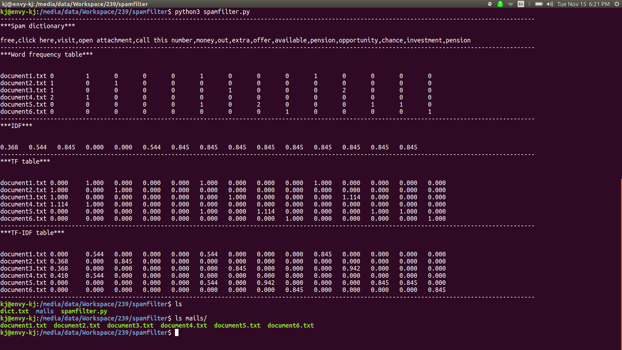
Github link:

https://github.com/kavishme/spamfilter_tf-idf

