SUPPLY CHAIN DELIVERY RISK PREDICTION
Using Logistic Regression, Random Forest and Gradient Boosting
Student Name | Kavita P
USN | RTU24101CS050
University | Rai Technology University
Submission Date | 27/09/2026

1. Introduction
Reliable delivery performance is central to business operations, and late deliveries can erode customer satisfaction while increasing operational cost. This project applies machine learning to predict whether an order is at risk of late delivery, using order- and shipping-related information collected across the supply chain.

2. Problem Statement
Conventional delivery-tracking systems often flag risk only after a delay has already occurred, leaving little room for preventive action. This project addresses that gap by building a machine learning system that predicts late-delivery risk in advance and compares three classification algorithms to identify the most suitable approach.

3. Objectives
- Analyze supply chain delivery data to identify patterns associated with delay.
- Preprocess and prepare the dataset for machine learning (Section 5, 8).
- Train Logistic Regression, Random Forest and Gradient Boosting models (Section 6).
- Compare model performance using standard evaluation metrics (Section 10).
- Predict the risk of late delivery for new, unseen orders.

4. Scope
The system is designed to support e-commerce, logistics, warehouse and transportation operations by identifying potentially risky deliveries in advance, allowing organizations to take preventive action such as reallocating resources or proactively notifying customers.

5. Methodology
The project follows a standard machine learning pipeline, shown below:
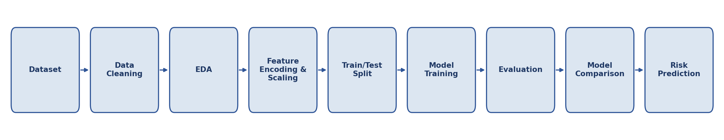
Categorical features (e.g., shipping mode, customer segment, product category, region) are converted using One-Hot Encoding, while numerical features (e.g., shipping distance, processing time, warehouse workload) are standardized using StandardScaler prior to model training.

6. Algorithms Used
Logistic Regression: A linear classification algorithm used as a baseline to estimate the probability of late-delivery risk.
Random Forest: An ensemble of decision trees whose combined predictions improve accuracy and reduce overfitting compared to a single tree.
Gradient Boosting: Builds decision trees sequentially, with each new tree correcting the errors of the previous ones, typically improving predictive performance further.

7. Software & Hardware Requirements
Software: Python, Jupyter Notebook / Google Colab, Pandas, NumPy, Matplotlib, Seaborn and Scikit-learn.
Hardware: Intel i5 processor or equivalent, 8 GB RAM, and sufficient storage for dataset and model files.

8. Dataset
The initial experimental dataset contains 100 order records across 13 columns. Key features include shipping mode, customer segment, product category, region, shipping distance, processing time, shipping time, previous delays and warehouse workload. The target variable, Late_Delivery_Risk, is binary: 0 indicates low/no risk and 1 indicates late-delivery risk. This dataset is a small prototype sample; the final implementation will use a larger dataset to obtain more reliable results.

9. Test Cases
# | Scenario | Expected Outcome
1 | Normal delivery conditions | Low / No risk prediction
2 | Long shipping distance | Risk score increases
3 | High warehouse workload | Risk score increases
4 | Multiple previous delays | Higher risk prediction
5 | New valid order submitted | System returns a risk prediction

10. Result and Discussion
The three models were trained on an 80/20 stratified train-test split (80 training orders, 20 test orders) and evaluated using accuracy, precision, recall and F1-score. The table below reports the actual results obtained on this experimental dataset.
Model | Accuracy | Precision | Recall | F1-Score
Logistic Regression | 80.0% | 1.00 | 0.56 | 0.71
Random Forest | 85.0% | 1.00 | 0.67 | 0.80
Gradient Boosting | 75.0% | 0.75 | 0.67 | 0.71

Random Forest achieved the strongest overall performance (85.0% accuracy, F1-score 0.80) among the three models, followed by Logistic Regression and Gradient Boosting, both of which trailed mainly on recall. All three models showed perfect or near-perfect precision but comparatively lower recall, indicating that when a model predicts “high risk” it is usually correct, but some genuinely at-risk orders are still missed. This pattern is common with small datasets (only 100 orders here) and is expected to improve once the models are retrained on a larger, production-scale dataset.

11. Conclusion
This project demonstrates that machine learning can effectively predict supply chain delivery risk. Comparing Logistic Regression, Random Forest and Gradient Boosting helps identify a model that balances accuracy and interpretability for this problem. The system can support proactive delivery management and can be extended in future work with real-time traffic, weather and GPS information to further improve prediction accuracy.

12. References
1. Breiman, L. (2001). Random Forests. Machine Learning.
2. Friedman, J. H. (2001). Greedy Function Approximation: A Gradient Boosting Machine.
3. Géron, A. Hands-On Machine Learning with Scikit-Learn, Keras & TensorFlow.
4. Pedregosa et al. (2011). Scikit-learn: Machine Learning in Python.

