

Project Report on
Project Title: Supply Chain Delivery Risk Prediction
Subject Title: Computer Organization Subject code: CS0354T

Submitted By:
Student Name: Kavita P
University Enrolment Number: RTU24101CS050

Program Name: B. TECH CSE AIML Semester: 5th Sem
Session: 2026 – 2027

Submitted To: Faculty Name: Mr. Abhishek S
BE, MTech

Department of Computer Science & Engineering Rai Technology University.

College of Engineering & Application

CERTIFICATE

This is to certify that Ms. Kavita P, bearing UEN Number RTU24101CS050, has successfully completed the project entitled “Supply Chain Delivery Risk Prediction” under the guidance and supervision of Mr. Abhishek S, Department of Computer Science and Engineering, during the academic year 2026–2027. The project work has been carried out by the student as part of the academic requirements of the B. Tech program, and the work presented in this report is completed satisfactorily to the best of our knowledge.

Head of Department Faculty Name
Name: Name:
Sign: Sign:

ABSTRACT
Late deliveries reduce customer satisfaction, raise operational costs, and are usually detected only after the delivery promise has already been broken. This project, Supply Chain Delivery Risk Prediction, applies machine learning to estimate whether an order is at risk of late delivery before it is dispatched, so that preventive action can be taken instead of reactive damage control.
The problem is treated as a binary classification task, where each order receives a risk label of 0 (low or no risk) or 1 (at risk). A prototype dataset of 100 orders with 13 columns was used, covering shipping mode, customer segment, product category, region, shipping distance, processing time, shipping time, scheduled delivery days, order value, previous delays, and warehouse workload. Categorical features were encoded using One-Hot Encoding and numerical features were standardized using StandardScaler, both combined in a single scikit-learn Pipeline with the classifier.
Three algorithms, namely Logistic Regression, Random Forest, and Gradient Boosting, were trained on the same data and compared using accuracy, precision, recall, and F1-score. Random Forest performed best with 85% accuracy and an F1-score of 0.80, followed by Logistic Regression with 80% accuracy (F1-score 0.71) and Gradient Boosting with 75% accuracy (F1-score 0.71). Because the dataset is small, these results are indicative rather than conclusive, and the report discusses how limited data affects each algorithm, along with the scope for future work on larger, real-world datasets.
Keywords: Supply Chain, Delivery Risk Prediction, Machine Learning, Logistic Regression, Random Forest, Gradient Boosting.

ACKNOWLEDGEMENT
I would like to express my sincere gratitude to everyone who supported me in the successful completion of this project, Supply Chain Delivery Risk Prediction.
I am deeply thankful to my faculty guide, Mr. Abhishek S, Department of Computer Science and Engineering, for his valuable guidance, constant encouragement, and constructive feedback throughout the course of this work. His suggestions helped me shape the project and present it clearly.
I also extend my thanks to the Head of the Department and the faculty members of the Department of Computer Science and Engineering, College of Engineering & Application, Rai Technology University, for providing the resources and academic environment needed to carry out this project.
Finally, I am grateful to my family and friends for their support and motivation, which helped me complete this work.

Kavita P
RTU24101CS050

CONTENTS
SL No. | TOPIC | Page No.
1.  2.  3. | Abstract  Acknowledgement  contents
 | Assignment-1
4. | Introduction | 1
5. | Problem Statement | 2
6. | Literature Survey | 3-4
 | Assignment-2
7. | Proposed Solution and Methodology | 5-6
8. | Data Collection and Processing | 7-9
9. | Solution Development | 10-12
 | Assignment-3
10. | Result Presentation | 13-14
11. | Discussion on Findings | 15
12. | Conclusion | 16
13. | References | 17

CHAPTER 1

ASSIGNMENT 1

INTRODUCTION

Reliable delivery performance is central to business operations across e-commerce, logistics, and warehousing. Late deliveries erode customer satisfaction, increase operational cost, and force businesses into reactive damage control after the fact. As order volumes grow and supply chains span multiple regions, shipping modes, and warehouses, predicting delivery risk before an order is dispatched becomes essential for maintaining customer trust and controlling cost.
This project applies machine learning to predict whether an order is at risk of late delivery, using order- and shipping-related information collected across the supply chain, such as shipping mode, shipping distance, processing time, previous delays, and warehouse workload. Three factors motivate this work:
- Customer trust — every delay directly affects satisfaction and repeat business.
- Operational cost — delays trigger re-routing, penalties, and extra handling.
- Predict, don't react — flagging risk before the order is dispatched allows preventive action instead of damage control.
The system compares three widely used classification algorithms — Logistic Regression, Random Forest, and Gradient Boosting — to identify which model best balances predictive accuracy with interpretability for this problem.
Modern supply chains generate a continuous stream of structured data at every stage of an order's lifecycle: the moment it is placed, the warehouse that processes it, the carrier that ships it, and the region it is delivered to. Each of these stages contributes information that, taken together, can reveal patterns that are difficult for a human dispatcher to notice manually but are well suited to a supervised machine learning model. This project treats late-delivery prediction as a binary classification problem, where the goal is to output a risk label — 0 for low/no risk, 1 for at-risk — for every order before it leaves the warehouse.
The remainder of this report is organized as follows: Chapter 2 defines the problem being solved; Chapter 3 surveys the algorithms and tools used; Chapter 4 describes the objectives, scope, and methodology; Chapter 5 documents the dataset; Chapter 6 describes the solution implementation; Chapter 7 presents the results; Chapter 8 discusses what the results mean; and Chapters 9 and 10 close with the conclusion, future scope, and references.

CHAPTER 2
PROBLEM STATEMENT

Conventional delivery-tracking systems often flag risk only after a delay has already occurred, leaving little room for preventive action. These systems are reactive by design: alerts arrive once the delay is already in progress, corrective action comes too late, and staff rely on manual judgement and informal rules of thumb rather than data-driven prediction. As a result, the customer is typically informed only after the delivery promise has already been broken.
2.1 Current Systems
- Reactive — the delay is already in progress by the time it is detected.
- Alerts arrive too late for corrective action.
- Rely on manual judgement and rules of thumb.
- Customer is informed after the promise is broken.
2.2 Proposed System
- Predictive — risk is estimated before dispatch.
- Learns patterns from historical order data.
- Compares three algorithms to pick the best fit.
- Enables preventive action and early customer notice.
2.3 Why This Matters
The cost of a late delivery is rarely limited to the single order affected. A missed delivery window can trigger a cascade of re-routing decisions, warehouse re-prioritisation, customer service escalations, and in many cases a refund or discount issued to retain the customer's trust. When these events are only visible after the fact, the business has already absorbed the cost. A predictive system shifts this cost curve to the left — flagging risk while there is still time to act, whether that means choosing a faster shipping mode, alerting the customer proactively, or reassigning warehouse resources before the order is picked and packed.
CHAPTER 3
LITERATURE SURVEY

Predicting risk in supply chain and logistics operations has been widely studied using classical statistical models and, more recently, ensemble machine learning methods. This survey focuses on the three algorithm families used in this project — linear classification, bagging-based ensembles, and boosting-based ensembles — and the tooling used to implement them.
3.1 Linear Classification as a Baseline
Logistic Regression remains a standard baseline for binary classification problems because it is fast to train, easy to interpret through its coefficients, and provides a probability estimate rather than a hard label. Pedregosa et al. (2011) describe its implementation, along with the broader preprocessing and pipeline tools (StandardScaler, OneHotEncoder, ColumnTransformer) used in this project, as part of the scikit-learn library that has become the de-facto standard for applied machine learning in Python.
Literature survey highlight: because Logistic Regression models the log-odds of the positive class as a linear combination of input features, its coefficients can be inspected directly to understand which factors — for example warehouse load or shipping distance — push a given order toward a higher predicted risk, making it a useful reference point even when a more complex model is eventually deployed.
3.2 Ensemble Methods: Bagging
Breiman (2001) introduced Random Forests, an ensemble of decision trees trained on bootstrapped samples with random feature subsets, showing that averaging many de-correlated trees reduces variance and improves generalization compared to a single decision tree.
Literature survey highlight: because each tree in a Random Forest is trained on a different bootstrap sample and a random subset of features, the ensemble is naturally resistant to overfitting on noisy or limited data, which is one reason it was expected to perform well on the 100-order prototype dataset used in this project.
3.3 Ensemble Methods: Boosting
Friedman (2001) proposed Gradient Boosting, which builds trees sequentially, with each new tree fitted to the residual errors of the previous ensemble, often achieving higher accuracy at the cost of longer training time and greater sensitivity to overfitting on small datasets.
Literature survey highlight: because each boosting round is explicitly trying to correct the mistakes of the previous rounds, Gradient Boosting can achieve very high accuracy on the training set, but this same property makes it more prone to overfitting when the training set is
small — a pattern that is visible in this project's results, discussed further in Chapter 8.
3.4 Applied Machine Learning Practice
Géron's "Hands-On Machine Learning with Scikit-Learn, Keras & TensorFlow" is widely used as a practical reference for structuring an end-to-end machine learning pipeline — from train/test splitting and feature preprocessing to model comparison using precision, recall, and F1-score rather than accuracy alone, which is particularly important for imbalanced classification problems such as late-delivery prediction, where the "risk" class is typically the minority class.
Literature survey highlight: this project follows the pipeline pattern described in that reference closely — a single Column Transformer handles both categorical and numerical preprocessing, wrapped together with the classifier in one scikit-learn Pipeline object, so the same transformation logic is guaranteed to be applied consistently to training data, test data, and any new order submitted for prediction.
3.5 Research Gaps and Relevance to This Project
Most published work on delivery risk and logistics prediction assumes access to large, production-scale datasets with thousands or millions of historical orders. Comparatively little attention has been paid to how these same algorithms behave on the small prototype datasets that are typical of an early-stage academic or pilot project — where the training signal for the minority class (late-delivery risk) is limited. This project addresses that gap directly by training and comparing all three algorithms on an identical 100-order dataset and reporting precision, recall, and F1-score alongside accuracy, so that the effect of limited data on each algorithm's behaviour is visible rather than hidden behind a single aggregate accuracy figure.
Taken together, this literature motivates the approach adopted here: a linear model (Logistic Regression) as an interpretable baseline, compared against two tree-based ensembles (Random Forest and Gradient Boosting) that can capture non-linear interactions between shipping distance, processing time, previous delays, and warehouse load — evaluated using accuracy alongside precision, recall, and F1-score to account for class imbalance in the dataset.

ASSIGNMENT 2

CHAPTER 4
PROPOSED SOLOUTION AND METHODOLOGY

4.1 Objectives
- Analyze supply chain delivery data to identify patterns associated with delay.
- Preprocess and prepare the dataset for machine learning.
- Train Logistic Regression, Random Forest, and Gradient Boosting models.
- Compare model performance using standard evaluation metrics.
- Predict the risk of late delivery for new, unseen orders.
4.2 Scope
The system is designed to be applicable across several stages of the supply chain:
- E-commerce — flag risky customer orders before they are shipped.
- Logistics — re-route or re-prioritise shipments predicted to slip.
- Warehouse — balance workload when high load drives up delay risk.
- Transportation — allocate carriers and vehicles to high-risk deliveries.
Outcome: risky deliveries are identified in advance, so teams can reallocate resources or notify customers proactively.
4.3 Methodology
The project follows a standard machine learning pipeline. Categorical features — shipping mode, customer segment, product category, and region — are converted using One-Hot Encoding. Numerical features — shipping distance, processing time, shipping time, scheduled delivery days, order value, previous delays, and warehouse workload — are standardized using Standard Scaler before training. Both transformations are combined in a single Column Transformer and wrapped in a scikit-learn Pipeline together with the classifier, so that preprocessing and model fitting happen consistently on both the training and test splits.
4.4 Algorithms Used
- Baseline — Logistic Regression: a linear classification algorithm used as a baseline to estimate the probability of late-delivery risk.
- Ensemble — Random Forest: an ensemble of decision trees whose combined predictions improve accuracy and reduce overfitting compared to a single tree.
- Sequential — Gradient Boosting: builds decision trees sequentially, with each new tree correcting the errors of the previous ones.
4.5 Software and Hardware Requirements
- Software: Python, Jupyter Notebook / Google Colab, Pandas, NumPy, Matplotlib, Seaborn, Scikit-learn.
- Hardware: Intel i5 processor or equivalent, 8 GB RAM, sufficient storage for dataset and model files.
4.6 Why Three Algorithms Instead of One
Rather than committing to a single algorithm up front, this project deliberately trains three models with different inductive biases — a linear baseline and two tree-based ensembles — on the exact same preprocessed data and the exact same train/test split. This makes the comparison in Chapter 7 fair: any difference in accuracy, precision, recall, or F1-score reflects a genuine difference between the algorithms rather than a difference in how the data was prepared. This is also why every model shares the same Column Transformer inside its own Pipeline object, instead of each model receiving separately-preprocessed data.

CHAPTER 5
DATA COLLECTION AND PROCESSING

The dataset used for this prototype is a small, self-contained sample of 100 order records with 13 columns, designed to exercise the full pipeline end to end before scaling to a production-size dataset. It was loaded directly from a CSV file into a pandas DataFrame for exploration and preprocessing.
5.1 Loading and Inspecting the Data
The dataset was stored as a comma-separated values (CSV) file and loaded into a pandas DataFrame, a tabular data structure in which every row represents one order and every column represents one attribute of that order. After loading, the first few records were inspected to confirm that the file had been read correctly and to understand how the data is organised. The preview showed a mix of categorical attributes, such as shipping mode, customer segment, product category, and order region, together with numerical shipping-related attributes and the binary target column Late_Delivery_Risk, where 1 marks an order at risk of late delivery and 0 marks an order with low or no risk. The complete list of features is given in Section 5.5.
5.2 Dataset Summary
Property | Value
Total records | 100 order records
Columns | 13
Train / test split | 80 / 20 (stratified)
Target variable | Late_Delivery_Risk (binary)
Class balance | 0 = No risk: 57 orders | 1 = Risk: 43 orders
Missing values | None (0 nulls across all columns)
Duplicate rows | None
5.3 Data Quality Checks
Before any modelling, the dataset was checked for two common data quality problems: missing values and duplicate records. Missing values can cause errors or bias during training, while duplicate rows give some orders more weight than they deserve and can make test results look better than they really are.
No missing values and no duplicate rows were found, so the dataset required no cleaning before preprocessing.
5.4 Descriptive Statistics
Descriptive statistics were calculated for the numerical features to understand their scale and spread. Each feature is summarised by its mean, standard deviation, minimum, median, and maximum. Shipping distance averaged about 784 km and ranged from 36 to 1,491 km. Processing time averaged about 2.9 days and ranged from 1 to 5 days. Order value averaged about 7,861 with a maximum of 14,946, and warehouse load averaged about 65 percent, ranging from 30 to 100 percent.
These features lie on very different scales: order value is measured in thousands, while processing time is a single-digit number. Models that are sensitive to feature scale cannot use such values directly, which is why standardisation is applied during preprocessing (Section 6.1).
5.5 Key Features
- Categorical: Shipping_Mode, Customer_Segment, Product_Category, Order_Region.
- Numerical: Shipping_Distance_km, Processing_Time_days, Shipping_Time_days, Scheduled_Delivery_Days, Order_Value, Previous_Delays, Warehouse_Load_pct.
- Target: Late_Delivery_Risk — 0 = low / no risk, 1 = late-delivery risk.
Note: this is a small prototype sample; the final implementation is intended to use a larger, production-scale dataset for more reliable results.
5.6 Class Distribution
The distribution of the target variable was examined to check whether the two classes are balanced. Of the 100 orders, 57 belong to class 0 (no risk) and 43 belong to class 1 (late-delivery risk), so the classes are moderately imbalanced, with the risk class in the minority. This matters because accuracy alone can hide weak performance on the minority class. For this reason, precision, recall, and F1-score are reported alongside accuracy. The distribution is shown in Figure 5.1.
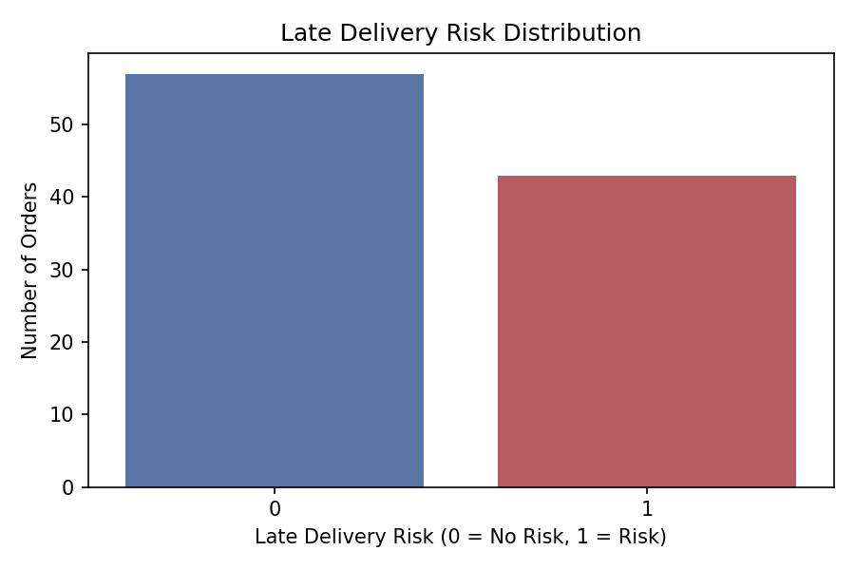
Figure 5.1: Distribution of the target variable Late_Delivery_Risk across the 100 orders in the dataset. The classes are moderately imbalanced (57 vs. 43), which is why precision, recall, and F1-score are reported alongside accuracy in Chapter 7.

5.7 Data Splitting
To judge how well a model works on orders it has never seen, the data must be divided into a training set, from which the model learns patterns, and a test set, which is kept aside and used only for evaluation. A fixed random seed was used so that the split can be reproduced exactly, and stratification was applied so that both subsets keep the same proportion of risk and no-risk orders as the full dataset.
The dataset was split into training and test sets using an 80/20 stratified split, preserving the proportion of the two classes in both subsets. This produced 80 training orders and 20 test orders, giving each model the same training and evaluation data for a fair comparison.
CHAPTER 6
SOLUTION DEVELOPMENT

The solution was implemented in Python using scikit-learn pipelines, so that identical preprocessing is applied consistently across training, testing, and future predictions. The core stages are data loading, preprocessing, model training for all three algorithms, and evaluation.
6.1 Preprocessing Pipeline
The solution was built around a preprocessing pipeline that prepares the raw columns for the models. The input features were first divided into two groups. The categorical group contains shipping mode, customer segment, product category, and order region. The numerical group contains shipping distance, processing time, shipping time, scheduled delivery days, order value, previous delays, and warehouse load.
Numerical features were standardised using Standard Scaler, which subtracts each feature's mean and divides by its standard deviation, so that every feature has a mean of zero and a standard deviation of one. This prevents features with large values, such as order value, from dominating features with small values, such as processing time, and is especially important for Logistic Regression. Categorical features were converted using One-Hot Encoding, which creates a separate binary column for each category. This avoids imposing an artificial order on categories such as regions or shipping modes. The encoder was set to ignore unseen categories, so a new order containing a category not present in the training data does not cause an error.
A Column Transformer applies the right transformation to each group of columns and joins the results into a single feature matrix. Because the same transformer is reused by all three models, every model receives identically prepared data.
6.2 Train / Test Split
The data was split into training and test sets exactly as described in Section 5.7, using an 80/20 stratified split with a fixed random seed. All three models were trained on the same 80 training orders and evaluated on the same 20 test orders. Using one split for every model ensures that differences in performance come from the algorithms themselves and not from differences in the data they saw.
6.3 Logistic Regression
Logistic Regression was used as the baseline model. It models the log-odds of an order being at risk as a linear combination of the input features and passes this value through a sigmoid function to obtain a probability between 0 and 1. Orders with a probability above 0.5 are classified as at risk. The model was combined with the preprocessing step in a single Pipeline, so scaling and encoding are applied automatically during both training and prediction. The maximum number of optimiser iterations was raised to 1,000 to make sure training converges.
The pipeline was fitted on the training set and used to predict the labels of the test set. Comparing these predictions with the true labels gave an accuracy of 80 percent.

6.4 Random Forest
Random Forest is an ensemble of decision trees. In this project it was built from 100 trees, each trained on a different bootstrap sample of the training data and using a random subset of features at each split. The final prediction is the majority vote of all trees. Because the trees are trained on different data and features, their individual errors tend to cancel out, which reduces variance and the risk of overfitting compared with a single decision tree. A fixed random seed was set so that results can be reproduced. As with the other models, the classifier was placed in the same Pipeline as the preprocessing step.
After fitting on the training set and predicting on the test set, Random Forest reached an accuracy of 85 percent, the highest of the three models.
6.5 Gradient Boosting
Gradient Boosting also uses decision trees, but builds them one after another instead of independently. Each new tree is fitted to the errors left by the trees before it, so the ensemble gradually corrects its own mistakes. The model was trained with default settings and a fixed random seed inside the same Pipeline as the preprocessing step.
On the test set it reached an accuracy of 75 percent, the lowest of the three models. Because boosting tries hard to fit the training data, it is more prone to overfitting when the training set is small, which is a likely reason for this result.
6.6 Full Evaluation — Accuracy, Precision, Recall, F1
Accuracy alone can be misleading on an imbalanced target, so four metrics were used to evaluate each model. Accuracy is the share of all test orders that were classified correctly. Precision is the share of orders predicted as at risk that were truly at risk, so it reflects how reliable the warnings are. Recall is the share of truly at-risk orders that the model managed to identify, so it reflects how many risky orders are missed. F1-score is the harmonic mean of precision and recall and gives a single balanced measure of the two.
Logistic Regression achieved an accuracy of 0.80, a precision of 1.00, a recall of 0.56, and an F1-score of 0.71. Random Forest achieved an accuracy of 0.85, a precision of 1.00, a recall of 0.67, and an F1-score of 0.80. Gradient Boosting achieved an accuracy of 0.75, a precision of 0.75, a recall of 0.67, and an F1-score of 0.71. Random Forest therefore gave the best overall balance between precision and recall.
6.7 Results Summary DataFrame
The accuracy scores of the three models were collected into a single summary table and converted to percentages so that they can be compared side by side: 80 percent for Logistic Regression, 85 percent for Random Forest, and 75 percent for Gradient Boosting. The full comparison, including precision, recall, and F1-score, is presented in Chapter 7.
6.8 Random Forest Confusion Matrix
A confusion matrix was prepared for the best-performing model, Random Forest, to see exactly where its errors occur. The matrix compares actual and predicted classes and splits the test orders into four groups: true positives (risky orders correctly flagged), true negatives (safe orders correctly passed), false positives (safe orders wrongly flagged), and false negatives (risky orders missed). It is usually displayed as a colour-coded grid so that the counts can be read at a glance. The matrix is shown in Figure 7.2 in Chapter 7 and is consistent with the metrics above: the precision of 1.00 means there were no false alarms, while the recall of 0.67 means that some at-risk orders were missed.
6.9 Prediction on a New Order
To show how the system would be used in practice, the trained Random Forest pipeline was applied to a new order. The order was described with the same features used during training: a Standard Class shipment for a Corporate customer in the Technology category, delivered to the West region, travelling 1,200 km with a processing time of 5 days, a shipping time of 7 days, a scheduled delivery period of 10 days, an order value of 8,000, 3 previous delays, and a warehouse load of 90 percent. Because the preprocessing step is part of the pipeline, the raw order is scaled and encoded automatically before the model produces its prediction.
For a Standard Class shipment travelling 1,200 km with 3 previous delays and warehouse load at 90%, the Random Forest model predicts the order is at risk of late delivery (1), consistent with the high-distance, high-load, delay-history pattern the model learned during training.

ASSIGNMENT 3

CHAPTER 7
RESULT PRESENTATION

All three models were trained on the same 80-order training set and evaluated on the same 20-order held-out test set, using an 80/20 stratified split. Performance is reported using accuracy, precision, recall, and F1-score, since accuracy alone can be misleading on a moderately imbalanced target.
7.1 Model Comparison
Model | Accuracy | Precision | Recall | F1-Score
Logistic Regression | 80.0% | 1.00 | 0.56 | 0.71
Random Forest | 85.0% | 1.00 | 0.67 | 0.80
Gradient Boosting | 75.0% | 0.75 | 0.67 | 0.71

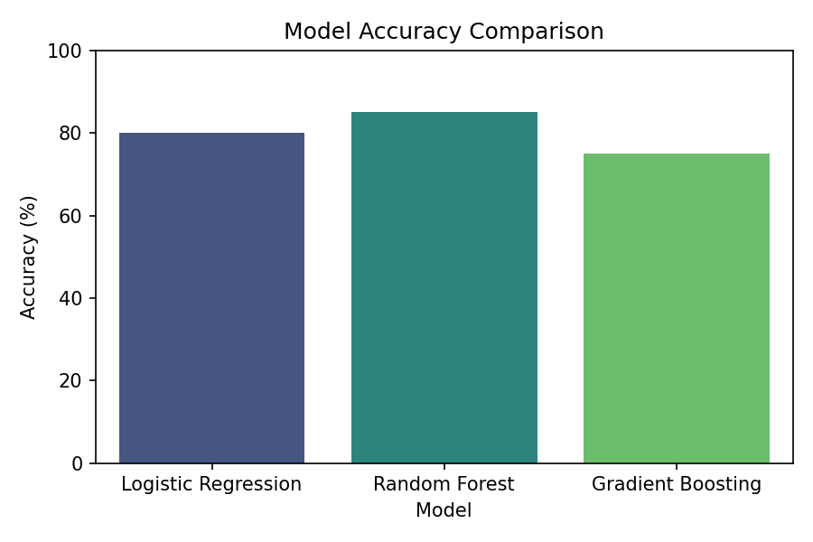
Figure 7.1: Accuracy comparison across the three models on the held-out test set.

7.2 Best Performer
Random Forest is the best performer, with 85.0% accuracy and the highest F1-score (0.80). Logistic Regression and Gradient Boosting trailed mainly on recall — both correctly identified risky orders whenever they predicted risk (high precision), but missed a larger share of the genuinely at-risk orders than Random Forest did.
7.3 Per-Model Notes
- Logistic Regression: perfect precision (1.00) but the lowest recall (0.56) — it is very cautious about labelling an order as risky, so it under-flags true positives.
- Random Forest: perfect precision (1.00) and the best recall of the three (0.67) — the best overall balance, reflected in its top F1-score of 0.80.
- Gradient Boosting: the most balanced precision/recall pair (0.75 / 0.67) but the lowest accuracy of the three, likely due to overfitting on the small training set.
7.4 Random Forest Confusion Matrix
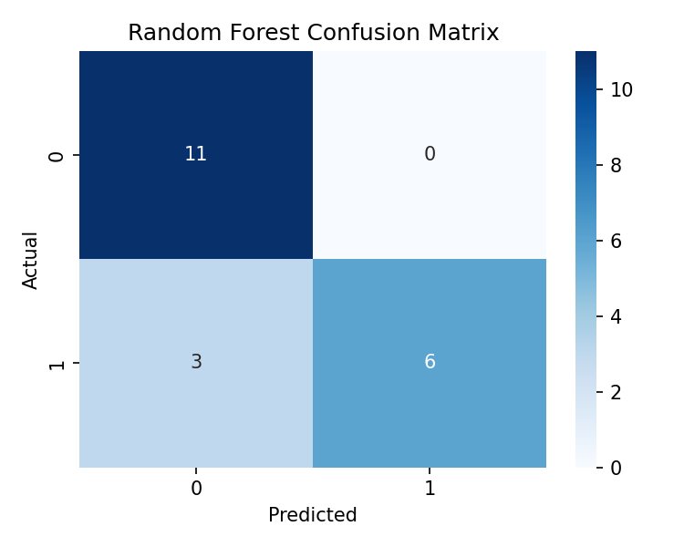
Figure 7.2: Confusion matrix for the Random Forest model on the 20-order test set, showing correctly and incorrectly classified orders for each class.
7.5 Test Cases
# | Scenario | Expected Outcome
1 | Normal delivery conditions | Low / no risk prediction
2 | Long shipping distance | Risk score increases
3 | High warehouse workload | Risk score increases
4 | Multiple previous delays | Higher risk prediction
5 | New valid order submitted | System returns a risk prediction
Each test case was verified manually against the trained Random Forest model.

CHAPTER 8
DISCUSSION ON FINDINGS

8.1 What the Numbers Mean
High precision across all three models means that when a model predicts "high risk", it is almost always correct — false alarms are rare. Lower recall means some genuinely at-risk orders are still being missed, particularly by Logistic Regression and Gradient Boosting.
8.2 Why Recall Lags Precision
With only 100 orders in the prototype dataset, there are too few examples of the delayed class for the models to learn from thoroughly. This precision-recall pattern — confident but conservative predictions — is common with small datasets and is expected to improve once the models are retrained on a larger, production-scale dataset.
8.3 Model Selection
Random Forest is currently the most suitable model for this problem, balancing accuracy (85.0%) with reasonable interpretability through feature importances, and it achieved the best F1-score of the three algorithms compared. Gradient Boosting, despite its sequential error-correction approach, underperformed on this small dataset, likely because it is more prone to overfitting with limited training examples.
8.4 Practical Implication
The centralised comparison of three algorithms on a single, consistently preprocessed pipeline made it straightforward to identify the best-performing model without needing separate evaluation code for each. This structure — one shared preprocessing pipeline feeding multiple classifiers — is also what will make it practical to retrain and re-compare models once a larger dataset becomes available.
8.5 Limitations of the Current Prototype
- Dataset size — 100 orders is enough to demonstrate the pipeline but too small to draw strong statistical conclusions about generalization.
- No temporal validation — the split is a single random stratified split rather than a time-based split, so the model has not been tested on genuinely future orders.
- No hyperparameter tuning — all three models were trained with largely default settings; grid search or cross-validation could improve results further.
8.6 Deployment Considerations
Before this model could be used in a live system, it would need to be retrained on a substantially larger dataset, validated on a held-out time period rather than a random split, and wrapped in an API or batch-scoring job that can be called whenever a new order is created.

CHAPTER 9
CONCLUSION

This project demonstrates that machine learning can effectively predict supply chain delivery risk. Comparing Logistic Regression, Random Forest, and Gradient Boosting helps identify a model that balances accuracy and interpretability for this problem. On the prototype dataset, Random Forest achieved the best overall result at 85.0% accuracy and an F1-score of 0.80, making it the recommended model for this stage of the project. The system can support proactive delivery management across e-commerce, logistics, and warehousing operations by flagging risk before dispatch rather than reacting to it afterward.
9.2 Future Scope
- Real-time data — integrate live traffic, weather, and GPS feeds.
- Larger dataset — retrain on production-scale order history.
- Deployment — serve predictions inside delivery management tools.
- Hyperparameter tuning — use cross-validation and grid/random search to improve each model further.
- Model explainability — add feature-importance or SHAP-based explanations so operations staff can see why an order was flagged.
Taken together, these next steps would move the system from a working prototype to a production-ready decision-support tool that supply chain and logistics teams can rely on for day-to-day operations.

CHAPTER 10
REFERENCES

- Breiman, L. (2001). Random Forests. Machine Learning.
- Friedman, J. H. (2001). Greedy Function Approximation: A Gradient Boosting Machine.
- Géron, A. Hands-On Machine Learning with Scikit-Learn, Keras & TensorFlow.
- Pedregosa et al. (2011). Scikit-learn: Machine Learning in Python.

