What is software? what is software engineering?
Software is instruction that tell a people what to do. Software engineering is discipline concerned about with the application of theory knowledge and practice to reliable software system for user or costomer.

2. Explain types of software?
a. types of software is :

1. Application software: application software is a computer software package that performs a specific function for user.
for example :Microsoft Office, Paint, Powerpoint and etc..

2. system software: system software is designed to run a computer's application programs.
it coordinates activities and functions of hardware and software.
for example os , notepad and etc..

3. driver software: driver software also known as device driver.
Device drivers control the devices and peripherals connected to a computer,enabling them to perform their specific tasks.
Every device that is connected to a computer needs at least one device driver to function.
for example: audio driver, video driver.

4. middleware: The term middleware describes software that mediates between application and system software or between two different kinds of application software.
For example, middleware enables Microsoft Windows to talk to Excel and word.
for example: database middleware,application server middleware.

5. programming software: this software use by programmer to write the code. it include assemblers, compilers, debuggers and interpreters.
for example: : Turbo c,Eclipse,Sublime etc.
3.what is SDLC? explain each phase of SDLC.

The software development lifecycle is the cost effective and time efficient process that development teams to design and build high quality software. The goal SDLC is minimize project risks through forward planning so that software meets costomer’s expectatioins and demands.

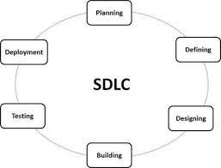
4. What is DFD? Create a DFD diagram on Flipkart.

a.A data flow diagram is a graphical view of how data is processed in a system in terms of input and output.
Data flow diagram (DFD) is a diagram being used frequently in software design.
It visually represents the flow of data throughout processes in a given system.

5. What is Flowchart?Create a flowchart to make addition of two numbers.

a.a diagram that shows the connections between different stages of a process or parts of a system.
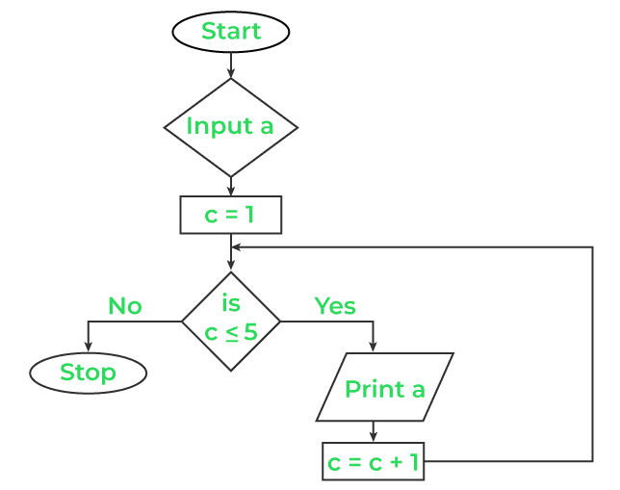

6. What is Use case Diagram? Create a use-case on bill payment on paytm.

a.Use-case diagrams describe the high-level functions and scope of a system.
These diagrams also identify the interactions between the system and its actors.
The use cases and actors in use-case diagrams describe what the system does and how the actors use it, but not how the system operates internally.

