**MODULE: 3.1 (C Language Fundamental)**

**(1) Display This Information using printf**

**1. Your Name**

**2. Your Birth date**

**3. Your Age**

**4. Your Address**

**Code….**

#include<stdio.h>

int main()

{

printf("\nMY INFORMATION :");

printf("\nname : Dipak Chaudhari");

printf("\nBODy : 14/04/2001");

printf("\nage : 22");

printf("\naddress : at-isar,ta-mandvi,di-surat");

}

**Output :**

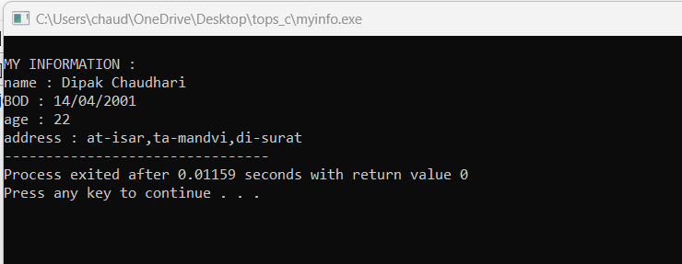

**(2) Write a program to make Simple calculator (to make addition, subtraction, multiplication, division and modulo)**

**Code…**

#include<stdio.h>

int main()

{

int a,b,c;

printf("please enter value of a:");

scanf("%d",&a);

printf("please enter value of b:");

scanf("%d",&b);

c=a+b;

printf("sum of two value :%d",c);

c=a-b;

printf("\nsub of two value :%d",c);

c=a*b;

printf("\nmultiplication of two value:%d",c);

c=a/b;

printf("\ndiv of two value:%f",c);

}

**Output :**

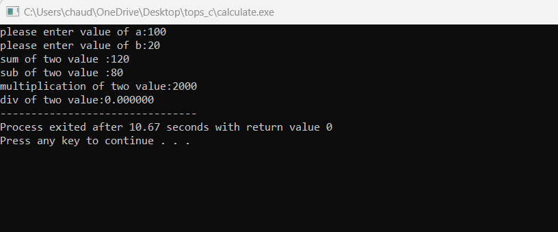

**(3)WAP to find area of circle, rectangle and triangle.**

**Code…**

#include <stdio.h>

void main()

{

int fig_code;

float side, base, length, breadth, height, area, radius;

printf("-------------------------\n");

printf(" 1 --> Circle\n");

printf(" 2 --> Rectangle\n");

printf(" 3 --> Triangle\n");

printf("-------------------------\n");

printf("Enter the Figure code\n");

scanf("%d", & fig_code);

switch (fig_code) {

case 1:

printf("Enter the radius\n");

scanf("%f", & radius);

area = 3.142 * radius * radius;

printf("Area of a circle=%f\n", area); /* find the area of circle */

break;

case 2:

printf("Enter the breadth and length\n");

scanf("%f %f", & breadth, & length);

area = breadth * length;

printf("Area of a Rectangle=%f\n", area); /* find area of the rectangle */

break;

case 3:

printf("Enter the base and height\n");

scanf("%f %f", & base, & height);

area = 0.5 * base * height;

printf("Area of a Triangle=%f\n", area); /* find the area of the triangle */

break;

default:

printf("please select given nomber\n");

break;

}

}

**Output :**

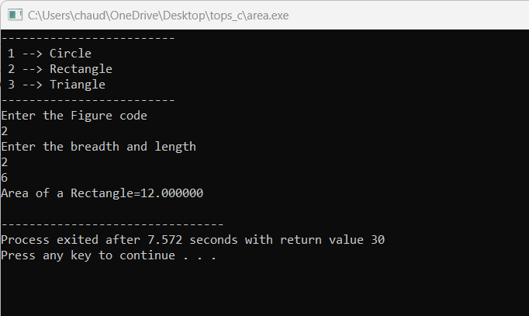

**(4)WAP to find simple interest.**

**Code…**

# include <conio.h>

# include <stdio.h>

# include <stdlib.h>

int main(){

//Simple interset program

int principal, rate, time, interest;

printf("Enter the principal: ");

scanf("%d", &principal);

printf("Enter the rate: ");

scanf("%d", &rate);

printf("Enter the time: ");

scanf("%d", &time);

interest = principal * rate * time / 100;

printf("The Simple interest is %d", interest);

return 0;

}

**Output :**

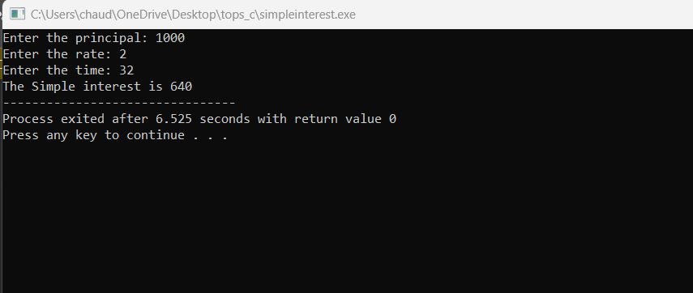

**(5)WAP to check if the given year is a leap year or not.**

**Code…**

#include <stdio.h>

int main()

{

int year;

printf("Enter a year: ");

scanf("%d", &year);

// leap year if perfectly divisible by 400

if (year % 400 == 0) {

printf("%d is a leap year.", year);

}

// not a leap year if divisible by 100

// but not divisible by 400

else if (year % 100 == 0) {

printf("%d is not a leap year.", year);

}

// leap year if not divisible by 100

// but divisible by 4

else if (year % 4 == 0) {

printf("%d is a leap year.", year);

}

// all other years are not leap years

else {

printf("%d is not a leap year.", year);

}

return 0;

}

**Output :**

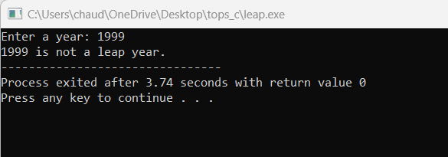

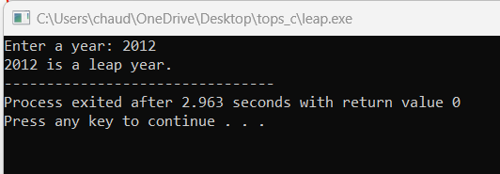

**(6)WAP to convert years into days and days into years.**

**Code…**

#include <stdio.h>

int main()

{

int days, years, weeks;

//user to input number of days

printf("Enter days: ");

scanf("%d", &days);

// Ignoring leap year

years = (days / 365);

weeks = (days % 365) / 7;

days = (days % 365) %7;

//Print the result

printf("YEARS: %d\n", years);

printf("WEEKS: %d\n", weeks);

printf("DAYS: %d", days);

return 0;

}

**Output :**

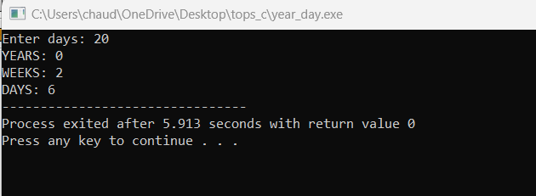

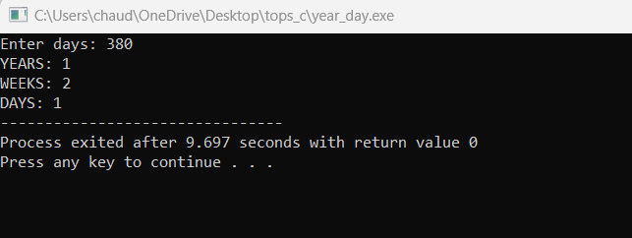

**MODULE: 3.2**

**(C Language Programing with C)**

• **WAP to make simple calculator (operation include Addition, Subtraction, Multiplication, Division, modulo)**

**Code :**

#include<stdio.h>

int main()

{

int a,b,c;

printf("please enter value of a:");

scanf("%d",&a);

printf("please enter value of b:");

scanf("%d",&b);

c=a+b;

printf("sum of two value :%d",c);

c=a-b;

printf("\nsub of two value :%d",c);

c=a*b;

printf("\nmultiplication of two value:%d",c);

c=a/b;

printf("\ndiv of two value:%f",c);

}

**Output :**



**• WAP to swap two numbers without using third variable .**

**Code :**

#include<stdio.h>

int main()

{

int a,b;

printf("please enter value of a :");

scanf("%d",&a);

printf("please enter value of b :");

scanf("%d",&b);

a=a+b;

b=a-b;

a=a-b;

printf("swapping the value.....\n");

printf("value of a %d \n",a);

printf("value of b %d",b);

}

**Output :**

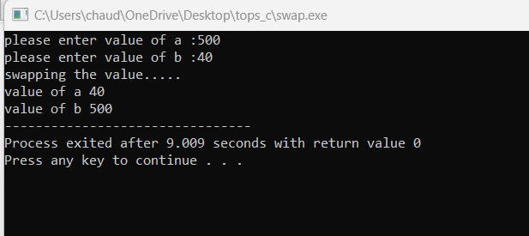

**• WAP to find number is even or odd using ternary operator.**

**Code :**

#include<stdio.h >

int main()

{

int n;

printf("Enter an integer number\n");

scanf("%d", &n);

(n % 2 == 0) ?

(printf("%d is Even number\n", n)) :

(printf("%d is Odd number\n", n));

return 0;

}

**Output :**

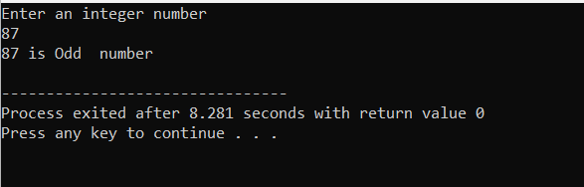

• **WAP to show**

1. **to Sunday Monday using switch case**

#include<stdio.h>

int main()

{

int wk;

/* Input week number from user */

printf("Enter week number(1-7): ");

scanf("%d", &wk);

switch(wk)

{

case 1:

printf("Monday");

break;

case 2:

printf("Tuesday");

break;

case 3:

printf("Wednesday");

break;

case 4:

printf("Thursday");

break;

case 5:

printf("Friday");

break;

case 6:

printf("Saturday");

break;

case 7:

printf("Sunday");

break;

default:

printf("Invalid input! Please enter week number between 1-7.");

}

}

**Output** :

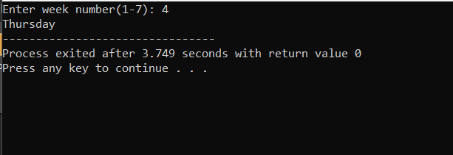

**2. Vowel or Consonant using switch case**

#include <stdio.h>

int main()

{

char vc;

/* Input an alphabet from user */

printf("Please enter any alphabet: ");

scanf("%c", &vc);

/* Switch value of vc */

switch(vc)

{

case 'a':

printf("Vowel");

break;

case 'e':

printf("Vowel");

break;

case 'i':

printf("Vowel");

break;

case 'o':

printf("Vowel");

break;

case 'u':

printf("Vowel");

break;

case 'A':

printf("Vowel");

break;

case 'E':

printf("Vowel");

break;

case 'I':

printf("Vowel");

break;

case 'O':

printf("Vowel");

break;

case 'U':

printf("Vowel");

break;

default:

printf("Consonant");

}

return 0;

}

**Output :**

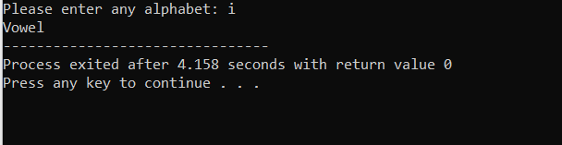

**• Looping programs:**

1. **WAP to print 972 to 897 using for loop**

#include <stdio.h>

int main() {

int i;

for (i = 972; i >= 897; i--) {

printf("%d ", i);

}

return 0;

}

**Output :**

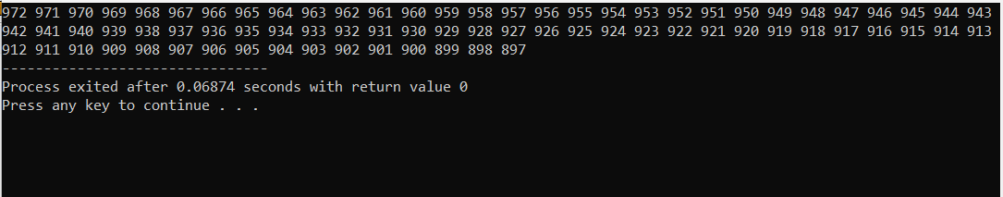

1. **WAP to take 10 no. Input from user and find out …**
2. **How many Even numbers are there**
3. **How many odd numbers are there**
4. **Sum of even numbers**
5. **Sum of odd numbers WAP to print table up to given numbers**

#include <stdio.h>

int main() {

int numbers[10];

int countEven = 0, countOdd = 0, sumEven = 0, sumOdd = 0;

// Input 10 numbers from the user

printf("Enter 10 numbers:\n");

for (int i = 0; i < 10; i++) {

scanf("%d", &numbers[i]);

}

// Calculate count and sum of even and odd numbers

for (int i = 0; i < 10; i++) {

if (numbers[i] % 2 == 0) {

countEven++;

sumEven += numbers[i];

} else {

countOdd++;

sumOdd += numbers[i];

}

}

// Output results

printf("Number of even numbers: %d\n", countEven);

printf("Number of odd numbers: %d\n", countOdd);

printf("Sum of even numbers: %d\n", sumEven);

printf("Sum of odd numbers: %d\n", sumOdd);

// Printing the table of numbers

int num;

printf("Enter a number to print its table: ");

scanf("%d", &num);

printf("Table of %d:\n", num);

for (int i = 1; i <= 10; i++) {

printf("%d x %d = %d\n", num, i, num * i);

}

return 0;

}

**Output :**

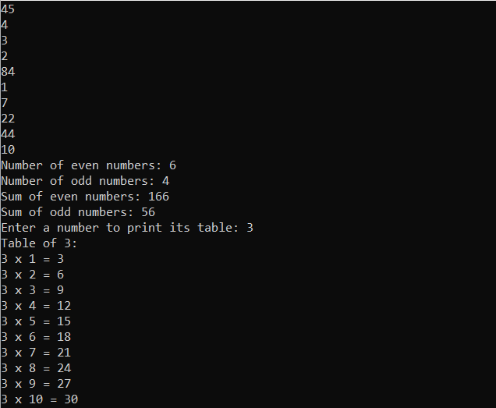

**• WAP to print factorial of given number.**

#include <stdio.h>

void main(){

int i,f=1,num;

printf("Input the number : ");

scanf("%d",&num);

for(i=1;i<=num;i++)

f=f*i;

printf("The Factorial of %d is: %d\n",num,f);

}

**Output** :

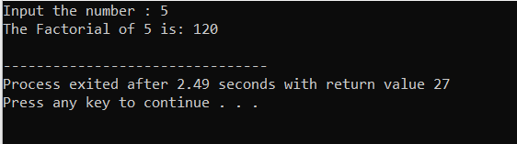

**• WAP to print Fibonacci series up to given numbers**

#include <stdio.h>

int main() {

int i, n;

// first and second terms

int t1 = 0, t2 = 1;

// next term (3rd term)

int Term = t1 + t2;

// get no. of terms from user

printf("Enter the number of terms: ");

scanf("%d", &n);

// print the first two terms t1 and t2

printf("Fibonacci Series: %d, %d, ", t1, t2);

// print 3rd to nth terms

for (i = 3; i <= n; ++i) {

printf("%d, ", Term);

t1 = t2;

t2 = Term;

Term = t1 + t2;

}

return 0;

}

**Output** :

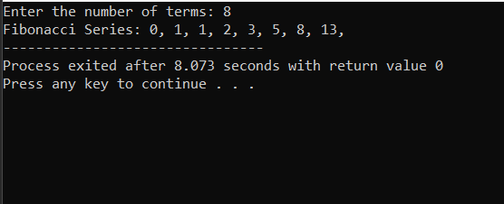

**• WAP to print number in reverse order e.g.: number = 64728 ---> reverse = 82746**

#include <stdio.h>

int main() {

int number, reverse = 0, remainder;

printf("Enter a number: ");

scanf("%d", &number);

while (number != 0) {

remainder = number % 10;

reverse = reverse * 10 + remainder;

number /= 10;

}

printf("Reverse of the number: %d\n", reverse);

return 0;

}

**Output** :

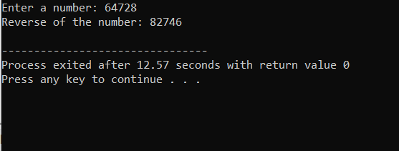

**• Write a program to find out the max from given number (E.g., No: -1562 Max number is 6)**

#include <stdio.h>

int main() {

double a, b, c;

printf("Enter three numbers: ");

scanf("%lf %lf %lf", &a, &b, &c);

if (a >= b && a >= c)

printf("%.2lf is the largest number.", a);

else if (b >= a && b >= c)

printf("%.2lf is the largest number.", b);

else

printf("%.2lf is the largest number.", c);

return 0;

}

**Output**:

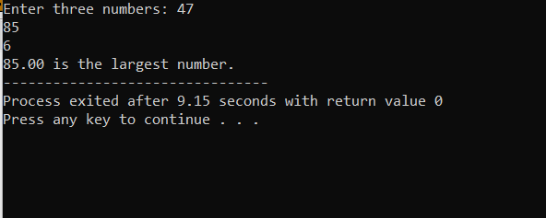

**• Write a program make a summation of given number (E.g., 1523 Ans: -11)**

#include <stdio.h>

int main() {

int number, sum = 0, digit;

printf("Enter a number: ");

scanf("%d", &number);

// Calculate the sum of digits

while (number != 0) {

digit = number % 10; // Get the last digit

sum += digit; // Add the digit to the sum

number /= 10; // Remove the last digit

}

printf("Sum of digits: %d\n", sum);

return 0;

}

**Output** :

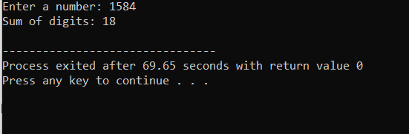

**• Write a program you have to make a summation of first and last Digit. (E.g., 1234 Ans: -5)**

#include <stdio.h>

int main() {

int number, fDigit, lDigit, sum;

printf("Enter a number: ");

scanf("%d", &number);

fDigit = number;

while (fDigit >= 10) {

fDigit /= 10;

}

// Extract last digit

lDigit = number % 10;

// Calculate the sum of first and last digits

sum = fDigit + lDigit;

printf("Sum of first and last digits: %d\n", sum);

return 0;

}

**Output** :

