|  |
| --- |
| College LaSalle |
| Project -SPORTS Technical Manual |
|  |
| Presented to: Mihai Maftei |

|  |
| --- |
| Kavita Kavita  12/9/2022 |

**Start by adding a short description of your project, and the languages (technologies) used**

Languages:

1. HTML
2. CSS
3. JQuery

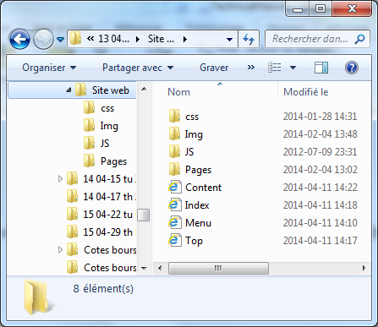**Presenting how the files/folders are organised.**

About.html

Contact.htm

Content.htmll

Gallery.html

Index_login.html

Index.html

1. Css
   1. Style.css
   2. Fontawesome.css
2. Images
3. JS
   1. App.js
   2. jQuery

**Present the functions and/or methods that you create or you did use into the web project.**

|  |  |
| --- | --- |
| **Function/Method** | **Description** |
| 1. document.getElementById() | Get the data using id |
| 1. alert() | Create an alert |
|  |  |
|  |  |

**Present the difficulties that you have, what was the hardest and the easiest part of your project.**

I tried to code the login button but that was not working for me.

Still it needs to be fixed.