Infosys
NCM APPLICATION FLOW DOCUMENTATION

INFOSYS LIMITED, HYDERABAD

COPYRIGHT NOTICE

This Quality System Documentation is the property of Infosys Limited. All ideas and information contained within these documents are the intellectual property rights of Infosys Technologies Limited. These documents are not for general distribution and are meant for use only for the person they are specifically issued to. These documents shall not be loaned to anyone, within or outside Infosys, including its customers. Copying or unauthorized distribution of these documents, in any form or means including electronic, mechanical, photocopying or otherwise is illegal.

Infosys Limited
Electronic City,
Hosur Road,
Bangalore 560 100
India.
Telephone: 91 80 2852 0261
Fax: 91 80 2852 0362
Website: http://www.infosys.com

Table of Contents

1. DOCUMENT Overview 2
1.1 DOCUMENT PURPOSE 2
1.2 DOCUMENT CONTENT 2
2. FUNCTIONAL FLOW 2
2.1 LOGIN SCREEN: 2
2.2 HOME SCREEN: 2
2.3 NCM EXPEDITER SCREEN: 3
2.4 NCM EXPEDITER SUBMISSION SCREEN: 3
3. LOGICAL ARCHITECTURE 4
4. TECHNICAL ARCHITECTURE 5
5. TECHNICAL FLOW 5

DOCUMENT Overview

DOCUMENT PURPOSE
The purpose of this document is to come up with functional flow of NCM Expediter iOS application. It provides an insight on the flow of the application.

DOCUMENT CONTENT
The below document contains the detailed design of the POC.
- Functional flow: Describes in detail the flow of the application.
- Logical Architecture: Describes the logical flow of the application.
- Technical Architecture: Describes the technical flow of the application.

FUNCTIONAL FLOW

LOGIN SCREEN:
When the user launches the application, user needs to swipe/scan his/her employee card to login into the application. On successful validation, the user is directly taken to the landing page of the application, which is the home screen of the application. If authentication is unsuccessful then user has to perform the swipe/scan again. The swipe/scan is enabled to the application by the use of Linea Pro Peripheral device.

HOME SCREEN:
The Home screen comprises of three segments Dashboard, Applications and Reports. Dashboard is highlighted on the launch of the home screen. It consists of expandable list of items as: Assembly, Fabrication, Paint and Safety.

Assembly shows the following list of sub items: "Production", "Downtime", "Quality" and “Post Assembly”.
Fabrication displays the following sub items: "Frame", "Gas Tank", and “Fender".
Paint displays the following sub items: "Runtime", "Schedule", "Downtime", and “Quality".
Safety displays the following sub items: "Injury".

When user goes to the Applications segment he can again see the following list of items: "Schedule", "Vehicle Status", "Non Conformance”, “Downtime Tracking", "NCM Expediter" and “Post Assembly". In which all the items are non-clickable except NCM Expediter. After clicking on NCM Expediter, the application navigates to NCM Expediter screen.

When the user goes to the Reports segment he can see expandable list of items as: Event Tracking, Production Matrix and Quality.

The Event Tracking item shows the following list of sub items "Top Events", "Event Co-Relation", "Quality". In a similar way, Production Matrix displays the following sub items: "OEE", "Production Trend". Quality displays the following sub items: "Defect Tracking", "FPY/CPH.

NCM EXPEDITER SCREEN:
This screen shows header with "NCM Expediter" along with home button on right corner of the page and is divided into two segments NCM Expediter & NCM Reorder.

NCM Expediter is initially selected which has "Storage Location" as a drop down list of storage locations and description, along with Material ID text filed, Go button, Bin Number (drop down), Quantity (drop down), Reason (drop down), Scan Toggle button, Reset button, Proceed button. The Bin Number, Quantity, Reason, Reset button, Proceed button are disabled.

Select the Storage Location from the drop down and scan the Material ID with the Linea bar code scanner. Material ID will be populated on the text filed, and auto submits the Material id. Material master (SAP) validates the Material ID and displays the Material Description. Using the Toggle button, user can scan a SEC Barcode into the comments field.

If the Material ID is not valid it displays the message as ‘Material ID not found’ message. On success of the Material ID validation "Bin Number", "Quantity", "Reason" & Comment text field, along with Reset and Proceed button all are enabled and populated accordingly.

After the corresponding, “Bin Number”, “Quantity”, and “Reason” are selected, users can fill in the comments and click on ‘Proceed’ button. On click of Proceed button it traverses to NCM Expediter submission page.

NCM Expediter Submission Screen:
This screen contains a drop down list of printers along with Cancel and save button, with save button disabled. When user selects any particular printer the Save button gets enabled.

And on click of the Save button Inventory Movement is performed.

Bike History Screen:
This screen contains VIN text field, Go button and header with home button.
Scan the VIN number with the Linea bar code scanner. VIN number will be populated on the text field, and auto submits the VIN number. (SAP) validates the VIN and displays the SEC number, Bike Model, Schedule date, Dom for history, Assessment date, tested date, created date, crane date and View Conditions/repair button.

2.6 View Conditions/Repair Screen

This Screen Shows the associated Bike Conditions and Repair details for a particular VIN number entered by the user.

LOGICAL ARCHITECTURE
The below diagram depicts the logical architecture of the current application.

User login by swiping the Harley Id card in the Linea peripheral attached iPod/iPhone device

NCM expediter application is opened where user selects respective Storage Location and scans the bar code using the device.

XMII web service for transaction

SAP Server
Contains the Bin Number, Description of the Material. This is returned on the basis of Material ID.
The Material Id is submitted automatically.

On Success, Bin Number gets populated. User selects the Quantity and Reason. In comments field user can type in comment. The user can also scan a SEC barcode into comments by keeping the toggle on SEC.

Success message is displayed

Proceed Button
On success drop down list of printers appears with list of printers.
Inventory Movement

Selection of particular printer and click on save button perform the Inventory Movement.

The below diagram depicts the logical architecture of the Bike History Screen.

XMII web service for transaction

SAP Server
Contains SEC number, Bike Model, Schedule date, Dom for history, Assessment date, tested date, created date, crane date. This is returned on the basis of VIN number.

User Scan/Enter VIN number and is submitted automatically.

On Success, SEC number, Bike Model, Schedule date, Dom for history, Assessment date, tested date, created date, crane date will be displayed.

SAP Server

Contains Bike conditions/Repair details.
XMII web service for transaction

On click of View Conditions/Repair button.

On Success, Bike Conditions details will be displayed.

TECHNICAL ARCHITECTURE
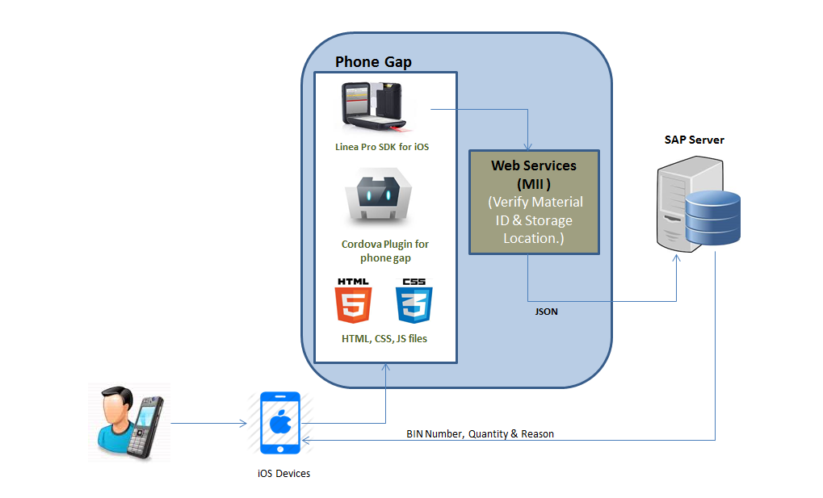

The external peripheral device provided by Infinite Peripherals is attached to the iPod device. Linea SDK is the API, which performs the communication with the external peripheral device. Phonegap is the cross platform library. It is a framework, which connects with native iOS functionality and performs the scanning. The Web services perform fetching the respective result for particular Material ID & Storage Location. The response obtained is Material Description & Bin number. The user can then select the Bin number, Quantity & Reason. In comments text field, user can scan the SEC barcode by keeping the toggle to SEC and can also enter comments manually. When user clicks on ‘Proceed’ button, NCM submission page is shown with a Printer drop down menu. The menu displays list of printers. On selecting a printer the save button is enabled. On click on save button Inventory Movement is performed and the control navigates back to NCM home page.

TECHNICAL FLOW

LOGIN SCREEN:
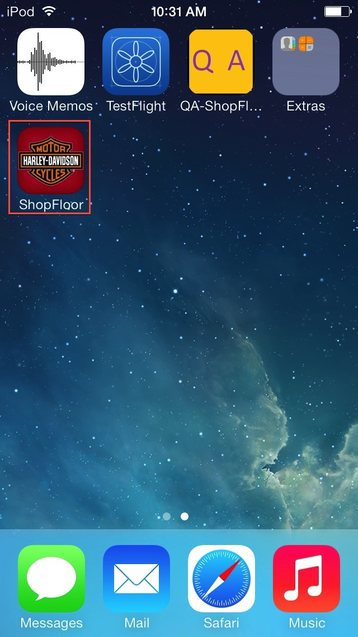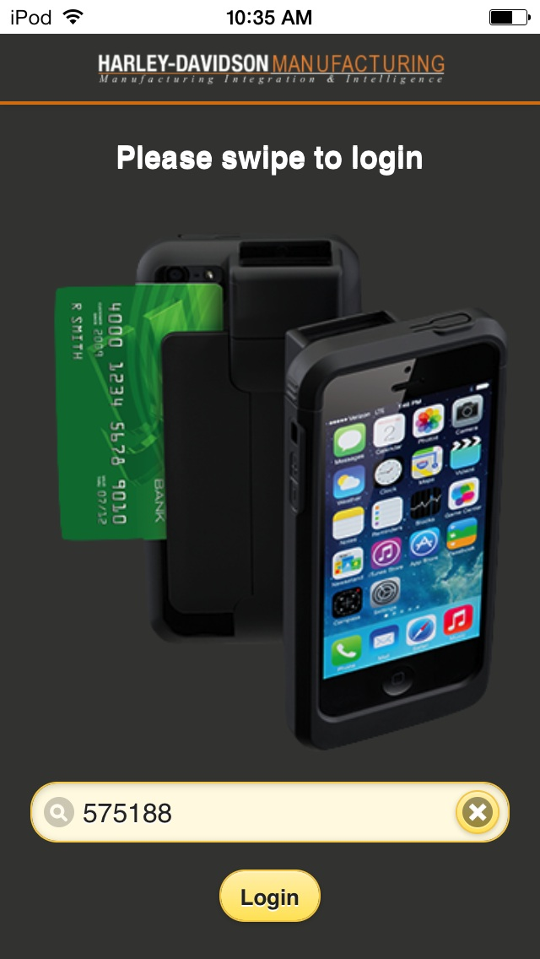
- 2

When user clicks on the Shop Floor icon as shown in Screen 1, he/she is directed to login screen as shown in Screen 2. Here user can perform login in three ways:
- By swiping the HD-ID cards. The card number is authenticated with the static database of limited HD users. The following step is performed before validation:
  - If ‘*’ is present in the start and end of the scanned employee id it is truncated and the last 2 letters are removed.
- By scanning the barcode on the HD-ID card. It is also authenticated with the static database of limited HD users. The following step is performed before validation:
  - First and last 3 letters are removed.
- By manually entering the valid card number which is present in the static database. The login button validates with the static database.

If login is not successful an alert message pops up mentioning “Card not authenticated” and user remains on same page.

HOME SCREEN:
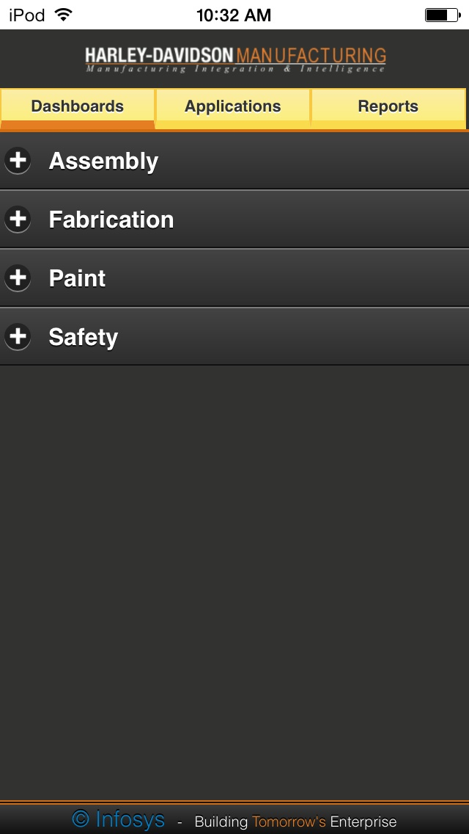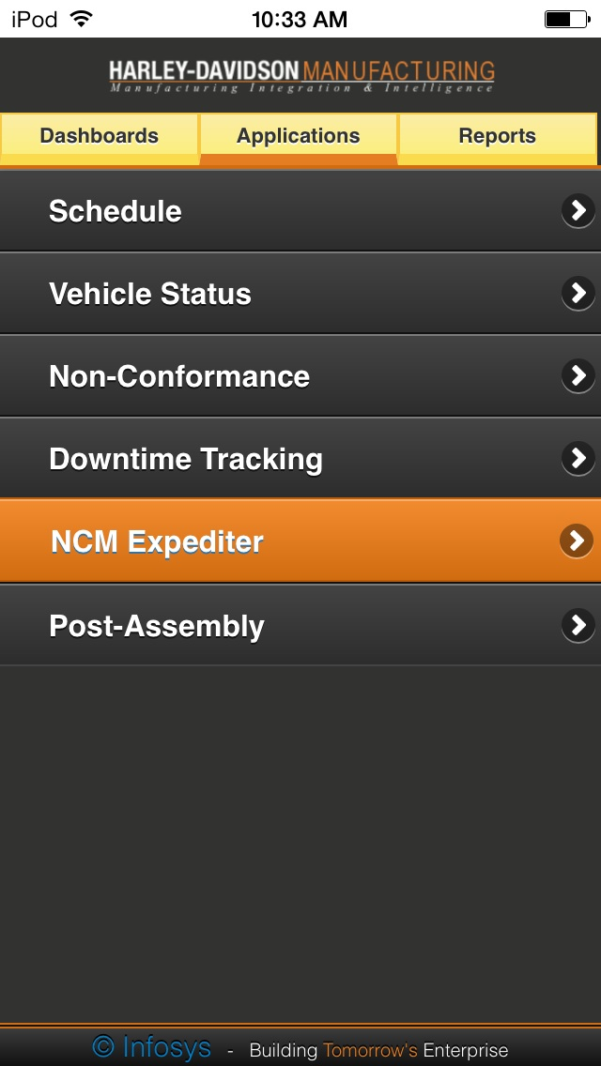
3 4
On successful login, home Screen (Screen 3) appears which comprises of three segments Dashboards, Applications and Reports along with the Harley Davison Logo. When user goes to Applications (Screen 4) segment he/she can click on NCM Expediter to get into the NCM Expediter Screen.

NCM EXPEDITER SCREEN:
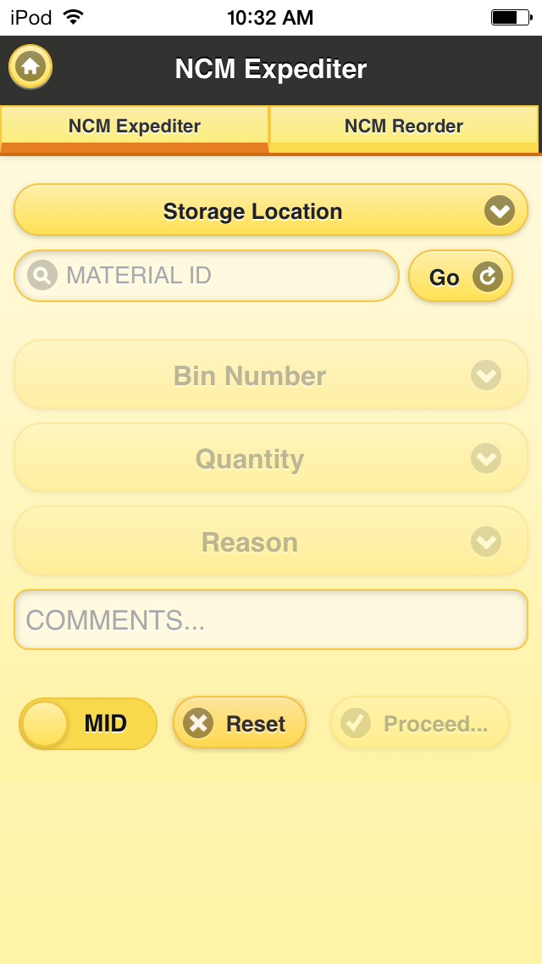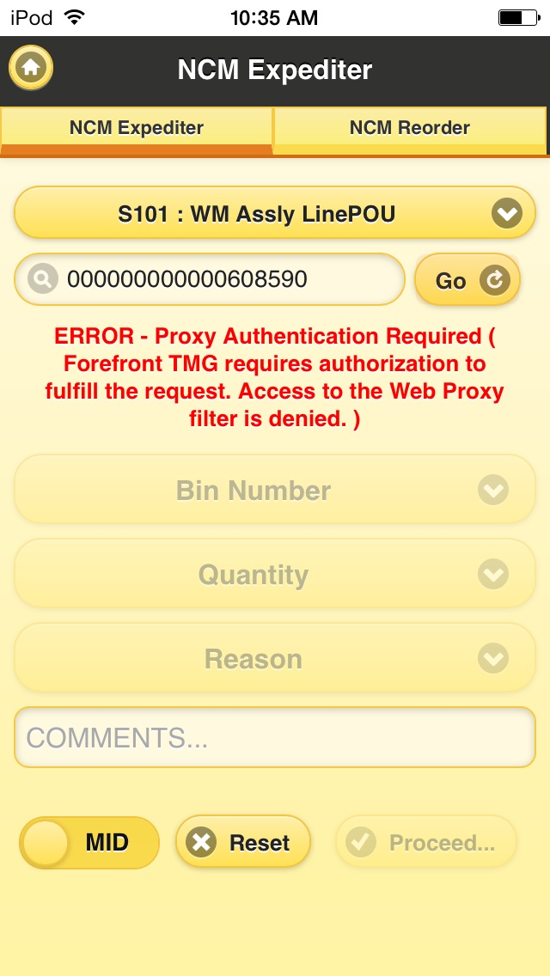
5 6

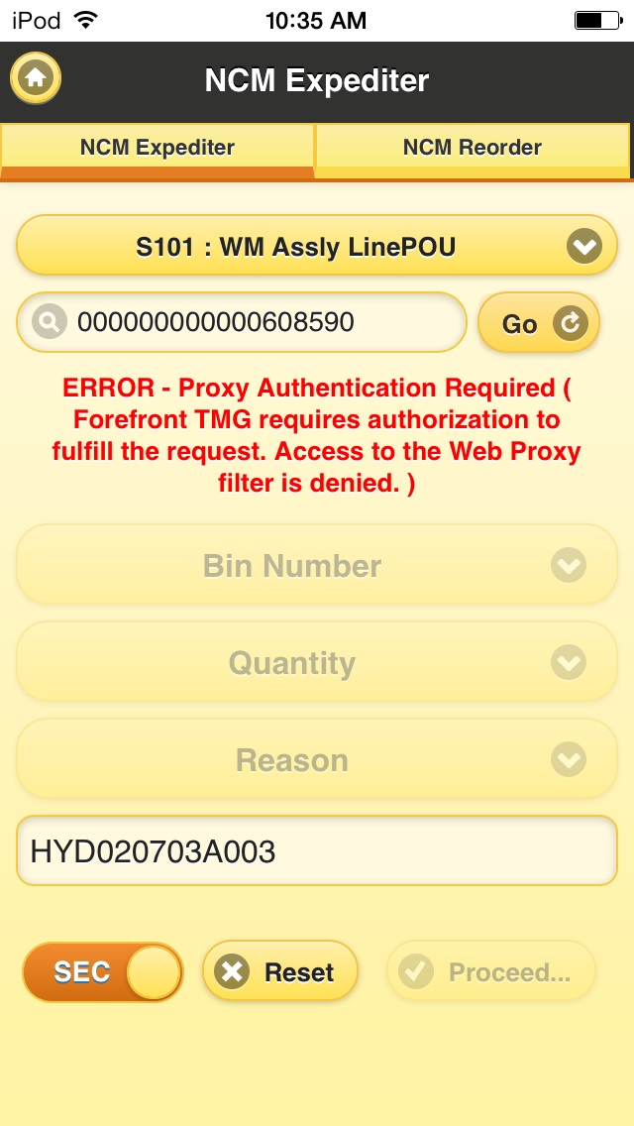
7
On click of NCM Expediter, NCM expediter page appears. It is divided into two sections “NCM Expediter” & “NCM Reorder”. NCM Expediter section is the one shown in Screen 5. It consists of drop down menu listing storage locations, an input field to enter/display the scanned Material ID. Bin Number, Quantity & Reason are also drop down menus which are activated on successful resolution of Material ID. User can enter manually in Comments input filed as well as scan the SEC barcode by setting the toggle button to SEC. Now when user scan the Material ID (Toggle is set to MID by default). Following step is performed before validation:
- If * is present in the first and last position of the text, it is trimmed.
- In the trimmed text a check is made on the first letter. If it is a P/p, it is removed.
- A check is also made to see if the material id is Alpha – numeric. If not, zeros are appended in the beginning to make the total length of the scanned material id as 18.

When user clicks on go button (Screen 2), following steps are performed:
- Get the Material Description with ajax call:
  - Url: ‘http://hdapsapmi01.hdmc.harley-davidson.com:57500/XMII/Runner’
  - Parameters as:
    - Type: Post
    - Transaction: ‘HdmcNCMScrap/GetMaterialList’
    - Material: Material value entered in the text field by user
    - StorageLocation: Storage location as selected by user
    - Output Parameter: MaterialDescription
    - J_user: ’$mii_env’
    - J_password: ’miitstusr2’

- Get the Bin Number:
A. For warehouse storage location:
  - Url: ‘http://hdapsapmi01.hdmc.harley-davidson.com:57500/XMII/Runner’
  - Parameters as:
    - Type: Post
    - Transaction: ‘HdmcNCMScrap/GetMaterialBins’
    - MaterialNumber: Material value entered in the text field by user
    - Plant: ‘1001’
    - StorageLocation: Storage location as selected by user
    - StorageType: ‘100’
    - Output Parameter: ‘OutputXML’
    - J_user: ’$mii_env’
    - J_password: ’miitstusr2’
B. For non-warehouse storage location:
No Ajax call is made for non-warehouse storage locations as bin number & storage Type is not required for Inventory movement. By default bin number and storage type are sent as null to the SAP system to complete the inventory movement.

After the successful execution of web services, the respective material description is displayed. And at the same time bin number, quantity and reason are enabled. In case of non-warehouse storage location “Bin Not Applicable” is displayed in Bin number drop down, while for warehouse storage location web service response, Bin Number is displayed. In comments field user can enter comments manually and even can scan SEC barcode by keeping the toggle button to SEC (refer: Screen 7). Click on the Proceed button.

NCM Expediter Submission Screen:

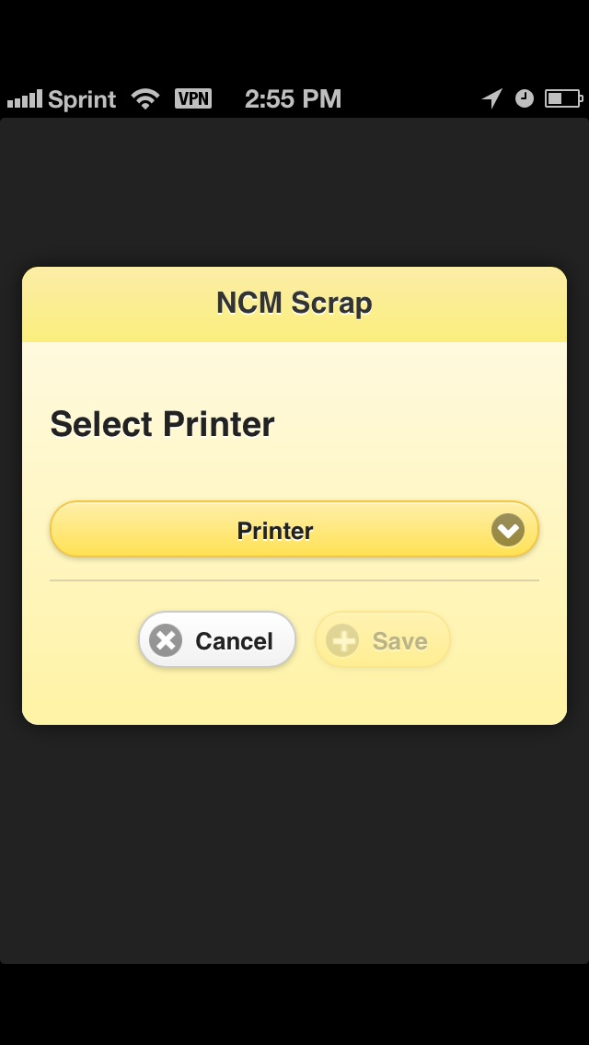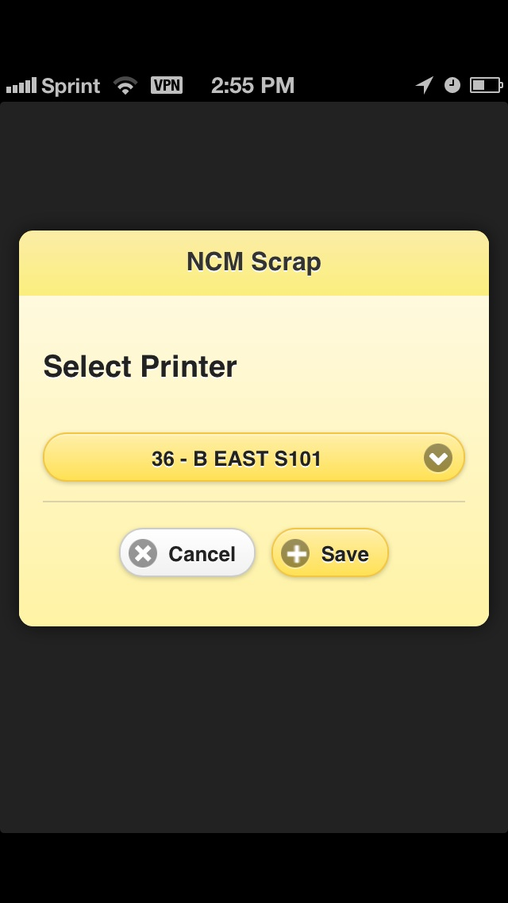
8 9

On click of Proceed button, user is navigated to the page with a Printer drop down menu (as shown in screen 8), which displays the list of printers. Here user selects the respective Printer and the Save button gets enabled (as shown in Screen 9).

And on click of the Save button Inventory Movement is performed. All the Printers present in the drop down list are mapped to respective workstation id. In the Inventory Movement web service call, the parameter for WorkStation the relative workstation id mapped to the printer is sent to the server.

- Inventory Movement for non ware house location:
  - url: ‘http://hdapsapmi01.hdmc.harley-davidson.com:57500/XMII/Runner’
  - Parameter as:
    - Type: ‘post’
    - Transaction: ‘HdmcNCMScrap/CreateGoodMovement’
    - Plant: ‘1001’
    - Material: Material value entered in the text field by user
    - Quantity: As selected by the user
    - Reason: As selected by the user
    - PostingDate: Current date in format (YYYYMMDD)
    - StorageLocation: As selected by the user
    - WorkStation: Workstation id mapped to the printer selected by the user
    - Comments: Text mentioned SEC # scanned by user in the comments text field
    - StorageType: ‘NULL’
    - StorageBin: ‘NULL’
    - OutputParameter: ‘Output’
    - J_user: ‘$mii_env’’
    - J_password: ‘miitstusr2’

- Inventory Movement for ware house location:
  - url: ‘http://hdapsapmi01.hdmc.harley-davidson.com:57500/XMII/Runner’
  - Parameter as:
    - Type: ‘post’
    - Transaction: ‘HdmcNCMScrap/CreateGoodMovement’
    - Plant: ‘1001’
    - Material: Material value entered in the text field by user
    - Quantity: As selected by the user
    - Reason: As selected by the user
    - PostingDate: Current date in format (YYYYMMDD)
    - StorageLocation: As selected by the user
    - WorkStation: Depend on the printer selected by the user
    - Comments: Text mention in the comments text field
    - StorageType: ‘100’
    - StorageBin: Bin number
    - OutputParameter: ‘Output’
    - J_user: ‘$mii_env’’
    - J_password: ‘miitstusr2’

After the successful inventory movement, user is displayed with a message saying successful transfer is made. Even if the movement fails alert with error message pops up. On click of ok button on the alert in either scenario user is taken back to the NCM Expediter screen.

Bike History Screen:
When user goes to the Applications segment he can see the following list of items: "Schedule", "Bike History", “Downtime Tracking", "NCM Expediter" and “Post Assembly". By clicking on Bike History, the application navigates to Bike History screen as shown in screen 10.

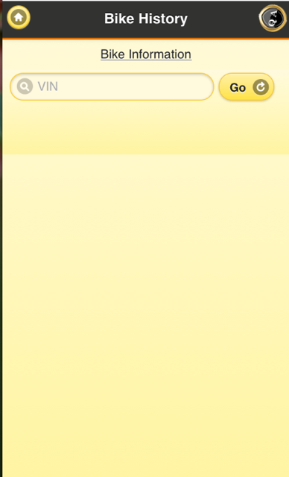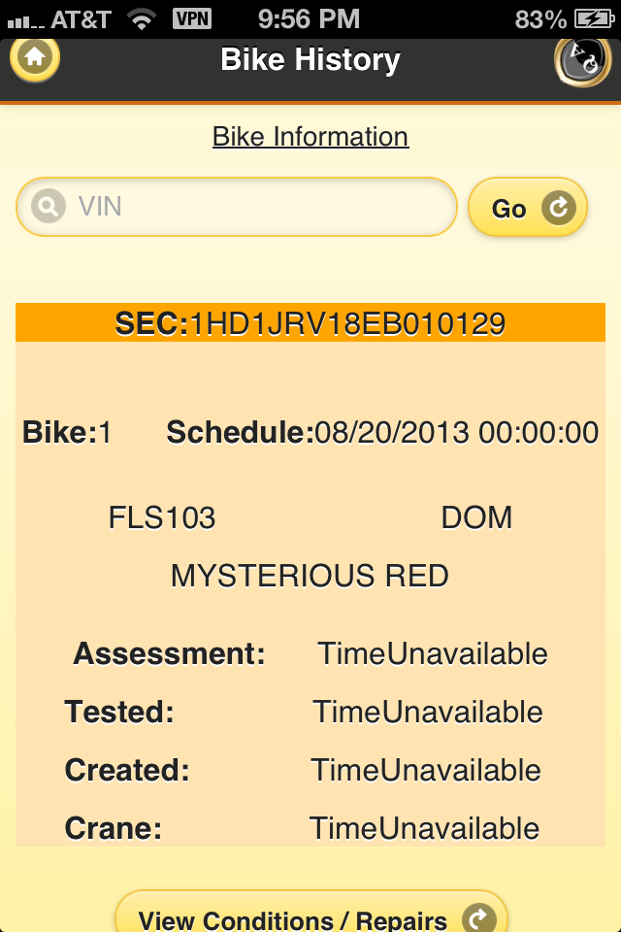
10 11

User can scan /enter the Vin number into the text field. When user clicks on go button it displays the SEC number, Bike Model, Schedule date, Dom for history, Assessment date, tested date, created date, crane date and View Conditions/repair button as shown in Screen 11.
- Get the Vehicle Details with ajax call:
  - Url: ‘http://hdaqmdm02.hdmc.harley-davidson.com:56500/XMII/Illuminator’
  - Parameters as:
i.Type: Post
ii. Query Template:'HarleyDavidson/meQueries/vehicleDetails'
iii. Content-Type: 'text/xml',
iv. Param.1: VIN entered in text field by user,
V. j_user: '$mii_env',
VI. j_password: 'miitstusr2’

When user clicks on View Conditions\Repair, on success of ajax call associated Bike Conditions and Repair details will be displayed for a particular VIN number entered by the user.
.

- Get the conditionsAndRepairsByVin with ajax call:
  - Url: ‘http://hdaqmdm02.hdmc.harley-davidson.com:56500/XMII/Illuminator’
  - Parameters as:
i.Type: Post
ii. Query Template:'HarleyDavidson/meQueries/ conditionsAndRepairsByVin'
iii. Content-Type: 'text/xml',
iv. Param.1: VIN entered in text field by user,
V. j_user: '$mii_env',
VI. j_password: 'miitstusr2’

