Instruction to run

1. Create a lambda Function “myPassportSeva” in AWS Account

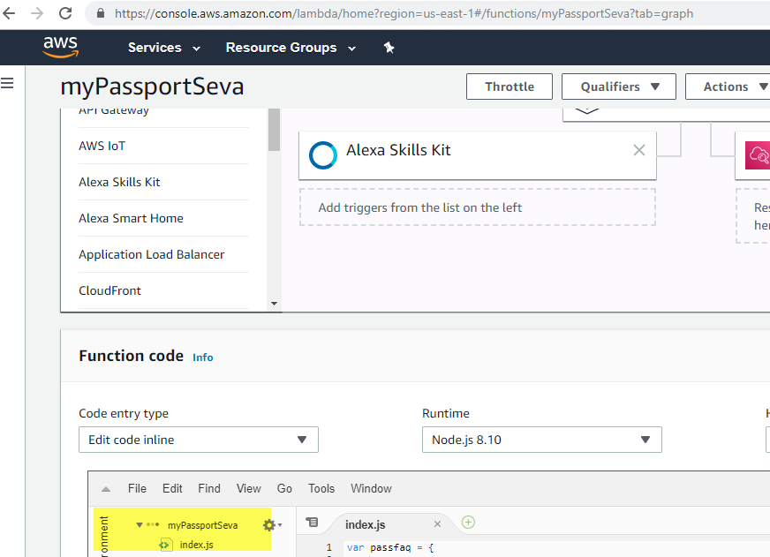

1. Copy code in index.js – Copy code from below link

<https://github.com/kavitazinage/PassportSeva/blob/master/index.js>

1. Copy ARN in Alexa Custom Skill’s endpoint 🡪 AWS Lambda ARN

Please refer below screenshots for the same

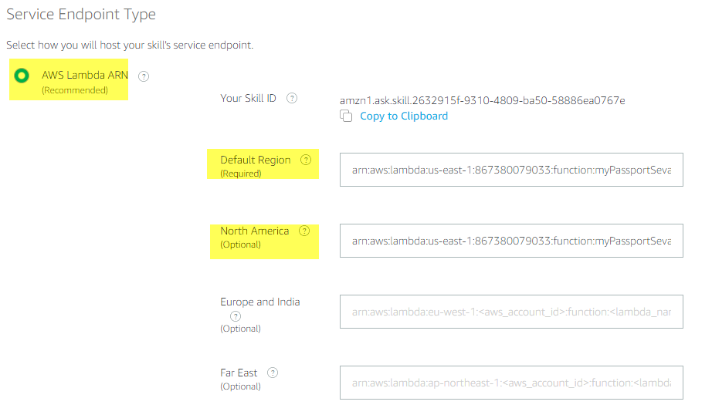

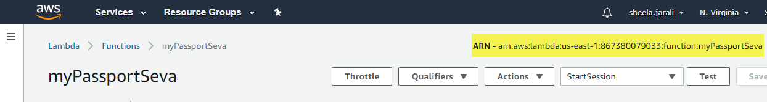

1. Through Alexa developer by clicking create a custom skill with name “Passport Seva”

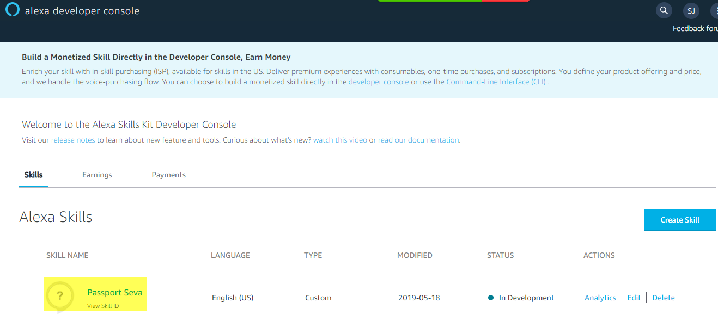

1. Create an intent as per below screenshot with sample utterances

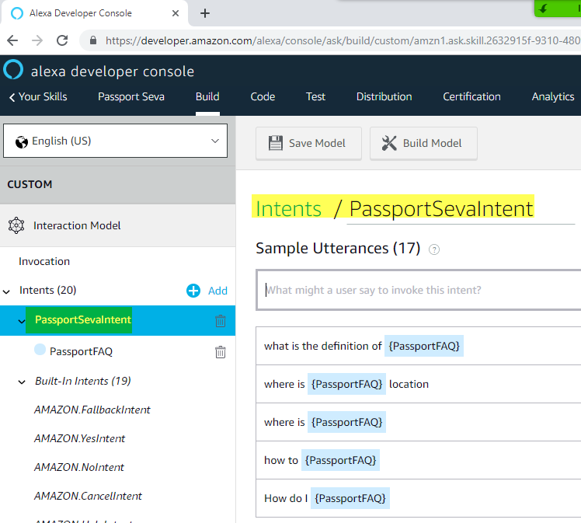

1. Create Slot Type with list of values as shown in screenshot

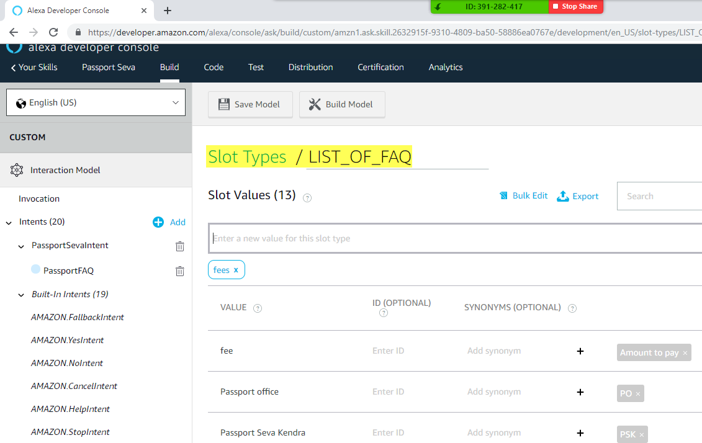

1. Build the Model and Test the Custom Skill

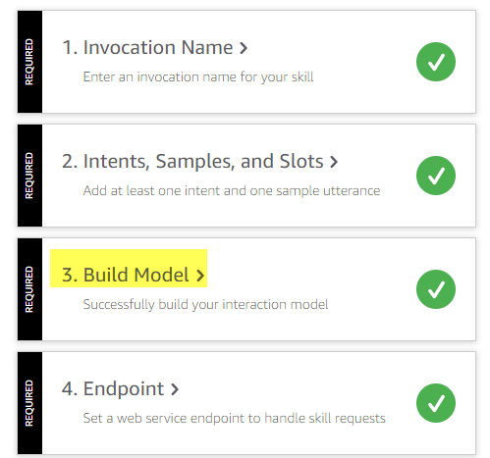

1. Test the “Passport Seva” Skill – by typing “Open Passport Seva”

