**1)Loading input files Movies.csv and Ratings.csv into HDFS**

acadgild@localhost ~]$ hadoop fs -put /home/acadgild/Downloads/movies.csv hadoopdata/hdfs/casestudy  
19/01/13 17:10:40 WARN util.NativeCodeLoader: Unable to load native-hadoop library for your platform... using builtin-java classes where applicable  
[acadgild@localhost ~]$ hadoop fs -put /home/acadgild/Downloads/ratings.csv hadoopdata/hdfs/casestudy  
19/01/13 17:11:10 WARN util.NativeCodeLoader: Unable to load native-hadoop library for your platform... using builtin-java classes where applicable  
You have new mail in /var/spool/mail/acadgild  
[acadgild@localhost ~]$ hdfs dfs -ls hadoopdata/hdfs/casestudy  
19/01/13 17:12:12 WARN util.NativeCodeLoader: Unable to load native-hadoop library for your platform... using builtin-java classes where applicable  
Found 2 items  
-rw-r--r--   1 acadgild supergroup    2283205 2019-01-13 17:10 hadoopdata/hdfs/casestudy/movies.csv  
-rw-r--r--   1 acadgild supergroup  709550327 2019-01-13 17:11 hadoopdata/hdfs/casestudy/ratings.csv  
[acadgild@localhost ~]$

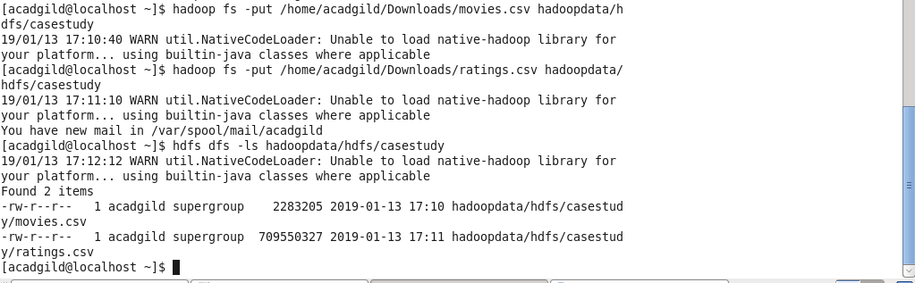

**Compiling and moving the source codes to a folder named executables to create a jar file:**

[acadgild@localhost executables]$ javac -cp /home/acadgild/install/hadoop/hadoop-2.6.5/share/hadoop/mapreduce/hadoop-mapreduce-client-core-2.6.5.jar:/home/acadgild/install/hadoop/hadoop-2.6.5/share/hadoop/common/hadoop-common-2.6.5.jar -d /home/acadgild/Downloads/CaseStudyIUseCasesDriver/executables /home/acadgild/Downloads/CaseStudyIUseCasesDriver/*.java  
You have new mail in /var/spool/mail/acadgild  
[acadgild@localhost executables]$ ls  
CaseStudyIUseCasesDriver.class        CaseStudyIUseCasesRatingsMapper.class  
CaseStudyIUseCasesMoviesMapper.class  CaseStudyIUseCasesReducer.class

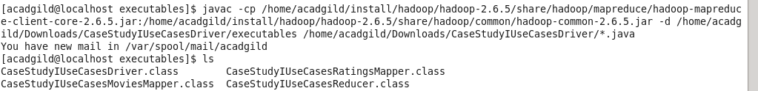

**Creating Jar file:**

[acadgild@localhost executables]$ jar -cvf session7_pig_movies.jar -C /home/acadgild/Downloads/CaseStudyIUseCasesDriver/executables/ .  
added manifest  
adding: CaseStudyIUseCasesDriver.class(in = 1948) (out= 952)(deflated 51%)  
adding: CaseStudyIUseCasesMoviesMapper.class(in = 1886) (out= 805)(deflated 57%)  
adding: CaseStudyIUseCasesReducer.class(in = 2635) (out= 1202)(deflated 54%)  
adding: CaseStudyIUseCasesRatingsMapper.class(in = 1888) (out= 808)(deflated 57%)  
You have new mail in /var/spool/mail/acadgild  
[acadgild@localhost executables]$



**Executing Jar file and Result output:**

[acadgild@localhost ~]$ hadoop jar session7_pig_movies.jar CaseStudyIUseCasesDriver hadoopdata/hdfs/casestudy/movies.csv hadoopdata/hdfs/casestudy/ratings.csv hadoopdata/hdfs/out

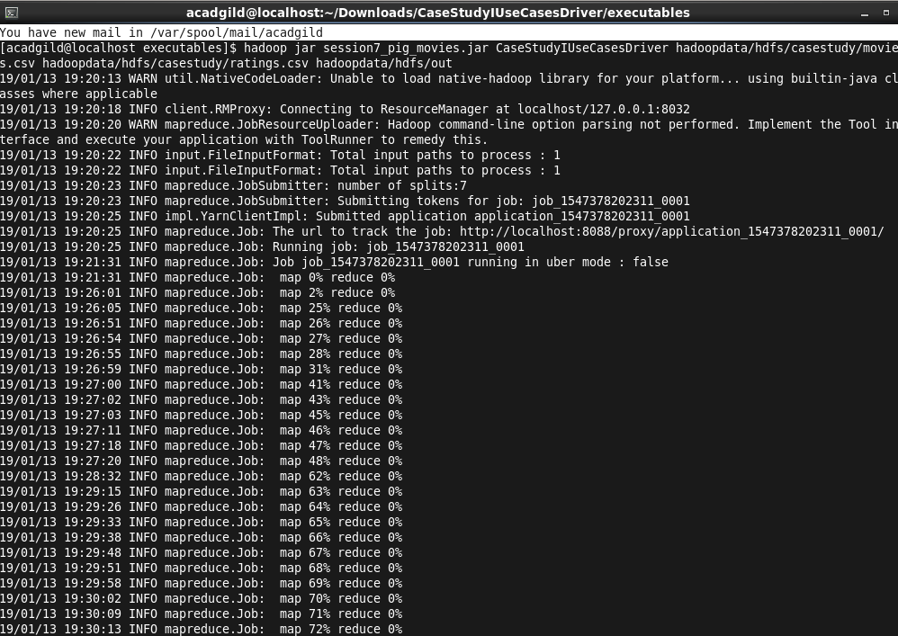

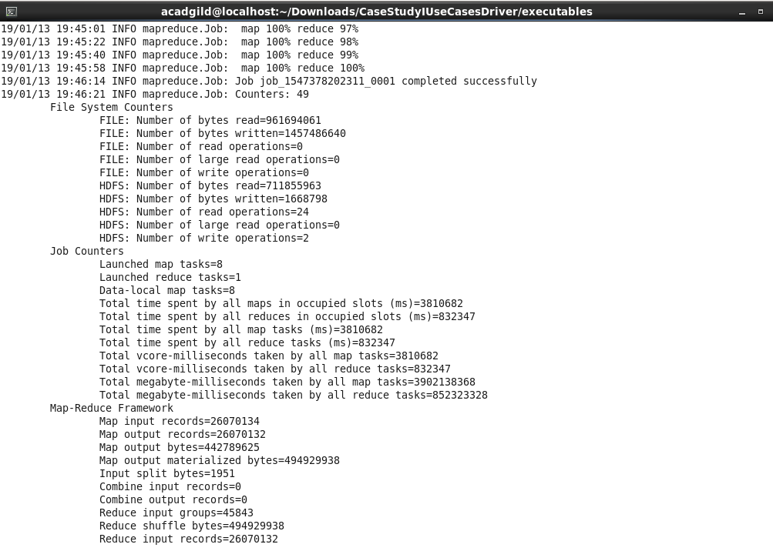

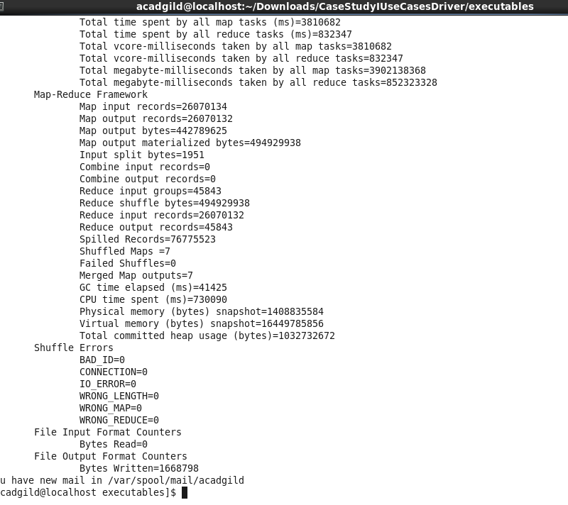

**Output:**  
[acadgild@localhost ~]$ hadoops fs -ls hadoopdata/hdfs/out

