**objective 1 – loading hvac fine and adding tem change column**

**result :**

hive> set hive.execution.engine=spark;  
hive> set hive.execution.engine;  
hive.execution.engine=spark

**//creating hvac table//**  
hive> create temporary table if not exists hvac(data string,time string,targettemp int,actualtemp int,system int, systemage int,buildingid int)  
    > row format delimited  
    > fields terminated by ','  
    > lines terminated by '\n'  
    > stored as textfile;  
OK  
Time taken: 11.006 seconds  
hive> describe hvac;  
OK  
data                    string                                        
time                    string                                        
targettemp              int                                           
actualtemp              int                                           
system                  int                                           
systemage               int                                           
buildingid              int                                           
Time taken: 0.756 seconds, Fetched: 7 row(s)  
hive>

**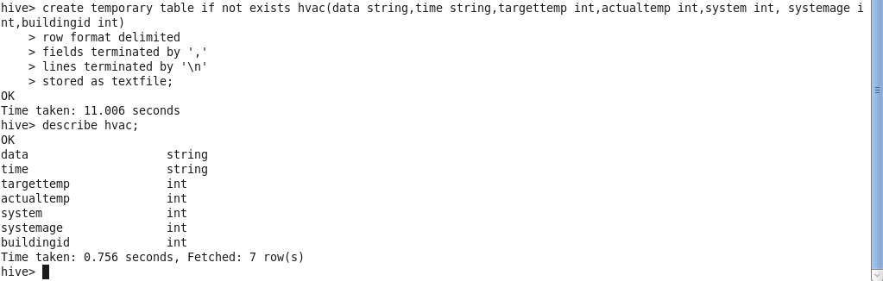**

**Loading data**  
hive> load data local inpath '/home/acadgild/Downloads/HVAC.csv' overwrite into table hvac;  
Loading data to table default.hvac  
OK  
Time taken: 3.695 seconds

**Adding tempchange colum**  
hive> alter table hvac add columns(tempchange int);  
OK  
Time taken: 0.362 seconds  
hive> desc hvac;  
OK  
data                    string                                        
time                    string                                        
targettemp              int                                           
actualtemp              int                                           
system                  int                                           
systemage               int                                           
buildingid              int                                           
tempchange              int                                           
Time taken: 0.704 seconds, Fetched: 8 row(s)

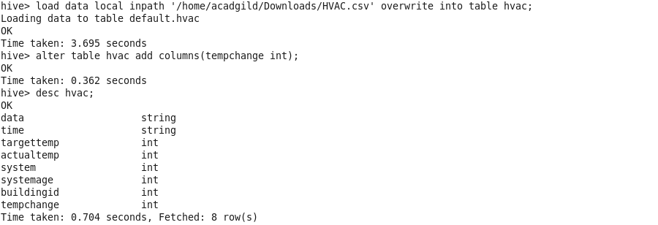

hive> insert overwrite table hvac  
hive> select data,time,targettemp,actualtemp,system,systemage,buildingid,case when ((actualtemp-targettemp > 5) or (targettemp-actualtemp > 5)) then 1 end as tempchange from hvac;

**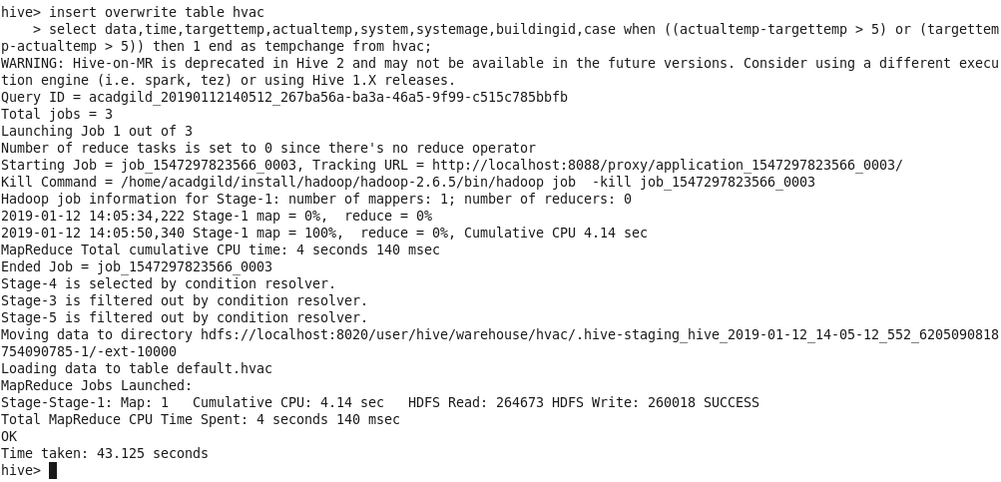**

**Objective 2 – Creating building table**

hive> create temporary table if not exists building(buildingid int,buildingmgr string,buildingage int,hvacproduct string,country string)  
    > row format delimited  
    > fields terminated by ','  
    > lines terminated by '\n'  
    > stored as textfile;  
OK  
Time taken: 1.288 seconds  
hive> load data local inpath '/home/acadgild/Downloads/building.csv' overwrite into table building;  
Loading data to table default.building  
OK  
Time taken: 1.554 seconds

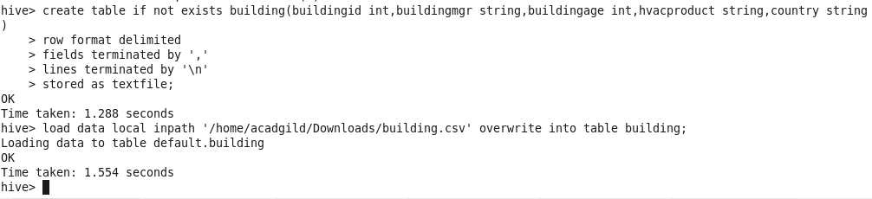

**Objective 3 – group the data by country who has tempcahnge as 1.**

hive> select h.tempchange,b.country,count(\*) from hvac h join building b  
    > on(b.buildingid=h.buildingid)  
    > where h.tempchange = 1  
    > group by b.country,h.tempchange;  
WARNING: Hive-on-MR is deprecated in Hive 2 and may not be available in the future versions. Consider using a different execution engine (i.e. spark, tez) or using Hive 1.X releases.  
Query ID = acadgild\_20190112141353\_e8c4c7c5-d329-40f6-9502-6514872ad1e1  
Total jobs = 1  
SLF4J: Class path contains multiple SLF4J bindings.  
SLF4J: Found binding in [jar:file:/home/acadgild/install/hive/apache-hive-2.3.2-bin/lib/log4j-slf4j-impl-2.6.2.jar!/org/slf4j/impl/StaticLoggerBinder.class]  
SLF4J: Found binding in [jar:file:/home/acadgild/install/hadoop/hadoop-2.6.5/share/hadoop/common/lib/slf4j-log4j12-1.7.5.jar!/org/slf4j/impl/StaticLoggerBinder.class]  
SLF4J: See [http://www.slf4j.org/codes.html#multiple\_bindings](http://www.slf4j.org/codes.html" \l "multiple_bindings" \t "_blank) for an explanation.  
SLF4J: Actual binding is of type [org.apache.logging.slf4j.Log4jLoggerFactory]  
2019-01-12 14:14:13    Starting to launch local task to process map join;    maximum memory = 518979584  
2019-01-12 14:14:17    Dump the side-table for tag: 1 with group count: 20 into file: file:/tmp/acadgild/e8bbb51e-3c38-4736-8abc-804296be0a12/hive\_2019-01-12\_14-13-53\_715\_8878390308075528567-1/-local-10005/HashTable-Stage-2/MapJoin-mapfile01--.hashtable  
2019-01-12 14:14:17    Uploaded 1 File to: file:/tmp/acadgild/e8bbb51e-3c38-4736-8abc-804296be0a12/hive\_2019-01-12\_14-13-53\_715\_8878390308075528567-1/-local-10005/HashTable-Stage-2/MapJoin-mapfile01--.hashtable (809 bytes)  
2019-01-12 14:14:17    End of local task; Time Taken: 3.959 sec.  
Execution completed successfully  
MapredLocal task succeeded  
Launching Job 1 out of 1  
Number of reduce tasks not specified. Estimated from input data size: 1  
In order to change the average load for a reducer (in bytes):  
  set hive.exec.reducers.bytes.per.reducer=<number>  
In order to limit the maximum number of reducers:  
  set hive.exec.reducers.max=<number>  
In order to set a constant number of reducers:  
  set mapreduce.job.reduces=<number>  
Starting Job = job\_1547297823566\_0004, Tracking URL = [http://localhost:8088/proxy/application\_1547297823566\_0004/](http://localhost:8088/proxy/application_1547297823566_0004/" \t "_blank)  
Kill Command = /home/acadgild/install/hadoop/hadoop-2.6.5/bin/hadoop job  -kill job\_1547297823566\_0004  
Hadoop job information for Stage-2: number of mappers: 1; number of reducers: 1  
2019-01-12 14:14:36,619 Stage-2 map = 0%,  reduce = 0%  
2019-01-12 14:14:51,421 Stage-2 map = 100%,  reduce = 0%, Cumulative CPU 4.15 sec  
2019-01-12 14:15:09,461 Stage-2 map = 100%,  reduce = 100%, Cumulative CPU 6.76 sec  
MapReduce Total cumulative CPU time: 6 seconds 760 msec  
Ended Job = job\_1547297823566\_0004  
MapReduce Jobs Launched:   
Stage-Stage-2: Map: 1  Reduce: 1   Cumulative CPU: 6.76 sec   HDFS Read: 272868 HDFS Write: 587 SUCCESS  
Total MapReduce CPU Time Spent: 6 seconds 760 msec  
OK  
1    Argentina    230  
1    Australia    225  
1    Belgium    199  
1    Brazil    226  
1    Canada    232  
1    China    241  
1    Egypt    236  
1    Finland    473  
1    France    251  
1    Germany    196  
1    Hong Kong    248  
1    Indonesia    243  
1    Israel    232  
1    Mexico    228  
1    Saudi Arabia    233  
1    Singapore    230  
1    South Africa    237  
1    Turkey    243  
1    USA    213  
Time taken: 78.001 seconds, Fetched: 19 row(s)  
hive>

