Homework 5c - Impossibility Result

**Objective:** Prove the impossibility result for leader election for the anonymous ring.

**Solution:**

How can a leader election algorithm for a ring system be anonymous?

A leader election algorithm is anonymous if the processors do not have unique identifiers that can be used by the algorithm. Every processor in the system has the same state machine. Every recipient of messages can be specified only in terms of channel labels, for example left and right neighbors.

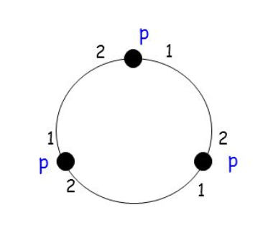

Impossibility Result in an anonymous ring, is the idea that symmetry between the processors can always be maintained, that is without some initial asymmetry, like unique identifies, symmetry can be broken. All processors in the anonymous ring start out in the same state, and because they are identical and execute the same program, in every round every processor sends exactly the same message. Every processor receives the same message in each round. If one processor is elected as leader, then so are all the processors. It is impossible to have an algorithm that elects a single leader in the anonymous ring.

Consider a ring R of size n > 1. Assume by way of contradiction, that there exists an anonymous algorithm, A, for electing a leader in this ring.

**Lemma 3.1:**  For every round k of the admissible execution of A in R, the states of all processors at the end of round k are the same.

**Proof:** The proof starts by induction on k where the base case k=0 (before the first round). The processors will being in the same initial state.

Assume now that the lemma holds for round k-1. The processors are all in the same state in k-, they all send the same message m_r to the right and message m_l to the left. In round k, every processor receives the message m_l  on it’s right edge and message m_r from it’s left edge. Thus all processors receive exactly the same message in round k. All processors in the ring execute the same program, and will be in the same state at the end of round k.

What can be drawn from this lemma is that at the end of some round some processor announces itself as the a leader, by entering an elected state, and so do all other processors. This is a contradiction of the assumption that the anonymous algorithm A is a leader election algorithm.

This proves theorem 3.2.

**Theorem 3.2:** There is no nonuniform anonymous algorithm for leader election in synchronous rings.

Another approach is to start with the assumption that there is no leader election algorithm.

**Theorem:** There is no leader election algorithm for anonymous rings,

**Proof:** In an anonymous ring assume that all processors wake-up simultaneously. Every processor begins in same state of non-elected with same outgoing messages. IN round 1 each processor will receive the same messages, do the same state transition, and sends same messages. This will be true of all the next rounds. Eventually some processor is the ring is supposed to enter an elected state. If one processor enters an elected state, all other processors will also. This proves that the impossibility result for leader election for the anonymous ring.