Industrial Internship Report on
” Python Projects Development”
Prepared by
-Sanapathi kavitha

Executive Summary
This report provides details of the Industrial Internship provided by upskill Campus and The IoT Academy in collaboration with Industrial Partner UniConverge Technologies Pvt Ltd (UCT).
During this internship, multiple Python-based projects were developed including File Organizer, URL Shortener, Quiz Game, and Password Manager. The projects were focused on improving programming knowledge, problem-solving abilities, and practical software development skills.
The internship provided hands-on experience in Python programming, file handling, encryption, automation, and application development. Different tools and libraries were used to design and implement efficient solutions for real-world problems.

TABLE OF CONTENTS
1 Preface 3
2 Introduction 4
2.1 About UniConverge Technologies Pvt Ltd 4
2.2 About upskill Campus 8
2.3 Objective 9
2.4 Reference 9
2.5 Glossary 10
3 Problem Statement 11
4 Existing and Proposed solution 12
5 Proposed Design/ Model 13
5.1 High Level Diagram (if applicable) 13
5.2 Low Level Diagram (if applicable) 13
6 Performance Test 14
6.1 Test Plan/ Test Cases 14
6.2 Test Procedure 14
6.3 Performance Outcome 14
7 My learnings 15
8 Future work scope 16

Preface
This internship program provided practical exposure to Python programming and real-world software development practices. During the 6-week internship, several projects were developed to improve technical knowledge, logical thinking, and programming skills.
The projects developed during the internship include File Organizer, URL Shortener, Quiz Game, and Password Manager. These projects helped in understanding concepts such as file handling, automation, encryption, user interaction, and application development
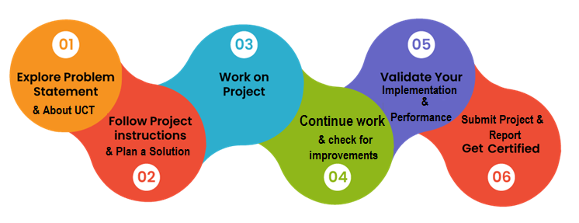
I would like to thank the mentors, trainers, and coordinators for their continuous support and guidance throughout the internship. This internship improved my confidence, technical abilities, and understanding of software development workflows.
The internship conducted by upskill Campus and UniConverge Technologies Pvt Ltd (UCT) provided a valuable opportunity to work on industry-oriented projects and improve technical expertise.

Introduction

About UniConverge Technologies Pvt Ltd
A company established in 2013 and working in Digital Transformation domain and providing Industrial solutions with prime focus on sustainability and RoI.
For developing its products and solutions it is leveraging various Cutting Edge Technologies e.g. Internet of Things (IoT), Cyber Security, Cloud computing (AWS, Azure), Machine Learning, Communication Technologies (4G/5G/LoRaWAN), Java Full Stack, Python, Front end etc.

- UCT IoT Platform ()
UCT Insight is an IOT platform designed for quick deployment of IOT applications on the same time providing valuable “insight” for your process/business. It has been built in Java for backend and ReactJS for Front end. It has support for MySQL and various NoSql Databases.
- It enables device connectivity via industry standard IoT protocols - MQTT, CoAP, HTTP, Modbus TCP, OPC UA
- It supports both cloud and on-premises deployments.
It has features to
• Build Your own dashboard
• Analytics and Reporting
• Alert and Notification
• Integration with third party application(Power BI, SAP, ERP)
• Rule Engine

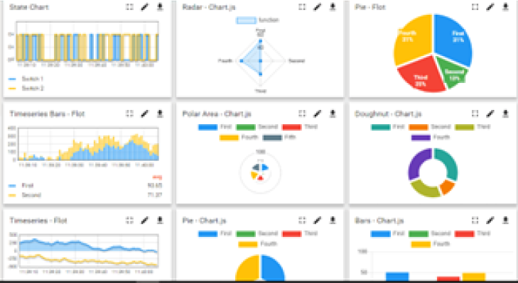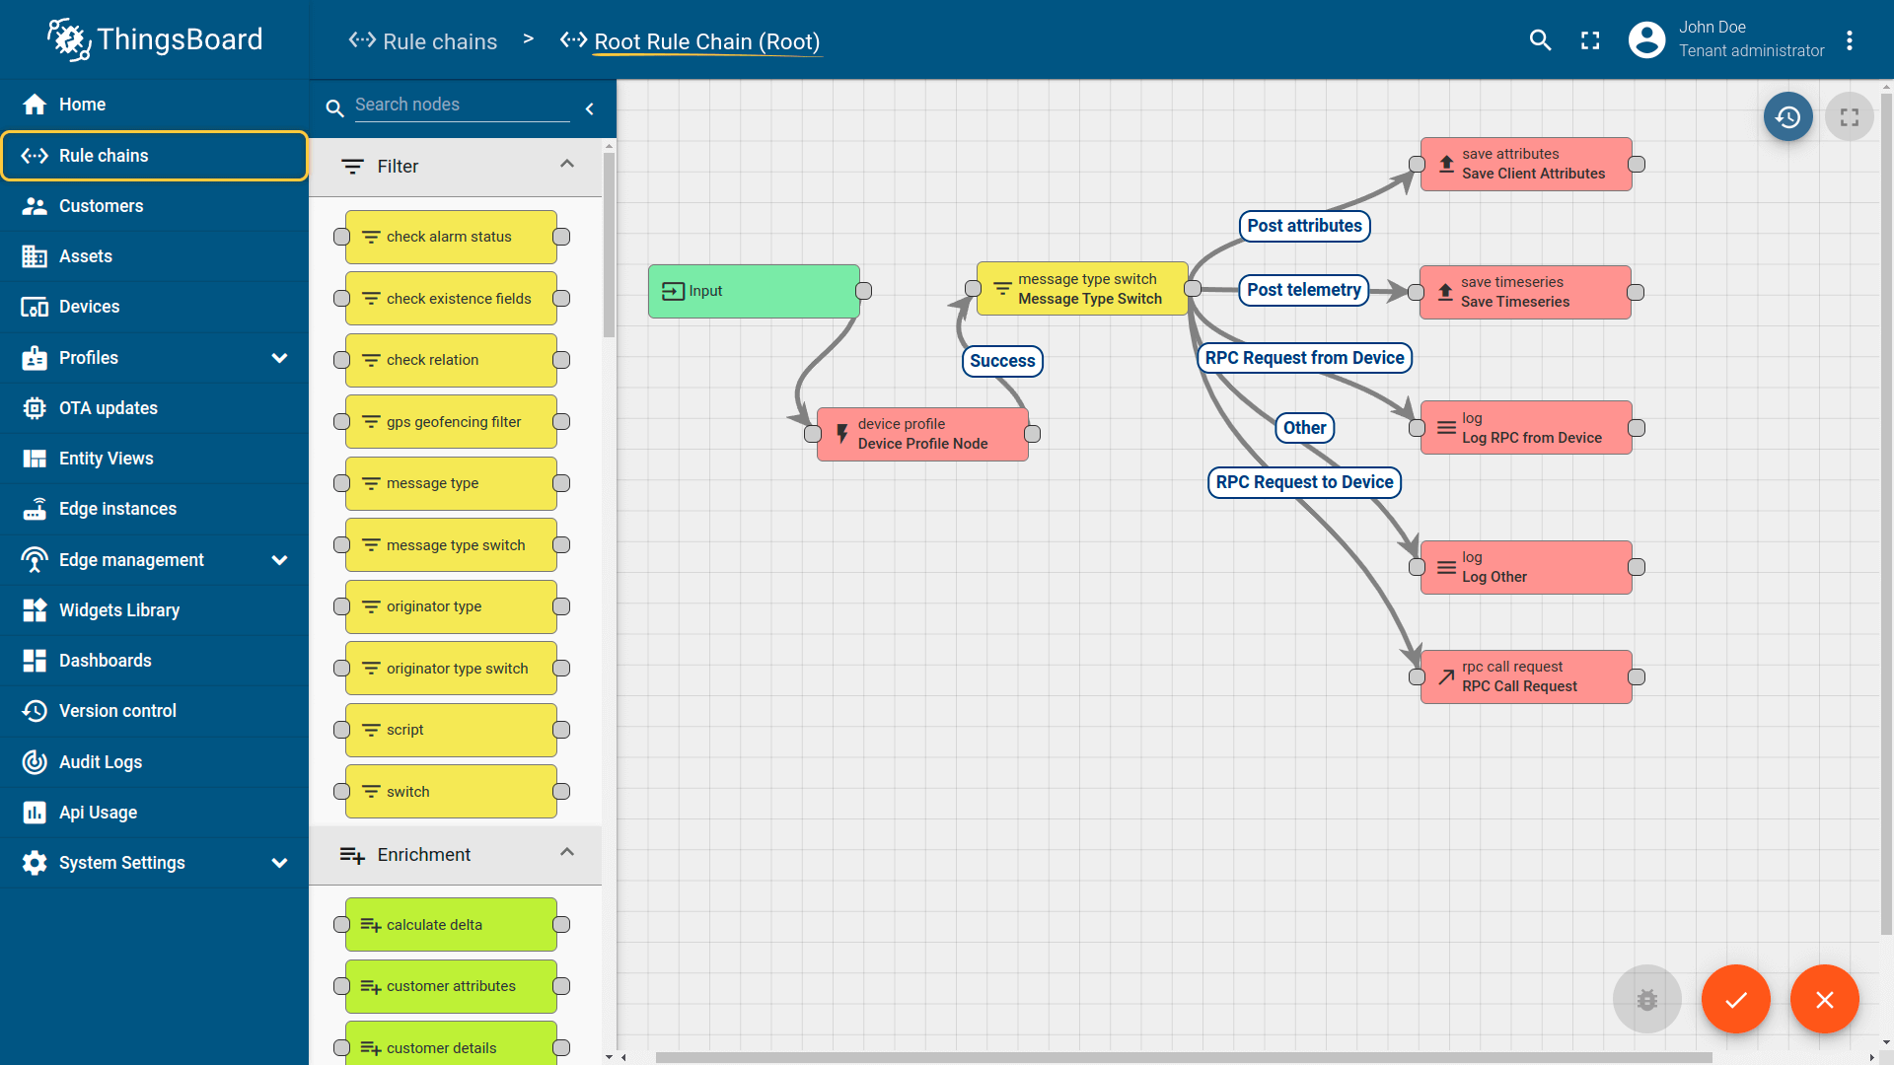

- Smart Factory Platform ()
Factory watch is a platform for smart factory needs.
It provides Users/ Factory
- with a scalable solution for their Production and asset monitoring
- OEE and predictive maintenance solution scaling up to digital twin for your assets.
- to unleased the true potential of the data that their machines are generating and helps to identify the KPIs and also improve them.
- A modular architecture that allows users to choose the service that they what to start and then can scale to more complex solutions as per their demands.
Its unique SaaS model helps users to save time, cost and money.
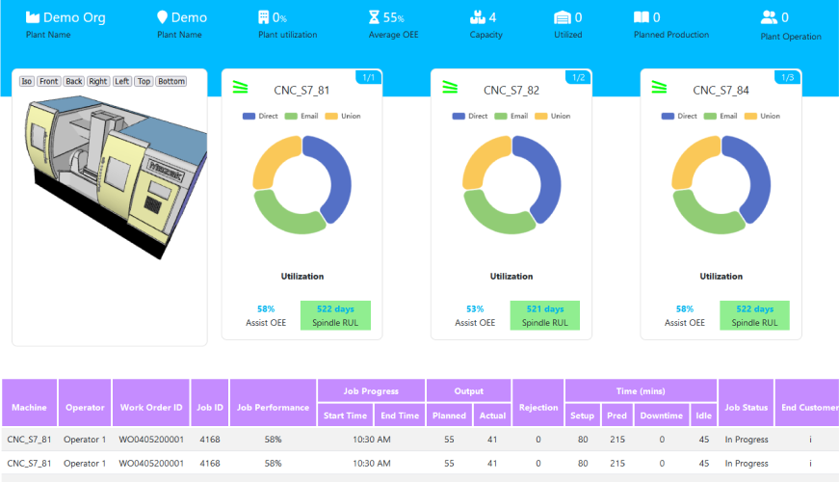

- based Solution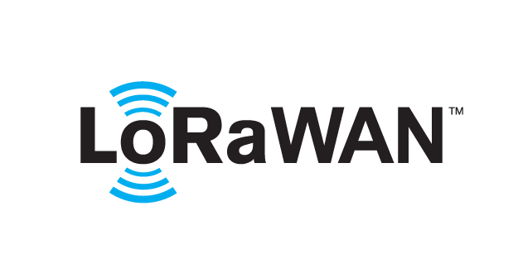
UCT is one of the early adopters of LoRAWAN teschnology and providing solution in Agritech, Smart cities, Industrial Monitoring, Smart Street Light, Smart Water/ Gas/ Electricity metering solutions etc.
- Predictive Maintenance
UCT is providing Industrial Machine health monitoring and Predictive maintenance solution leveraging Embedded system, Industrial IoT and Machine Learning Technologies by finding Remaining useful life time of various Machines used in production process.
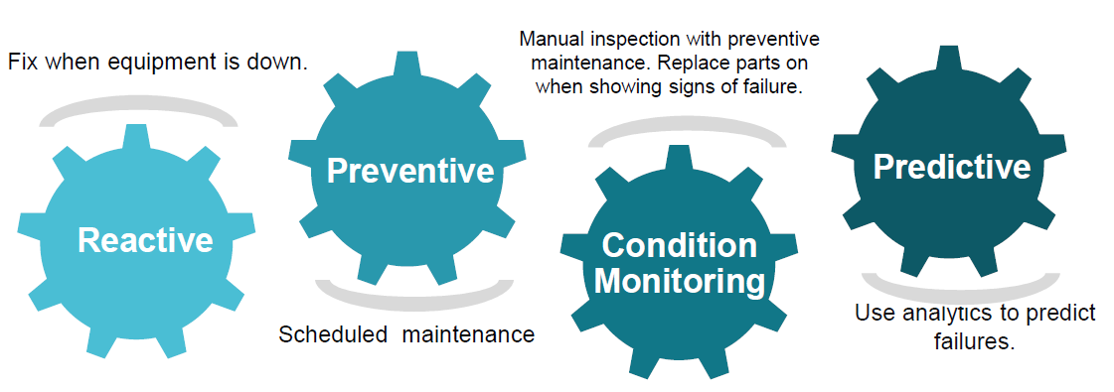

About upskill Campus (USC)
upskill Campus along with The IoT Academy and in association with Uniconverge technologies has facilitated the smooth execution of the complete internship process.
USC is a career development platform that delivers personalized executive coaching in a more affordable, scalable and measurable way.




Seeing need of upskilling in self paced manner along-with additional support services e.g. Internship, projects, interaction with Industry experts, Career growth Services
https://www.upskillcampus.com/
upSkill Campus aiming to upskill 1 million learners in next 5 year

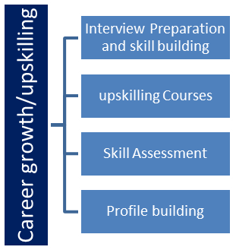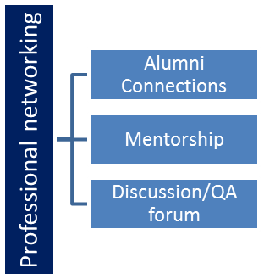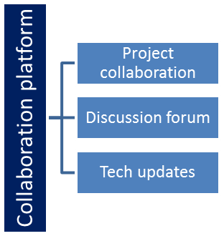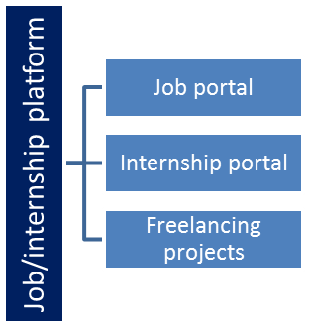

The IoT Academy
The IoT academy is EdTech Division of UCT that is running long executive certification programs in collaboration with EICT Academy, IITK, IITR and IITG in multiple domains.

Objectives of this Internship program
• To gain practical experience in Python programming.
• To understand real-world software development processes.
• To improve logical thinking and problem-solving skills.
• To develop projects using Python and related libraries.
• To gain experience in GitHub project management and documentation.
• To improve communication and technical skills.

Reference
[1] Python Official Documentation
[2] GitHub Documentation
[3] Flask Documentation
[4] Cryptography Library Documentation

Glossary
GUI – Graphical User Interface
URL – Uniform Resource Locator
IDE – Integrated Development Environment
OS – Operating System

Problem Statement

Project | Problem Statement
File Organizer | Users face difficulty managing scattered files manually. The project organizes files automatically based on file types.
URL Shortener | Long URLs are difficult to share and manage. The project converts long URLs into shorter links.
Quiz Game | Manual quiz evaluation is time-consuming. The project automates question handling and score calculation.
Password Manager | Storing passwords manually is insecure. The project securely stores and retrieves passwords using encryption.

Existing and Proposed solution
Existing solutions for file management, password storage, and URL handling often require manual effort or complex software systems.

The proposed solutions developed during this internship provide simple, efficient, and user-friendly applications using Python programming.

The developed projects improve automation, reduce manual work, increase security, and provide better user interaction through practical software implementations.

Code submission (Github link)
https://github.com/kavitha1156/Upskill-internship-projects.git

Report submission (Github link) :

Proposed Design/ Model
The projects follow a structured workflow for processing user input, performing operations, and generating outputs.

File Organizer:
Reads files from a folder, identifies file types, creates folders automatically, and moves files into categorized directories.

URL Shortener:
Accepts a long URL from the user, generates a shortened URL, and displays the result.

Quiz Game:
Displays questions, accepts answers, validates responses, and calculates the final score.

Password Manager:
Encrypts user passwords, stores them securely, and retrieves them when required.

High Level Diagram (output)
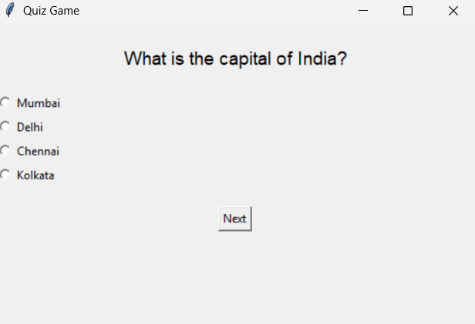

Figure 1: HIGH LEVEL DIAGRAM OF THE SYSTEM

Low Level Diagram (if applicable)

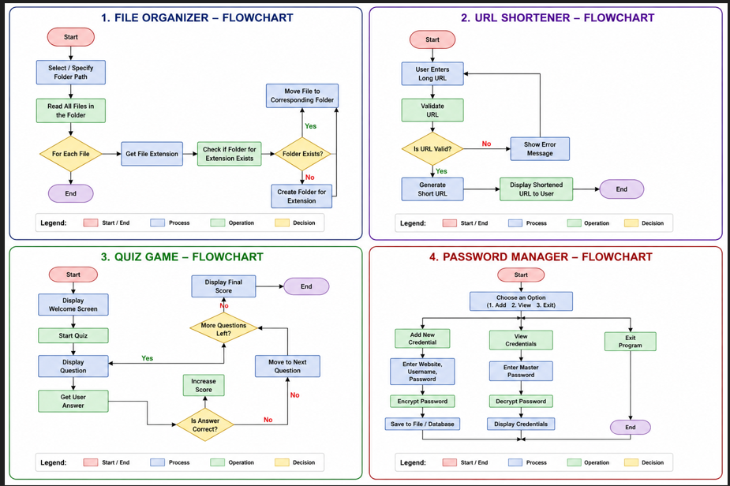

Performance Test
The developed applications were tested using different user inputs and scenarios to ensure proper functionality.

Test Cases:
• File sorting and folder creation
• URL shortening functionality
• Quiz answer validation and score calculation
• Password encryption and retrieval

Performance Outcome:
• Accurate execution of operations
• Fast processing speed
• User-friendly interaction
• Efficient handling of multiple inputs
• Secure password management

Test Plan/ Test Cases
• Verify file organization process
• Verify URL conversion accuracy
• Verify score calculation in quiz game
• Verify password encryption and decryption

Test Procedure
Applications were executed using multiple test inputs. Outputs were verified manually to ensure correct functionality and performance.

Performance Outcome
All applications performed successfully with accurate outputs and stable performance under normal operating conditions.

My learnings

Through this internship, I improved my Python programming skills and gained practical experience in software development.
I learned:
• File handling in Python
• Python libraries and modules
• Encryption and security basics
• GitHub repository management
• Project documentation
• Problem-solving and debugging techniques

This internship enhanced my technical confidence and understanding of industry-oriented project development.

Future work scope

Future improvements for these projects include:

• Adding graphical user interfaces (GUI)
• Database integration
• Cloud storage support
• Advanced encryption methods
• Web deployment of applications
• AI-based automation features

