LOOPS
1. For Loop(Counting Loop):


for-loop

-executes block of code a fixed number of times.
- we can iterate over range,string,sequence ,etc..,

e.g.

for i in "apple":
print(i)

Range function

for i in range(5):


print(i)

output:
0
1
2
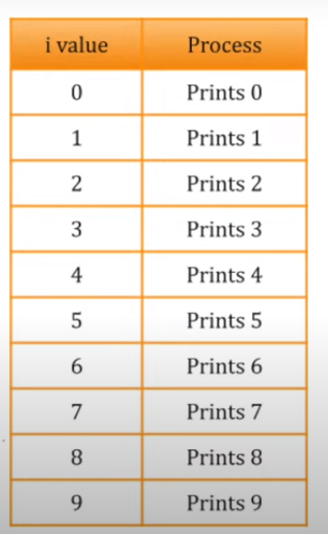
3
4

for i in range(0,10):
print(i)

for i in range(1,5):
print(i)

what will the output????


for i in range(0,10,2):
print(i)

Q: Get input for a and b
print numbet between a and b

While Loop
With the while loop we can execute a set of statements as long as a condition is true.
E.g:
i = 1
while i < 6:
print(i)
i += 1

Break Statement
With the break statement we can stop the loop even if the while condition is true:

i = 0
while i < 6:
i += 1
if i == 3:
break
print(i)

Continue Statement
With the continue statement we can stop the current iteration, and continue with the next:
i = 0
while i < 6:
i += 1
if i == 3:
continue
print(i)

The else Statement
With the else statement we can run a block of code once when the condition no longer is true:

i = 1
while i < 6:
print(i)
i += 1
else:
print("i is no longer less than 6")

Assignment:
for-loop

1.Python program to calculate the sum of all numbers from 1 to a given number.
2.Python program to print a multiplication table of a given number
3.Python program to count the total number of digits in a number.

While-loop
Print the following patterns using loop :
a.
*
**
***
****
b.
*
***
*****
***
*
c.
1010101
10101
101
1

