Integrated Anti-Money Laundering (AML) &
Transaction Risk Management Platform
Project Report — Methodology, KPIs & Deliverables
Built with Python, SQL (SQLite) & an interactive web dashboard

Prepared: September 2026

1. Executive Summary
This report documents an end-to-end AML and transaction risk management platform built against four source datasets: customers, banks, transactions, and sanctions. The platform covers all seven steps of the original brief: data integration and cleaning, real-time risk monitoring, rule-based fraud detection, customer risk profiling, compliance and sanctions monitoring, bank risk comparison, and a unified reporting layer.
The full pipeline runs end-to-end with a single command (python run_pipeline.py) and takes under three seconds on the supplied datasets (1,000 customers, 1,010 banks, 1,000 transactions, 1,000 sanction records). It produces a SQLite database, a set of CSV data marts for every analytical step, a PDF fraud report, a KPI summary, and a self-contained interactive dashboard.
Headline result | Value
Data completeness / consistency | 100.0% / 100.0%
Transactions flagged for the watchlist | 600 of 1,000 (60.0%)
Transactions requiring analyst review | 146 (14.6%) — 14 Critical, 132 High
High-risk customers (computed segment) | 101 of 1,000
Banks below the compliance threshold | 199 of 1,010 (19.7%)
High-risk banks (risk score ≥ 50) | 113 of 1,010 (11.2%)

2. Architecture & Tech Stack
The brief calls for Python, SQL, and Power BI/Tableau. This environment has no licensed BI tool and no running database server, so the platform substitutes the closest faithful equivalents without changing the analytical design:
- SQL layer: SQLite, chosen for a real, runnable relational database with primary keys, foreign keys, and indexes, with every .sql file written in portable ANSI SQL — directly portable to PostgreSQL or MySQL (see notes in sql/01_schema.sql).
- Python layer: pandas for data wrangling, matplotlib for the PDF report, sqlite3 for the database, smtplib for the (stubbed) alerting integration.
- Visualization layer: every data mart is exported as CSV, ready to import into Power BI or Tableau directly. A self-contained interactive HTML dashboard (Chart.js, vanilla JS, no server, no external dependency at runtime) is included as a working substitute in the meantime.

Pipeline flow
raw_data/*.csv → SQLite staging tables → cleaned relational schema → feature engineering → [fraud rules | customer profiling | compliance monitoring | bank comparison] → KPI summary & alerts → dashboard.html

3. Methodology & Results by Step

Step 1 — Data Integration, Cleaning, Feature Engineering & KPIs
The four CSVs were loaded into staging tables, then validated and cleaned: null checks across every column, deduplication on primary keys and on a full business-key match, date standardization to YYYY-MM-DD, and referential-integrity checks (orphaned customer_id / bank_id foreign keys). An IQR-based outlier scan was run on transaction amounts.
Result: the supplied data was already clean — 0 nulls, 0 duplicate keys, 0 orphaned foreign keys, 0 IQR outliers, 100% ISO-date consistency. Feature engineering then built customer-level, bank-level, and region-level tables (transaction frequency, average/total/max amount, high-risk transaction counts, sanction counts) plus a transaction-level risk-flag table consumed by every later step.
Data-quality KPI | Result
Data completeness rate | 100.0%
Data consistency score (date format) | 100.0%
Feature coverage (customers with ≥1 transaction) | 64.0% (640 of 1,000)

Step 2 — Real-Time Transaction Risk Monitoring
The source data has no latitude/longitude, so the brief's map visualization is implemented as a regional risk heatmap (North / South / East / West), which is the finest geography actually present (customer region, bank region). Each region is scored by the share of its transactions flagged high-risk, color-coded green→amber→red, alongside transaction count and average amount.
Region | Txn Count | Avg Amount | High-Risk %
East | 257 | $4,976 | 54.5%
North | 243 | $4,925 | 53.5%
West | 247 | $5,054 | 47.8%
South | 253 | $4,796 | 47.0%

Alert Timeliness (time for compliance teams to respond to a flagged transaction) cannot be computed from the source data — there is no incident-response timestamp. The alerting step now writes a timestamped entry to reports/alerts_log.csv for every threshold breach going forward, which is what this KPI would be measured against once response times are logged.

Step 3 — Rule-Based Fraud Detection System
Six candidate rules were evaluated: large single transaction (>$9,000, just under the $10k CTR threshold), high transaction frequency, high-risk transaction location, low bank compliance score, and sanctions history on the customer or the bank. An equally-weighted combination of all rules was tried first and rejected: the supplied sanctions.csv covers roughly 85% of all transactions' customers or banks — far denser than a real watchlist — so it dominated the score and flagged 74% of all transactions, which is not actionable for an AML team.
The final design scores transactional behaviour (large amount, frequency, location, low compliance — 0 to 4 points) separately from sanctions history (0 or 1 point), matching standard AML practice where a watchlist hit is a hard compliance control rather than one more point in a blended score. fraud_score = behavioural score + sanctions flag (0–5).
Fraud-detection KPI | Result
Flagged for the watchlist (fraud_score ≥ 2) | 600 of 1,000 (60.0%)
Requires analyst review (fraud_score ≥ 3) | 146 (14.6%)
Critical severity | 14
High severity | 132
False Positive Rate / Detection Accuracy | Not computable — no analyst disposition data in source files (see §5)

Step 4 — Customer Risk Profiling & Segmentation
Each customer gets a composite 0–100 risk score blending high-risk transaction count, large-transaction count, sanction count, and their stated risk_level, then a computed segment (Low / Medium / High). This was checked against the customer's stated risk_level as a sense-check, not ground truth — the two are independent signals (one behavioural, one on-file) and are expected to diverge somewhat.
Customer-profiling KPI | Result
High-risk customer count (computed) | 101
Segmentation agreement with stated risk_level | 57.6%
Profile completeness rate | 64.0%

Step 5 — Compliance & Sanctions Monitoring
Every bank's compliance_score is paired with its sanctions history (count and reason breakdown: Money Laundering / Fraud / Compliance Violation) and classified into Adequate / Watch / Below Threshold bands.
Compliance KPI | Result
Total sanctioned accounts | 1,000
Average bank compliance score | 0.751
Compliance gap (banks below 0.60) | 19.7% (199 of 1,010)

Step 6 — Bank Risk Comparison & Analysis
A composite bank_risk_score (0–100) blends inverse compliance score, sanctioned-account count, and high-risk transaction share, letting auditors rank every bank and drill into the highest-risk ones directly.
Bank-comparison KPI | Result
High-risk banks (score ≥ 50) | 113 of 1,010 (11.2%)
Average bank risk score | 29.17
Riskiest bank in this dataset | Bank 508 / Bank 651 (tied, score 78.4)

Step 7 — Unified Monitoring & Reporting
All six modules feed one kpi_summary.csv/json and a shared alerts_log.csv. Two threshold-based alerts fire automatically on this dataset: 14 Critical-severity fraud flags, and 199 banks below the compliance threshold. The alerting function (send_email_alert) is a real smtplib integration — supply SMTP credentials to activate it; with none configured it logs what it would have sent instead of silently no-op'ing.

4. Dashboard
dashboard.html is a single, self-contained file (no server, no internet connection required — Chart.js is bundled inline) with six linked views: Overview, Risk Monitoring, Fraud Detection, Customer Profiling, Compliance & Sanctions, and Bank Comparison. Every table supports search, filtering, and column sorting.
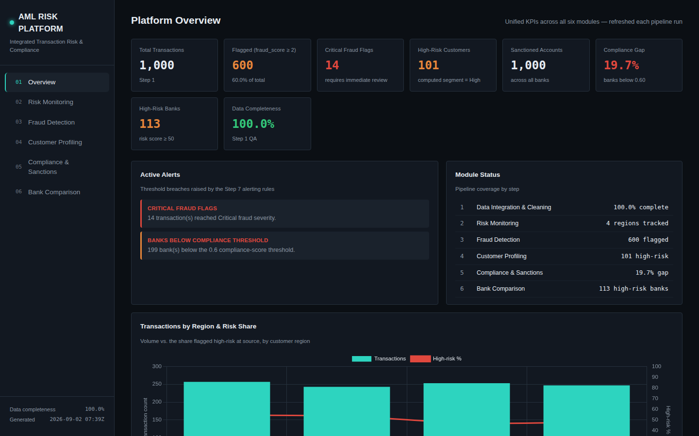
Overview — unified KPIs, active alerts, module status
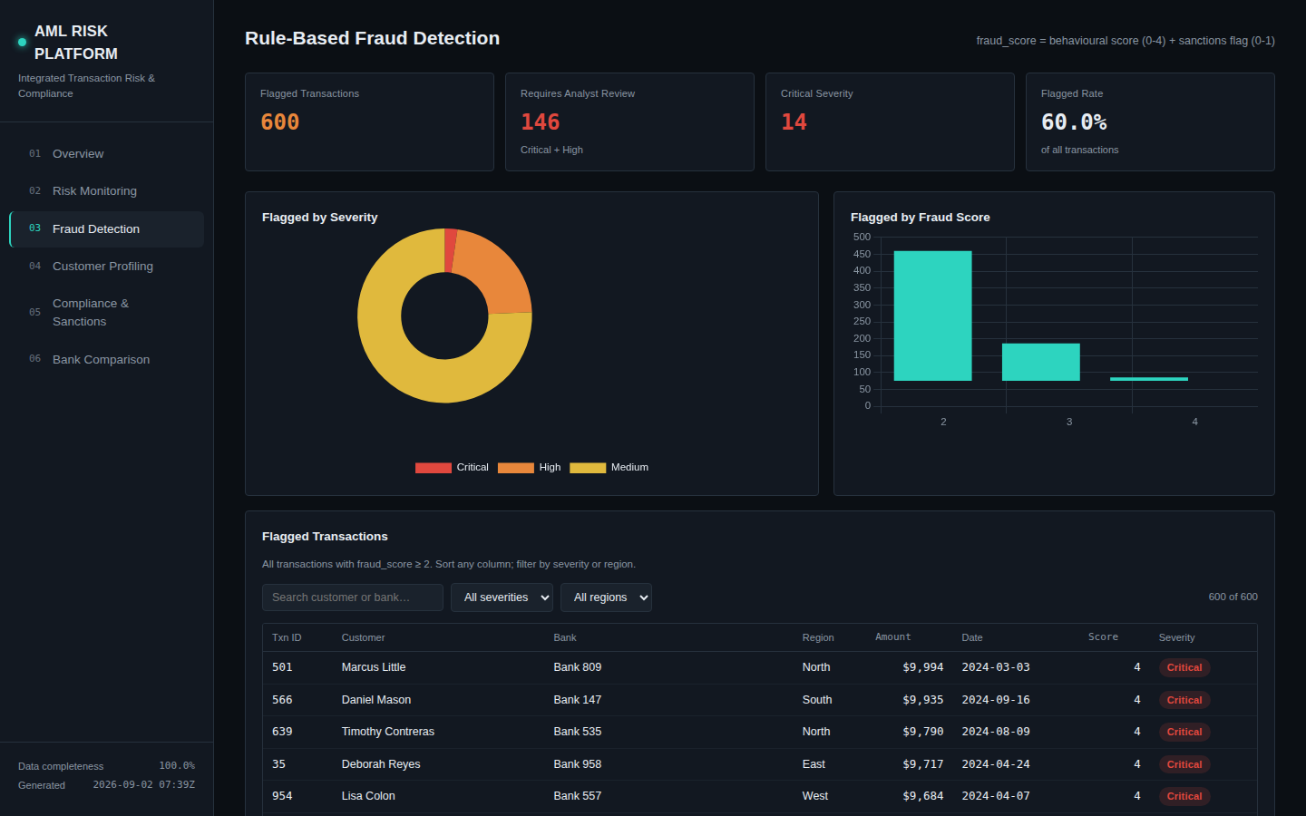
Fraud Detection — severity/score breakdown and a searchable, sortable flagged-transaction table
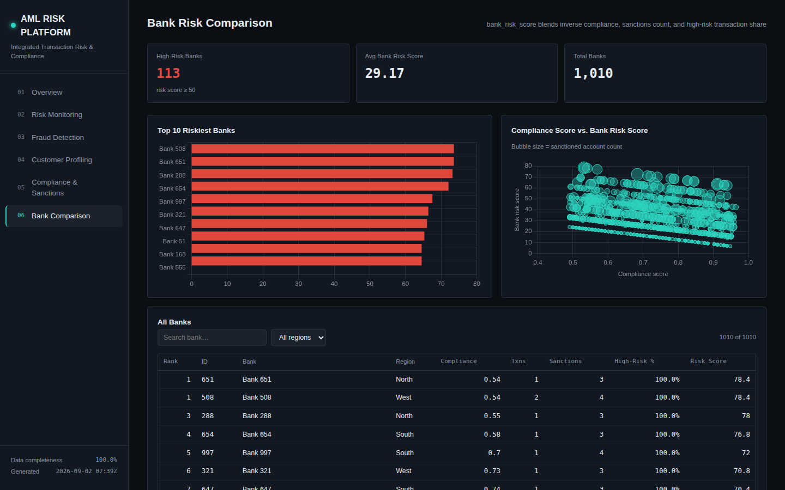
Bank Comparison — top-10 riskiest banks and a compliance-vs-risk bubble chart

5. Known Limitations & Recommended Next Steps
- False Positive Rate and Detection Accuracy require analyst-confirmed outcomes per flagged transaction. reports/fraud_disposition_log_template.csv is provided so compliance staff can log Confirmed Fraud / Cleared / Escalated per case; both KPIs become a one-line ratio once populated.
- Alert Timeliness requires an incident-response timestamp not present in the source data. reports/alerts_log.csv now timestamps every alert going forward as the basis for this measurement.
- The sanctions dataset's unusually broad coverage (~85% of transactions touch a sanctioned party) means it was deliberately down-weighted in the fraud rules (§3, Step 3) rather than treated as a strong standalone signal, which it would be on real, sparse watchlist data.
- No true geographic coordinates exist in the source data, so Step 2's map is implemented as a four-region heatmap rather than a literal map. If lat/long or city-level geocoding becomes available, the same region_features table extends directly to a real choropleth in Power BI/Tableau or the dashboard.
- Email alerting is wired to a real SMTP integration but has no credentials configured in this environment; supply them in 07_unified_kpis_and_alerts.py to activate live email notifications.
- For production use against a live database, swap SQLite for PostgreSQL/MySQL by pointing db_utils.py at that connection — the .sql files need no rewriting.

6. Deliverables Guide
File / folder | What it is
run_pipeline.py | Single command that runs the entire platform end-to-end
sql/01 – 07 | Schema, cleaning, feature engineering, and all five analytical modules
python/01 – 09 | The Python driver for every SQL step, plus report and dashboard generation
aml_platform.db | The SQLite database — browse with any SQLite client
data_marts/*.csv | Every clean table and analytical output — import directly into Power BI/Tableau
reports/AML_Fraud_Detection_Report.pdf | Print-ready summary for the AML team
reports/fraud_disposition_log_template.csv | Template for analysts to log review outcomes
reports/alerts_log.csv | Timestamped log of threshold-breach alerts
dashboard.html | The unified, self-contained interactive dashboard — open in any browser
README.md | Setup instructions and full design-decision rationale

