COMPLETED APIS

1. Employee:

1. UI Screenshot: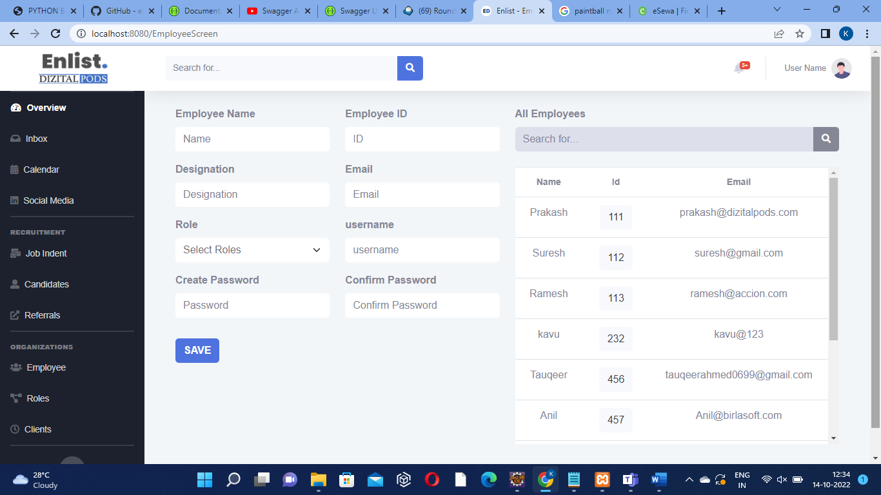
2. API Detailed Description: This is a CRUD API through which we save the information of the employee(NAME, ID, DESIGNATION, EMAIL, ROLE, USERNAME, CREATE PASSWORD, CONFIRM PASSWORD) into the database. And we can do the basic CRUD (CREATE, READ, UPDATE, DELETE)
3. GET/POST/PUT all three apis are used in employee
4. The inputparameters of employee are

eid

employeename

designation

username

password

confirmpassword

email

rollid

e)api output response

eid=”23”,

employeename=”xyz”,

designation=”lmn”,

username=”pok”,

password=”7854”,

confirmpassword=”7854”,

email=”@gmail.com”,

rollid=”plm”

f)url:

<http://localhost:8080/EmployeeScreen>

g)expected error:

2)Roles:

a)UI Screenshot: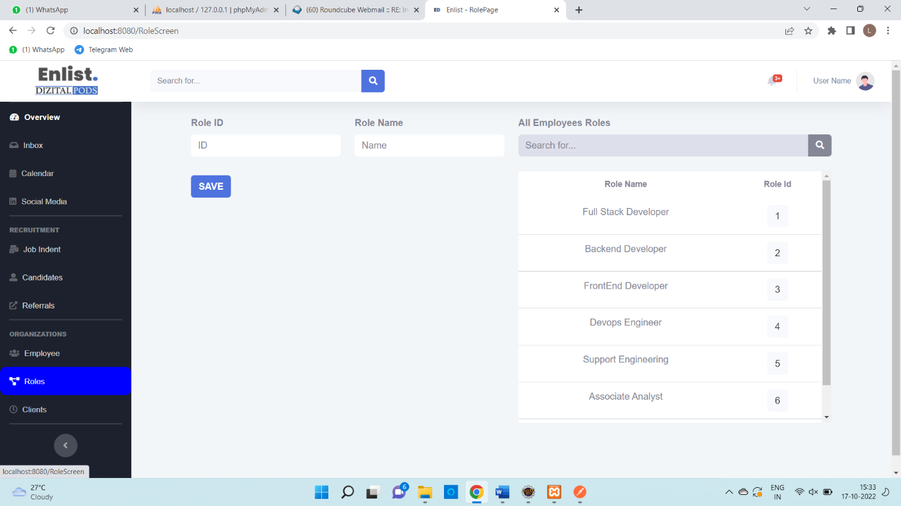

b)API Detailed Description:This is the crud api through which we save the information of ROLE (ROLENAME,ROLEID) into the database

c)GET/POST/PUT all three api are use in ROLE

d)The input parameters of the role are:

roleid

rolename

e)api output response:

roleid:”434”,

rolename:”lmn”

f)expected error:

g)url:

<http://localhost:8080/RoleScreen>

3)Clients:

a)UI Screenshot:

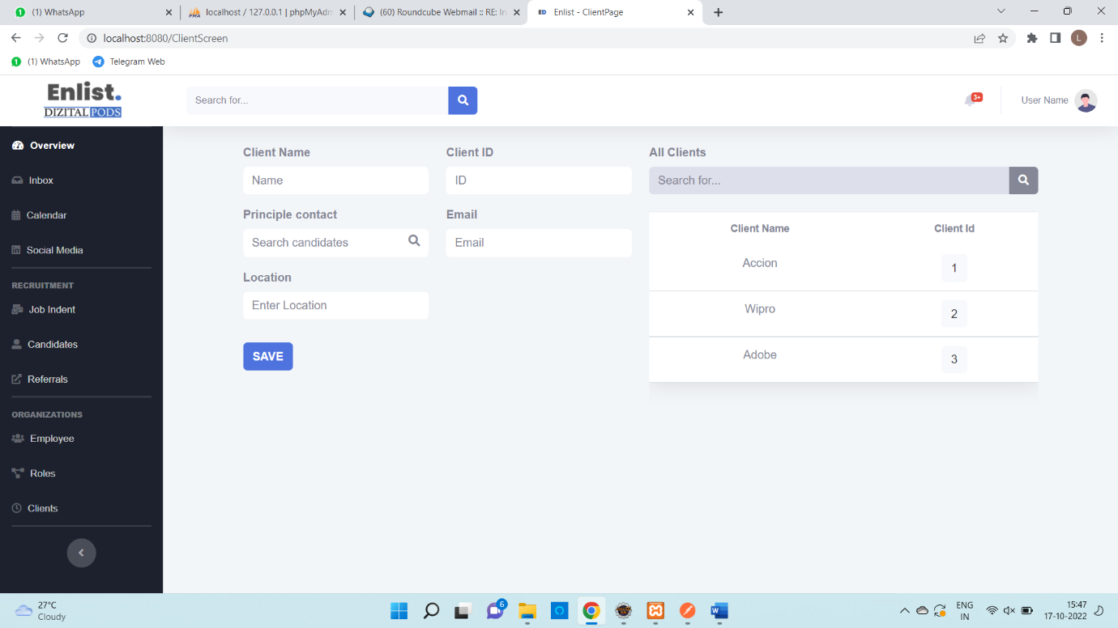

b)API Detailed Description:This is the crud api through which we save the information of the Client(Clientname,Clientid,Principlecontact,Email,Location)into the database.

c) GET/POST/PUT all three api are use in CLIENT.

d) The input parameters of the Client are:

Clientname

Clientid

Principlecontact

Email

Location

e) api output response:

Clientname=”mnb”,

Clientid=”098”,

Principlecontact=”plk”,

Email=”@gmail.com”,

Location=”lkj”

f)url:

<http://localhost:8080/ClientScreen>

g)Expected error:

4)Candiates:

a)UI Screenshot:

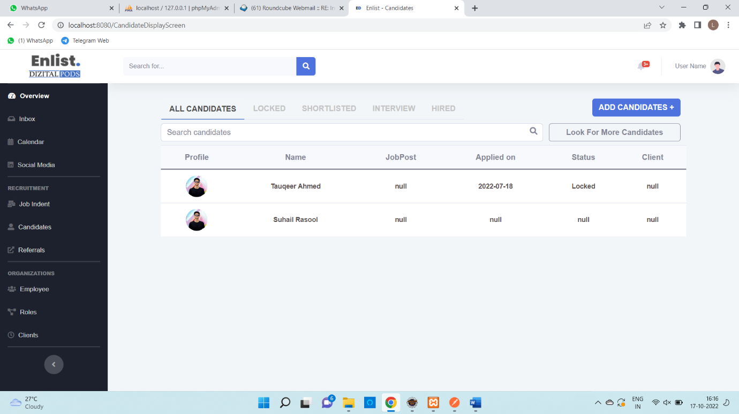

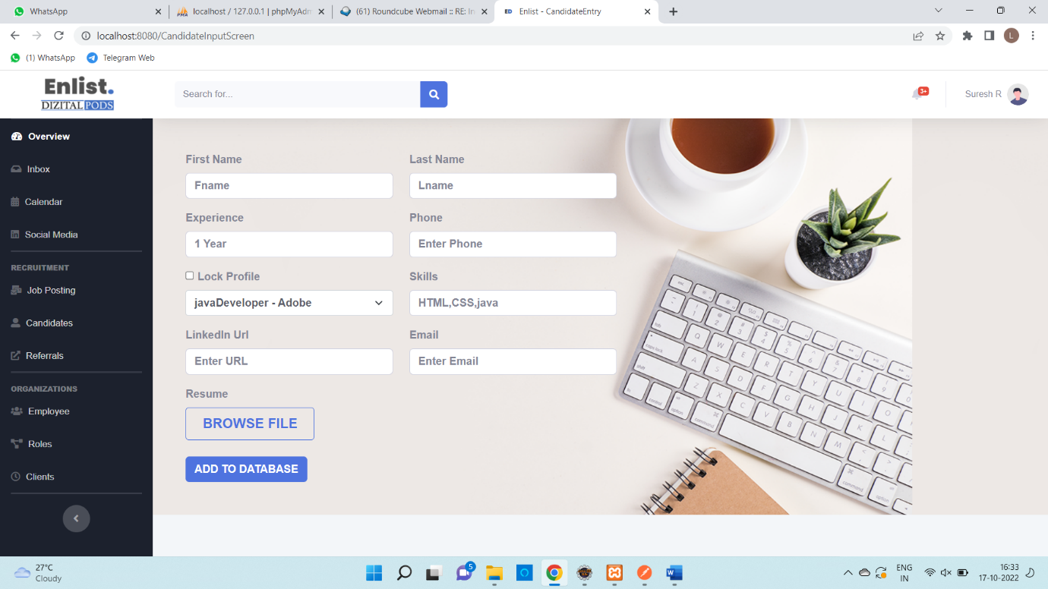

b)API Detailed Description:

In the ALL CANDIDATES PAGE it displays the number of students are locked,it displays the number of students are shortlisted,it displays the number of students are interviewed and it displays the number of students are hired

c) GET/POST/PUT all three api are use in CANDIDATE.

d) The input parameters of the Candidate are:

First name

Last name

Experience

Phone

Lock profile

Skills

Linkedin url

Email

Resume

e)api output response:

First name=”jhl”,

Last name=”lkj”,

Experience=”9”,

Phone=”9878988”,

Lock profile=”yes”,

Skills =”java”

Linkedin url=”lkjknjkbji”,

Email=”@gmail.com”,

Resume

f)url:

ALL CANDIDATES PAGE= <http://localhost:8080/CandidateDisplayScreen>

ADD CANDIDATES PAGE=

<http://localhost:8080/CandidateInputScreen>

g)Expected error:

5)Referrals

a)UI Screenshot:

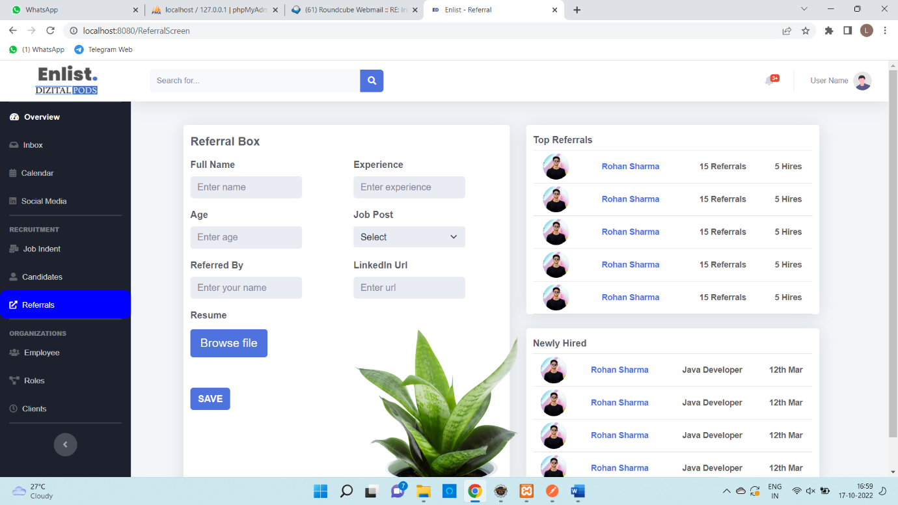

b)API Detailed Description: