PROGRAMM:

<html>
<head>
<title>
Heading
</title>
</head>
<body>
<h1>Bvrit hyderabad</h1>
<h2>information technology</h2>
<h3>bachpally</h3>
<h4>web programming</h4>
</body>
</html>

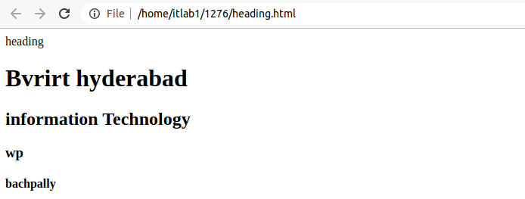
OUTPUT:

