PROGRAMM:

<html>
<head>
<title>
image
</title>
</head>
<body>
<img src="images.png" width=200 height=200 alt=BVRITLOGO></img>
</body>
</html>

OUTPUT 1:

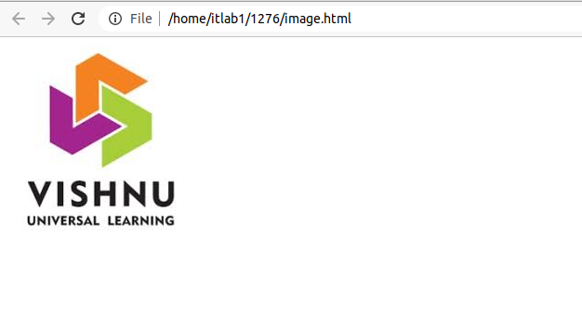
OUTPUT 2:
