PROGRAMM:

<html>
<head>
<title>
lists
</title>
</head>
<body>
engineering colleges
<ol>
<li>BVRITH</li>
<li>BVRIT</li>
<li>VNRVJIT</li>
<li>MLRIT</li>
<li>GNITS</li>
</ol>
Branches:
<ul>
<li>cse</li>
<li>it</li>
<li>ece</li>
<li>eee</li>
<li>aiml</li>
</ul>
</body>
</html>

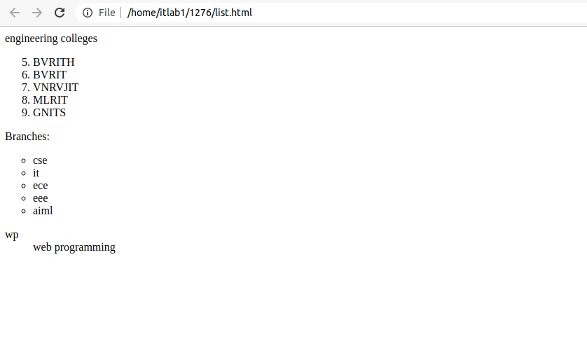
OUTPUT:

