Backend_deployment:

Jar file is in /CAG_NAB_CODE_TEST\BACKEND\target.

Go to the folder and run java -jar currencyAnalyser.jar. this will start back end.

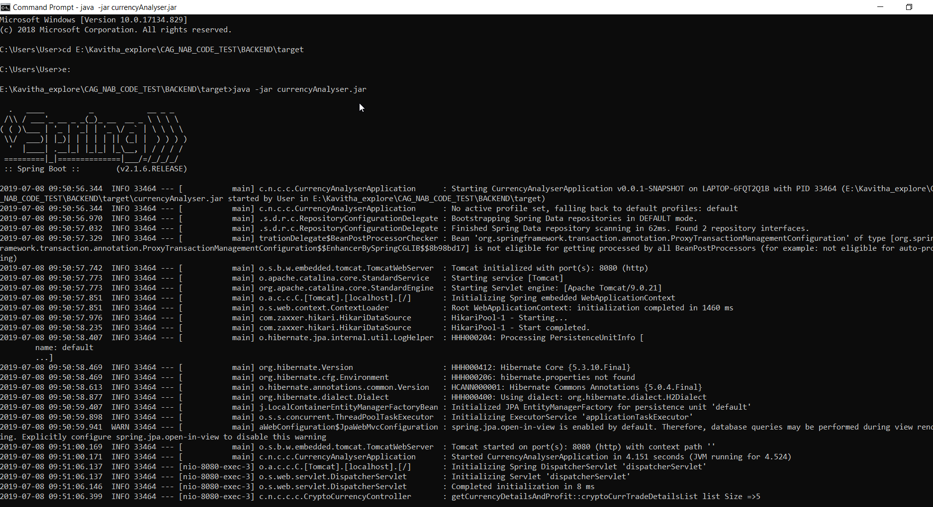

**Front End:**

**Dev node server:**

Import the package in /CAG_NAB_CODE_TEST\FRONTEND\crypto-currencies.

Go to the folder and run ng install , ng serve.

For Production build, run below command. Webpack will create bundles of the project, which creates ‘dist’ folder with all bundles.

Ng build –prod

