**REST API POSTMAN Integration Testing:**

**For BTC:**

**http://localhost:8080/cryptoCurrency/currencyProfitDetails/1**

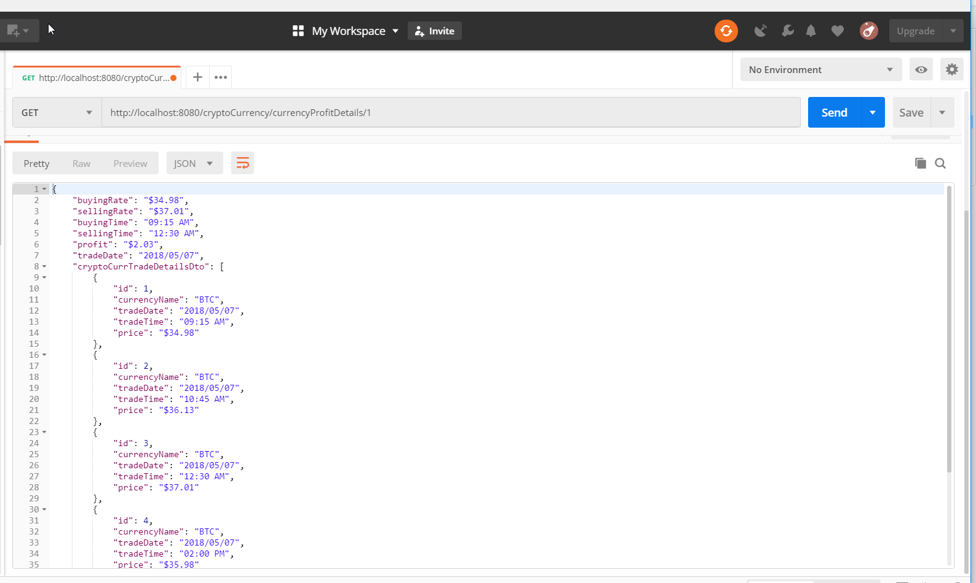

**For ETH:**

**http://localhost:8080/cryptoCurrency/currencyProfitDetails/2**

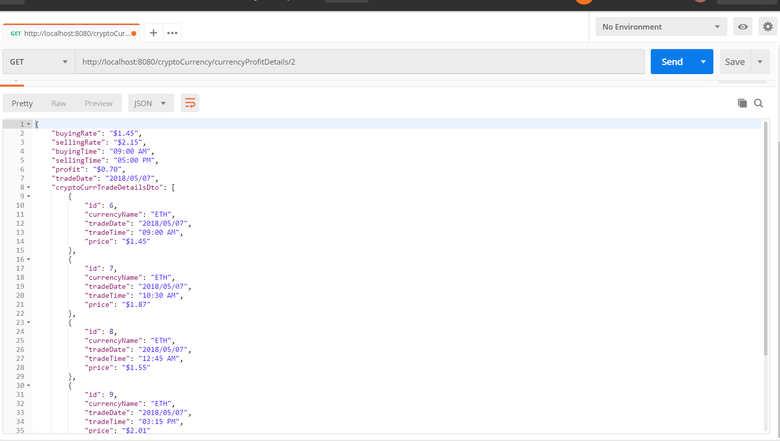

**For LTC**

**http://localhost:8080/cryptoCurrency/currencyProfitDetails/3**

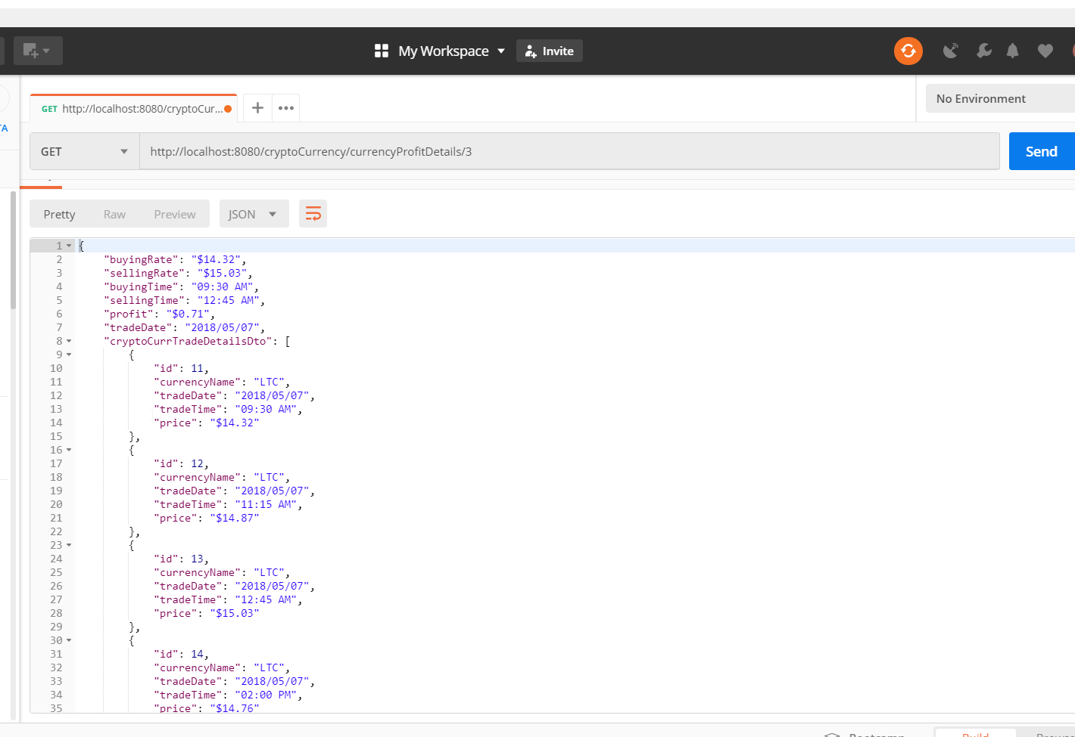

**Unit test case Results:**

