[DigitalContentDeveloper](https://github.com/DigitalContentDeveloper)/[**challenge1**](https://github.com/DigitalContentDeveloper/challenge1)

Challenge:



**I have used following technology Stack:**

**Frontend :** Angular 8.0

Code done with visual studio code.

Backend:

Spring boot 2.1.6.RELEASE (Rest API). Unit Tested using Junit and Mockito. Postman I used for Integration testing. Used eclipse for development. I have used H2 in memory DB.

Back end is running as separate REST API, running 8080 pot in spring boot in built Tomcat server.

Frontend in dev environment runs in node server in 4200 port. Using http calls these two service communicate with each other. So both backend and frontend are running independently.

Back End REST API in Java, running in 8080 port

Frontend Angular 8, running in 4200 port

**When backend server starts , the below highlighted files run and create schema with tables**.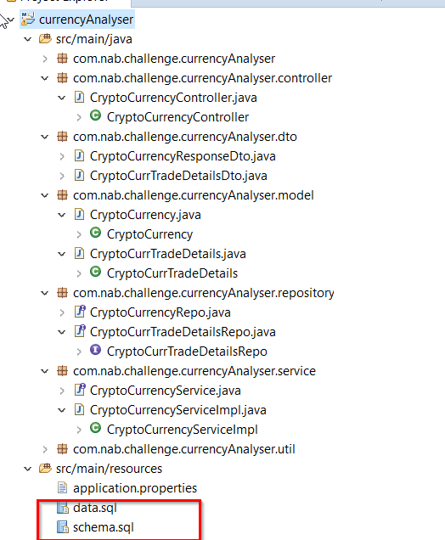

**In Memory DB:**

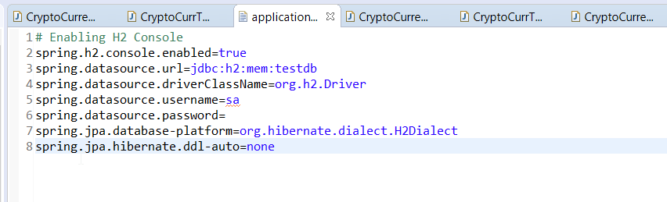

**Frond end:**

Red color highlighted is the component structure. Service are dependency injected to component.

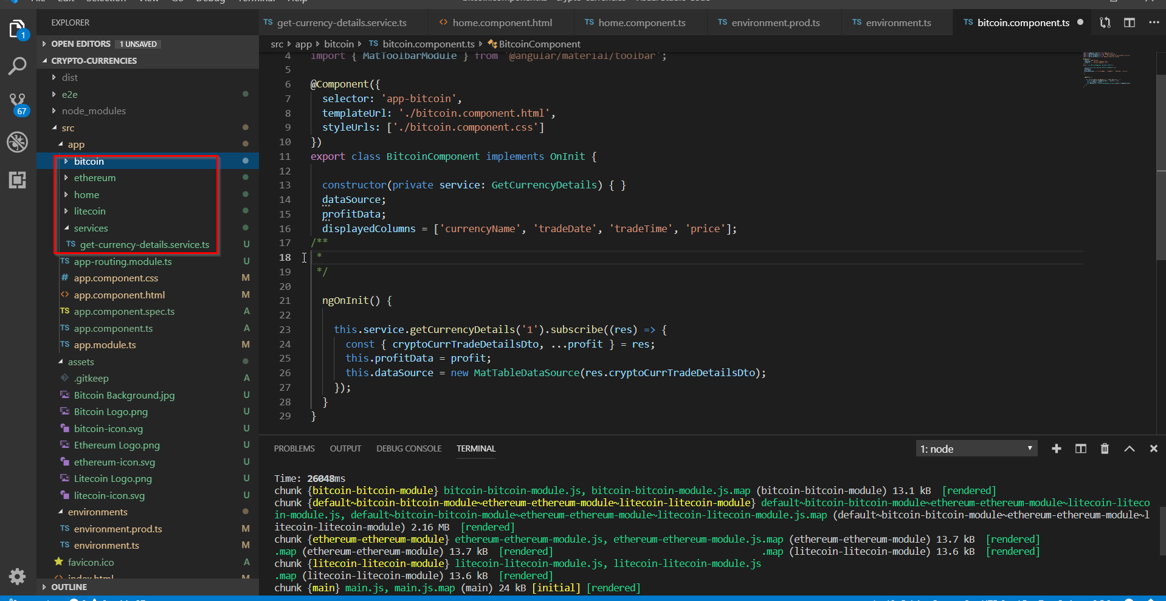

**Back end Package structure:**

