This Grocery Helper project I have designed as a two independent layer. UI is in React JS running in a separate node server and Rest API is running in tomcat server using spring boot. Both are running in different port

<http://localhost:8080> is rest api server ULR.

<http://localhost:3000> is rest UI node URL.

**I have done unit testing and integration testing. Included results in**

REACTJS_UI_Integration_Testing.docx

RestAPIIntegrationTestResult.docx.

**Unit test results:**

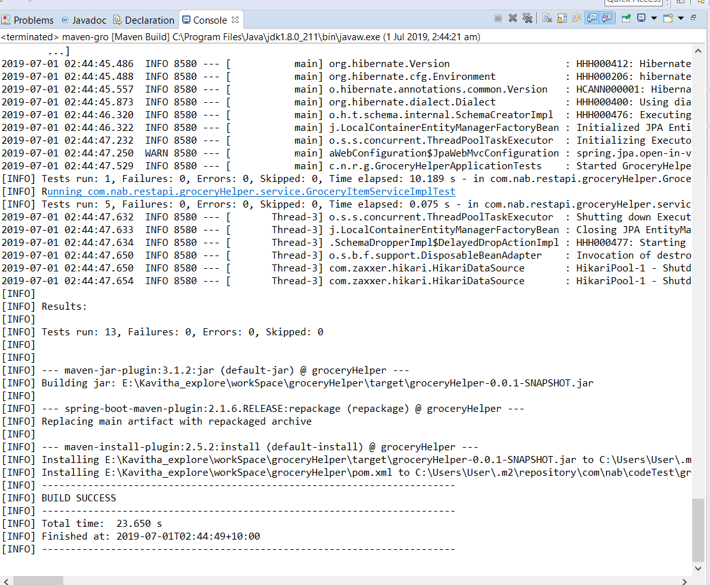

**Local deployment setup:**

**Rest API:**

Source is in JAVA_REST_API folder, in that /groceryHelper/target has jar file.

Check out the folder and go to target folder, run below command,

java -jar groceryHelper-0.0.1-SNAPSHOT.jar

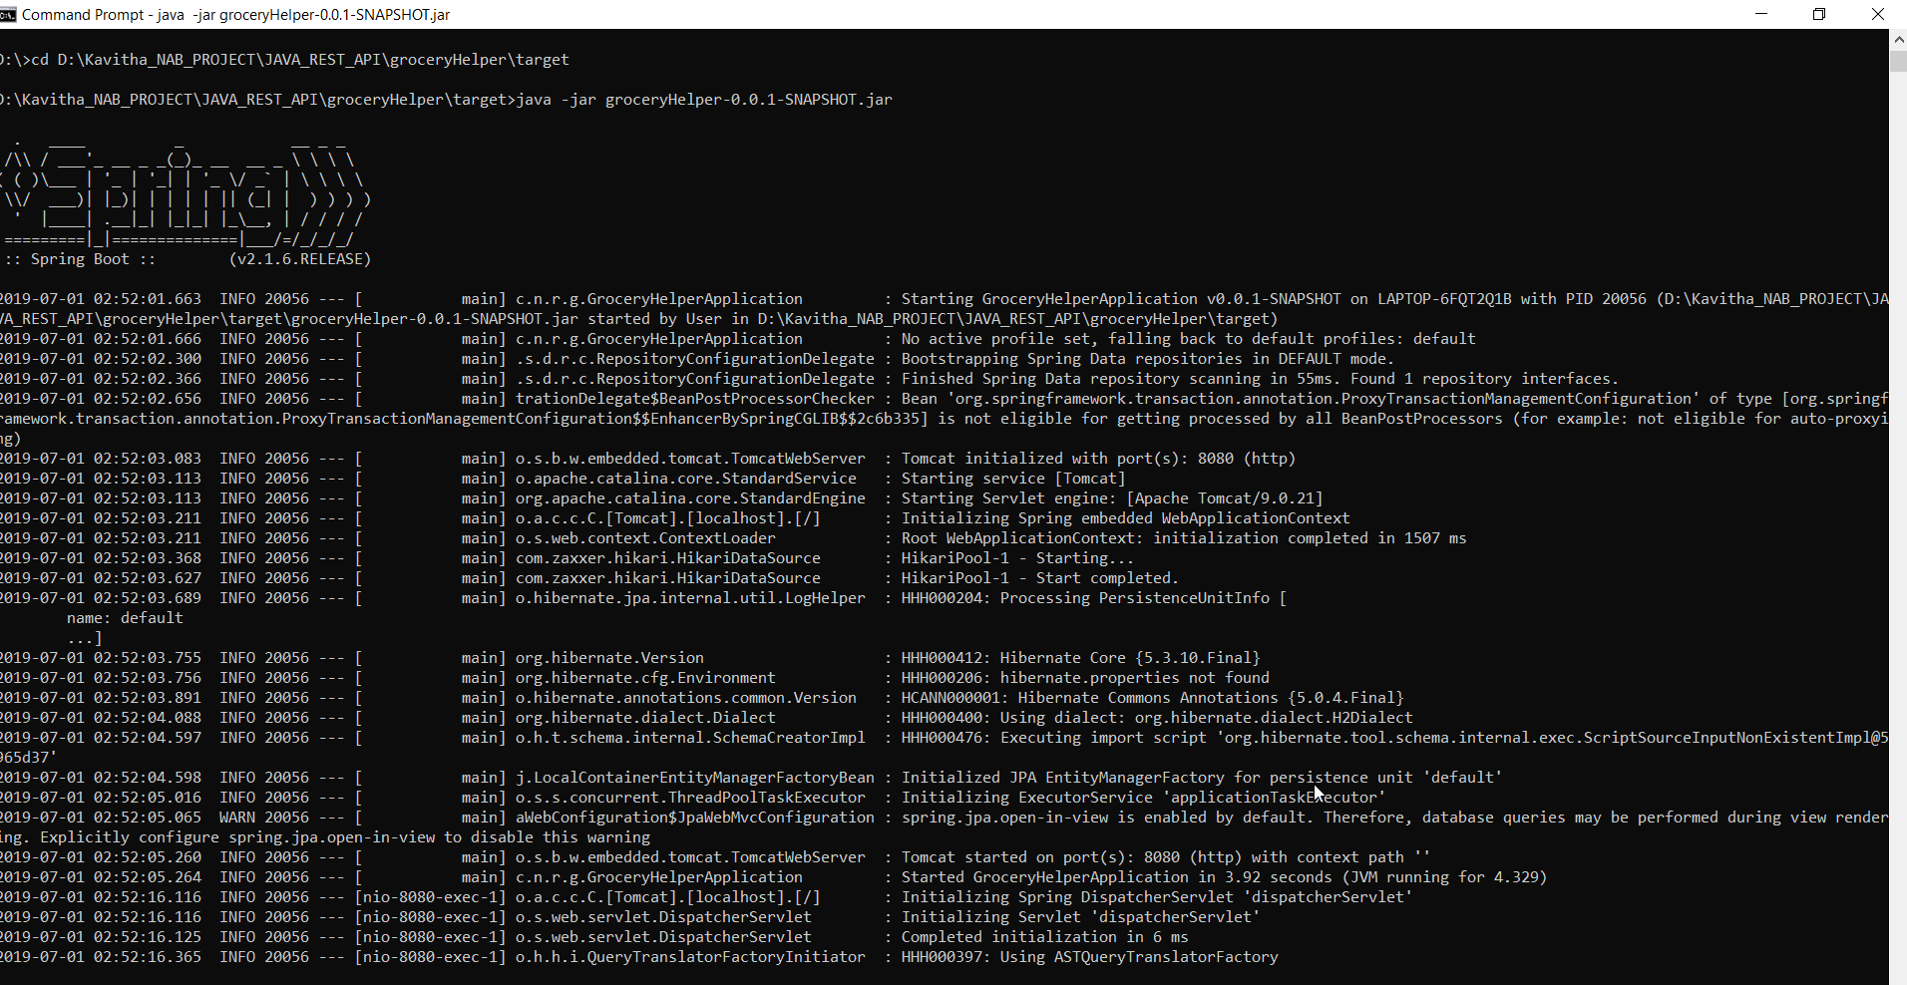

**React UI:**

Check out REACT_UI folder go to \Kavitha_NAB_PROJECT\REACT_UI\**groceryhelpe**r

In cmd , run below command,

**>npm start**

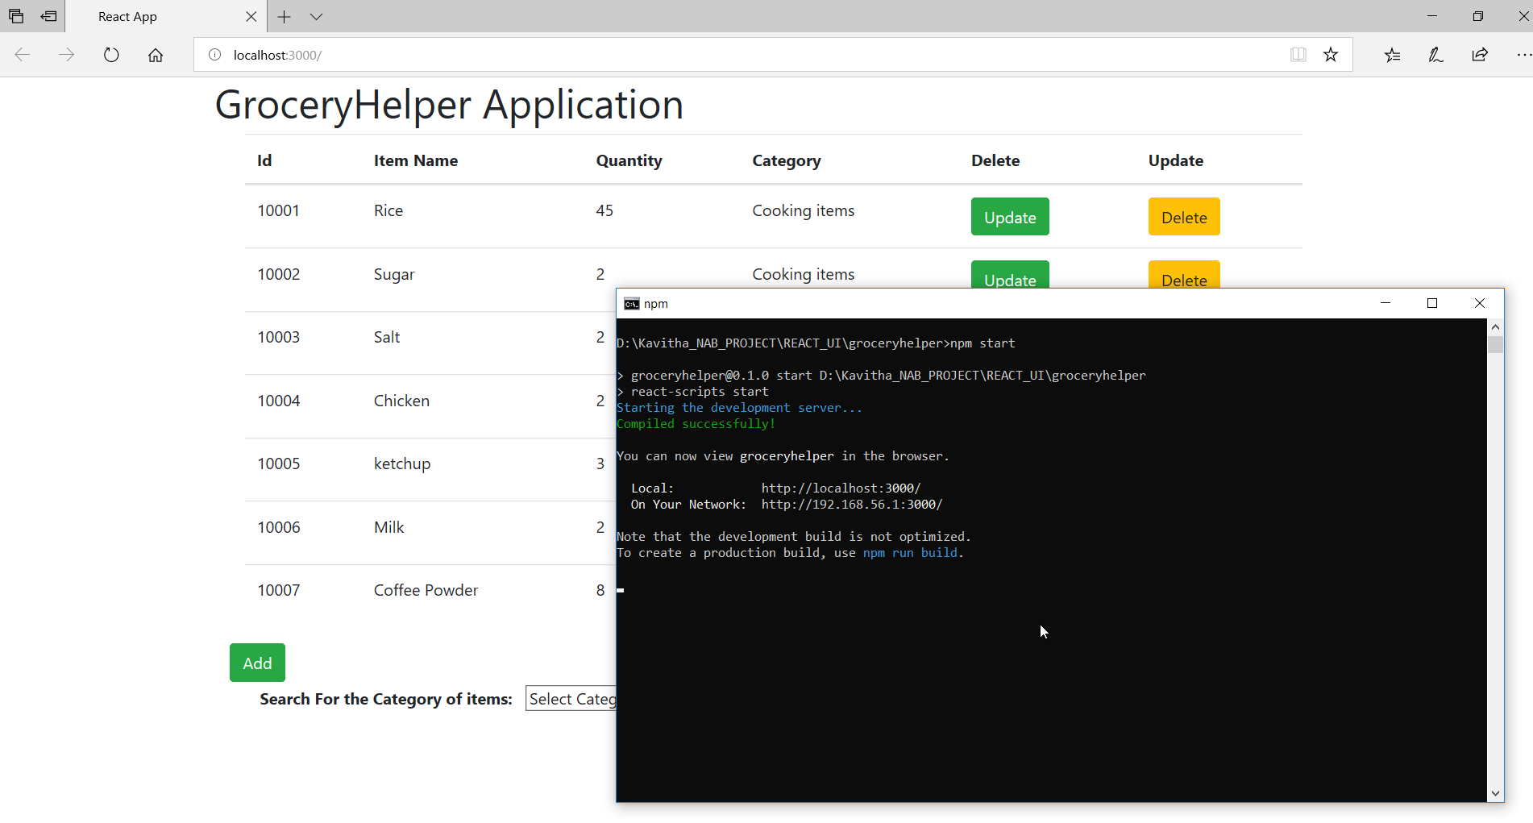

The above command with bring the UI up. Cross orgin feature has been enabled, so Rest API allow RectUI to communicate.