1. **http status 200 response:**

**Input:**

Incoming Json message:==>[{"name":"LOL-palooza","bands":[{"name":"Frank Jupiter","recordLabel":"Pacific Records"},{"name":"Jill Black","recordLabel":"Fourth Woman Records"},{"name":"Winter Primates","recordLabel":""},{"name":"Werewolf Weekday","recordLabel":"XS Recordings"}]},{"name":"Small Night In","bands":[{"name":"Squint-281","recordLabel":"Outerscope"},{"name":"The Black Dashes","recordLabel":"Fourth Woman Records"},{"name":"Wild Antelope","recordLabel":"Marner Sis. Recording"},{"name":"Green Mild Cold Capsicum","recordLabel":"Marner Sis. Recording"},{"name":"Yanke East","recordLabel":"MEDIOCRE Music"}]}]

Size =>7

**Output:**

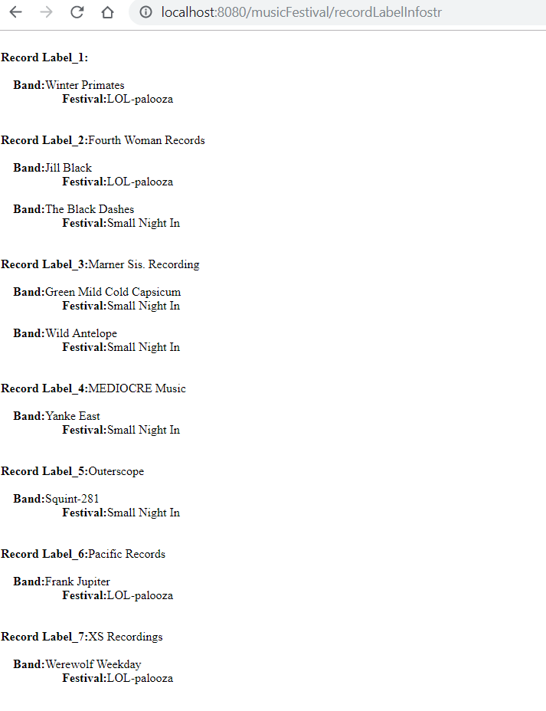

2. **http status 200 response:**

Incoming Json message:==>[{"name":"LOL-palooza","bands":[{"name":"Frank Jupiter","recordLabel":"Pacific Records"},{"name":"Jill Black","recordLabel":"Fourth Woman Records"},{"name":"Winter Primates","recordLabel":""},{"name":"Werewolf Weekday","recordLabel":"XS Recordings"}]},{"name":"Small Night In","bands":[{"name":"Squint-281","recordLabel":"Outerscope"},{"name":"The Black Dashes","recordLabel":"Fourth Woman Records"},{"name":"Wild Antelope","recordLabel":"Marner Sis. Recording"},{"name":"Green Mild Cold Capsicum","recordLabel":"Marner Sis. Recording"},{"name":"Yanke East","recordLabel":"MEDIOCRE Music"}]},{"name":"Trainerella","bands":[{"name":"Wild Antelope","recordLabel":"Still Bottom Records"},{"name":"Manish Ditch","recordLabel":"ACR"},{"name":"YOUKRANE","recordLabel":"Anti Records"},{"name":"Adrian Venti","recordLabel":"Monocracy Records"}]},{"name":"Twisted Tour","bands":[{"name":"Auditones","recordLabel":"Marner Sis. Recording"},{"name":"Summon","recordLabel":"Outerscope"},{"name":"Squint-281"}]},{"bands":[{"name":"Critter Girls","recordLabel":"ACR"},{"name":"Propeller","recordLabel":"Pacific Records"}]}]

**Size =>11**

**Record Label_1:**  
  
 **Band:**Squint-281  
     **Festival:**Twisted Tour  
  
 **Band:**Winter Primates  
     **Festival:**LOL-palooza  
  
  
**Record Label_2:**ACR  
  
 **Band:**Critter Girls  
     **Festival:**  
  
 **Band:**Manish Ditch  
     **Festival:**Trainerella  
  
  
**Record Label_3:**Anti Records  
  
 **Band:**YOUKRANE  
     **Festival:**Trainerella  
  
  
**Record Label_4:**Fourth Woman Records  
  
 **Band:**Jill Black  
     **Festival:**LOL-palooza  
  
 **Band:**The Black Dashes  
     **Festival:**Small Night In  
  
  
**Record Label_5:**Marner Sis. Recording  
  
 **Band:**Auditones  
     **Festival:**Twisted Tour  
  
 **Band:**Green Mild Cold Capsicum  
     **Festival:**Small Night In  
  
 **Band:**Wild Antelope  
     **Festival:**Small Night In  
  
  
**Record Label_6:**MEDIOCRE Music  
  
 **Band:**Yanke East  
     **Festival:**Small Night In  
  
  
**Record Label_7:**Monocracy Records  
  
 **Band:**Adrian Venti  
     **Festival:**Trainerella  
  
  
**Record Label_8:**Outerscope  
  
 **Band:**Squint-281  
     **Festival:**Small Night In  
  
 **Band:**Summon  
     **Festival:**Twisted Tour  
  
  
**Record Label_9:**Pacific Records  
  
 **Band:**Frank Jupiter  
     **Festival:**LOL-palooza  
  
 **Band:**Propeller  
     **Festival:**  
  
  
**Record Label_10:**Still Bottom Records  
  
 **Band:**Wild Antelope  
     **Festival:**Trainerella  
  
  
**Record Label_11:**XS Recordings  
  
 **Band:**Werewolf Weekday  
     **Festival:**LOL-palooza

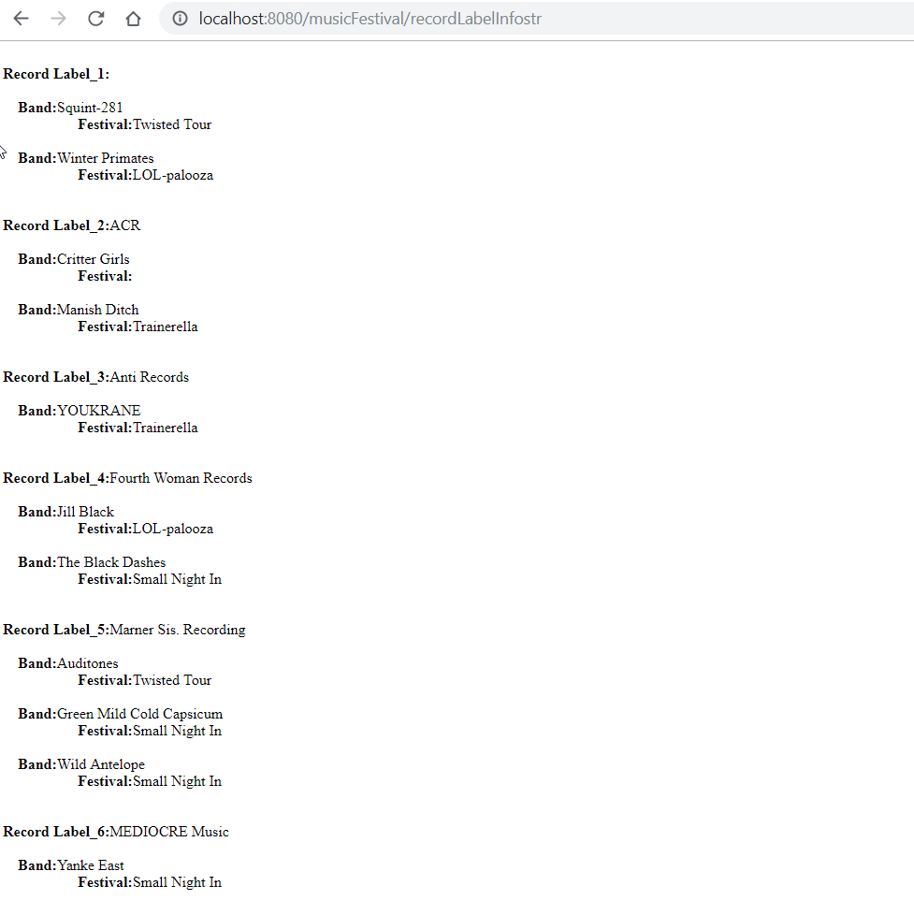

1. **Http status 429( too many request)**

**Input:**

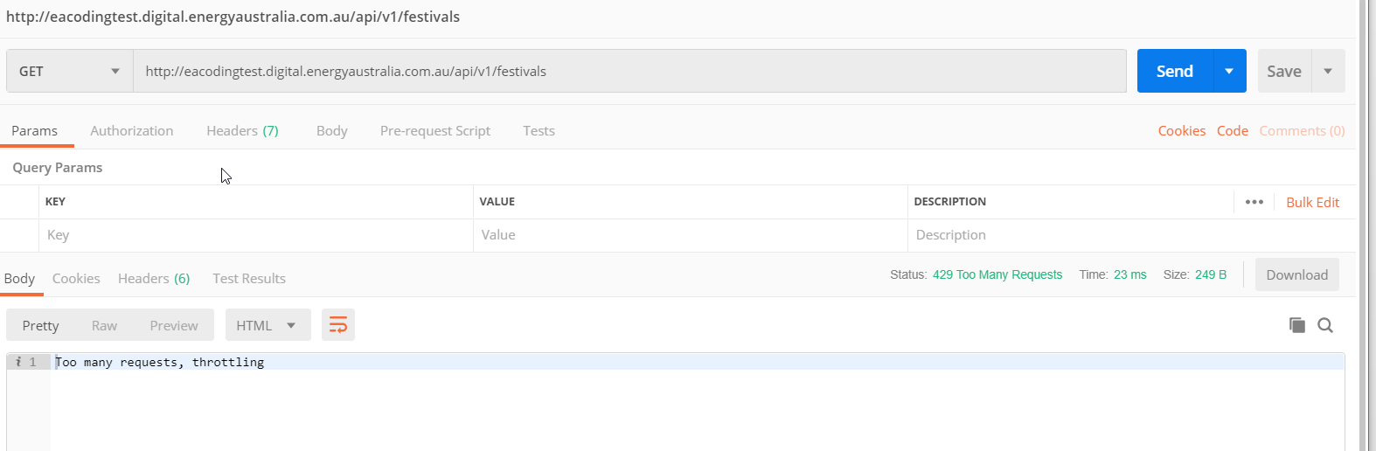

**Output:**

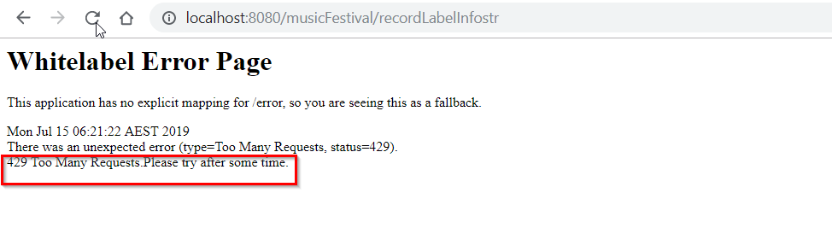

1. **Http status ok. But empty response.**

**Input:**

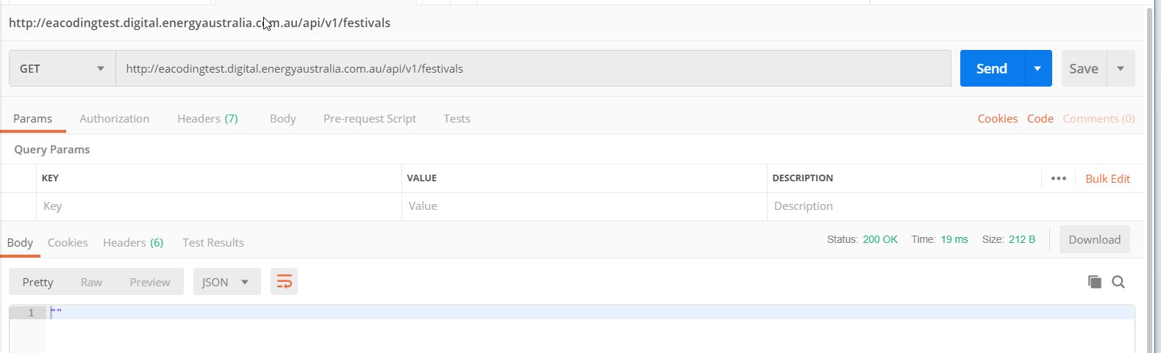

**Output:**

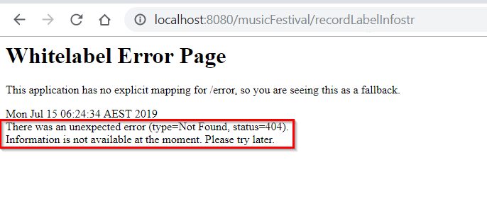

**5.Http status 200 , for different input**

**Input:**

Incoming Json message:==>[{"name":"LOL-palooza","bands":[{"name":"Jill Black","recordLabel":"Fourth Woman Records"},{"name":"Frank Jupiter","recordLabel":"Pacific Records"},{"name":"Werewolf Weekday","recordLabel":"XS Recordings"},{"name":"Winter Primates","recordLabel":""}]}]

Size =>4

**Output:**

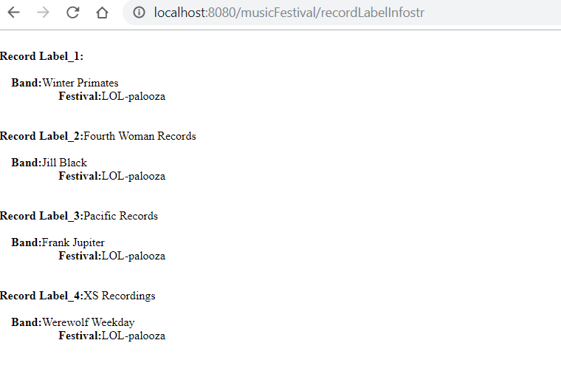

**Incoming Json message:==>[{"**bands":[{"name":"Critter Girls","recordLabel":"ACR"},{"name":"Propeller","recordLabel":"Pacific Records"}]}]

Size =>2

**Output**

