**Introduction:**

I have solved this problem using spring boot rest API with java 8. The output is played in a web page both as html content and JSON. So two API URLs are exposed.

**Deploy and run:**

Since it is spring boot, it has in build tomcat. Need to run jar file in /SolutionCode/target/musicfestival.jarby following command,

java -jar musicfestival.jar.

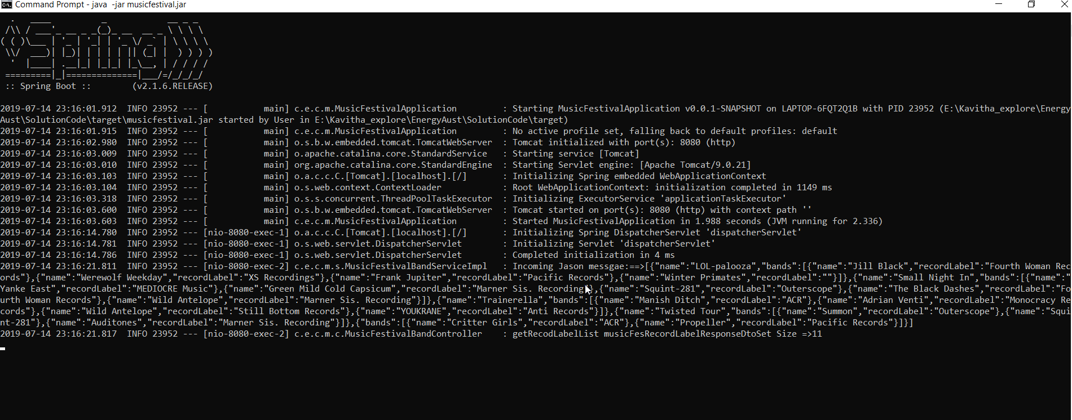

Note:

While importing project to eclipse, if there is any error in pom, please update maven project.

<http://localhost:8080/musicFestival/recordLabelInfostr>

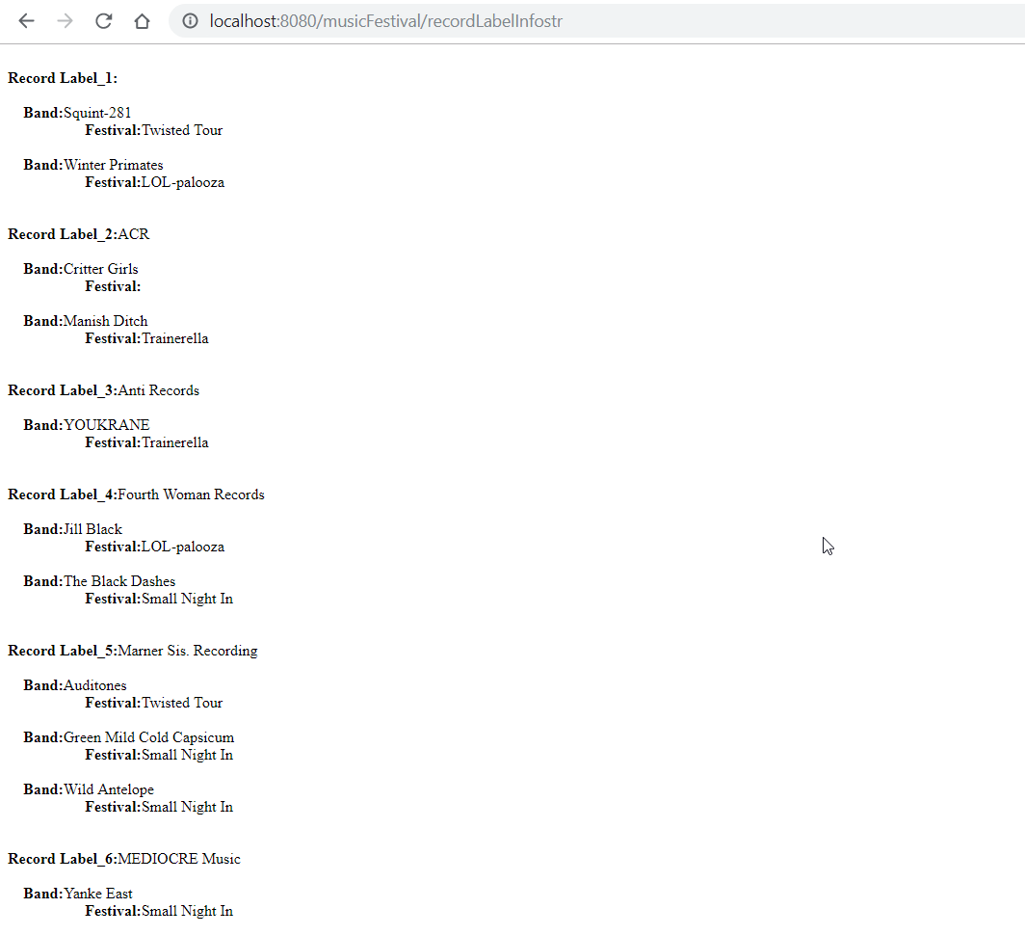

<http://localhost:8080/musicFestival/recordLabelInfo>

