What is Front end?

Front end is an application that the users can see either running in their computer or in a web page. Front end contains no business logic, it only captures user requests & interactions, forwards to the back end for processing and then the corresponding results back to the user.

What is Back end?

Back end implements the business logic (i.e. how to process data), stores and retrieves the data.

There can be different front ends (i.e. a website, mobile app, desktop app) or multiple instances of the same front end running in different machines (e.g. Adobe Acrobat Reader) connecting to the same backend.

In software world, we describe this as a 3-tier architecture, where the first tier is the front end and the 2nd and 3rd tiers the back end. I have drawn this diagram to explain the process clearly.

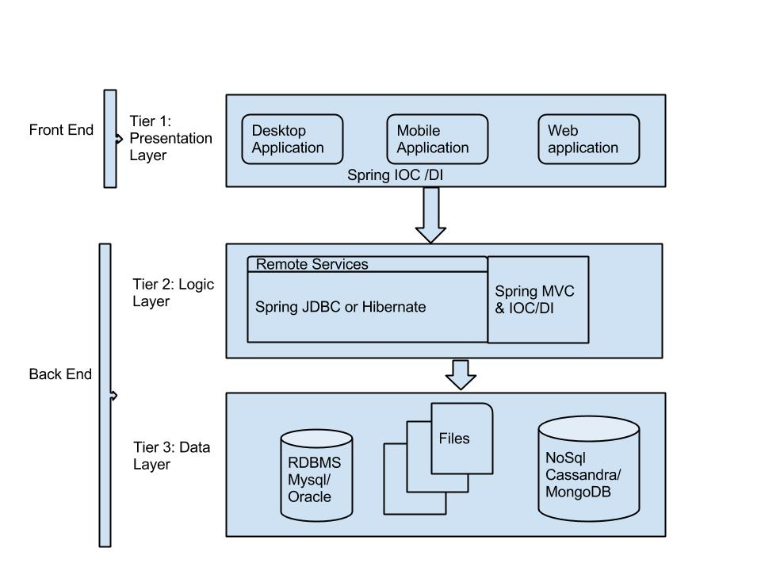

tier 1: Presentation layer- can be a web application or you can implement the app using Java Swing. You can also use the spring framework which provides IOC/DI Dependency Injection which allows the code to be modularized (organize into proper modules for flexibility and reusability)

tier 2: logic tier is where all the business logic is implemented. It controls the application’s functionality by performing detailed processing. It can expose remote services to the front end using which front end communicates and uses the data for presentation. You can use Spring framework IOC/DI and also the utilities provided by Spring one of which is SpringJDBC or Hibernate to communicate to the database. Spring MVC for web applications.

tier 3: Data tier is where the data is stored. Data stores can range from simple files to well-structured relational databases like MySQL, Oracle etc.