Azure Spring Project Deployment Guide

Overview

In this document, we will cover the required to deploy a Springboot project on Azure Cloud.

Note that a limitation of deploying to Azure is that the Springboot project must be compiled on either **Java version 8 or 11** only.

|  |  |
| --- | --- |
|  |  |
| Section A | Getting an Azure Student Account |
| Section B | Creating Azure Spring Cloud |
| Section C | Creating MySQL Database |
| Section D | Preparing Springboot project for deployment |
| Section E | Deploy Springboot project |
|  |  |

Section A - Getting an Azure Student Account

1. Visit <https://azure.microsoft.com/en-us/free/students/>and click the button **[ Activate Now > ]**.

1. Sign in using your RP account 19NNNNNN@myrp.edu.sg and password. You will be presented a page where you can enter your personal particulars.

1. Do the following data inputs under **About you**
   1. **Country/Region**: Select Singapore.
   2. **First name**:
   3. **Last name**:
   4. **Email address**: Enter the same RP email address in Step 2
   5. **Phone**: Enter your 8 digit mobile phone
   6. Click on the button **[ Next ]**

1. Do the following data inputs under Agreement
   1. Check the two check boxes.
   2. Click on the button **[ Sign up ]**

1. You will be redirected the Welcome to Microsoft Azure page. Click on the button **[ Maybe later ]**.

1. From the menu at the top-right corner, click **Home**
2. Click  and you should see a new subscription created for you.



Section B - Creating Azure Spring Cloud

1. Once logged into Azure portal, you will see the screenshot similar to below.

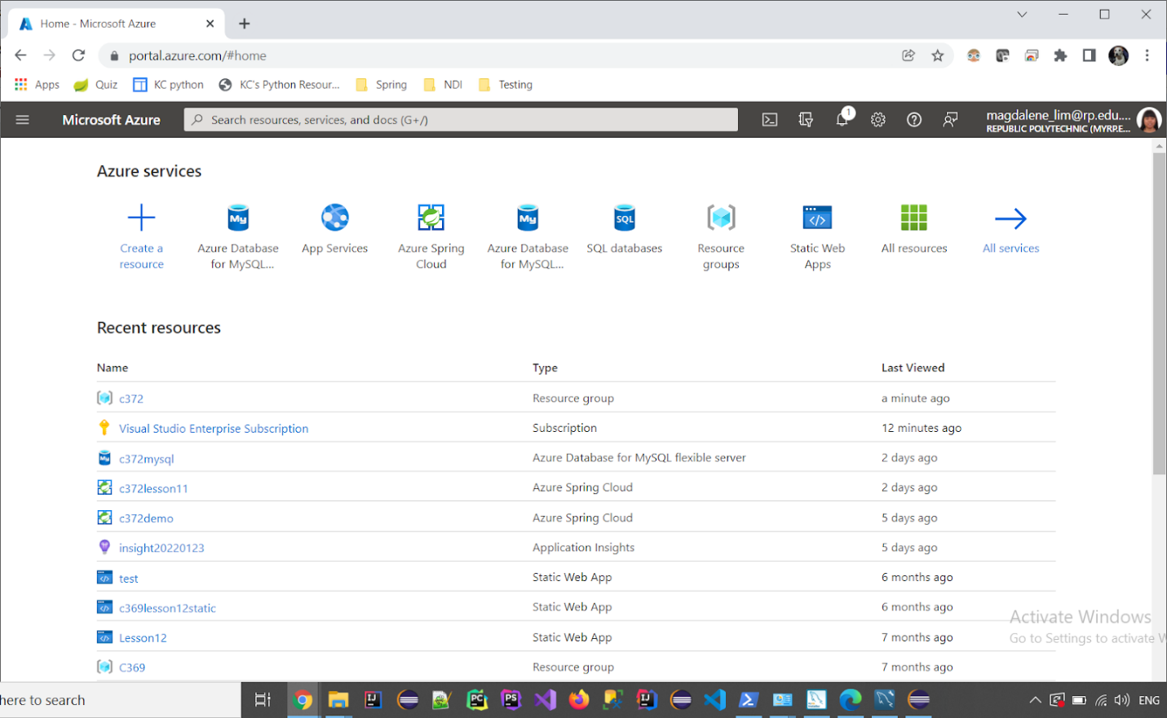

1. Click **Create a resource**



1. In the **Create a resource page**, enter **Azure Spring Cloud** in the search bar and select **Azure Spring Cloud.**

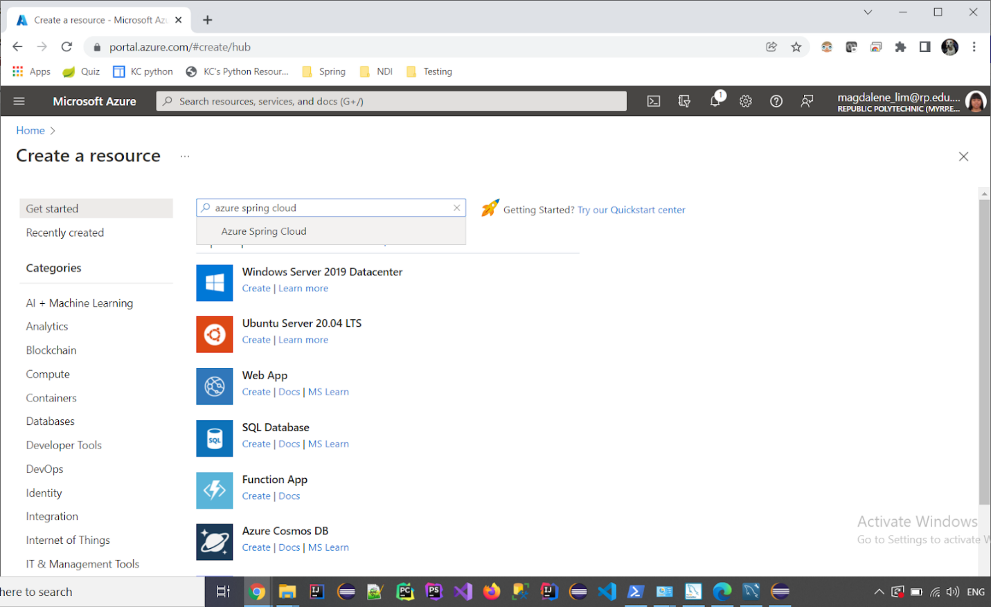

1. Click **Create**

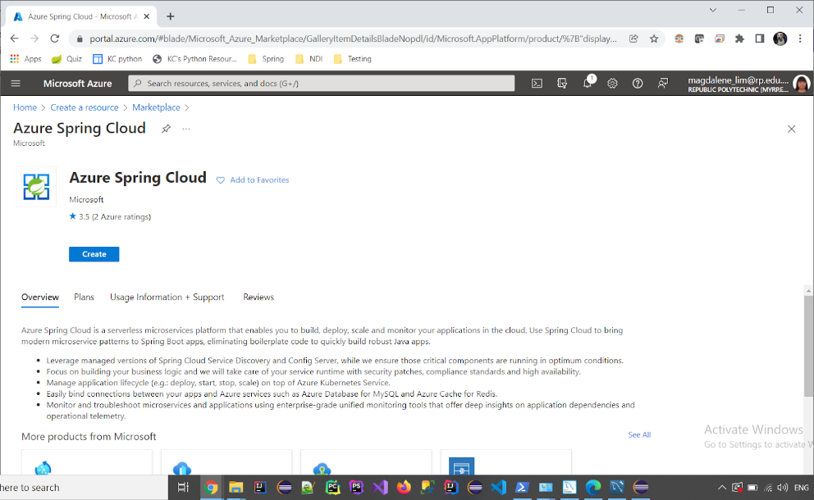

1. In the configurations that comes up in **Project Details**,
   1. Under **Subscription**, select **Azure for Students**
   2. Under **Resource group**, click **Create new** and enter **c372** as the Name, click **OK**

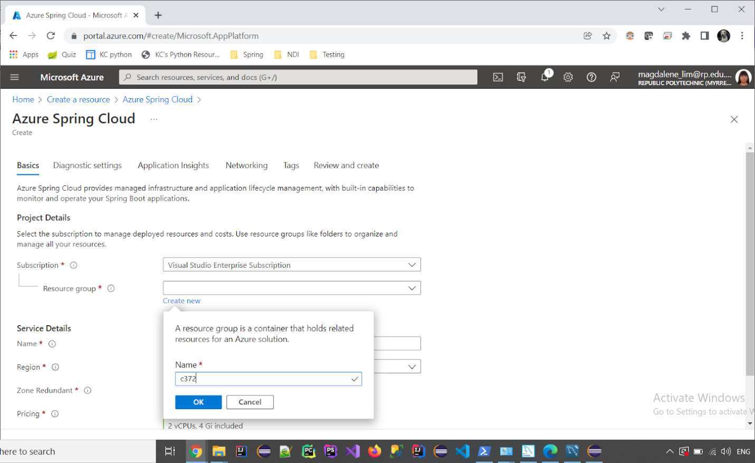

1. In **Service Details**,
   1. Under **Name**, enter **c372projects**
   2. Under **Region**, select **East US**

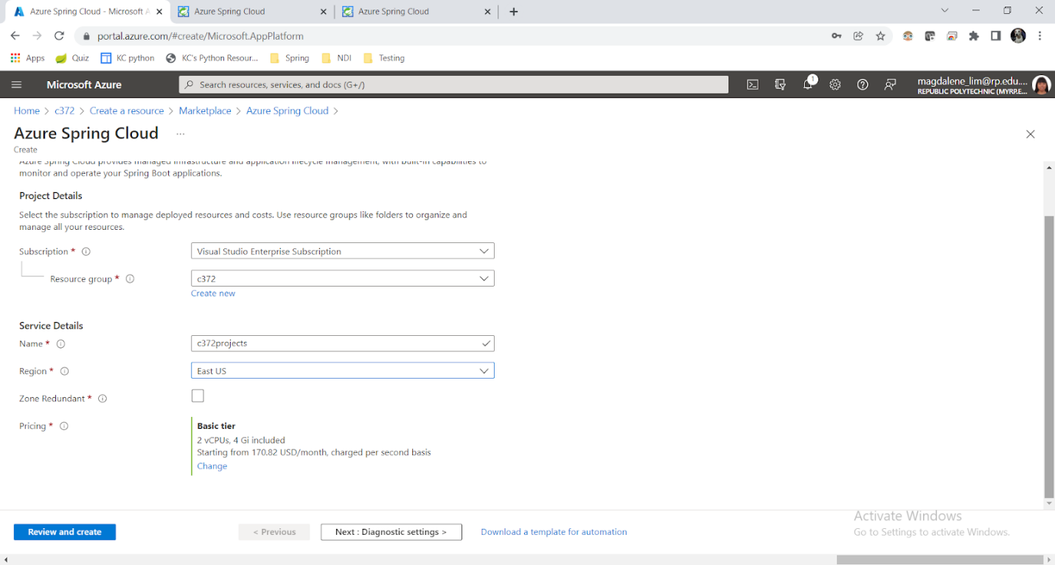

1. Click **Review and Create**



1. The resource group will take a while to be created and deployed. You will receive a notification once it is done.

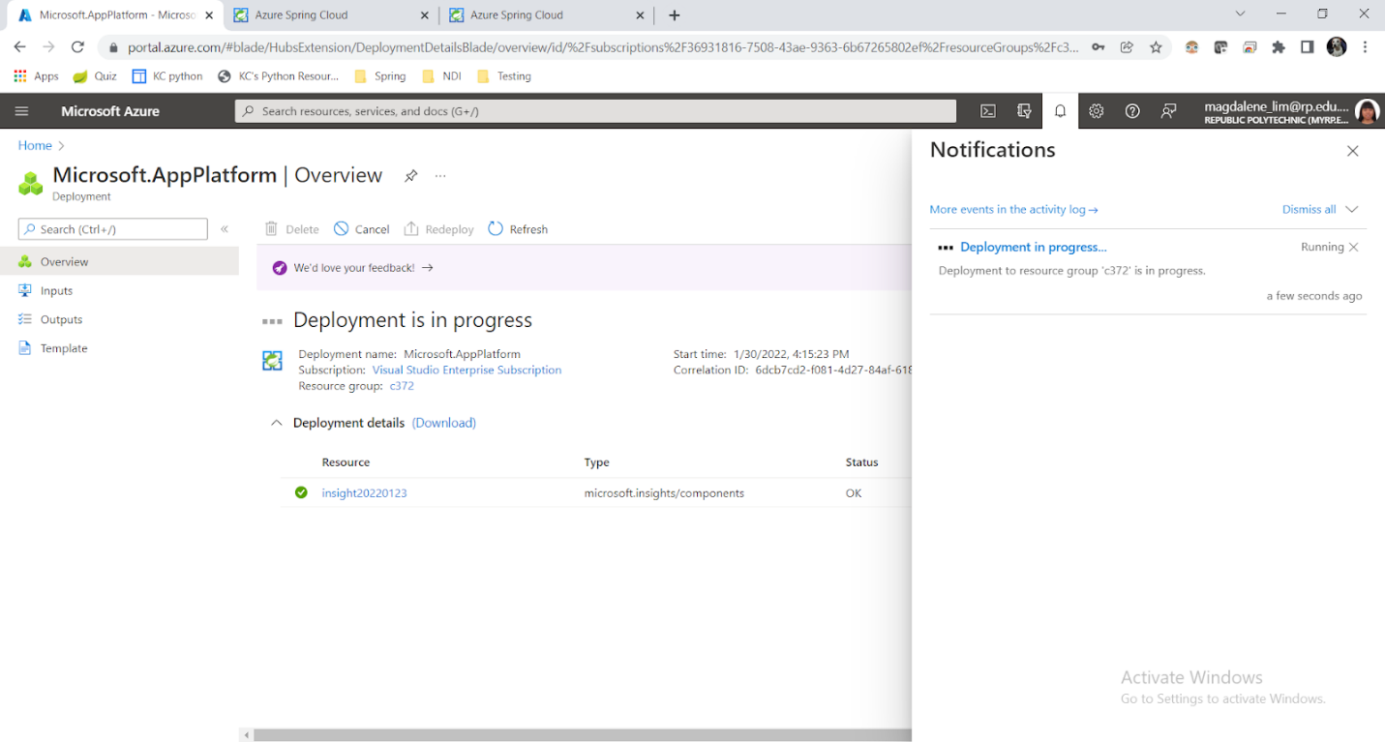

1. Once completed, you should see this a similar screen to below.

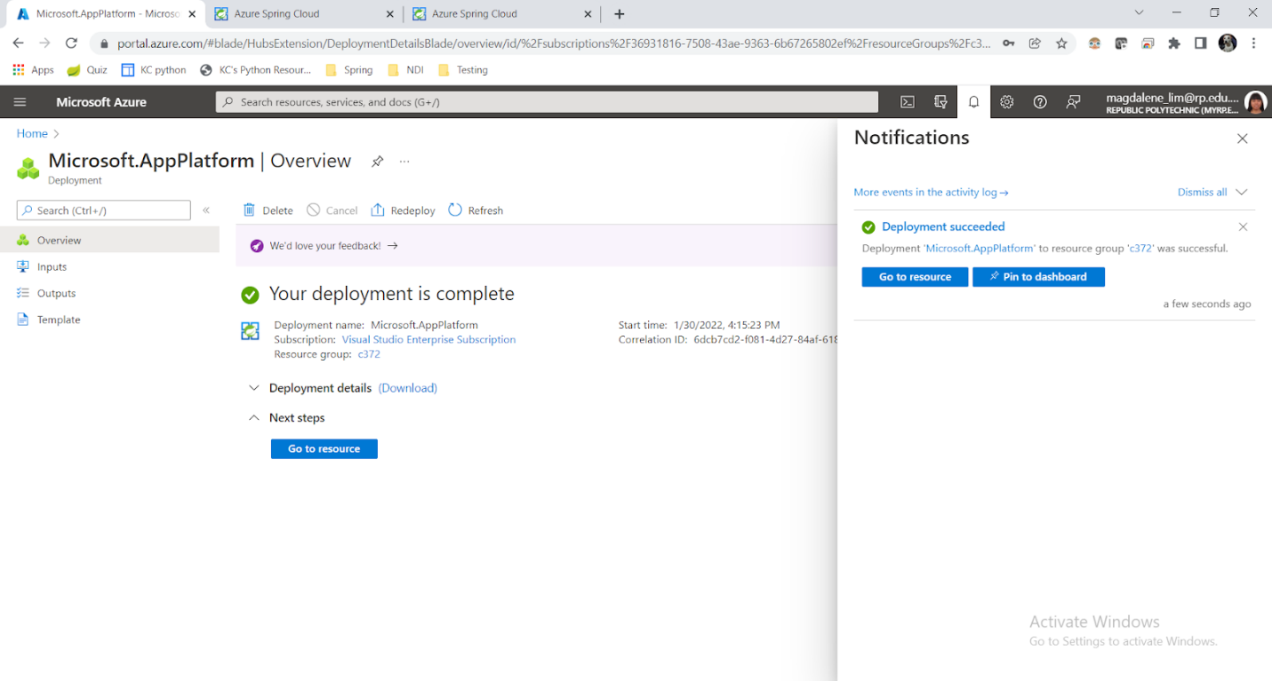

Section C - Creating MySQL Database

1. Go back to Azure portal homepage.



1. Click **Create a resource**



1. In the **Create a resource page**, enter **Mysql** in the search bar and select **Azure Database for MySQL**

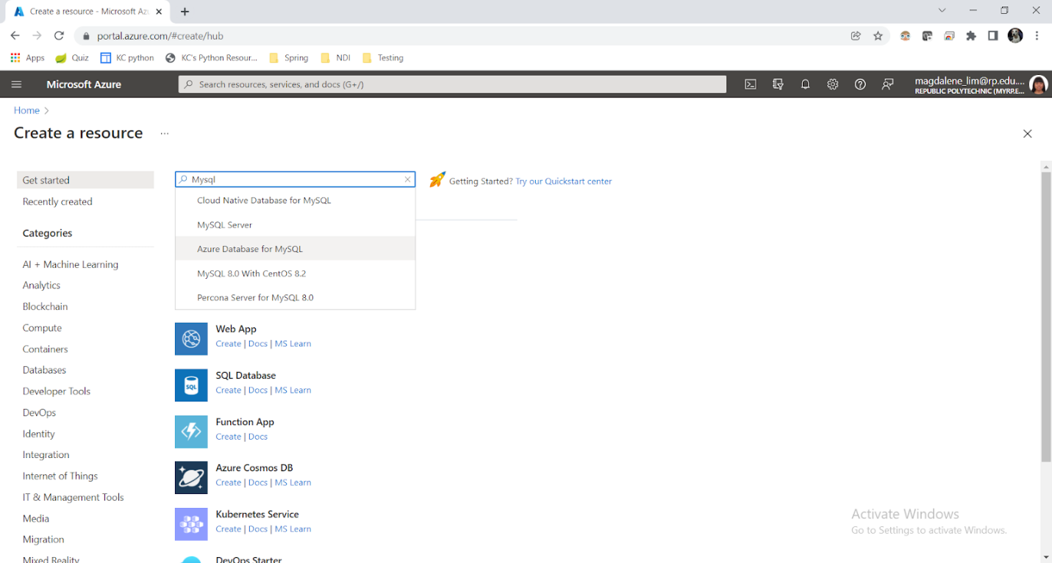

1. Click **Create**

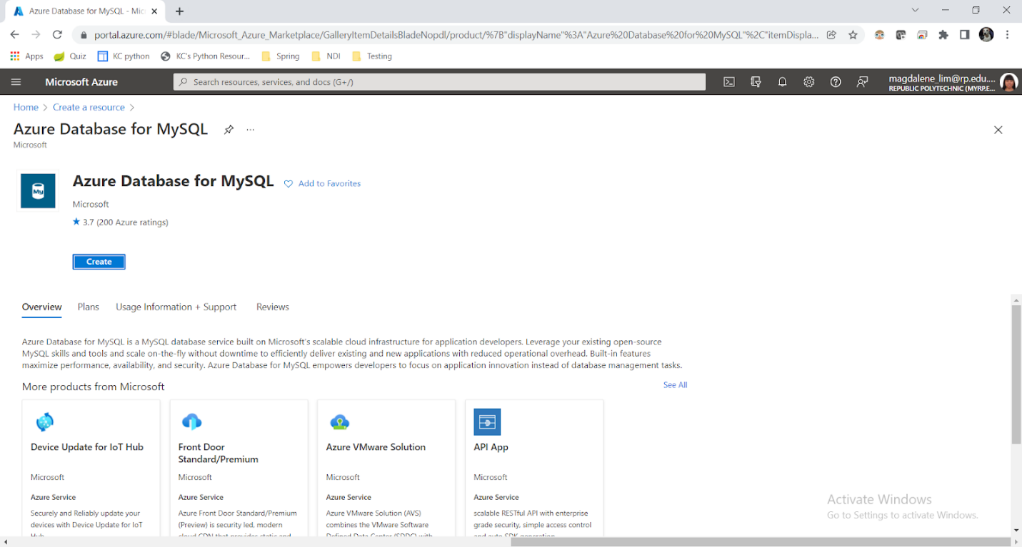

1. In the page below, select **Create** for the **Flexible server**

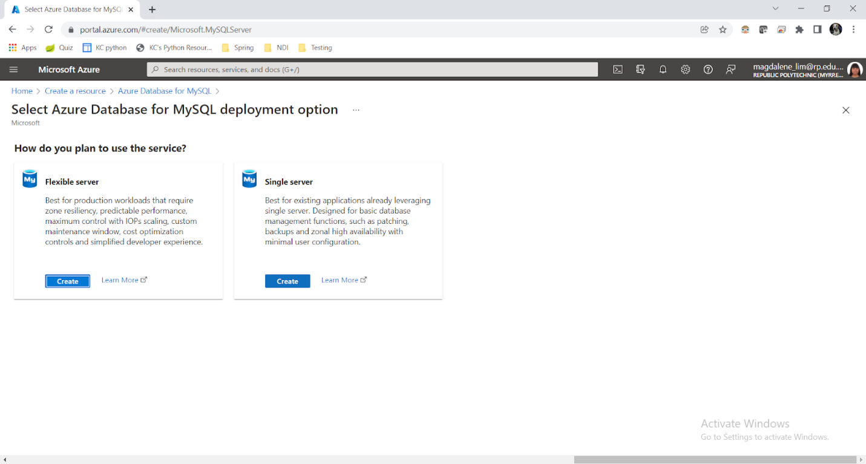

1. In the **Basics** tab, in **Project Details**,
   1. Under **Subscription**, select **Azure for Students**
   2. Under **Resource group**, select **c372**

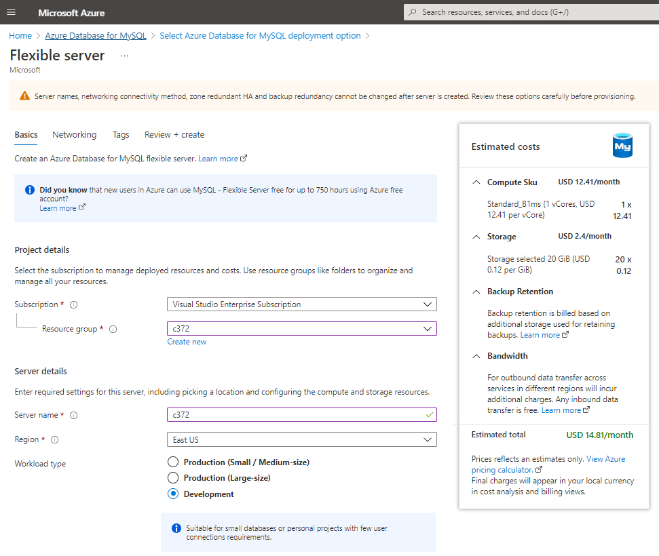

1. In the **Basics** tab, in **Server Details**,
   1. Under **Server name**, enter **c372mysql**
   2. Under **Region**, select **East US**
   3. Under **Workload type**, select **Development**
   4. Under **Compute + storage**, leave it if it is similar to the screenshot. Otherwise, click on **configure server** to select the lowest setting.
   5. Under **Availability**, leave it as **No preference**
   6. Under **MySQL version**, select **5.7** (Note, we are not using version 8 as workbench will only work with version 5)

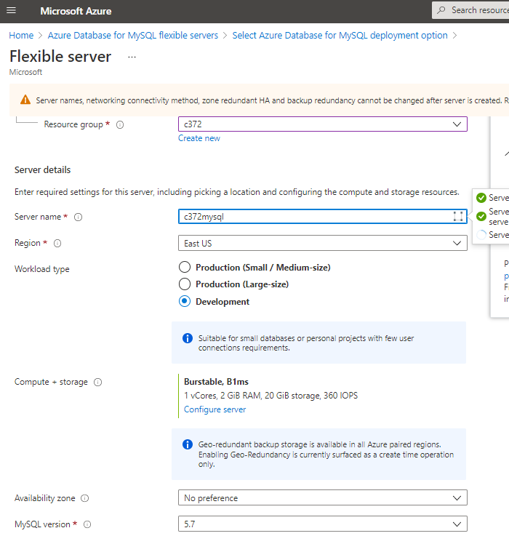

1. In the **Basics** tab, in **High Availability** and **Administrator** account:
   1. Do not check **Enable high availability**
   2. Create an admin username and password. (Note this down)

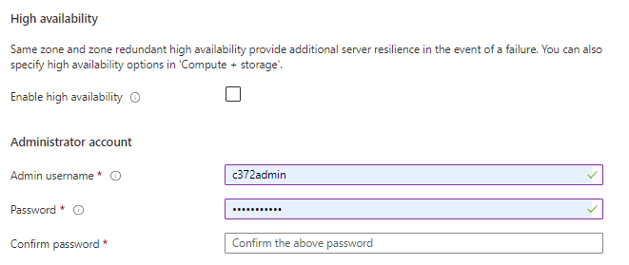

1. In the **Networking** tab,
   1. Under **Network connectivity**, select **Public access**
   2. Under **Firewall rules**, check **Allow public access ….**
   3. Under **Firewall rules**, click **Add current client IP**

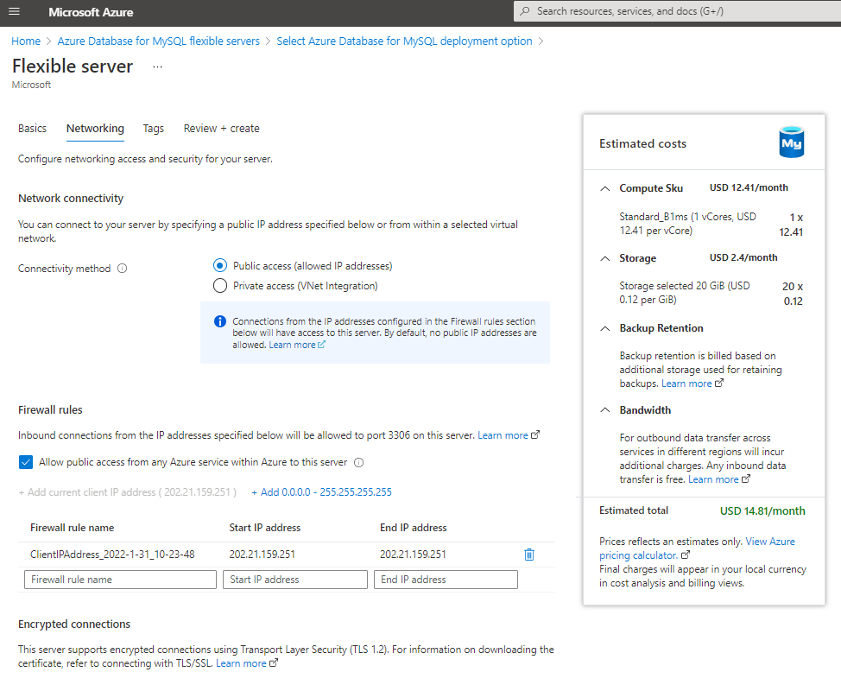

1. Click **Review and create**
2. After the settings are validated, click **Create**
3. Creation and Deployment of the database will take a while. You will receive a notification once deployed.
4. Once deployed, go to the database resource to get the server name. Do make a note of it as you will need to use it later.

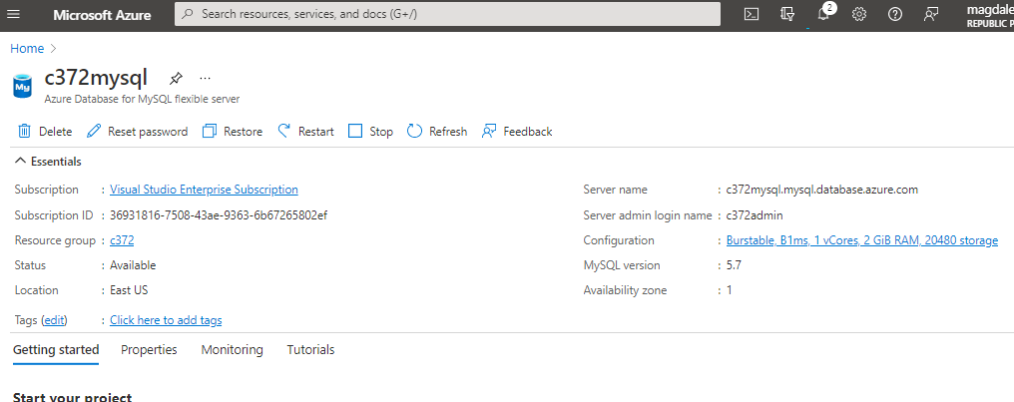

1. Start MySQL Workbench, click on the + symbol to create a new connection

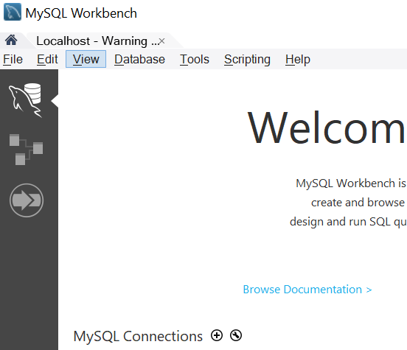

1. Enter connection details similar as shown.
   1. Under **Hostname**, use the database hostname from step 13
   2. Under **username**, use the username that you set.
   3. The password will be prompted

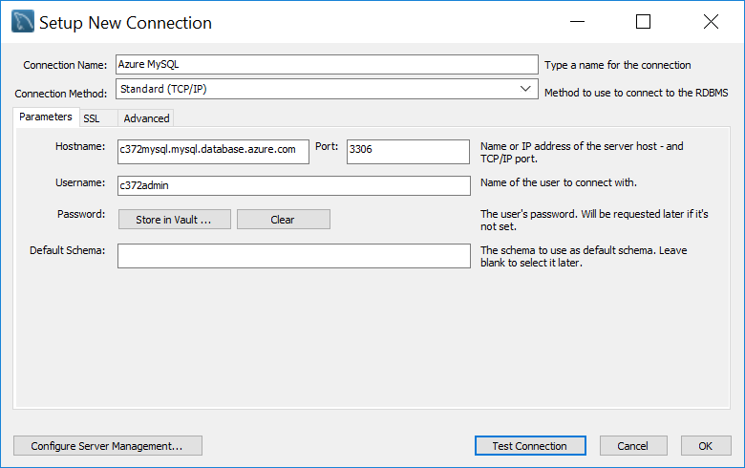

1. Click **Test Connection** to check that the connection works. (Note, this may not work if using RP network)
2. Click **OK**
3. You can use workbench as per how you normally do it.
4. Create a database named **c372** (Or the same name as you use in the local MySQL)

Section D - Preparing Springboot project for deployment

In pom.xml, you should remove dependencies that are not required when deploying to reduce the size of the upload. For e.g. spring-boot-devtools is only helpful during development.

1. In **application.properties**, you will need to update the mysql database host.
2. Comment the existing configurations for mysql.

Note:

* When you are working on localhost, you will need to switch back to this
* Use the database hostname, username and password from the previous section

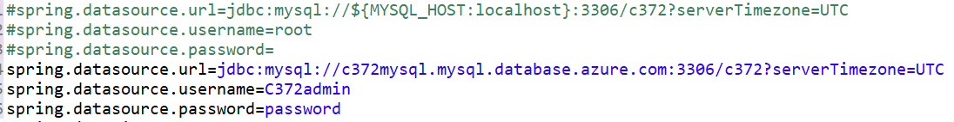

//change project JRE

Section E - Deploy Springboot project

Before you start this section, you will need to:

* Install Azure CLI, get it here: <https://docs.microsoft.com/en-us/cli/azure/install-azure-cli-windows?tabs=azure-cli>
* Ensure that Azure MySQL is started

1. Start Windows PowerShell and change directory to your project folder.
   1. To find your project folder, in Eclipse, right click on the project, select Properties
   2. You will see the location of your code, copy that location
   3. Use the cd command in PowerShell to change directory to that folder
2. In PowerShell, ensure that you are inside the project folder and type the following command to package the project into a JAR file:

mvn clean package -DskipTests

1. In Eclipse, refresh your project, you should see the JAR file created.

Note the name of the JAR file as you will need to use it later.

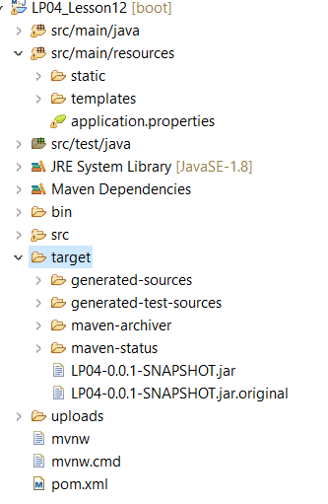

1. In Powershell, login to azure by executing the command:

az login

1. You will be prompted to login on a web browser, use the same login details as you do for the Azure Portal.
2. Onced logged in, you will see the output similar to below:

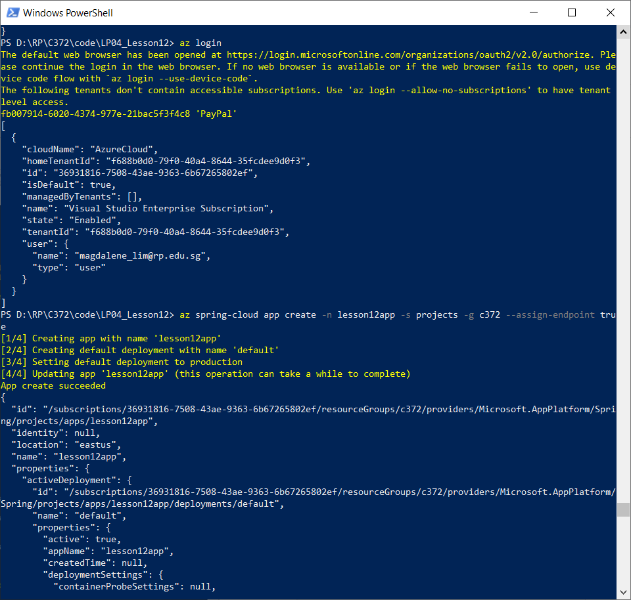

1. To create an app, use the command below:

az spring-cloud app create -n <app name> -s <service name> -g <resource group name> --assign-endpoint true --runtime-version=Java_11

Note:

* Replace <app name> with something suitable such as lesson12
* Replace <service name> with the name of the Azure Spring Cloud created earlier in **Section B**. In this document, we called it c372projects.
* Replace <resource group name> with the resource group created earlier in **Section B** In this document, we called it c372.
* If your project is compiled with Java 8, then omit --runtime-version=Java_11

1. To deploy the app, use the command below:

az spring-cloud app deploy -n <app name> -s <service name> -g <resource group name> --artifact-path target/<JAR file name> --verbose

Note:

* Replace JAR file name with the actual JAR name found in the project target folder in Eclipse. E.g. LP04-0.0.1-SNAPSHOT.jar

1. To check the logs in case of any issue, use the command:

az spring-cloud app logs -<app name> -s <service name> -g <resource group name>

* Set up azure spring cloud instance
* Setup azure mysql
  + Configure networking settings to public
* Update springboot app application.properties
* Test azure mysql works in workbench
* Install azure client
* Use powershell to access azure client
  + Create app with endpoint on azure
  + Jar springboot project
  + Deploy to azure
* Stop or remove resources when not needed

**Need to use either Java 8 or 11**