**Setting Authorship of files**

1. In Eclipse, go to **Window > Preferences**
2. Type **“Code Templates”**

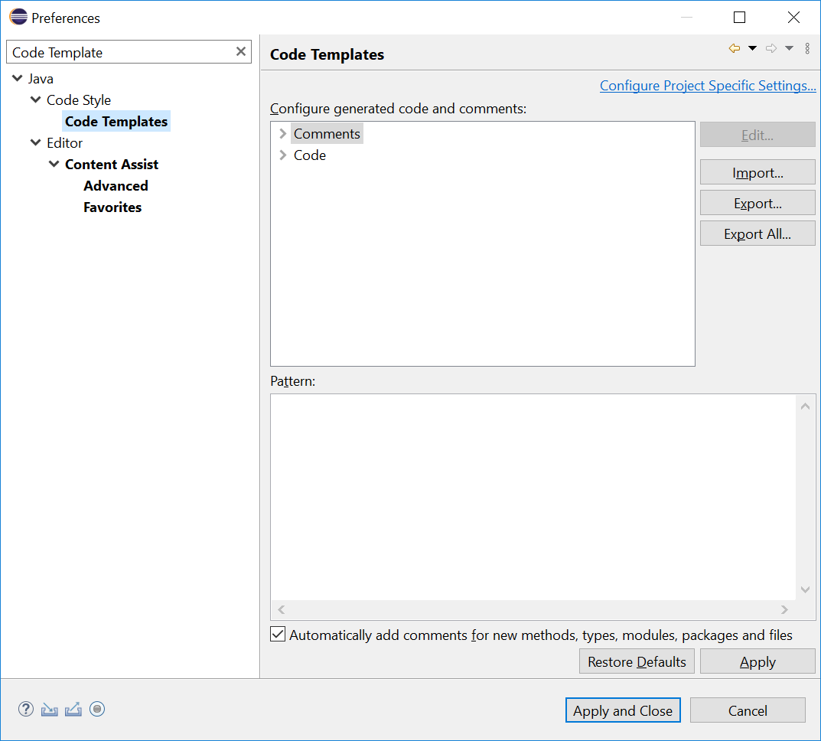

1. Expand **Comments** and select **Files.** Click **Edit** and paste the text below.

Remember to replace the student name, id and class below with your own.

|  |
| --- |
| /**  *  * I declare that this code was written by me, ${user}.  * I will not copy or allow others to copy my code.  * I understand that copying code is considered as plagiarism.  *  * Student Name: Bobo Chan  * Student ID: 654321  * Class: ABC1  * Date created: ${id:date('YYYY-MMM-dd')} ${time}  *  */ |

1. Click **OK**. You should see something similar to the below.
   1. Remember to check **“Automatically add comments….”**

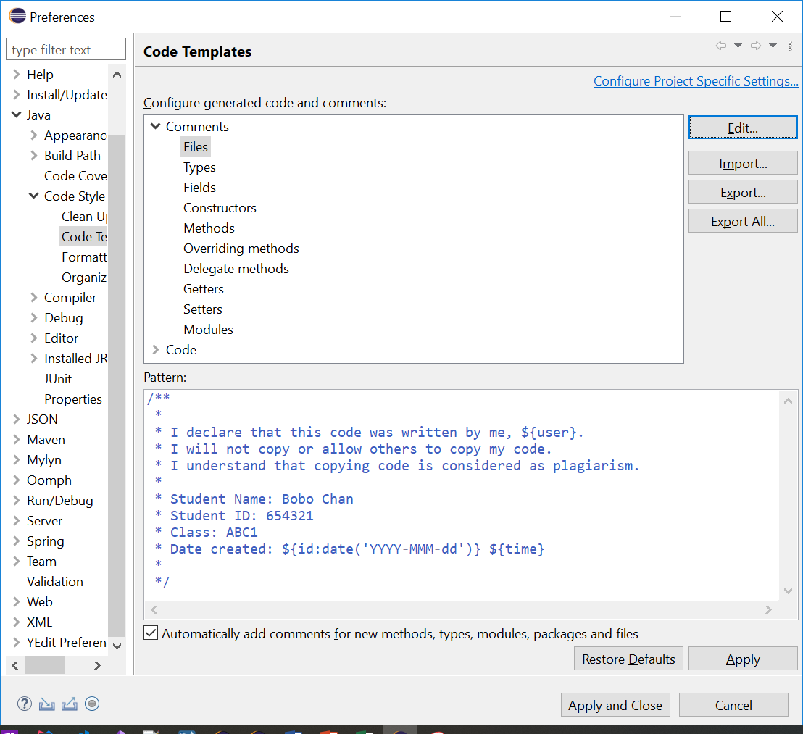

1. Click **Apply and Close**.
2. Try creating a new class named **TestAuthorship**. You should see the code generated as below.

