# Getting Java and Eclipse

1. You can get **jdk-15.0.2_windows-x64_bin.exe** and **eclipse-java-2020-12-R-win32-x86_64.zip** from your Lecturer’s thumb drive or you can download them from the links below.
2. Download (Not necessary if you already have the above software from a thumb drive

* Get both **Java** and the **Eclipse** here: <http://bit.ly/2021c209> (if Ctrl-Click does not work, try copying and pasting the link).

* **Java SE 15**

<https://www.oracle.com/sg/java/technologies/javase-jdk15-downloads.html>

OR

[Java Archive Downloads - Java SE 15 (oracle.com)](https://www.oracle.com/java/technologies/javase/jdk15-archive-downloads.html)

* **Eclipse 2020-12**  
  <https://www.eclipse.org/downloads/download.php?file=/technology/epp/downloads/release/2020-12/R/eclipse-java-2020-12-R-win32-x86_64.zip>

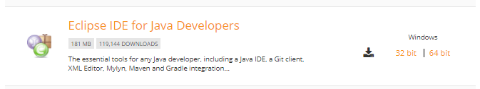

# Pre-installation Tasks

1. To ensure a smooth and successful installation operation, it is strongly recommended that you perform the following housekeeping tasks first:
2. Back up Eclipse projects
   1. Start your Eclipse and choose the following option:

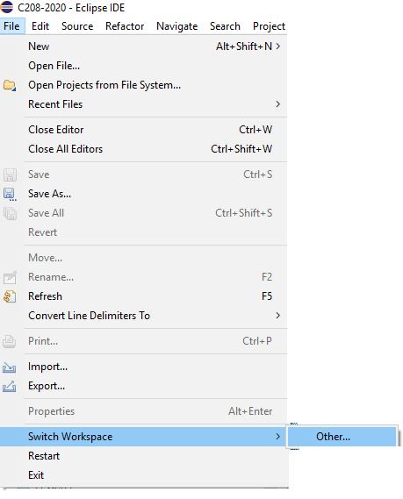

* 1. Note your Eclipse workspace directory, which will likely be different from the following example:

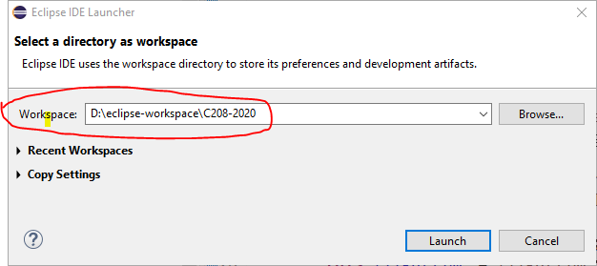

* 1. Open Windows Explorer and navigate to the Eclipse workspace directory. Create a zip file of that directory:

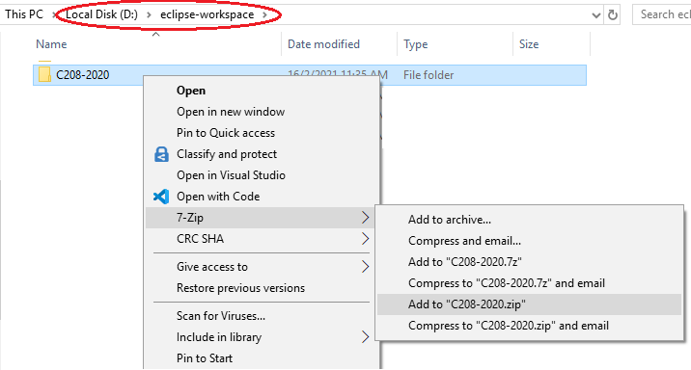

* 1. Save the zip file in a secure location as a backup copy of your work.

1. Delete all older versions of Eclipse
   1. Locate the directory where your Eclipse version is installed. If you start Eclipse with a shortcut, right-click on it and select Properties:

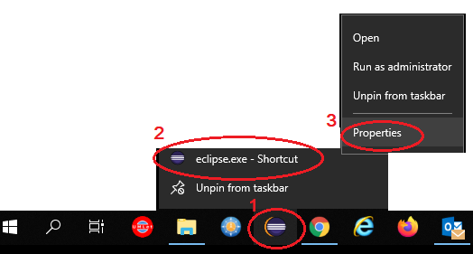

* 1. Note the Eclipse directory, which will likely be different from the following example:

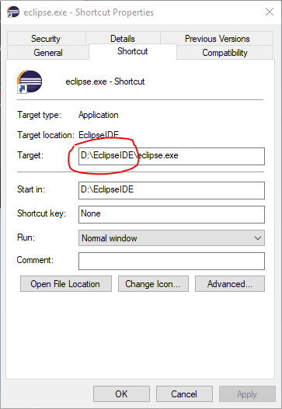

* 1. Delete Eclipse directory

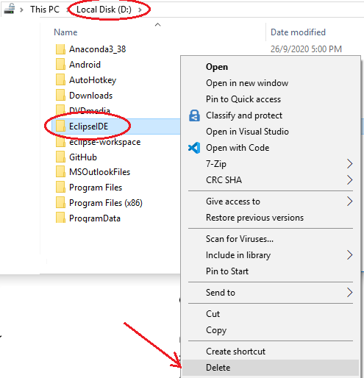

1. Remove all older versions of Java
   1. Start Windows Settings by clicking on the Gear icon above the Windows icon:

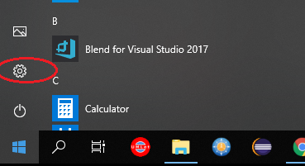

* 1. Click on Apps:

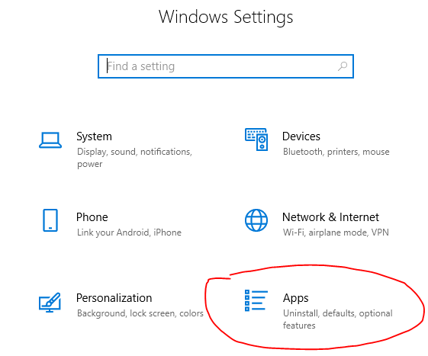

* 1. In the Apps & Features option windows, look for ALL Java installations and uninstall.

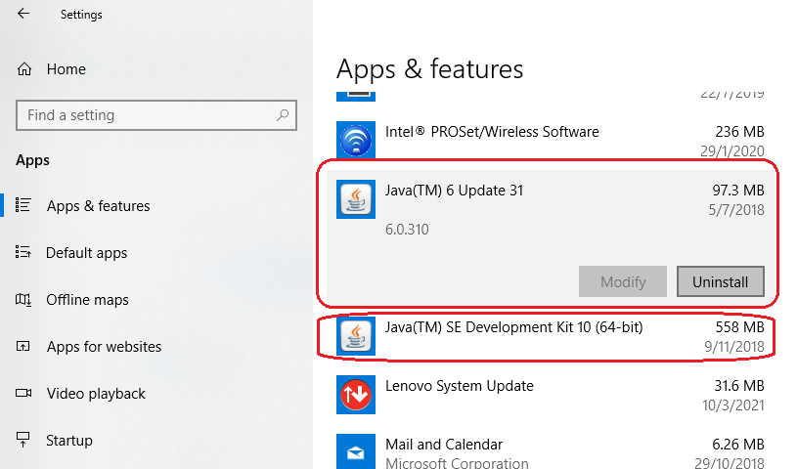

# Installing Java

1. To install Java SE Development Kit, double click on the file **jdk-15.0.2_windows-x64_bin.exe**

Follow the steps listed below.

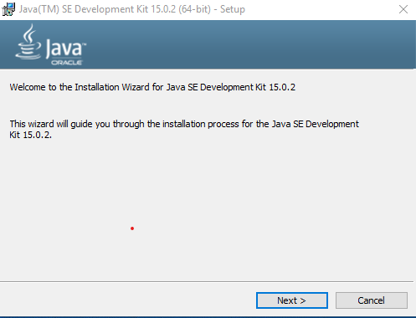

1. Click **[Next]**

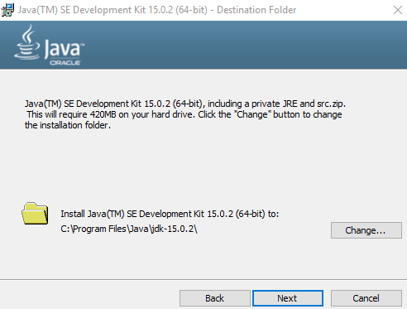

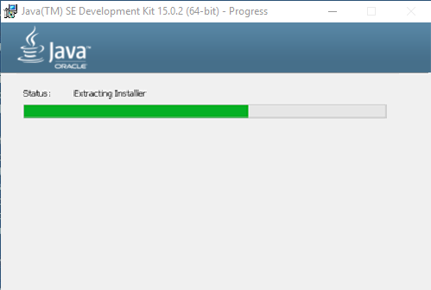

1. Click **[close]** to complete the installation.

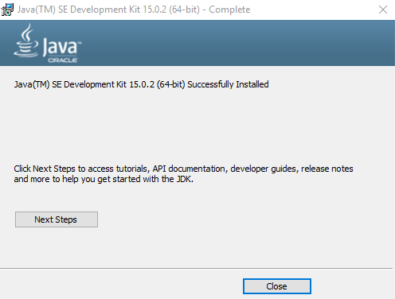

# Installing Eclipse

1. Double-click on **eclipse-java-2020-12-R-win32-x86_64.zip**

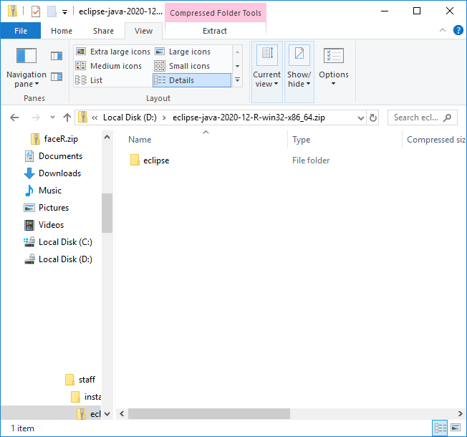

1. Copy the **eclipse** folder

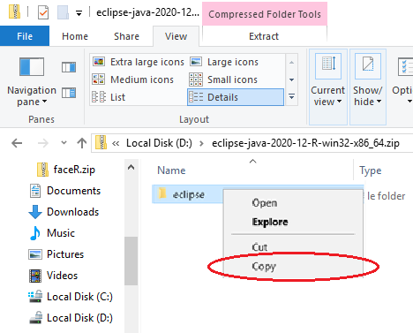

1. Paste the **eclipse** folder to a location of your choice. E.g.(D:\)
2. After pasting, your directory structure should look similar to the below.

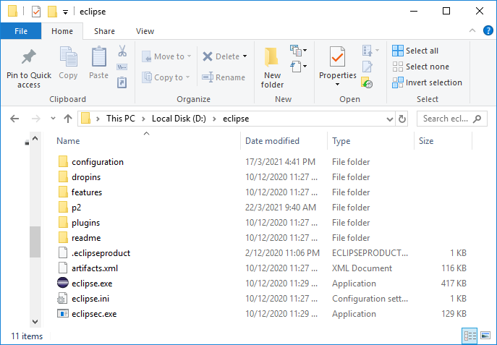

1. Double click on **eclipse.exe**
2. You will be asked to **select a workspace**. This will be the folder which Eclipse stores all your codes.

Chose a meaningful folder. E.g. C:\RP\C209\workspace. Ensure that your **workspace folder should** **NOT be in the eclipse program folder** in Step 10. You can change the location of this workspace whenever you want. Click on the checkbox **Use this as the default**.

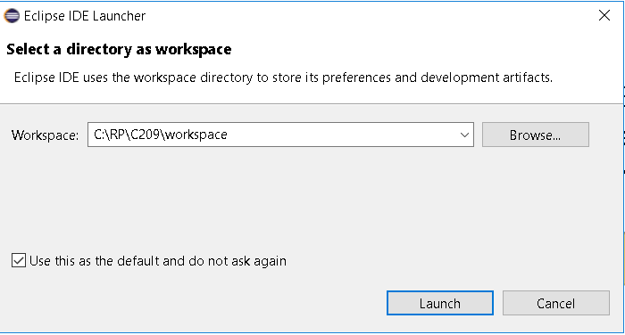

1. After Eclipse has started, right-click on the Eclipse’s icon at the taskbar and click **Pin this program to taskbar**.

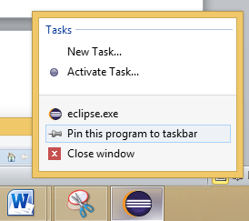

1. Uncheck **Always show Welcome at start up**.

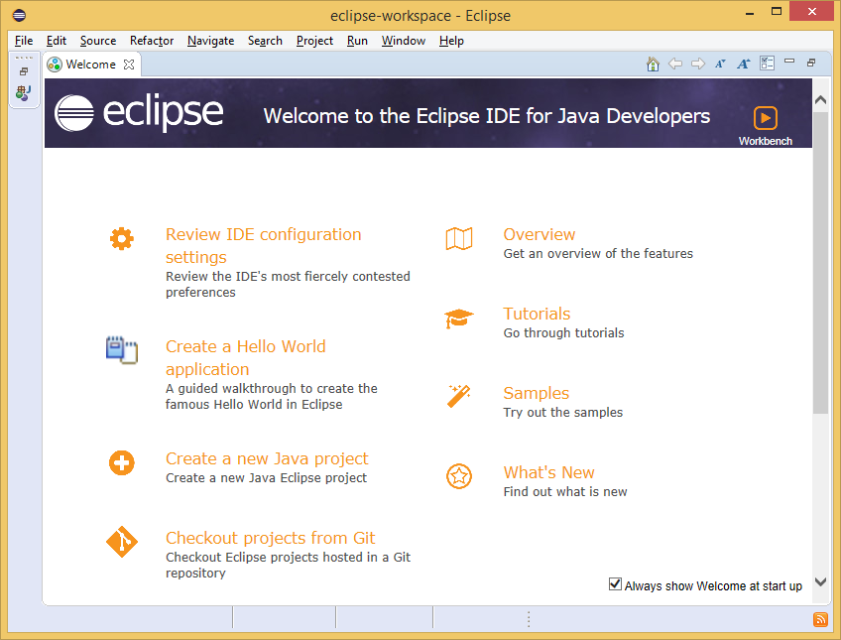

1. Dismiss the **Welcome Window** by clicking on the [**X**] on the Welcome Tab as circled above. You can bring back the **Welcome Window** by clicking **Help** 🡪 **Welcome**.
2. You should now see the empty workspace.

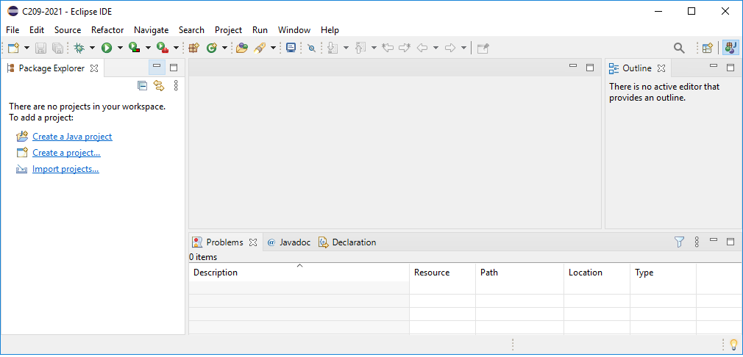

# Configuring Eclipse

1. Click **Window** 🡪 **Preferences**. Type “**font**” in the text box. The following dialog will appear.

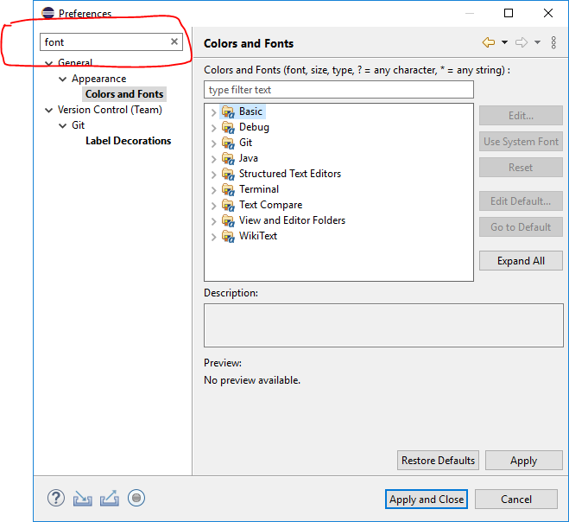

1. Select **Colors and Fonts**. Select **Basic,** then scroll down to select **Text Font**. Click the [Edit…] button. Change the font to **Consolas 10**. Click **[Apply and Close]**.

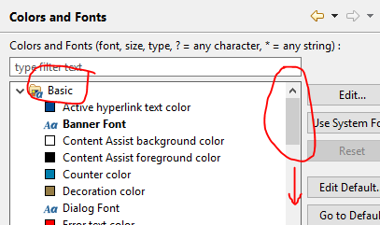 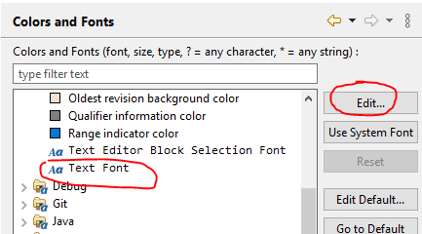

# Check Compliance Level

1. Go to Windows > Preferences > Java > Compiler
2. Ensure that your compiler compliance level is 15. Click **[Apply and Close]**.

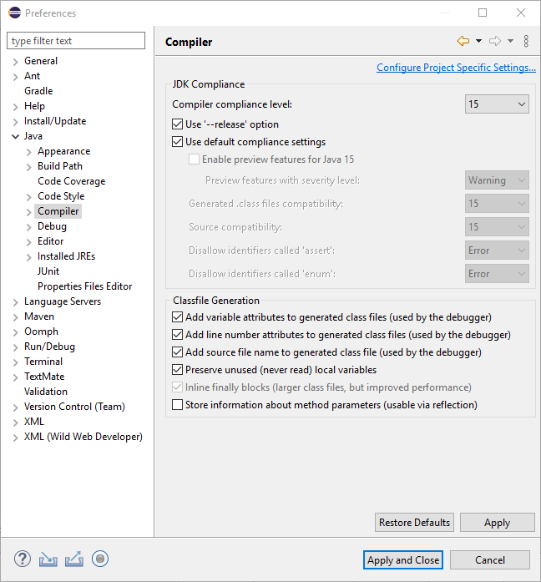

# Creating Your First Project

1. Click **File** 🡪 **New** 🡪 **Java Project**. In the Project Name, key in **P000**.

Ensure that you are using **default JRE (third JRE option).**

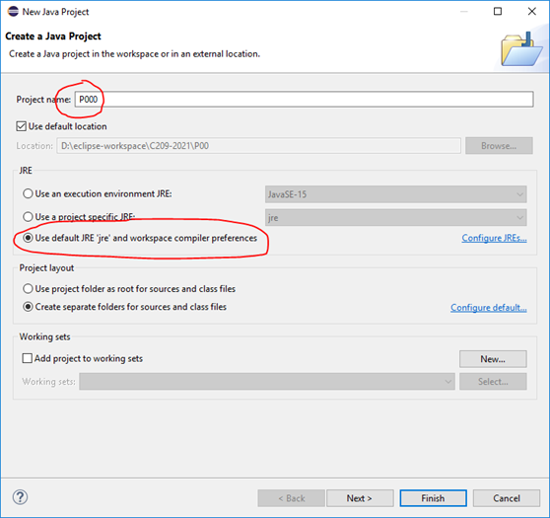

1. Click [**Finish**]. When prompted to **create module-info.java**, select **[Don’t Create]**.

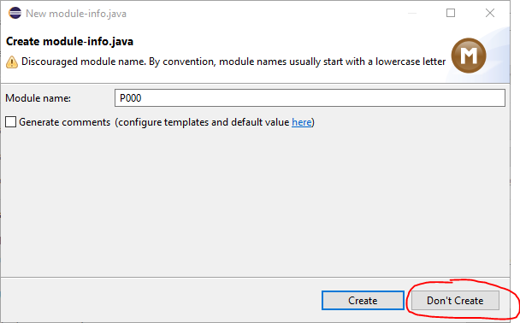

1. You will be able to see the newly created project in the Package Explorer as illustrated.

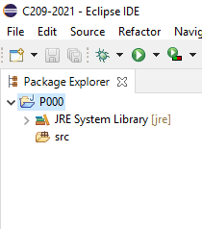

# Creating Your First Class

1. Right-click on **P000.** Select **New🡪Class**.
2. In the Name, key in **HelloWorld**, ensure that **“public static void main(String[] args)”** is checked. Click **[Finish]**.

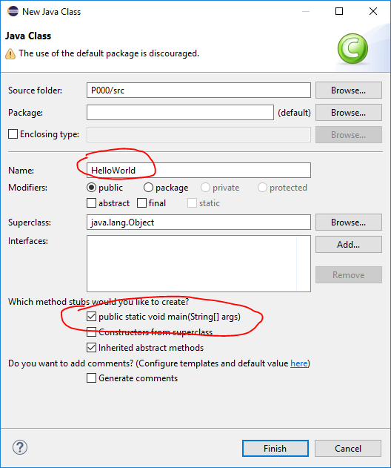

1. Expand the **src** folder and you should see the file **HelloWorld.java** created there.

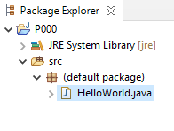

1. Move the mouse pointer to the margin of the editor window and right-click to bring up the pop-up menu. Select **Show Line Numbers**.

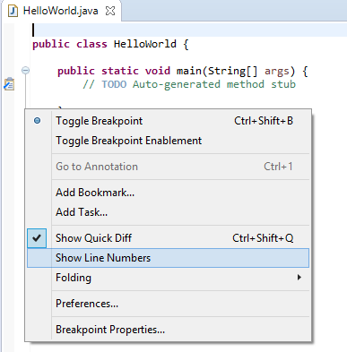

After line numbers shown:

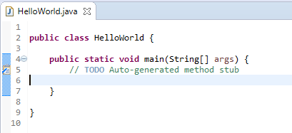

1. Enter the following codes at Line 6 and press [Ctrl]+S to save the codes.

System.out.println("My First Java Program");

# Executing Your Program

1. Click **Run** 🡪 **Run**.
   1. Or you can click on the ‘play’ button shown below

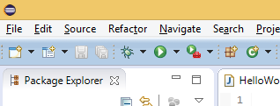

1. The program outputs to the **Console** window as illustrated below.

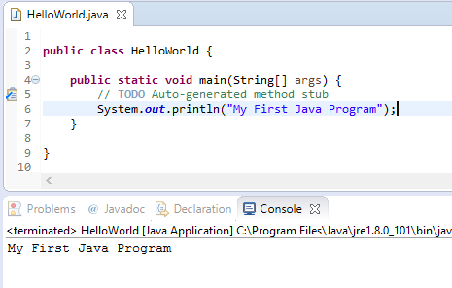

# Configuring The Language Bar

If you have additional Language installed in your computer, you need to perform the steps given in this section.

Using Windows Search, click on the magnifying glass icon, then key in Advanced Keyboard Settings:

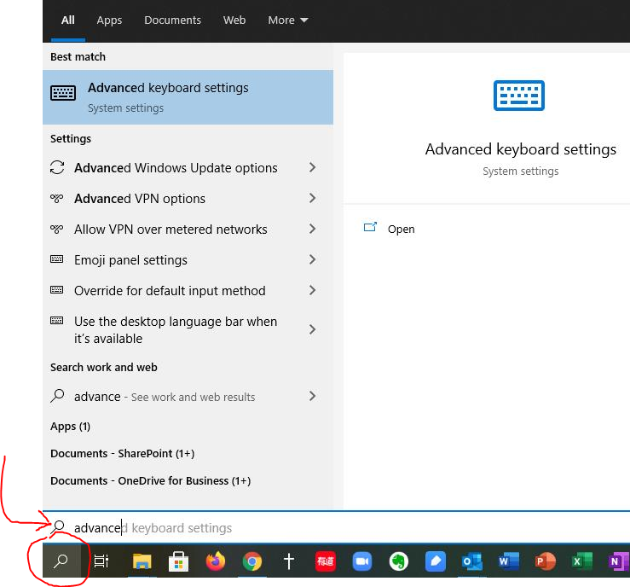

In the Advanced keyboard settings window, click on Input language hot keys:

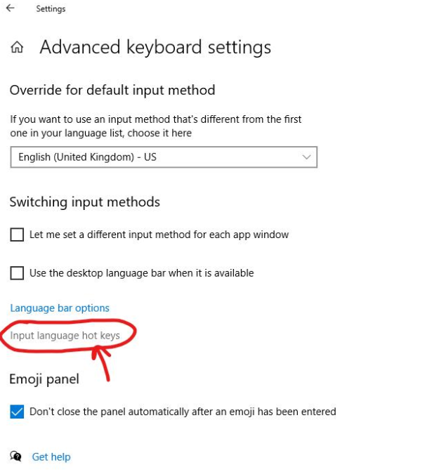

Select any **Ctrl+Space** key sequence and click [Change Key Sequence…]:

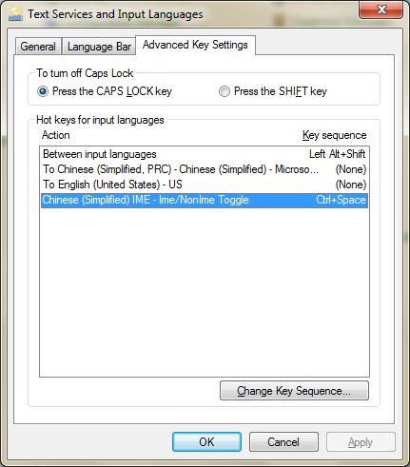

Change **Ctrl+Space** to **Left Alt + Shift**. Click [OK] and click [OK] again.

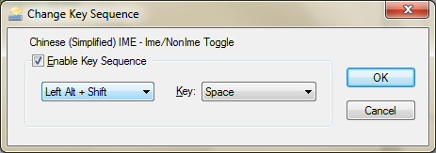

**Restart your computer**.