RTL Issues – AXI FIFO BFM

Issue 1: AWCACHE and ARCACHE Signal Mismatch with AXI Spec
Description: AWCACHE[3:0] and ARCACHE[3:0] are not aligned with AXI specification, causing issues while sending transactions to slave.
Impact: Transactions fail or behave unexpectedly.
Affected Files: TOP file, AXI_master.sv, AXI_MASTER_WRITE_CONTROL.sv, AXI_MASTER_READ_CONTROL.sv
Recommendation: Update cache signal encoding as per AXI4 spec across all mentioned files.
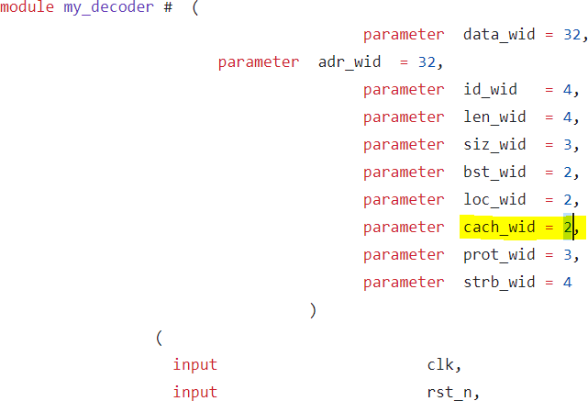

Issue 2: Decoder Does Not Support Multiple Write/Read Packets
Description: When two write packets are sent from write FIFO, decoder treats second packet as continuation of first.
Impact: Multiple packets are merged incorrectly into one transaction.
Affected Files: decoder.sv
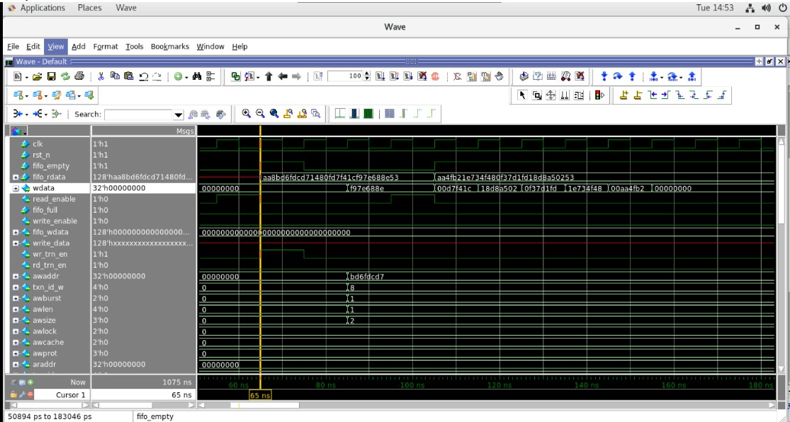
Recommendation: Fix SOP/EOP detection logic to correctly identify packet boundaries.

Issue 3: Decoder Treats EOP as WDATA and Incorrect Data Slicing
Description: EOP is incorrectly considered as wdata and 64-bit data slicing is not done properly.
Impact: Corrupted data sent to AXI master.
Affected Files: decoder.sv
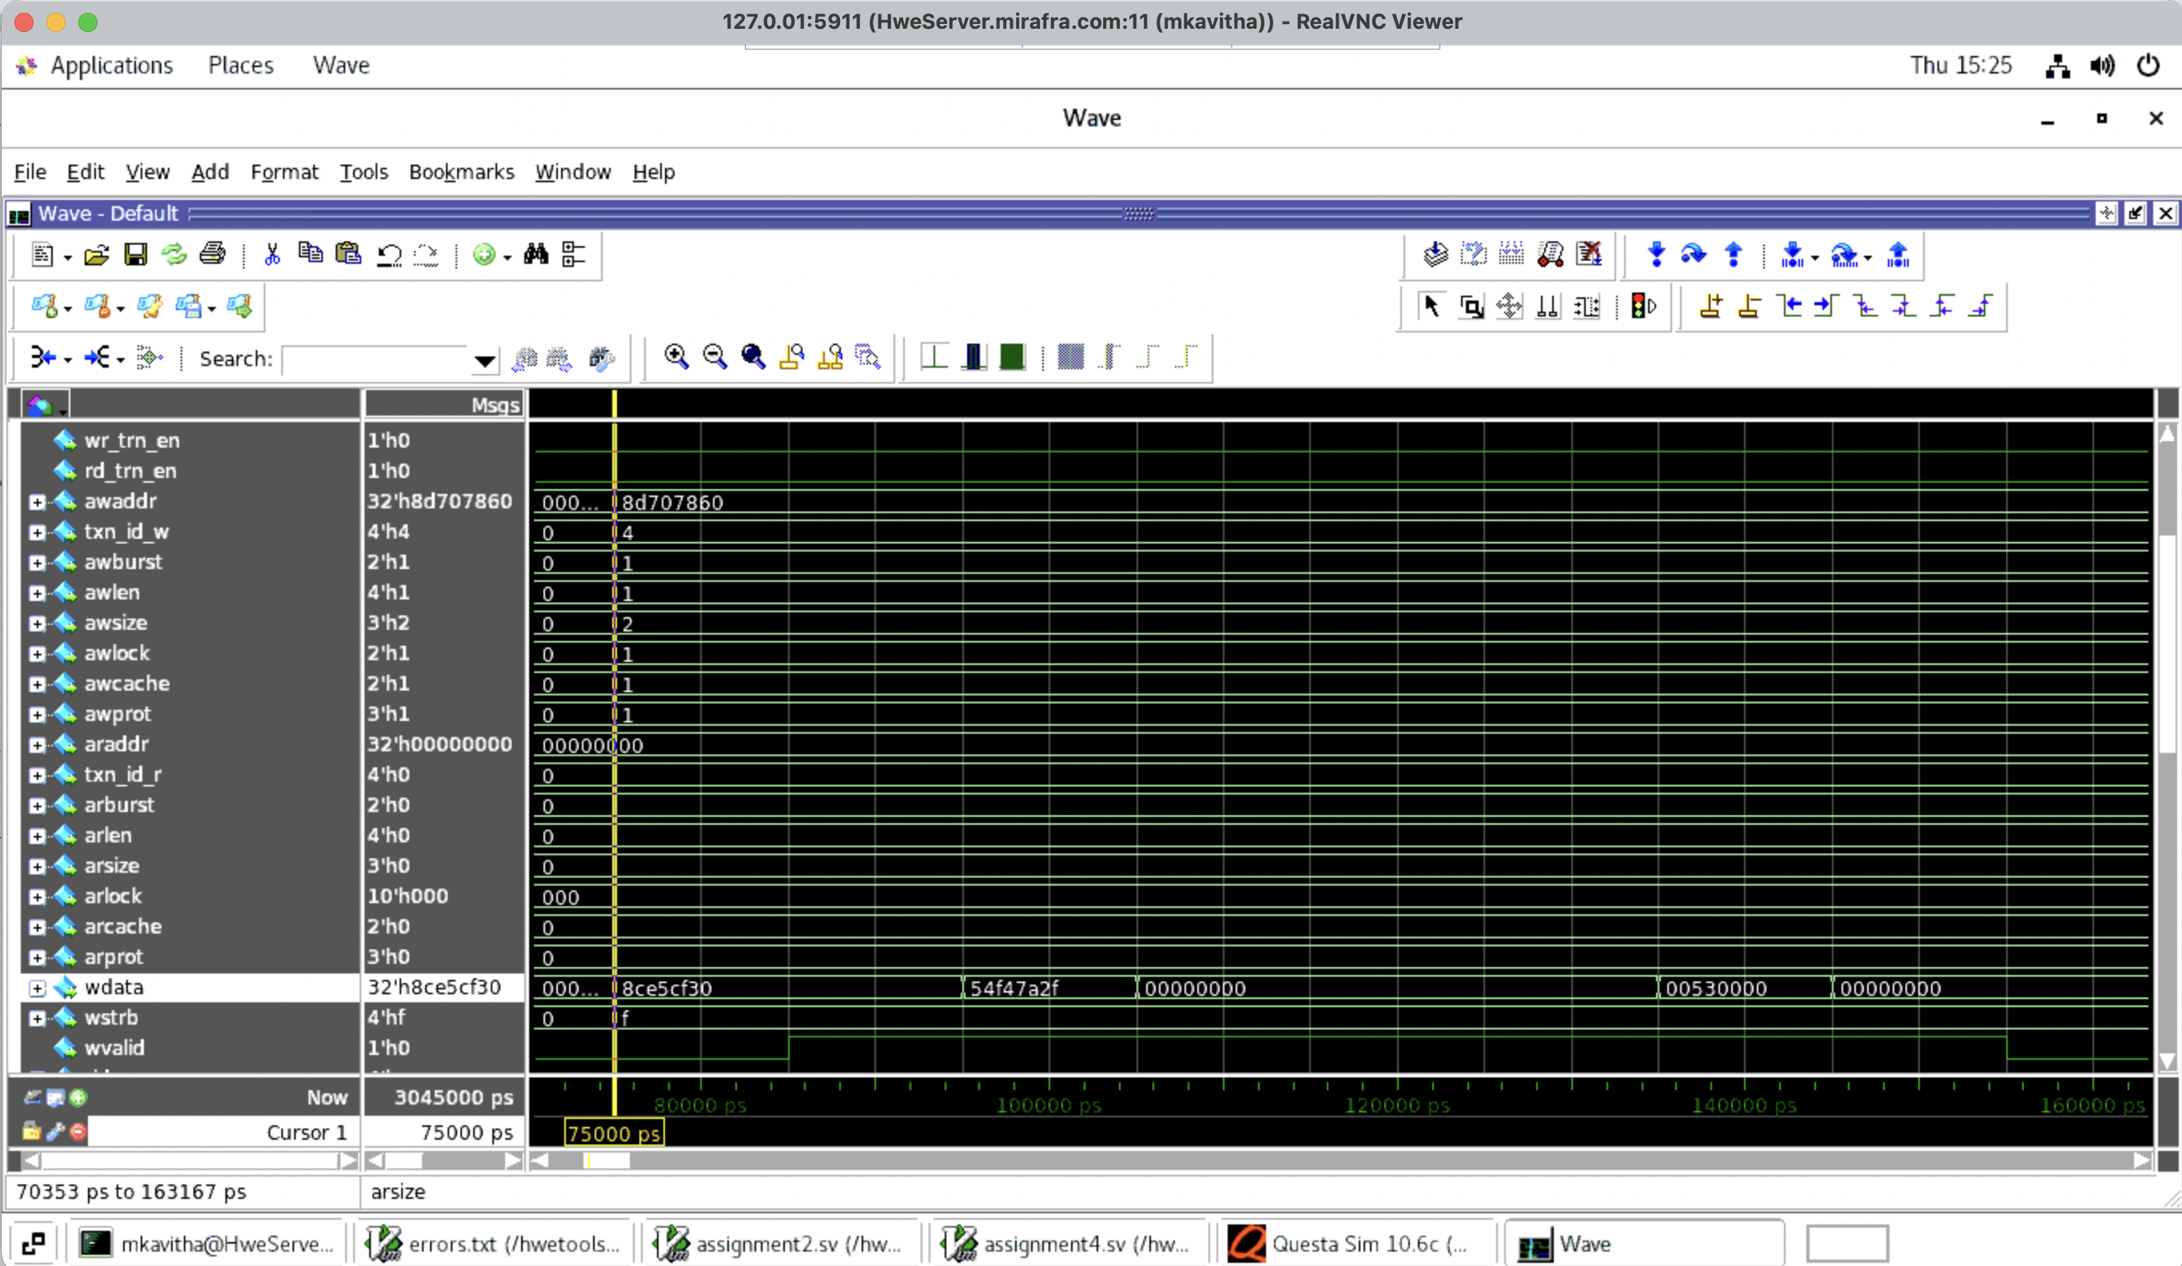
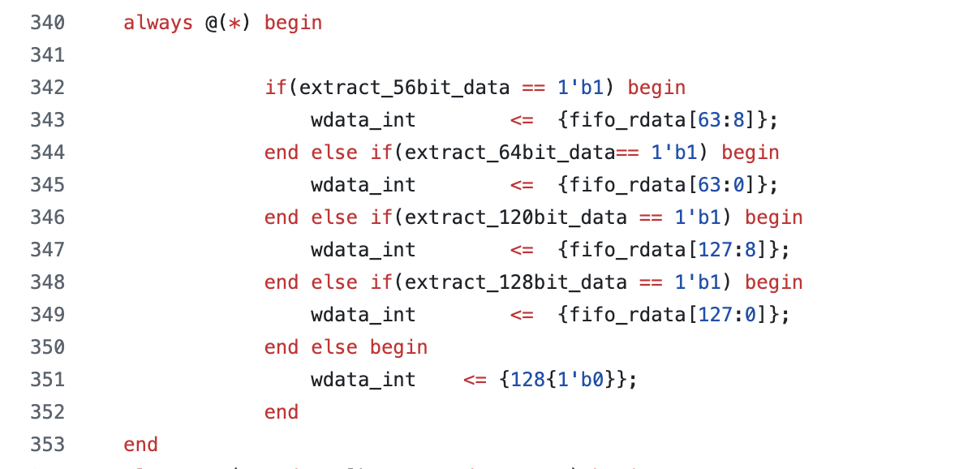
Recommendation: Exclude EOP from data payload and correct 64-bit slicing logic

Issue 4: Missing Read Response Packet Construction Logic
Description: Decoder has only read response input ports but no logic to build read response packet.
Impact: Read data is lost .
Affected Files: decoder.sv
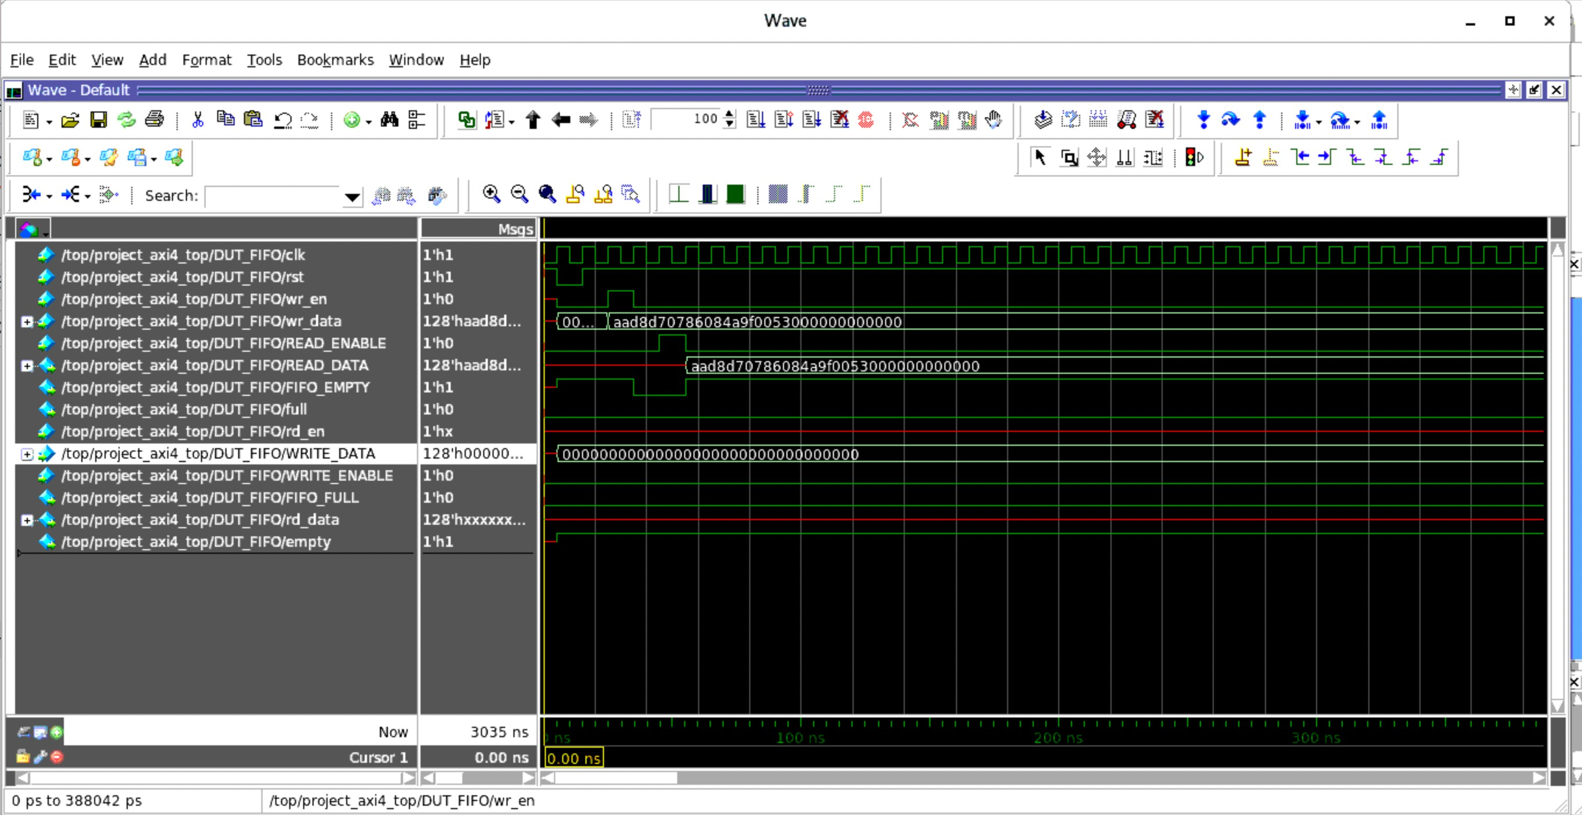
Recommendation: Implement read response packet assembly and push to read FIFO.

Issue 5: AXI Master Repeats Read Transaction for Same Address
Description: rd_trn_en never deasserts causing FSM to re-enter Addr_State.
Impact: Duplicate read transactions for same address.
Affected Files: AXI_MASTER_READ_CONTROL.v
Recommendation: Deassert rd_trn_en after transaction completion and gate state transitions.

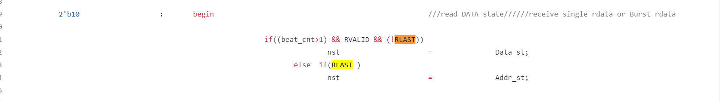

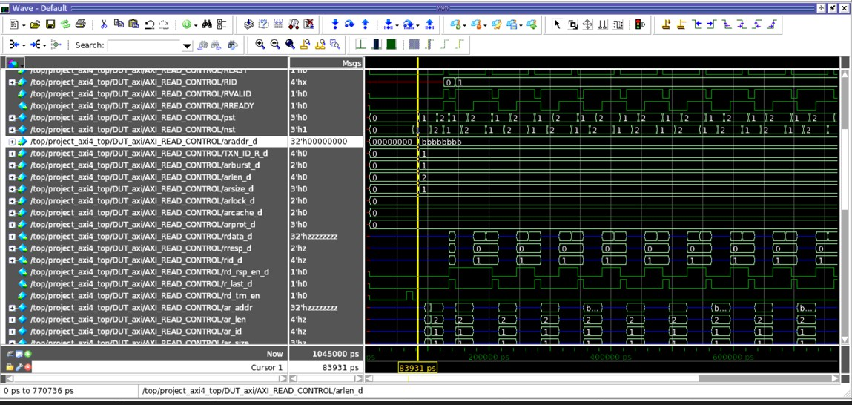
Waveform of decoder input:

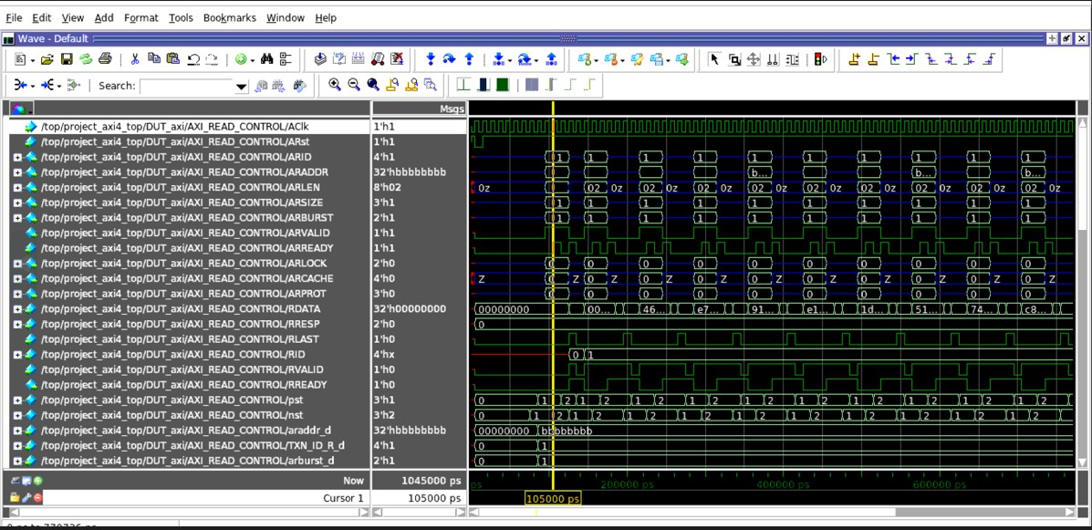
Waveform of Axi read control:

Issue 6: ARVALID Asserted Before Valid Address and Control Signals
Description: ARVALID asserted early and RREADY asserted same cycle as RVALID, violating AXI timing.
Impact: Slave interprets address as 0x00000000 and returns incorrect data.
Affected Files: AXI_MASTER_READ_CONTROL.v
Recommendation: Align ARVALID with valid address/control and assert RREADY one cycle before RVALID.
