PROJECT IMPLEMENTATION PLAN
Disaster Relief Medical Donation Module
SOS Alerting • Risk Heatmap Optimization • Priority-Based Smart Donation Matching
Backend architecture, role-based access control, database design,
ML model pipeline and a 4-day implementation roadmap
Project ID: R26-IT-047
B.Sc. (Hons) in Information Technology
Sri Lanka Institute of Information Technology (SLIIT)
Supervisor: Mrs. Anjali Gamage • Co-Supervisor: Ms. Chathurya Kumarapperuma
Component owner: Kavitha — SOS, Heatmap/Camp Identification & Smart Matching
August 2026

Table of Contents

1. Purpose of This Plan
This document is a practical implementation plan for the part of the Smart Medical System that you own — the Disaster Relief Medical Donation Module, covering the SOS Message Component, the Medical Camp Identification & Heatmap Optimization Component, and the Priority-Based Smart Matching Component. It is written to take you from where you are now (a working backend without role separation) to a complete, role-based, ML-integrated system within a 4-day window.
The plan focuses on the one thing you said you are stuck on — role-based access (admin, user, and the other stakeholder roles) — and places it in context alongside the architecture, database, ML pipeline, and API design so every piece fits together.

2. Recap: Scope of Your Components
Your dissertation proposal defines three components that form a single pipeline, from the moment a disaster-affected person raises an alert to the moment a donor's contribution reaches them:
- SOS Message Component — a one-tap emergency button that auto-collects the victim's pre-registered details and live GPS location, then dispatches an alert to at least five contacts/responders simultaneously (police, hospitals, family, relief camps).
- Medical Camp Identification & Heatmap Optimization Component — builds a risk heatmap from historical disaster data (flood/landslide records, rainfall, elevation, slope) and continuously updates it with live SOS signals; warns registered users inside danger zones; recommends temporary medical camp locations.
- Priority-Based Smart Matching Component — scores each SOS request by urgency, affected-people count, medical needs, presence of vulnerable people, and heatmap risk, then matches the highest-priority requests to the most suitable available donors.
These three components are supported by four machine-learning models (flood risk, landslide risk, medical camp recommendation, and heatmap optimization), detailed in Section 6.

3. Objectives for This Implementation Phase
- Add a proper role-based access control (RBAC) layer — Admin, Victim/Public User, Donor, Medical Authority, Volunteer — without restructuring work you have already built.
- Finish the SQLite/SQLAlchemy schema so every component (SOS, heatmap, matching, donations) shares one consistent data model.
- Train and integrate the Random Forest flood and landslide models, with a documented fallback for the missing verified flood labels.
- Expose all functionality through versioned FastAPI endpoints that your existing React frontend can call directly.
- Deliver a demonstrable, end-to-end flow: SOS submitted → heatmap updates → priority scored → camp recommended → donor matched → notification sent.

4. System Architecture
The system is organized into five layers. Requests flow downward from the client through authentication, into the FastAPI service modules, through the ML inference layer, and finally to persistent storage. This separation means the role-based access work in Section 5 only touches the Auth & Gateway layer — it does not require rewriting your SOS, heatmap, or matching logic.
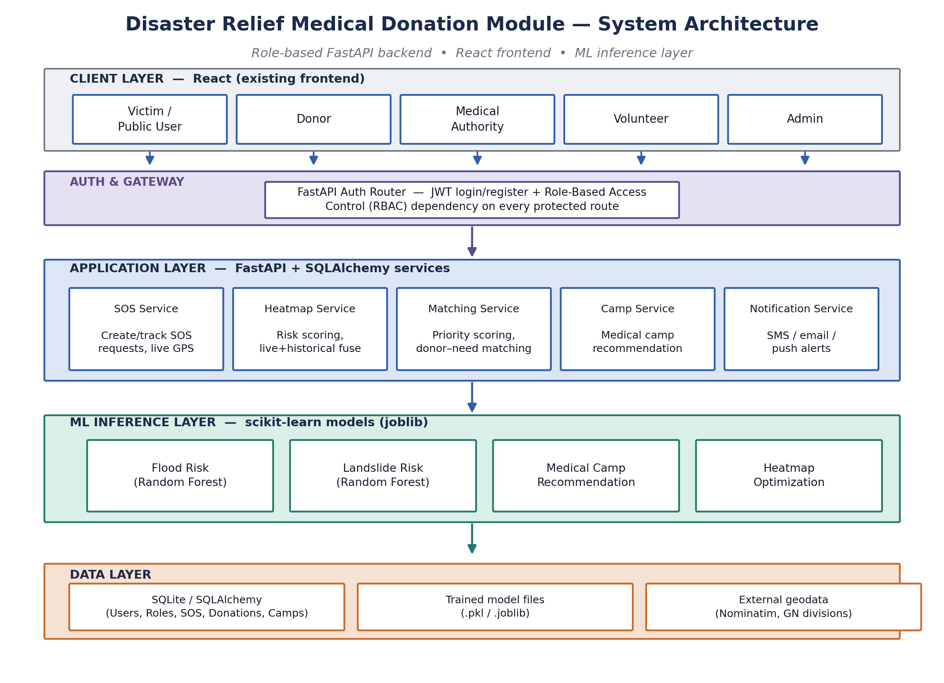
Figure 1. System architecture — client, auth/gateway, application services, ML inference, and data layers.

4.1 Why this layering matters for you right now
- Your existing FastAPI route logic for SOS, heatmap, and matching stays inside the Application Layer — unchanged.
- Role checking is added as a single reusable dependency at the Auth & Gateway layer and attached to routes, rather than rewritten per-endpoint.
- ML models are loaded once at startup and called from the service layer, keeping training code separate from request-handling code.

5. Role-Based Access Control (RBAC) Design
This is the piece you were stuck on. FastAPI does not require a separate “admin panel” framework — role checking is implemented as one reusable dependency function that every protected route uses. The flow below shows the full path from login to an authorised (or rejected) request.
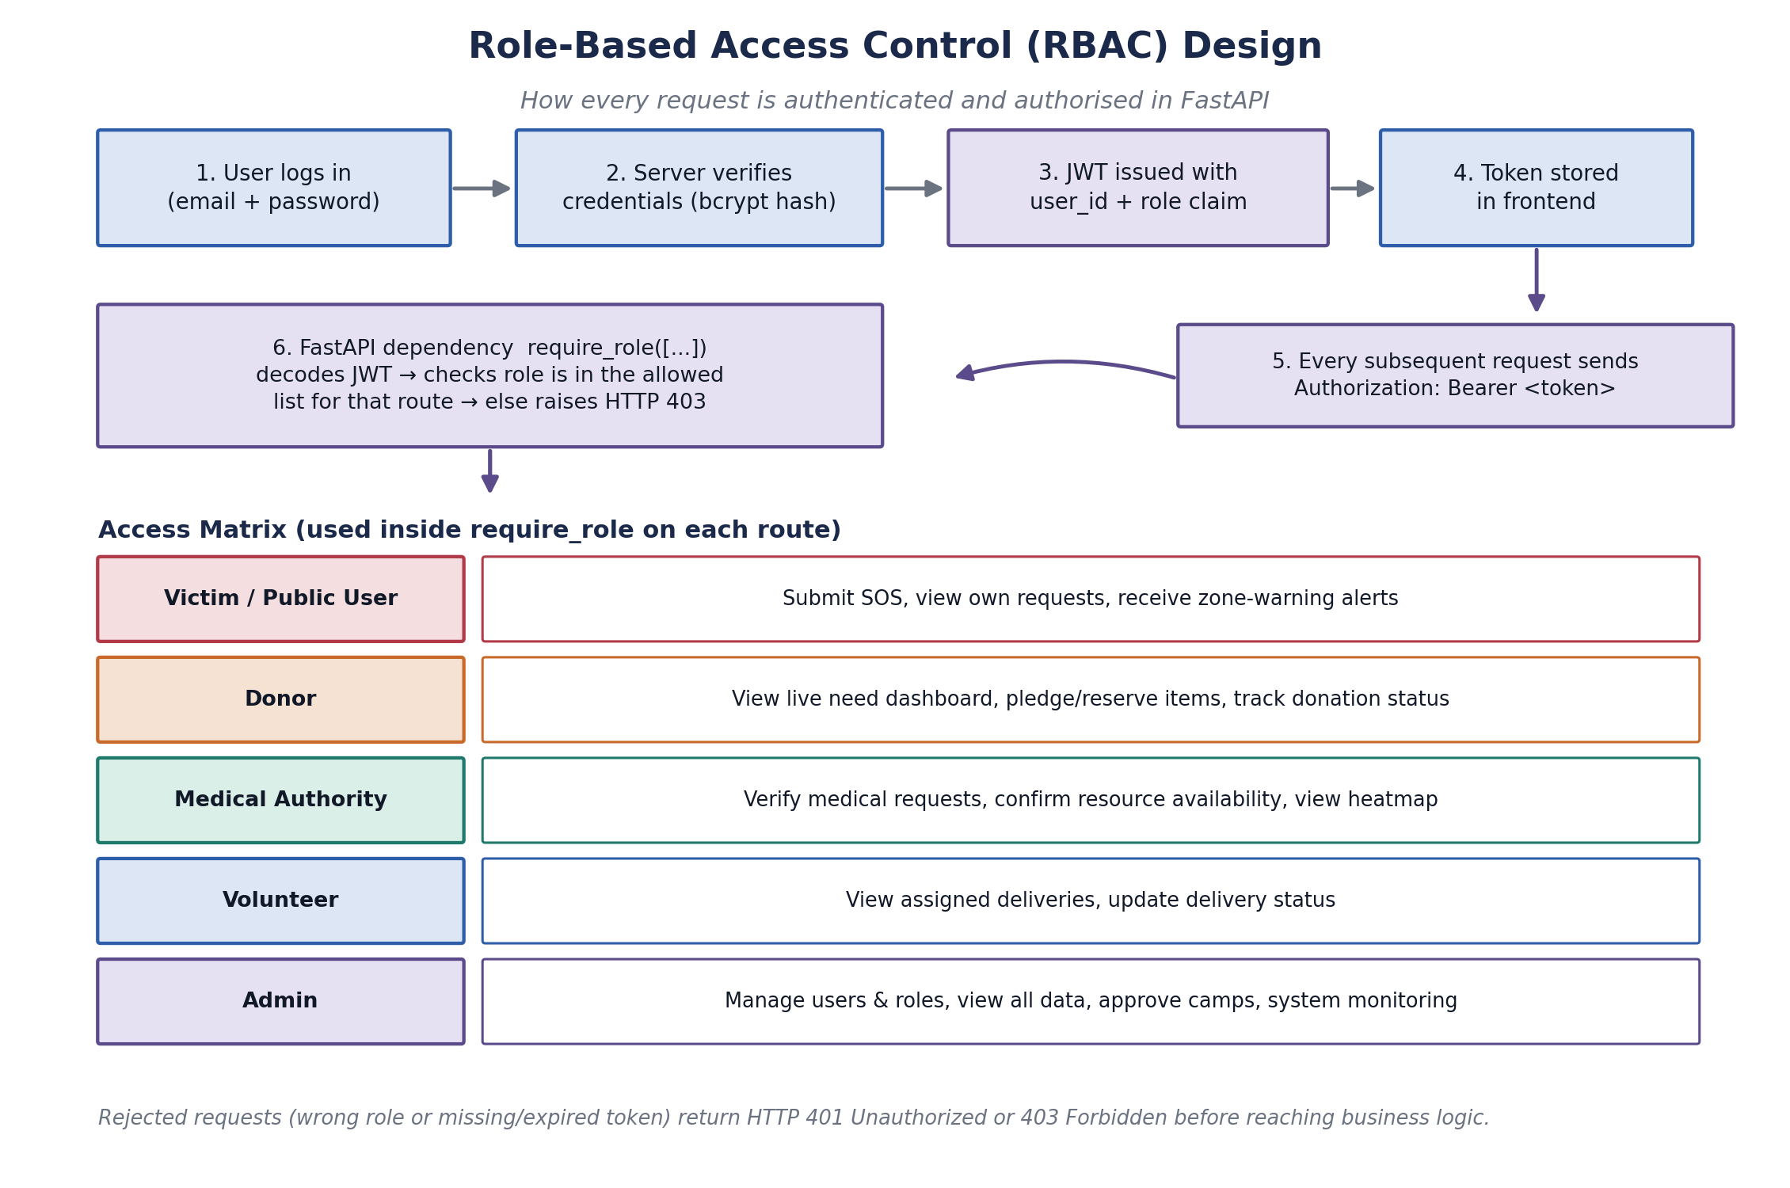
Figure 2. RBAC flow — login, JWT issuance, and per-route role checking, with the access matrix used across the system.

5.1 Implementation steps
- Add a Role table (or a fixed Enum) with the five roles: admin, victim, donor, authority, volunteer.
- Add a role_id foreign key on the User table; assign a default role (victim) at self-registration, and let only an admin promote or change roles.
- On login, issue a JWT whose payload includes user_id and role (not just user_id).
- Write one dependency, e.g. require_role(['admin', 'authority']), that decodes the JWT, reads the role claim, and raises HTTP 403 if the caller's role is not in the allowed list.
- Attach that dependency to each router with Depends(require_role([...])) — for example, camp-approval endpoints require ['admin', 'authority'], while SOS submission only requires a valid logged-in user of any role.
- Keep a small, explicit access matrix (Figure 2) as your source of truth so you and your two teammates apply roles consistently across all modules.
This pattern needs no extra library beyond what FastAPI already gives you (OAuth2PasswordBearer + python-jose or PyJWT + Depends), so it fits your existing stack without new dependencies.

6. Database Design
The schema below consolidates the SOS, heatmap/camp, matching, and donation data behind your three components into one consistent relational model, ready for SQLAlchemy models in SQLite.
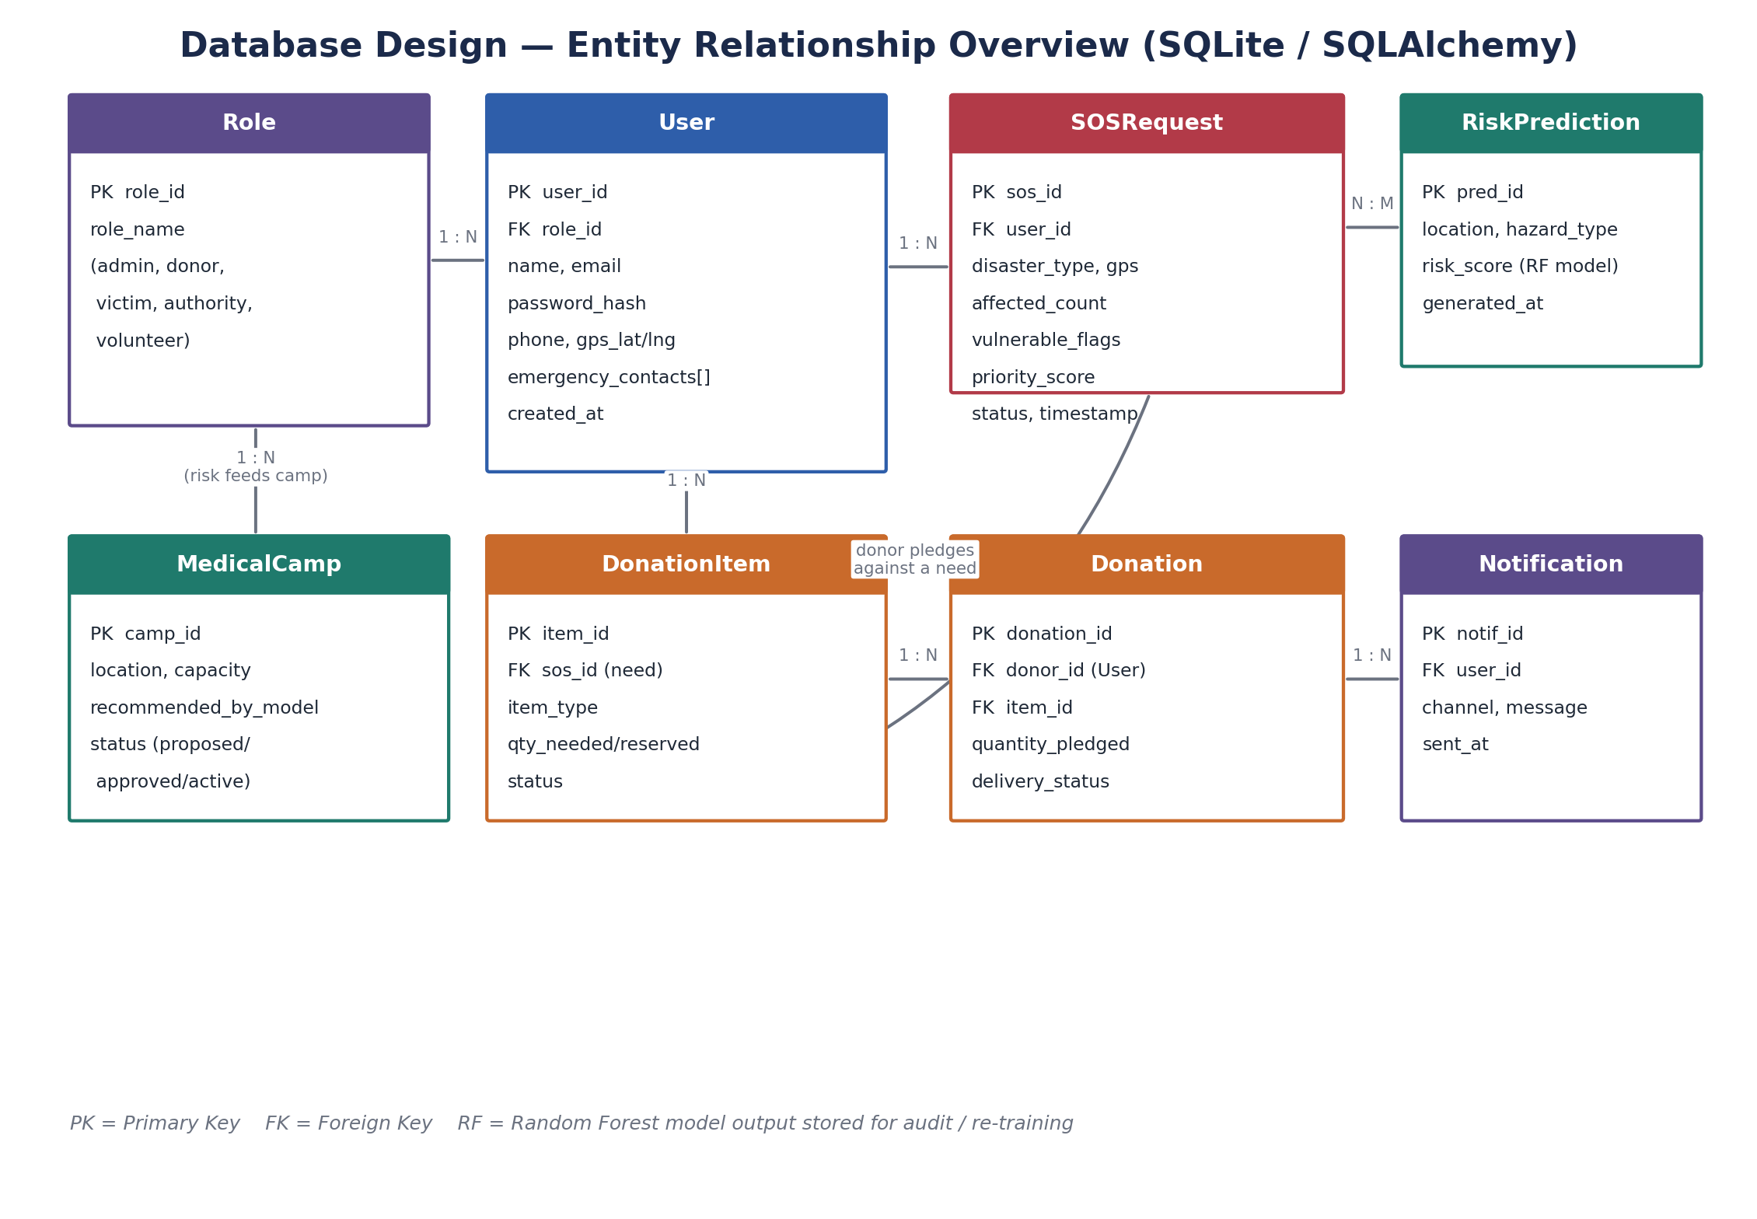
Figure 3. Entity-relationship overview — Role, User, SOSRequest, RiskPrediction, MedicalCamp, DonationItem, Donation, and Notification.

6.1 Entity summary
Entity | Purpose | Key relationships
Role | Fixed list of the five system roles. | 1 Role → many Users
User | Registered account for any stakeholder. | belongs to 1 Role; has many SOSRequests, Donations
SOSRequest | One emergency alert with location & urgency data. | belongs to 1 User; feeds priority_score and MedicalCamp logic
RiskPrediction | Stored output of the flood/landslide RF models per location. | linked to SOSRequest locations (N:M by area)
MedicalCamp | A proposed/approved temporary medical camp. | generated from RiskPrediction + SOSRequest density
DonationItem | A specific need (item type + quantity) tied to an SOS request. | belongs to 1 SOSRequest; has many Donations
Donation | A donor's pledge against a DonationItem. | belongs to 1 User (donor) and 1 DonationItem
Notification | A dispatched SMS/email/push message. | belongs to 1 User

7. Machine Learning Model Pipeline
All four models follow the same pipeline — collect data, clean and engineer features, train with scikit-learn, evaluate, then serve the trained model file from inside a FastAPI endpoint using joblib.
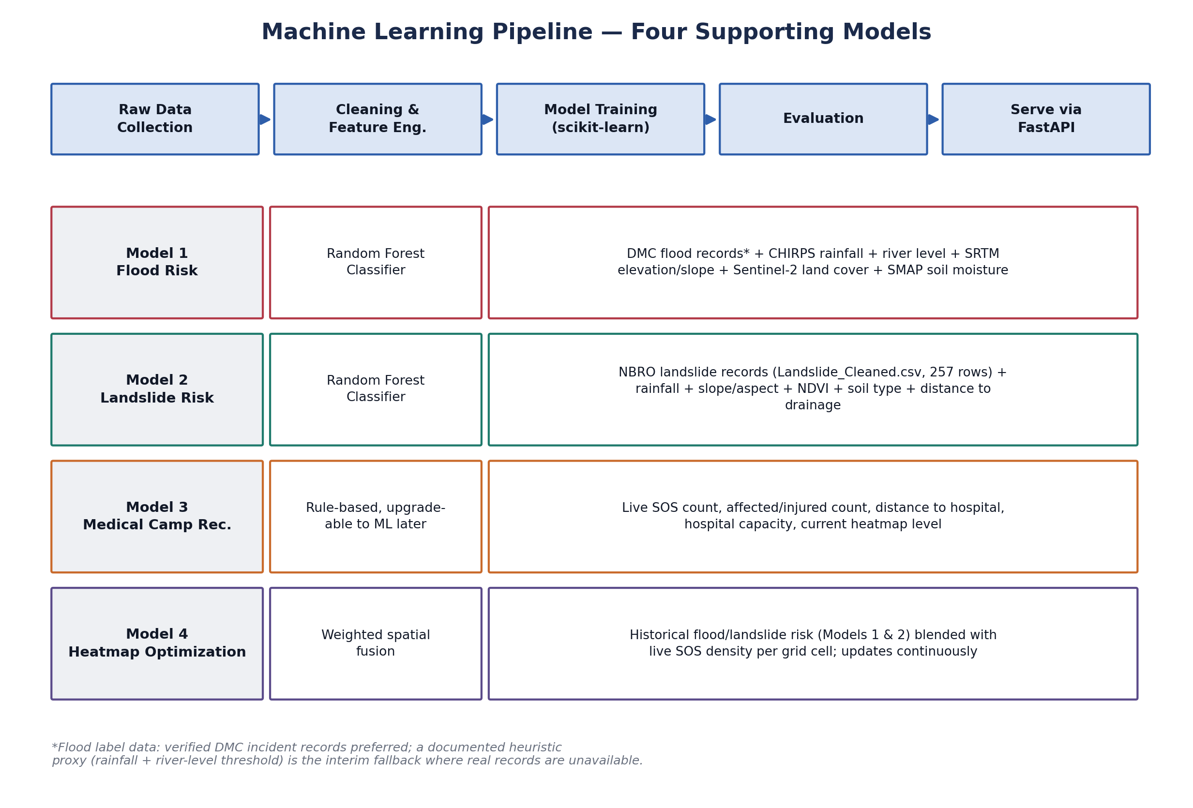
Figure 4. The four supporting models, their algorithms, and their data sources.

7.1 Handling the missing verified flood labels
Since verified flood incident labels are not yet available, keep the heuristic proxy (a rainfall + river-level threshold rule) as a documented, clearly-labelled fallback for Model 1. Train and validate Model 2 (landslide) first on the real 257-row Landslide_Cleaned.csv dataset — this gives you one fully data-driven model to present, while the flood model's methodology section can honestly describe the proxy-label approach and note it as a direction for future refinement with verified DMC records.

8. API Endpoint Plan
Endpoints are grouped by component. The “Allowed roles” column is what you pass into require_role([...]) for that route.
Endpoint | Method | Allowed roles | Purpose
/auth/register | POST | public | Create account, default role = victim
/auth/login | POST | public | Verify credentials, issue JWT
/sos | POST | victim, donor, authority, volunteer, admin | Submit an SOS request
/sos/{id} | GET | owner, authority, admin | View a specific SOS request
/sos | GET | authority, admin | List/filter all SOS requests
/heatmap | GET | all authenticated | Fetch current risk heatmap
/predict/flood | POST | authority, admin | Run flood RF model for an area
/predict/landslide | POST | authority, admin | Run landslide RF model for an area
/camps | GET | all authenticated | List proposed/approved camps
/camps/{id}/approve | PATCH | authority, admin | Approve a recommended camp
/donations/needs | GET | donor, admin | View live donation needs, priority-sorted
/donations | POST | donor | Pledge a donation against a need
/users | GET | admin | List/manage all users and roles
/users/{id}/role | PATCH | admin | Change a user's role

9. Technology Stack
Layer | Technology
Backend framework | FastAPI (Python)
ORM / Database | SQLAlchemy + SQLite
Authentication | OAuth2PasswordBearer + JWT (python-jose), bcrypt password hashing
Machine learning | scikit-learn (Random Forest), pandas, joblib for model persistence
Frontend | React (existing pre-built frontend, connected via REST API)
Geocoding support | Nominatim, with multi-level fallback for rural addresses
Notifications | SMS/email/push provider integration from the Notification Service

10. 4-Day Implementation Roadmap
The roadmap sequences work so that role-based access is solved first — every later endpoint can then be built with the correct require_role(...) guard from the start, instead of retrofitted later.
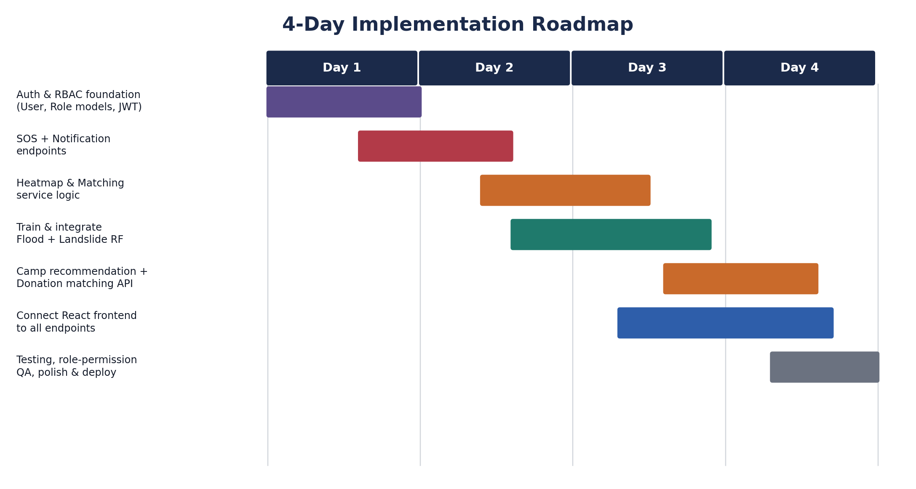
Figure 5. Four-day roadmap from RBAC foundation to tested, deployed system.

Day 1 — Foundations
- Create Role and User SQLAlchemy models; seed the five roles.
- Implement register/login endpoints with JWT issuance including the role claim.
- Write and test the require_role(...) dependency on one sample route.

Day 2 — Core components
- Build SOS submission + retrieval endpoints, guarded by role.
- Wire the Notification service (stub or real provider) to fire on SOS creation.
- Start heatmap and priority-matching service logic using existing risk data.

Day 3 — ML integration
- Train the landslide Random Forest model on Landslide_Cleaned.csv; evaluate and save with joblib.
- Train the flood Random Forest model using the heuristic proxy labels, clearly documented as interim.
- Expose both via /predict/flood and /predict/landslide; feed outputs into the heatmap and camp-recommendation logic.

Day 4 — Integration, testing, polish
- Connect the existing React frontend to every endpoint; confirm each role sees only what it should.
- Run through the full pipeline end-to-end: SOS → heatmap update → priority score → camp recommendation → donor match → notification.
- Fix edge cases, tidy error responses (401/403), and prepare the demo.

11. Known Risks & Mitigations
Risk | Mitigation
Verified flood incident labels unavailable | Use the documented heuristic proxy for Model 1 now; present the landslide model (real NBRO/Landslide_Cleaned.csv data) as the primary evidence of model validity; note real-label integration as future work.
Role-based access implemented late touches many files | Add the require_role dependency first (Day 1) so every subsequent endpoint is written with it from the start, avoiding rework.
Tight 4-day timeline | Roadmap sequences the highest-risk, most foundational work (auth/RBAC, ML training) earliest, leaving Day 4 purely for integration and polish.
Two teammates' components integrate with yours | Keep the Role/User schema and the require_role pattern as the single shared contract other modules should also follow for consistency.

12. Conclusion
With role-based access handled as one dependency function applied consistently across routes, the rest of your backend — SOS, heatmap, matching, camp recommendation, and donation flows — can be built and demonstrated without further architectural rework. Following the 4-day sequence above gets the foundation, core components, ML integration, and full end-to-end testing done in order, so each day builds cleanly on the last.

