PROJECT PROPOSAL
Disaster Relief Medical Donation Module
SOS Alerting • Risk Heatmap Optimization • Priority-Based Smart Donation Matching
A deep, explainable account of the system architecture, role-based access control design, database model, machine-learning pipeline, API plan, and 4-day implementation roadmap for the disaster relief module of the Smart Medical System.

Project ID: R26-IT-047
B.Sc. (Hons) in Information Technology
Sri Lanka Institute of Information Technology (SLIIT)
Supervisor: Mrs. Anjali Gamage
Co-Supervisor: Ms. Chathurya Kumarapperuma
Component owner: Kavitha — SOS, Heatmap/Camp Identification & Smart Matching
August 2026

Table of Contents
1. Executive Summary
2. Introduction and Problem Statement
3. Recap: Scope of the Owned Components
4. Objectives for This Implementation Phase
5. System Architecture
6. Role-Based Access Control (RBAC) Design
7. Database Design
8. Machine Learning Model Pipeline
9. API Endpoint Plan
10. Technology Stack
11. 4-Day Implementation Roadmap
12. Testing and Quality Assurance Strategy
13. Known Risks and Mitigations
14. Conclusion
15. References

1. Executive Summary
This proposal presents a complete, explainable implementation plan for the Disaster Relief Medical Donation Module — one of three interlocking components of a larger Smart Medical System dissertation. The module spans the full lifecycle of a disaster response event: a victim raises an SOS alert, the system evaluates area risk from historical and live data, a temporary medical camp is recommended if warranted, the request is scored for priority, and a suitable donor is matched and notified. The proposal explains not only what will be built, but why each design choice was made, so that the reasoning survives scrutiny at both the technical-review and viva stages.
The central engineering problem this phase resolves is role-based access control (RBAC). The existing backend runs without role separation: any authenticated caller can reach any route. Before further endpoints are added, a single reusable authorization dependency is introduced so that every subsequent route — SOS submission, heatmap queries, camp approval, donation pledges, user administration — is protected consistently, by construction, rather than patched in after the fact.
Around that RBAC core, this report explains the five-layer system architecture, a normalized eight-entity relational schema, a four-model machine-learning pipeline (flood risk, landslide risk, medical camp recommendation, and heatmap optimization), a versioned FastAPI endpoint plan, the justification for each technology choice, a day-by-day four-day delivery roadmap, a testing strategy, and a risk register with concrete mitigations. Each section is written to be read on its own, with the reasoning stated explicitly rather than left implicit in a diagram.

2. Introduction and Problem Statement
Sri Lanka experiences recurring flood and landslide events, particularly during monsoon seasons, that displace communities with little warning and strain the ability of relief organisations to route medical donations to the people who need them most urgently. Existing disaster-response tooling in this space tends to fall into one of two categories: manual, phone- and radio-based coordination that does not scale past a small geographic area, or generic donation platforms that treat every request as equally urgent and have no concept of real-time geographic risk.
The Smart Medical System project addresses this gap by combining three capabilities that are usually built separately — emergency alerting, geospatial risk prediction, and priority-based resource matching — into a single pipeline. The component covered by this proposal is the practical bridge between "a victim needs help" and "a donor's contribution reaches them," implemented as a role-aware backend service that a pre-built React frontend can call directly.

2.1 Current state
The starting point for this implementation phase is a working backend without role separation: SOS, heatmap, and matching logic already exist in some form, but any authenticated user can call any endpoint, and there is no schema-level distinction between a disaster victim, a donor, a medical authority, a volunteer, and a system administrator. This is the single blocking issue the plan is organised around.

2.2 Why this matters
Role separation is not a cosmetic requirement. A donation-matching system that cannot distinguish a victim from a donor cannot enforce who is allowed to approve a medical camp, who is allowed to see the full list of active SOS requests, or who is allowed to change another user's role — all of which have real safety and abuse implications in a disaster-relief context, where the data includes live victim locations and vulnerable-person flags.

3. Recap: Scope of the Owned Components
The dissertation proposal defines three components that form a single pipeline, from the moment a disaster-affected person raises an alert to the moment a donor's contribution reaches them.
- SOS Message Component — a one-tap emergency button that auto-collects the victim's pre-registered details and live GPS location, then dispatches an alert to at least five contacts/responders simultaneously (police, hospitals, family, relief camps).
- Medical Camp Identification & Heatmap Optimization Component — builds a risk heatmap from historical disaster data (flood/landslide records, rainfall, elevation, slope) and continuously updates it with live SOS signals; warns registered users inside danger zones; recommends temporary medical camp locations.
- Priority-Based Smart Matching Component — scores each SOS request by urgency, affected-people count, medical needs, presence of vulnerable people, and heatmap risk, then matches the highest-priority requests to the most suitable available donors.
These three components are supported by four machine-learning models — flood risk, landslide risk, medical camp recommendation, and heatmap optimization — detailed in Section 7. The three components are not independent features; they form a directed pipeline where each stage's output is the next stage's input, which is why the database schema in Section 6 is designed as one consolidated relational model rather than three separate ones.

4. Objectives for This Implementation Phase
Each objective below is stated together with the reasoning behind it, so that the roadmap in Section 10 can be read as a direct consequence of these priorities rather than an arbitrary sequence.

4.1 Add a proper role-based access control layer
Introduce Admin, Victim/Public User, Donor, Medical Authority, and Volunteer roles without restructuring the SOS, heatmap, or matching logic that already works. This is prioritised first because every other objective depends on it: an endpoint built before RBAC exists will need to be revisited once RBAC lands, whereas an endpoint built after RBAC exists is protected from day one.

4.2 Finish the shared relational schema
Complete the SQLite/SQLAlchemy schema so every component — SOS, heatmap, matching, donations — shares one consistent data model. A shared schema is what allows the priority-matching logic to join across SOS requests, risk predictions, and donation items without ad-hoc translation layers between components owned by different teammates.

4.3 Train and integrate the Random Forest risk models
Train the flood and landslide Random Forest models, with a documented fallback for the missing verified flood labels. The objective is framed around honesty about data limitations: rather than presenting an unverified flood model as equivalent in rigor to the landslide model, the plan treats them differently and says so explicitly (Section 7.1).

4.4 Expose functionality through versioned FastAPI endpoints
Every capability needs to be reachable by the existing React frontend through a stable, versioned REST contract, so that frontend and backend can be developed and deployed somewhat independently once the contract is agreed.

4.5 Deliver a demonstrable, end-to-end flow
The system must be shown working end-to-end: SOS submitted → heatmap updates → priority scored → camp recommended → donor matched → notification sent. This objective exists because a set of correctly-functioning individual endpoints is not the same as a working system; the demo target forces integration testing to happen, not just unit testing.

5. System Architecture
The system is organised into five layers. Requests flow downward from the client through authentication, into the FastAPI service modules, through the ML inference layer, and finally to persistent storage.
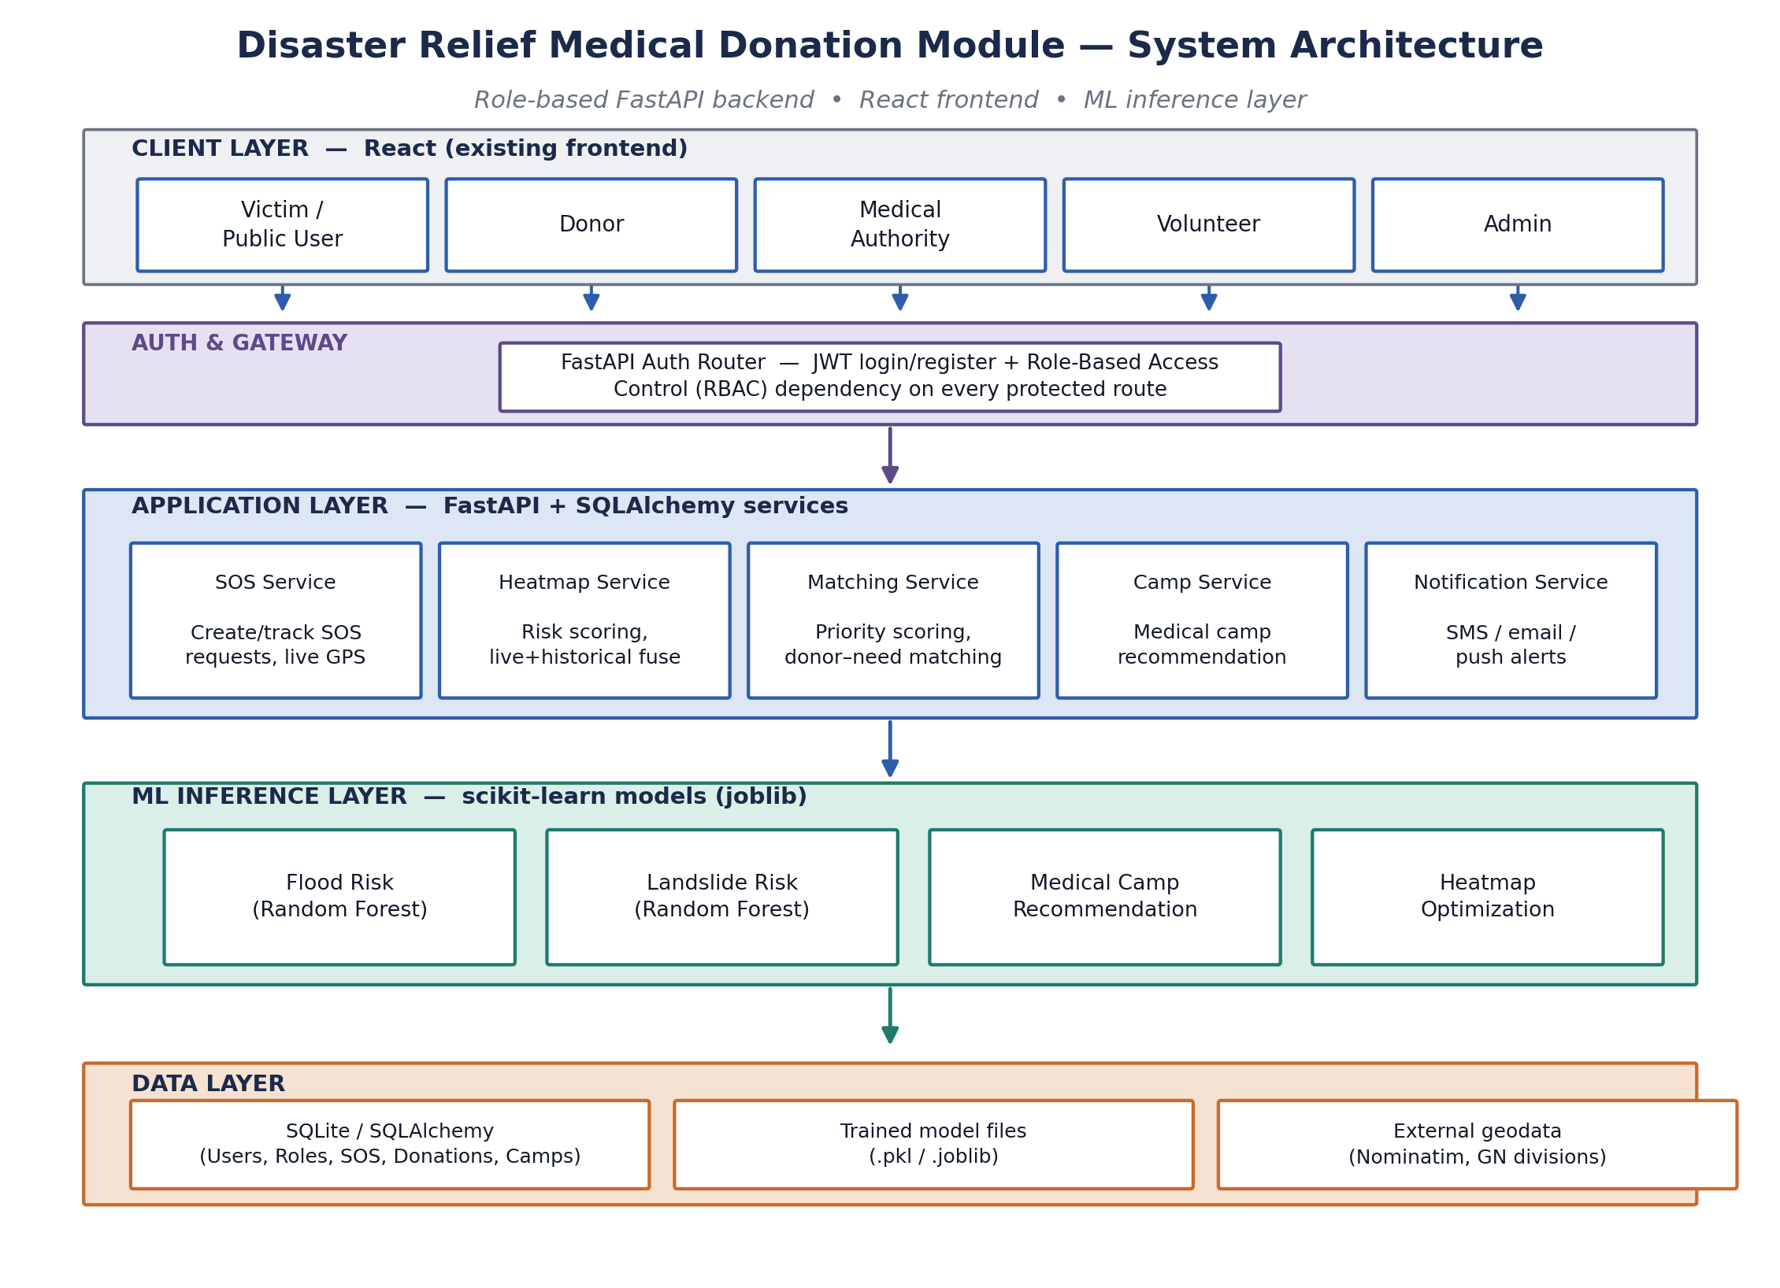
Figure 1. System architecture — client, auth/gateway, application services, ML inference, and data layers.

5.1 Layer-by-layer explanation
- Client layer — the existing React frontend. It holds no business logic; it authenticates once, stores the issued JWT, and attaches it to every subsequent request.
- Auth & Gateway layer — verifies the JWT signature and expiry, extracts the role claim, and rejects the request before it reaches any business logic if the role is not permitted for that route. This is the only layer touched by the RBAC work in Section 6.
- Application Services layer — the FastAPI route handlers for SOS, heatmap, matching, camps, and donations. This is where request validation (via Pydantic schemas), orchestration, and response shaping happen.
- ML Inference layer — the four trained models, loaded once into memory at process startup and invoked synchronously from the service layer. Keeping this separate from training code means a request handler never re-trains or re-loads a model per call.
- Data layer — SQLite via SQLAlchemy, holding the eight entities described in Section 6.

5.2 Why this layering matters for delivery
The practical benefit of this separation is scoping: the existing FastAPI route logic for SOS, heatmap, and matching stays inside the Application Services layer, unchanged. Role checking is added as a single reusable dependency at the Auth & Gateway layer and attached to routes, rather than rewritten per-endpoint. ML models are loaded once at startup and called from the service layer, keeping training code separate from request-handling code. In short, the architecture is drawn the way it is specifically so that the highest-risk piece of remaining work — RBAC — can be inserted without touching code that already works.

6. Role-Based Access Control (RBAC) Design
This is the design for the piece of the system that was previously unresolved. FastAPI does not require a separate "admin panel" framework — role checking is implemented as one reusable dependency function that every protected route uses. The diagram below shows the full path from login to an authorised, or rejected, request.
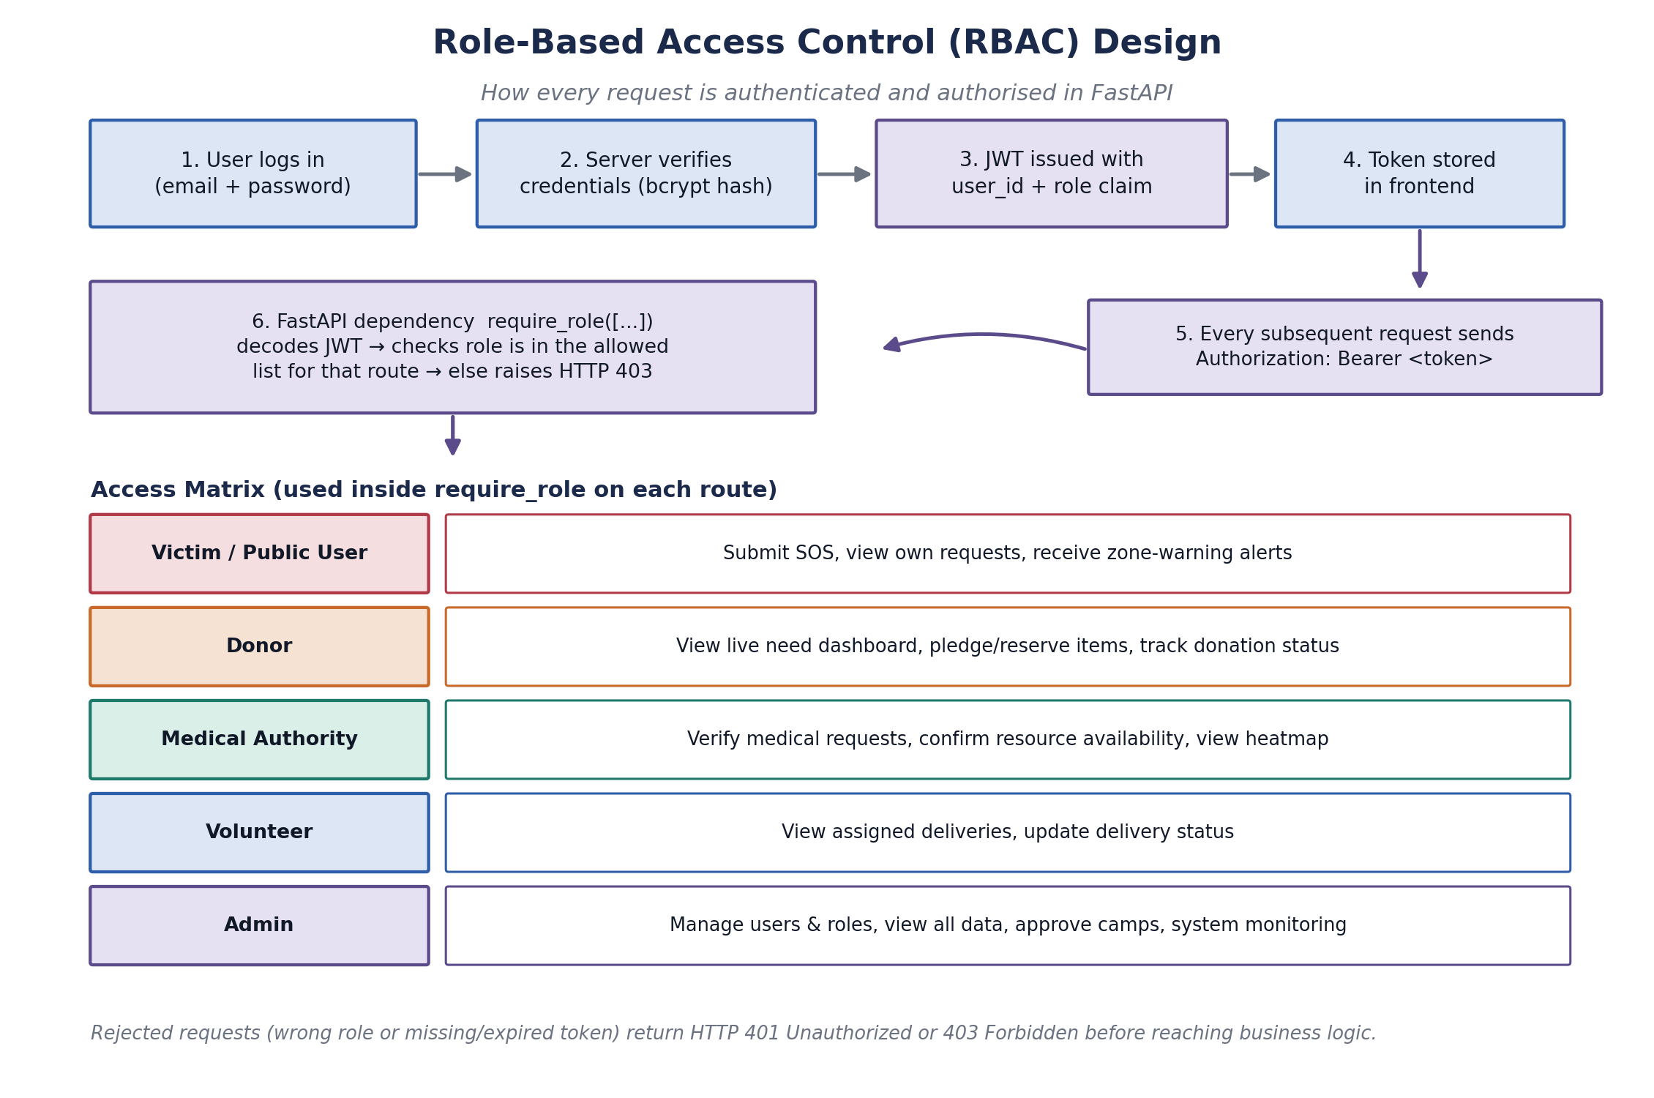
Figure 2. RBAC flow — login, JWT issuance, and per-route role checking, with the access matrix used across the system.

6.1 Why a claims-based JWT approach was chosen over alternatives
Three approaches were considered: (a) a session table looked up on every request, (b) an external identity provider, and (c) a self-contained JWT carrying the role as a claim. A session table adds a database round-trip to every single request and a new table to keep consistent; an external identity provider is disproportionate for a five-role, single-institution system built in a four-day window. The JWT approach was chosen because the role check becomes a pure, stateless function of the token — no database hit is needed to authorise a request, which keeps the Auth & Gateway layer fast and simple to test in isolation.

6.2 Implementation steps
- Add a Role table (or a fixed Enum) with the five roles: admin, victim, donor, authority, volunteer.
- Add a role_id foreign key on the User table; assign a default role (victim) at self-registration, and let only an admin promote or change roles.
- On login, issue a JWT whose payload includes user_id and role, not just user_id — this is what makes the role check stateless.
- Write one dependency, require_role(['admin', 'authority']), that decodes the JWT, reads the role claim, and raises HTTP 403 if the caller's role is not in the allowed list.
- Attach that dependency to each router with Depends(require_role([...])) — for example, camp-approval endpoints require ['admin', 'authority'], while SOS submission only requires a valid logged-in user of any role.
- Keep a small, explicit access matrix (Figure 2) as the single source of truth so all teammates apply roles consistently across all modules.

6.3 Security considerations that follow from this design
- Because the role is embedded in the JWT at issuance time, a role change made by an admin does not take effect for a user until their existing token expires or they log in again — the token lifetime should therefore be kept short (for example, 30–60 minutes) with a refresh-token flow, rather than issuing long-lived access tokens.
- The require_role dependency should fail closed: if the role claim is missing, malformed, or the token cannot be decoded, the request is rejected with 401, not silently treated as a low-privilege role.
- Passwords are hashed with bcrypt before storage; the JWT itself never carries the password hash or any other sensitive field beyond user_id and role.
This pattern needs no extra library beyond what FastAPI already provides (OAuth2PasswordBearer + python-jose or PyJWT + Depends), so it fits the existing stack without introducing new dependencies or a new subsystem to maintain.

7. Database Design
The schema below consolidates the SOS, heatmap/camp, matching, and donation data behind the three owned components into one consistent relational model, ready for SQLAlchemy models in SQLite.
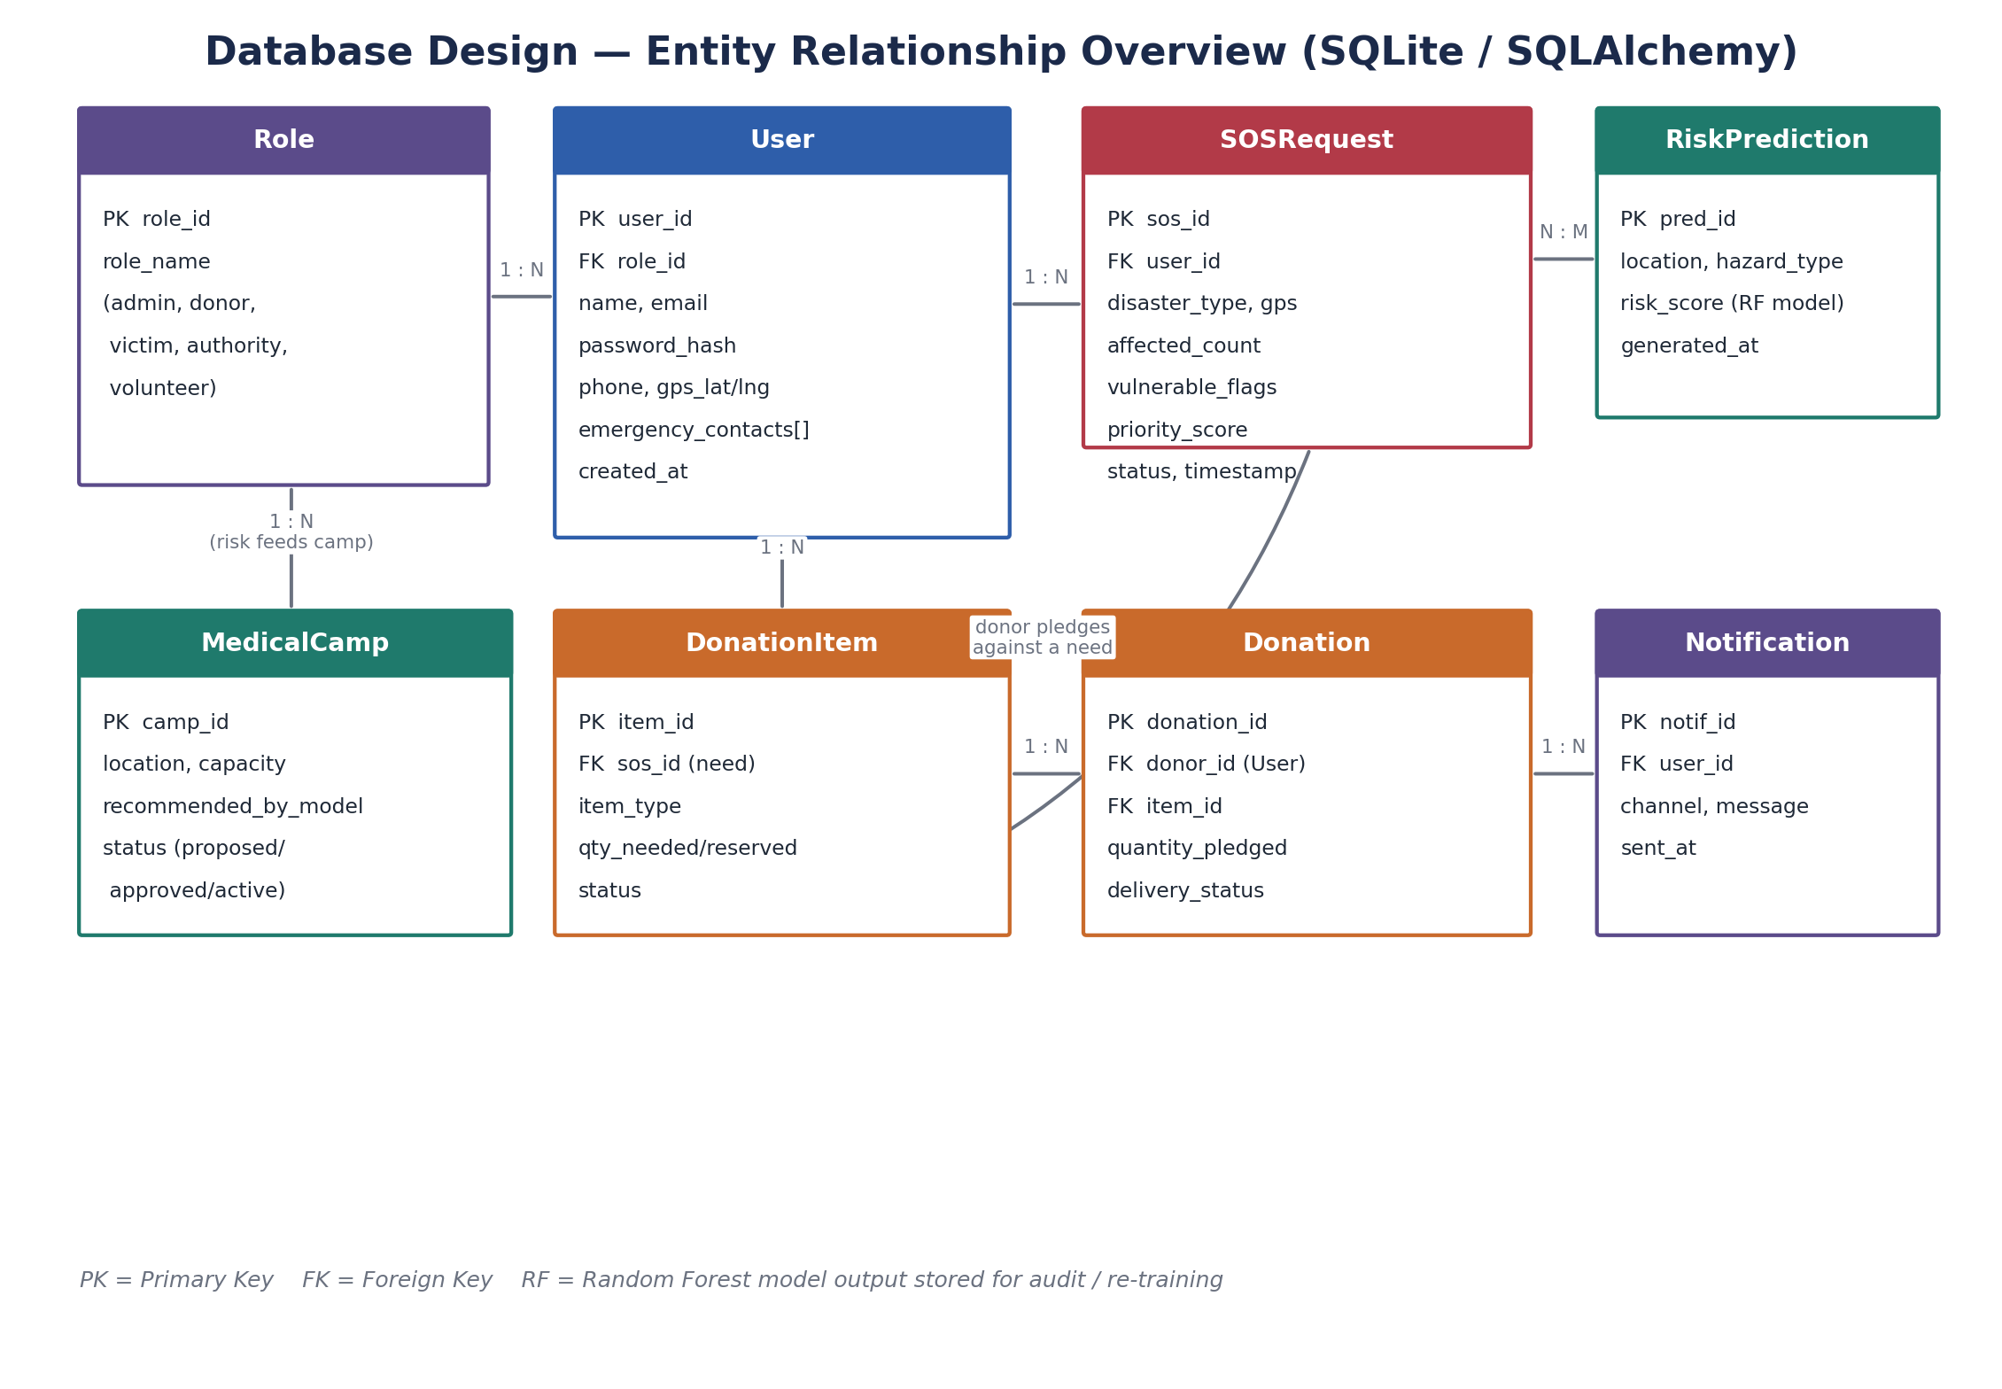
Figure 3. Entity-relationship overview — Role, User, SOSRequest, RiskPrediction, MedicalCamp, DonationItem, Donation, and Notification.

7.1 Entity summary and design rationale
Entity | Purpose | Key relationships
Role | Fixed list of the five system roles. | 1 Role -> many Users
User | Registered account for any stakeholder. | belongs to 1 Role; has many SOSRequests, Donations
SOSRequest | One emergency alert with location & urgency data. | belongs to 1 User; feeds priority_score and MedicalCamp logic
RiskPrediction | Stored output of the flood/landslide RF models per location. | linked to SOSRequest locations (N:M by area)
MedicalCamp | A proposed/approved temporary medical camp. | generated from RiskPrediction + SOSRequest density
DonationItem | A specific need (item type + quantity) tied to an SOS request. | belongs to 1 SOSRequest; has many Donations
Donation | A donor's pledge against a DonationItem. | belongs to 1 User (donor) and 1 DonationItem
Notification | A dispatched SMS/email/push message. | belongs to 1 User

7.2 Why this shape and not an alternative
Two structural decisions deserve explicit justification. First, RiskPrediction is stored as its own entity rather than as a column on SOSRequest, because risk predictions are computed per geographic area on a schedule and are consumed by multiple SOS requests in the same area — collapsing it into SOSRequest would mean re-computing or duplicating the same prediction for every request in a danger zone. Second, DonationItem is separated from Donation so that a single need (for example, "200 units of IV fluid") can receive partial pledges from several donors, which the priority-matching logic needs in order to report remaining unmet need rather than treating a request as either fully donated or not at all.

7.3 Referential integrity and role enforcement
Foreign keys enforce the relationships shown above at the database level, but role restrictions — for example, that only a donor may create a Donation, or only admin/authority may approve a MedicalCamp — are enforced at the API layer via require_role, not at the schema level. This keeps the schema itself role-agnostic and reusable even if the access matrix changes later.

8. Machine Learning Model Pipeline
All four models follow the same pipeline: collect data, clean and engineer features, train with scikit-learn, evaluate, then serve the trained model file from inside a FastAPI endpoint using joblib.
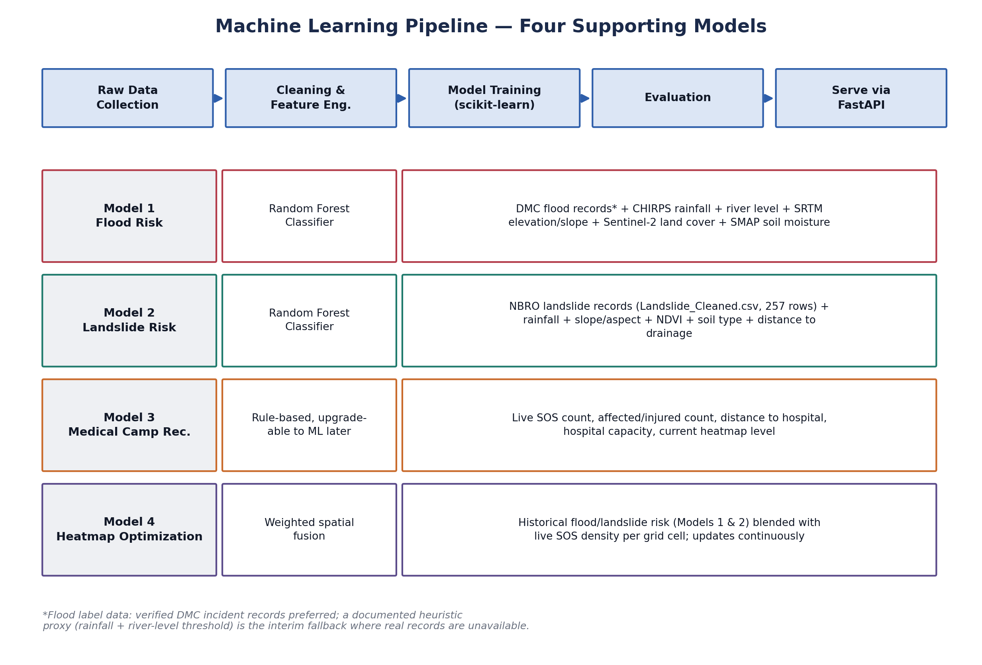
Figure 4. The four supporting models, their algorithms, and their data sources.

8.1 Model roles within the pipeline
- Flood risk model — Random Forest classifier estimating flood likelihood per area, from rainfall, river-level and historical incident features.
- Landslide risk model — Random Forest classifier trained on the verified Landslide_Cleaned.csv dataset (257 rows), using rainfall, elevation, and slope features.
- Medical camp recommendation model — consumes the outputs of the two risk models plus live SOS density to propose candidate camp locations.
- Heatmap optimization model — continuously blends historical risk scores with live SOS signals to keep the risk heatmap current rather than static.

8.2 Handling the missing verified flood labels
Since verified flood incident labels are not yet available, the plan keeps a heuristic proxy — a rainfall + river-level threshold rule — as a documented, clearly labelled fallback for the flood model. The landslide model is trained and validated first, on the real 257-row Landslide_Cleaned.csv dataset, because it is the model that can be presented as fully data-driven evidence of the approach's validity. The flood model's methodology section should describe the proxy-label approach honestly and note verified-label integration (for example, from the Disaster Management Centre, DMC) as future work, rather than presenting proxy-derived predictions with the same confidence as the landslide model's real-data predictions.

8.3 Evaluation approach
For the landslide model, a held-out test split should be used to report standard classification metrics — precision, recall, and F1, not accuracy alone, since a false negative (missing a genuine landslide risk) is materially more costly than a false positive in this domain. For the flood proxy model, because the labels themselves are heuristic rather than ground truth, evaluation should focus on sanity-checking predictions against known historical flood events in the dataset, and the report should state plainly that formal precision/recall figures for this model describe agreement with the proxy rule, not with verified ground truth.

8.4 Serving models in production
Each trained model is persisted with joblib and loaded once at FastAPI startup (see Section 5.1), rather than reloaded per request. Inference is then a pure function call inside the /predict/flood and /predict/landslide route handlers, keeping request latency low and training code fully separated from the request-serving path.

9. API Endpoint Plan
Endpoints are grouped by component. The "Allowed roles" column is what gets passed into require_role([...]) for that route, making the access matrix in Figure 2 directly traceable to the route definitions.
Endpoint | Method | Allowed roles | Purpose
/auth/register | POST | public | Create account, default role = victim
/auth/login | POST | public | Verify credentials, issue JWT
/sos | POST | victim, donor, authority, volunteer, admin | Submit an SOS request
/sos/{id} | GET | owner, authority, admin | View a specific SOS request
/sos | GET | authority, admin | List/filter all SOS requests
/heatmap | GET | all authenticated | Fetch current risk heatmap
/predict/flood | POST | authority, admin | Run flood RF model for an area
/predict/landslide | POST | authority, admin | Run landslide RF model for an area
/camps | GET | all authenticated | List proposed/approved camps
/camps/{id}/approve | PATCH | authority, admin | Approve a recommended camp
/donations/needs | GET | donor, admin | View live donation needs, priority-sorted
/donations | POST | donor | Pledge a donation against a need
/users | GET | admin | List/manage all users and roles
/users/{id}/role | PATCH | admin | Change a user's role

9.1 Design conventions and reasoning
- Versioning — all routes are mounted under an /api/v1 prefix, so that once the frontend integration in Day 4 is stable, future breaking changes (for example, a v2 priority-scoring formula) can be introduced without disrupting the existing frontend build.
- Ownership checks — /sos/{id} allows the requesting user's own record in addition to authority/admin, which is enforced in the handler by comparing the JWT's user_id to the record's owner, layered on top of (not instead of) the role check.
- Error semantics — a missing or invalid token returns 401 Unauthorized; a valid token with an insufficient role returns 403 Forbidden; these are kept distinct so the frontend can tell "log in again" apart from "you don't have permission" and show the correct message.
- Read/write separation — GET routes that expose aggregate or sensitive data (all SOS requests, all users) are restricted to authority/admin, while GET routes that expose already-public operational state (the heatmap, the camp list) are open to any authenticated role, since narrowing them further would not add meaningful protection but would complicate the frontend.

10. Technology Stack
Layer | Technology
Backend framework | FastAPI (Python)
ORM / Database | SQLAlchemy + SQLite
Authentication | OAuth2PasswordBearer + JWT (python-jose), bcrypt password hashing
Machine learning | scikit-learn (Random Forest), pandas, joblib for model persistence
Frontend | React (existing pre-built frontend, connected via REST API)
Geocoding support | Nominatim, with multi-level fallback for rural addresses
Notifications | SMS/email/push provider integration from the Notification Service

10.1 Why these choices, specifically
- FastAPI — chosen over Flask/Django primarily for native Pydantic request/response validation and first-class support for dependency injection, which is exactly the mechanism require_role relies on; it also generates OpenAPI docs automatically, which helps the React team integrate without a separate API-spec document.
- SQLite — appropriate for a four-day academic delivery timeline and a single-instance deployment; the schema is written in standard SQLAlchemy so a later migration to PostgreSQL, if the project continues past the dissertation, requires no schema redesign.
- JWT via python-jose — avoids introducing a session store, keeping the Auth & Gateway layer stateless, as justified in Section 6.1.
- scikit-learn Random Forest — chosen for the risk models because the available feature sets (rainfall, elevation, slope, river level) are tabular and modestly sized (257 rows for landslide), where Random Forest reliably outperforms simpler linear models without requiring the tuning effort or data volume a neural approach would need.
- Nominatim — a free, self-hostable geocoding service appropriate for a project without a commercial mapping API budget; the multi-level fallback exists because rural Sri Lankan addresses frequently fail to resolve on the first geocoding attempt and need a coarser (e.g. district-level) retry.

11. 4-Day Implementation Roadmap
The roadmap sequences work so that role-based access is solved first — every later endpoint can then be built with the correct require_role(...) guard from the start, instead of retrofitted later.
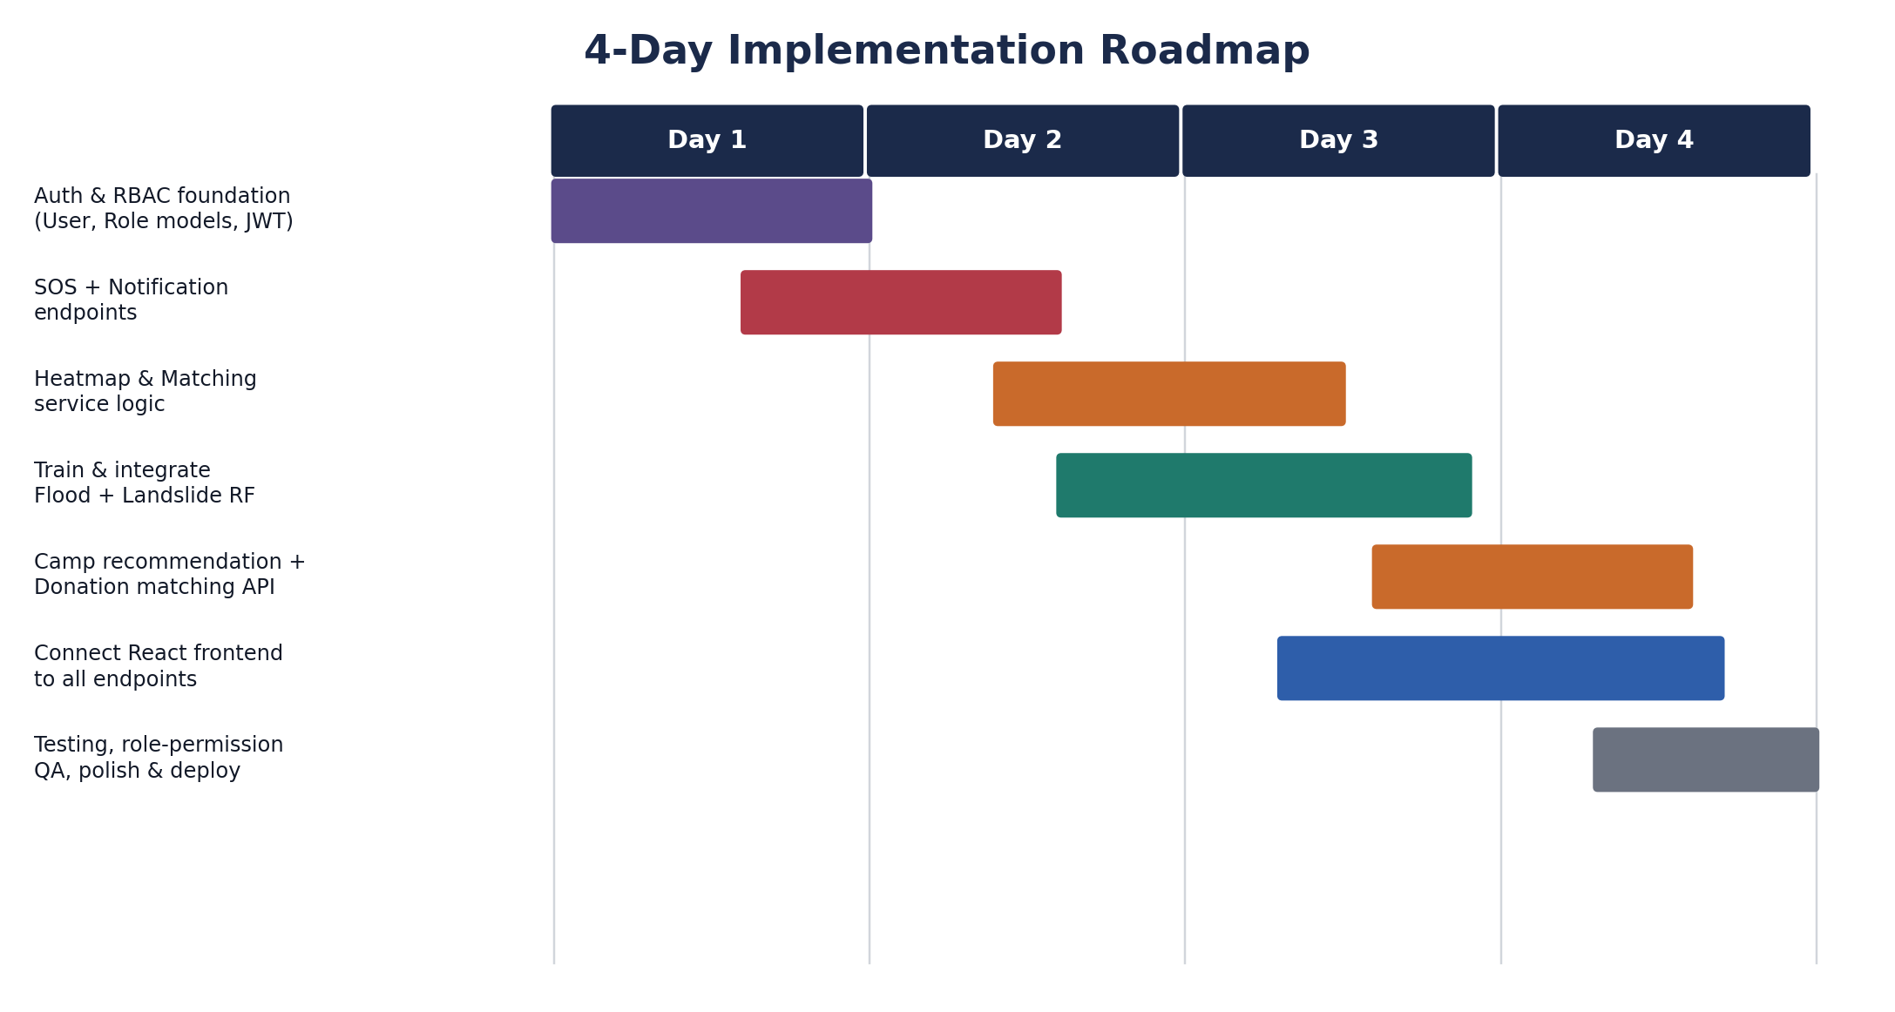
Figure 5. Four-day roadmap from RBAC foundation to tested, deployed system.

Day 1 — Foundations
- Create Role and User SQLAlchemy models; seed the five roles.
- Implement register/login endpoints with JWT issuance including the role claim.
- Write and test the require_role(...) dependency on one sample route.

Day 2 — Core components
- Build SOS submission + retrieval endpoints, guarded by role.
- Wire the Notification service (stub or real provider) to fire on SOS creation.
- Start heatmap and priority-matching service logic using existing risk data.

Day 3 — ML integration
- Train the landslide Random Forest model on Landslide_Cleaned.csv; evaluate and save with joblib.
- Train the flood Random Forest model using the heuristic proxy labels, clearly documented as interim.
- Expose both via /predict/flood and /predict/landslide; feed outputs into the heatmap and camp-recommendation logic.

Day 4 — Integration, testing, polish
- Connect the existing React frontend to every endpoint; confirm each role sees only what it should.
- Run through the full pipeline end-to-end: SOS -> heatmap update -> priority score -> camp recommendation -> donor match -> notification.
- Fix edge cases, tidy error responses (401/403), and prepare the demo.

11.1 Why this sequencing, and not a feature-first order
A tempting alternative would be to build the SOS, heatmap, and matching endpoints first, since they are the visibly demoable parts of the system, and add RBAC afterwards. This plan deliberately rejects that ordering: adding role checks after routes already exist means revisiting every route a second time, and risks inconsistent enforcement across routes written by different teammates. Placing RBAC on Day 1 costs one day up front but removes an entire category of rework from Days 2 through 4.

12. Testing and Quality Assurance Strategy
Testing is organised in three tiers, matched to the architecture layers in Section 5, so that a failure can be localised to the layer that caused it.

12.1 Unit tests
- require_role dependency — tested in isolation with fabricated JWTs covering: no token, expired token, malformed token, valid token with a disallowed role, and valid token with an allowed role.
- Priority-scoring function — tested with fixed input combinations (urgency, affected-people count, medical needs, vulnerable-person flag, heatmap risk) against expected score ordering, independent of the database or API layer.
- ML model wrappers — tested by asserting the loaded joblib model produces a prediction within a valid probability range for a fixed sample input, catching model file corruption or a feature-order mismatch.

12.2 Integration tests
- Each endpoint in Section 9 is tested with an authenticated client for every role in the access matrix, asserting 200/201 for allowed roles and 403 for disallowed ones — this directly checks the access matrix in Figure 2 against the running system rather than only against the code that implements it.
- Database relationship tests confirm that deleting or updating a SOSRequest correctly cascades or is blocked (per the intended behaviour) for its dependent DonationItem and RiskPrediction rows.

12.3 End-to-end (system) test
A single scripted scenario exercises the full pipeline named as the project's demo target: an SOS is submitted by a seeded victim account, the heatmap updates, a priority score is computed, a camp recommendation appears, a seeded donor account pledges against a resulting donation need, and a notification record is created. This scenario is run manually before the Day 4 demo and, time permitting, automated as a single pytest scenario so it can be re-run after any later change.

13. Known Risks and Mitigations
Risk | Mitigation
Verified flood incident labels unavailable | Use the documented heuristic proxy for the flood model now; present the landslide model (real NBRO/Landslide_Cleaned.csv data) as the primary evidence of model validity; note real-label integration as future work.
Role-based access implemented late touches many files | Add the require_role dependency first (Day 1) so every subsequent endpoint is written with it from the start, avoiding rework.
Tight 4-day timeline | Roadmap sequences the highest-risk, most foundational work (auth/RBAC, ML training) earliest, leaving Day 4 purely for integration and polish.
Two teammates' components integrate with this one | Keep the Role/User schema and the require_role pattern as the single shared contract other modules should also follow for consistency.
JWT role claim can become stale after an admin changes a user's role | Keep access-token lifetime short (30-60 minutes) and require re-login or token refresh to pick up a role change.
Geocoding failures for rural addresses | Multi-level fallback in the Nominatim integration, retrying at a coarser (district-level) resolution when a precise address fails to resolve.

14. Conclusion
With role-based access handled as one dependency function applied consistently across routes, the rest of the backend — SOS, heatmap, matching, camp recommendation, and donation flows — can be built and demonstrated without further architectural rework. Following the four-day sequence set out in Section 11 gets the foundation, core components, ML integration, and full end-to-end testing done in order, so each day builds cleanly on the last. Where the underlying data is incomplete, as with the flood model's verified labels, the plan is explicit about the limitation rather than obscuring it, which strengthens rather than weakens the case made at review: the landslide model demonstrates the approach works on real data, and the flood model's proxy-label methodology is presented as a stated, defensible interim choice with a clear path to improvement.

15. References
Landslide_Cleaned.csv — project dataset (257 records), used to train and validate the landslide Random Forest model.
Disaster Management Centre (DMC), Sri Lanka — identified as the intended future source of verified flood incident records for Model 1 refinement.
FastAPI, SQLAlchemy, scikit-learn, and Nominatim official documentation — reference material for the implementation patterns described in Sections 6, 7, 8, and 10.

