AI-Based Chatbot for Oral Health Education Platform
Project Workflow and Module-wise Explanation

1. Overall Project Workflow

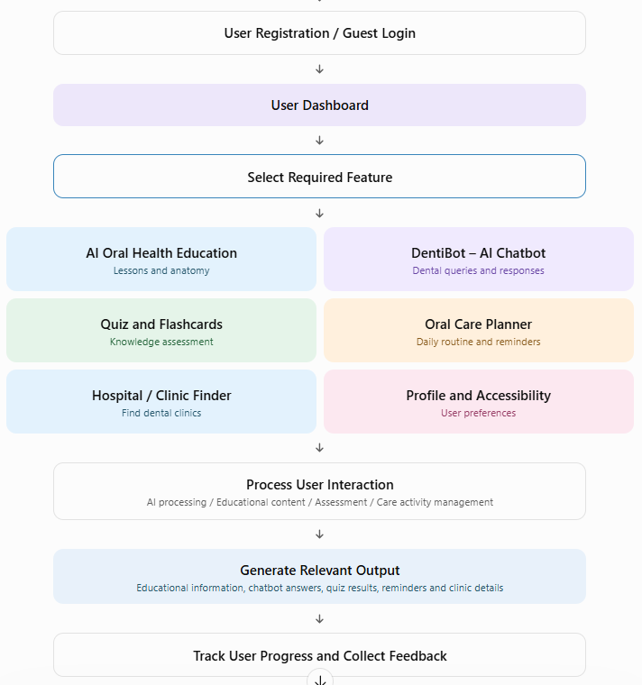

2. Prototype:

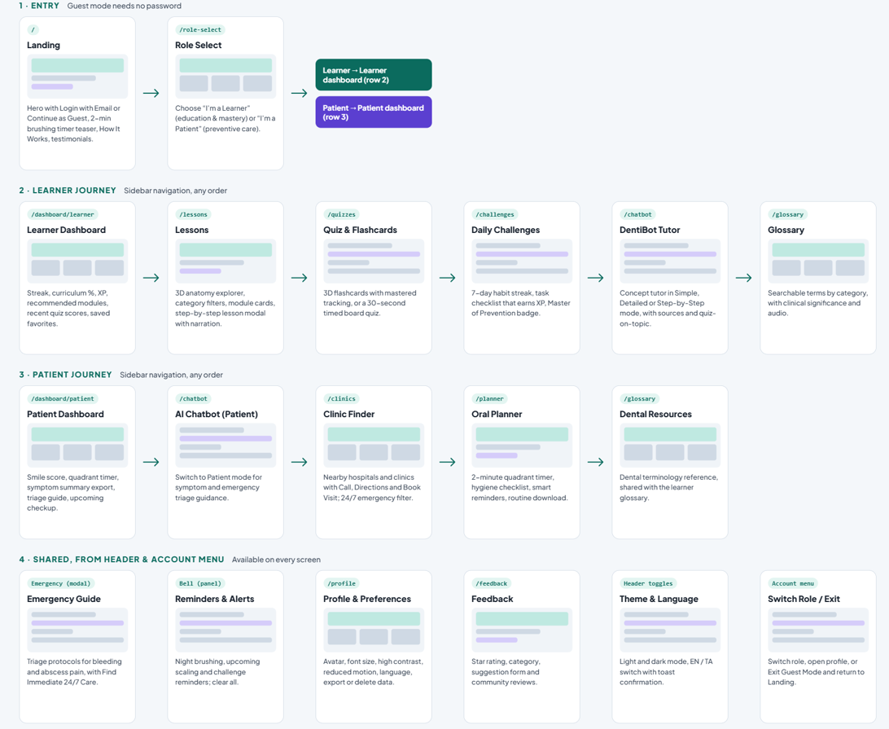

3. Main Features and Modules

Module 1: User Registration and Dashboard
- The user opens the DentiAI website.
- The user registers or logs in. Guest access may also be available.
- The dashboard displays the oral healthcare services.
- The user selects the required feature.

Module 2: AI-Powered Oral Health Education
- The user selects a dental learning topic.
- The platform displays educational lessons and explanations.
- Topics may include dental anatomy, pediatric dental care, gum health, cavities and prevention, and orthodontics.
- The user explores the learning content and interactive tooth anatomy.
- The user completes lessons and may earn experience points (XP), as shown in the application.

Module 3: DentiBot – AI Dental Chatbot
- The user enters a dental-related question.
- The chatbot receives and processes the question.
- The system identifies the topic or intent of the question.
- Relevant dental educational information is retrieved from its knowledge source, if retrieval is implemented.
- The AI generates an understandable response.
- The user may access response options such as simple or detailed explanations, audio, copying the answer, or generating a quiz, depending on the available interface.

Module 4: Oral Health Quiz and Flashcards
- The user selects the quiz or flashcard option.
- The system displays dental-related questions or learning cards.
- The user selects or enters an answer.
- The system checks the answer and provides marks or feedback.
- Quiz performance can be recorded so that users can identify topics requiring further learning.

Module 5: Oral Care Planner and Smart Reminders
- The user opens the oral care planner.
- The system displays a daily oral hygiene checklist.
- Activities may include morning brushing, flossing, mouthwash usage, tongue cleaning and night brushing.
- A guided two-minute brushing timer supports a brushing routine; the demonstrated interface divides the mouth into four quadrants.
- The user configures reminders and marks completed activities.
- The platform displays the user’s recorded daily progress.

Module 6: Dental Hospital and Clinic Finder
- The user opens the clinic or hospital finder.
- The platform displays available dental clinics or facilities.
- The user views available clinic details and services.
- Contact or navigation options help the user reach a clinic, where supported.

Module 7: Personal Profile and Accessibility
- The user updates profile information and selects an avatar, where available.
- The user can configure accessibility options such as font size, high contrast and reduced motion.
- The user can choose a light or dark theme and preferred language, where supported.
- The user can manage available privacy and account settings.

Module 8: Feedback and Community Reviews
- The user submits feedback, ratings, suggestions or issue reports.
- The platform may display community reviews.
- Feedback can be considered when improving the application.

4. Internal Workflow of the AI Dental Chatbot
User Question
Example: “What causes gum bleeding?”
↓
Text Processing
The question is cleaned or prepared for processing.
↓
Natural Language Processing (NLP)
The system identifies the meaning, intent and dental topic of the question.
↓
Dental Knowledge Source
Relevant information is retrieved from trusted dental educational sources or a curated knowledge base, if this retrieval component is implemented.
↓
AI Response Generation
The AI produces a clear response grounded in the available information.
↓
Response to User
The platform displays the answer and may provide audio, a detailed explanation or a related quiz.

5. Complete Workflow
User Input → Registration/Login → Dashboard → Feature Selection → AI-Based Processing / Educational Content Retrieval → Response Generation → User Interaction → Progress Tracking → Feedback



