Financial Risk Analytics with Polyglot Data Engineering
A Project Based Learning Report Submitted in partial fulfilment of the requirements for
the award of the degree
of
Bachelor of Technology
in The Department of Electronics and Communication Engineering
25CS1302E – DBE & DSD
Submitted by
2510080004: UTKALIKA
2510080025: DIVYA SRI
2510080033: KAVITHA
2510080035: AMBIKA
Under the guidance of
MELINDA

Department of Electronics and Communication Engineering
Koneru Lakshmaiah Education Foundation, Aziz Nagar
Aziz Nagar – 500075
OCTOBER - 2026

ABSTRACT
Financial institutions process structured customer, account, and transaction records while also needing flexible storage for risk indicators and analytical results. The project “Financial Risk Analytics with Polyglot Data Engineering” implements a DBMS-centered prototype that separates these workloads between PostgreSQL and MongoDB. PostgreSQL acts as the relational source of truth for customer, account, and transaction data, while MongoDB stores risk-analysis documents containing the calculated score, risk level, and indicators.
The implemented backend is developed with FastAPI and exposes REST endpoints for login, customer management, account management, deposits, withdrawals, transaction retrieval, and risk analysis. JWT-based authentication is used to protect the application endpoints. The frontend is implemented using HTML, CSS, and JavaScript and provides pages for login, dashboard, customers, accounts, transactions, and risk analysis. The current risk engine is rule-based: a transaction amount above 50,000 adds 50 points, a frequency above 10 adds 30 points, and the final score maps to LOW, MEDIUM, or HIGH risk. This design demonstrates how relational integrity, document flexibility, API security, and operational risk analysis can be combined in a single project workflow.

LIST OF FIGURES
Figure 1. Implemented System Architecture
Figure 2. End-to-End Data and Risk Analysis Lifecycle
Figure 3. Project Data Model and Polyglot Persistence
Figure 4. Implemented Rule-Based Risk Scoring
Figure 5. Risk-Level Rule Coverage
Figure 6. Login Interface
Figure 7. Dashboard Interface
Figure 8. Risk Analysis Interface

LIST OF TABLES
Table 1. Project Technology Stack
Table 2. Core Relational Data Model
Table 3. MongoDB Risk Document Structure
Table 4. REST API Endpoints
Table 5. Risk-Scoring Rules
Table 6. Functional Test Cases
Table 7. Project Results and Verification

TABLE OF CONTENTS
1. INTRODUCTION 6
2. METHODOLOGY 6
2.1 Project Architecture and Technology Selection 6
2.2 Relational Data Management 7
2.3 Document-Based Risk Storage 8
2.4 Authentication and API Security 8
2.5 Frontend Methodology 9
3. EXPERIMENTS 11
3.1 Authentication Experiment 11
3.2 Customer and Account Experiment 11
3.3 Transaction Experiment 11
3.4 Risk Analysis Experiment 12
4. RESULTS 13
5. CONCLUSION AND FUTURE WORK 14
References 14

1. INTRODUCTION
Financial risk analytics requires more than calculating a numerical risk value. A practical financial information system must maintain reliable customer and account records, preserve transaction history, validate relationships between records, protect sensitive operations, and provide flexible storage for analytical outputs. The project addresses these requirements through a polyglot data-engineering approach in which each database is assigned a workload that matches its strengths.
The project uses PostgreSQL as the relational core. Customer, account, and transaction records are treated as structured data, with account records linked to customers and transactions linked to accounts. The application code performs inserts, reads, balance updates, transaction logging, and account deletion through PostgreSQL connections. Deposit and withdrawal operations update account balances and create corresponding transaction records. Withdrawal processing additionally checks the available balance before completing the operation.
MongoDB is used as the analytics document store. The implemented risk module calculates a score from transaction amount and transaction frequency and then stores a document containing customer ID, account ID, risk score, risk level, and risk indicators. This flexible document structure is suitable for adding new indicators without changing the relational ledger tables.
The application layer is implemented with FastAPI. Pydantic request models define the expected structure for login, customers, accounts, transactions, and risk-analysis requests. JWT authentication is applied through HTTP Bearer tokens. The login endpoint accepts the configured demonstration credentials and returns a token, while protected endpoints depend on token verification.
A browser-based frontend provides the operational interface. The project contains separate HTML pages for login, dashboard, customers, accounts, transactions, and risk analysis. JavaScript functions communicate with the FastAPI backend using fetch requests, store the JWT token in local storage, render returned records in tables, and display risk results to the user. The interface therefore connects the DBMS layer, backend services, authentication mechanism, and risk-analysis function into one demonstrable workflow.
The PPT frames the broader project vision as “From Financial Data to Risk Intelligence” and identifies fragmented data, single-database bottlenecks, and opaque risk insights as the main challenges. The implemented prototype directly addresses these themes through PostgreSQL for structured financial records, MongoDB for risk documents, a FastAPI service layer, and authenticated REST endpoints. Some PPT items such as Kafka streaming, SHAP/LIME explainability, cloud clustering, and automated compliance reporting are treated as future extensions rather than implemented features.

2. METHODOLOGY

2.1 Project Architecture and Technology Selection
The methodology follows a workload-oriented architecture. Structured financial records are persisted in PostgreSQL, analytical risk results are persisted in MongoDB, FastAPI coordinates application operations, JWT protects API access, and the HTML/CSS/JavaScript frontend provides user interaction. This arrangement follows the PPT principle that one database does not have to perform every workload.
Layer | Technology | Role in the implemented project
Frontend | HTML, CSS, JavaScript | Login, dashboard, CRUD screens, transaction actions and risk-analysis UI
Backend | FastAPI, Pydantic | REST API, request validation, routing and static frontend serving
Authentication | JWT / HTTP Bearer | Token generation and protected endpoint verification
Relational DB | PostgreSQL | Customer, account and transaction persistence
Document DB | MongoDB | Risk-analysis result documents
Python drivers | psycopg2, PyMongo | Database connectivity
Table 1. Project Technology Stack
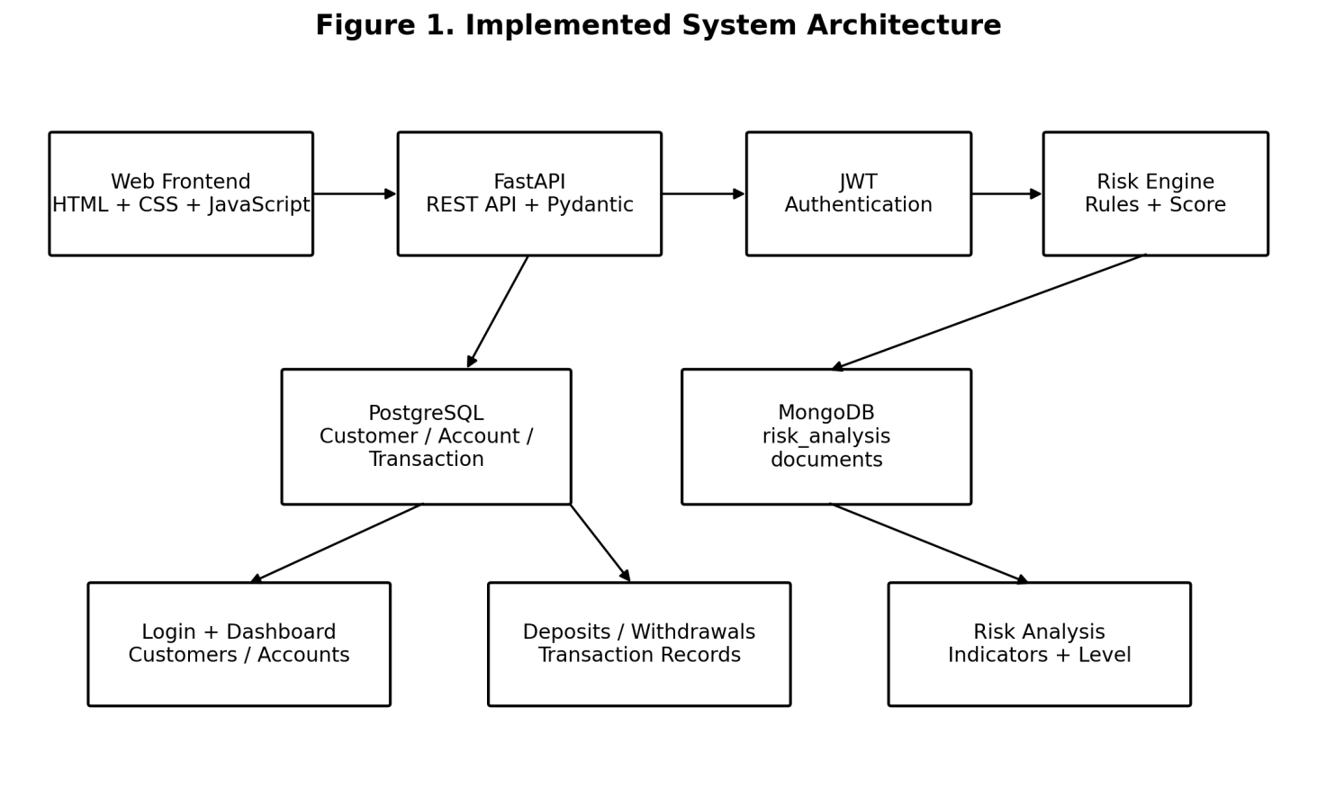
Figure 1. Implemented System Architecture

2.2 Relational Data Management
The relational layer contains customer, account, and transaction entities. The account creation API requires an existing customer ID, and the backend explicitly handles foreign-key and unique-constraint errors. Account deletion first removes related transaction rows and then deletes the account. The transaction module reads the current balance before updating it, and withdrawal is rejected when the requested amount exceeds the available balance.
Entity | Fields used by application | Relationship / purpose
Customer | customer_id, name, email, phone | Base customer record
Account | account_id, customer_id, account_type, balance | Belongs to a customer
Transaction | transaction_id, account_id, transaction_type, amount | Records deposit or withdrawal
Table 2. Core Relational Data Model
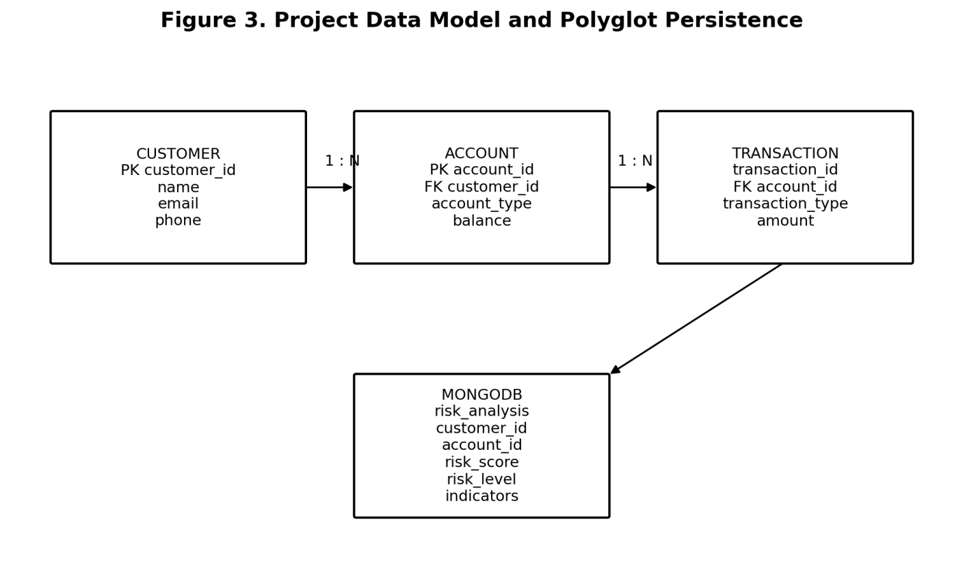
Figure 3. Project Data Model and Polyglot Persistence

2.3 Document-Based Risk Storage
The risk module separates the risk result from the core ledger. The calculate_risk function receives amount and frequency, produces a numeric score and textual level, and records indicator messages when thresholds are crossed. The save_risk function inserts a MongoDB document into the risk_analysis collection. This provides a flexible place for analytical attributes while leaving core customer, account, and transaction records in PostgreSQL.
MongoDB field | Type / example | Purpose
customer_id | String | Identifies the customer being analyzed
account_id | String | Identifies the associated account
risk_score | Number | Sum of triggered rule scores
risk_level | LOW / MEDIUM / HIGH | Categorical risk classification
risk_indicators | Array of strings | Explains which thresholds were triggered
Table 3. MongoDB Risk Document Structure

2.4 Authentication and API Security
The backend uses HTTPBearer to receive a bearer token and python-jose to encode and decode JWT tokens. A token is created with a 30-minute expiration and contains the username as the subject. Protected endpoints use verify_token as a dependency. Invalid or expired tokens result in an HTTP 401 response. The implementation therefore demonstrates stateless authentication at the API boundary, while the PPT describes role-based permission gating as the broader security direction.
Method | Endpoint | Protection | Function
POST | /login | Public | Validate demo credentials and issue JWT
POST | /customers | JWT | Create customer
GET | /customers | JWT | Read customers
POST | /accounts | JWT | Create account
GET | /accounts | JWT | Read accounts
DELETE | /accounts/{account_id} | JWT | Delete account and related transactions
POST | /transactions/deposit | JWT | Deposit and record transaction
POST | /transactions/withdraw | JWT | Withdraw after balance check
GET | /transactions | JWT | Read transaction records
POST | /risk | JWT | Calculate and save risk result
Table 4. REST API Endpoints

2.5 Frontend Methodology
The frontend is intentionally simple and page-oriented. The login page obtains a JWT and redirects to the dashboard. The dashboard requests customer, account, and transaction collections in parallel and displays their counts. The customer and account pages provide forms and record tables. The transaction page provides deposit and withdrawal operations. The risk page accepts customer ID, account ID, amount, and frequency and displays the returned risk score, risk level, and indicators.
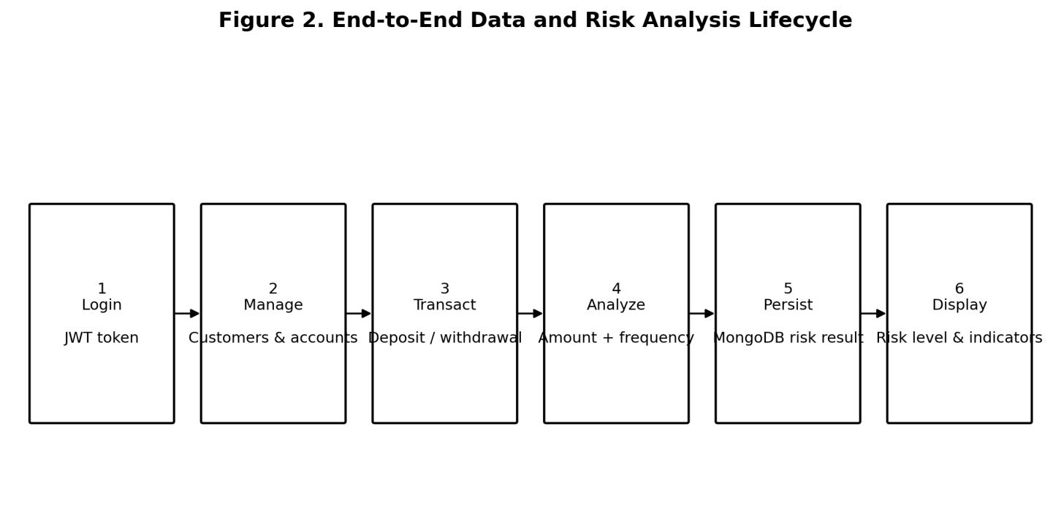
Figure 2. End-to-End Data and Risk Analysis Lifecycle
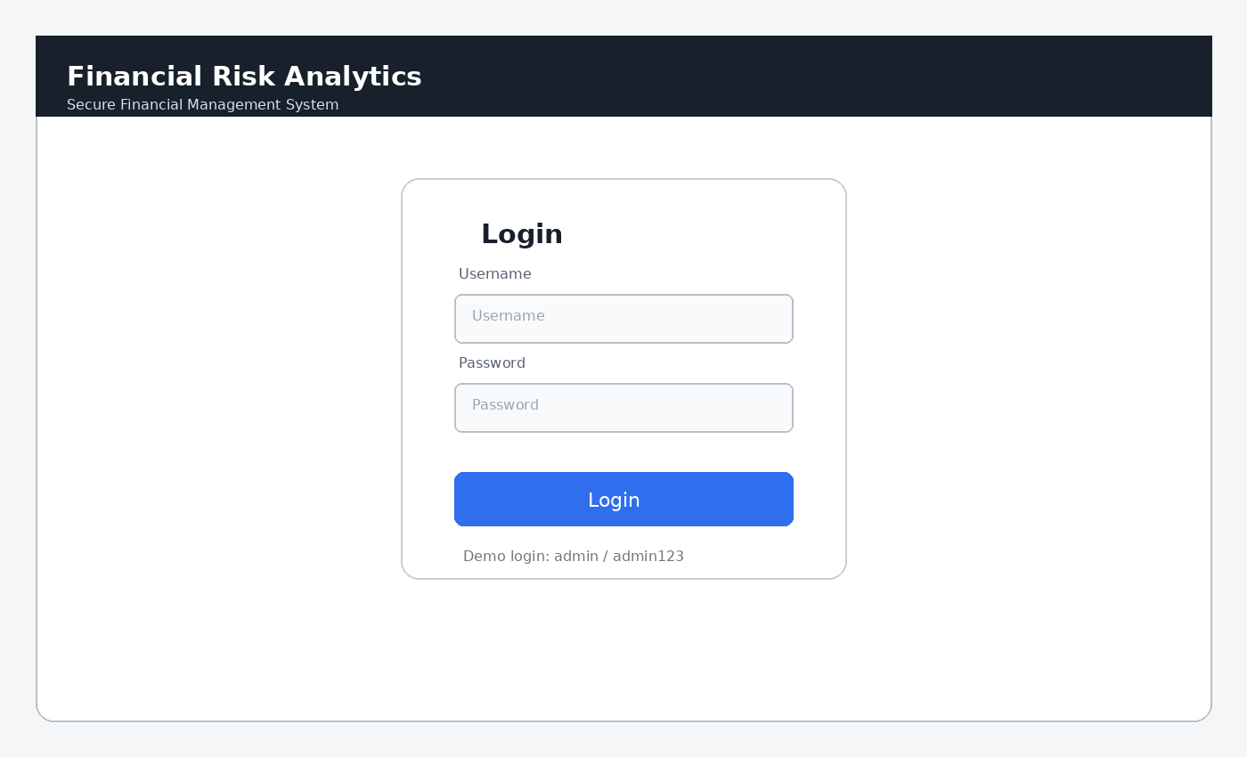
Figure 6. Login Interface
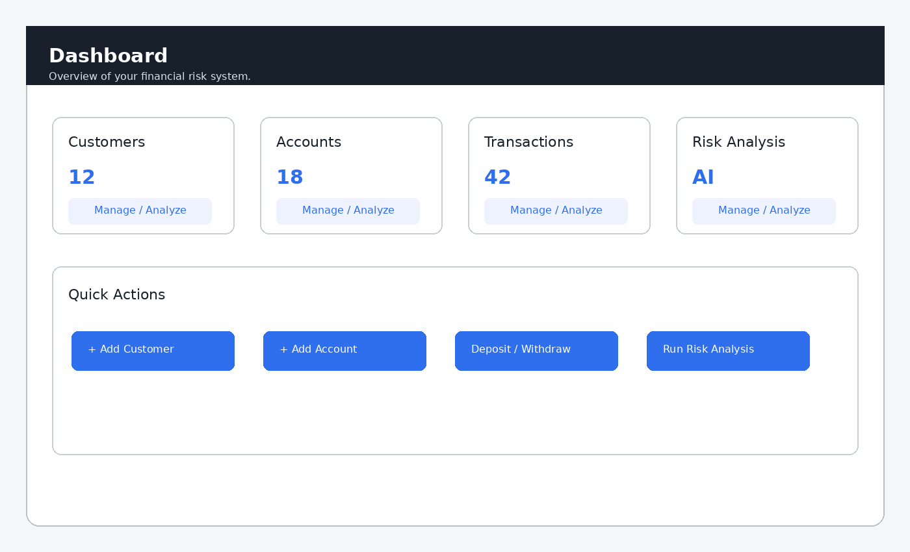
Figure 7. Dashboard Interface
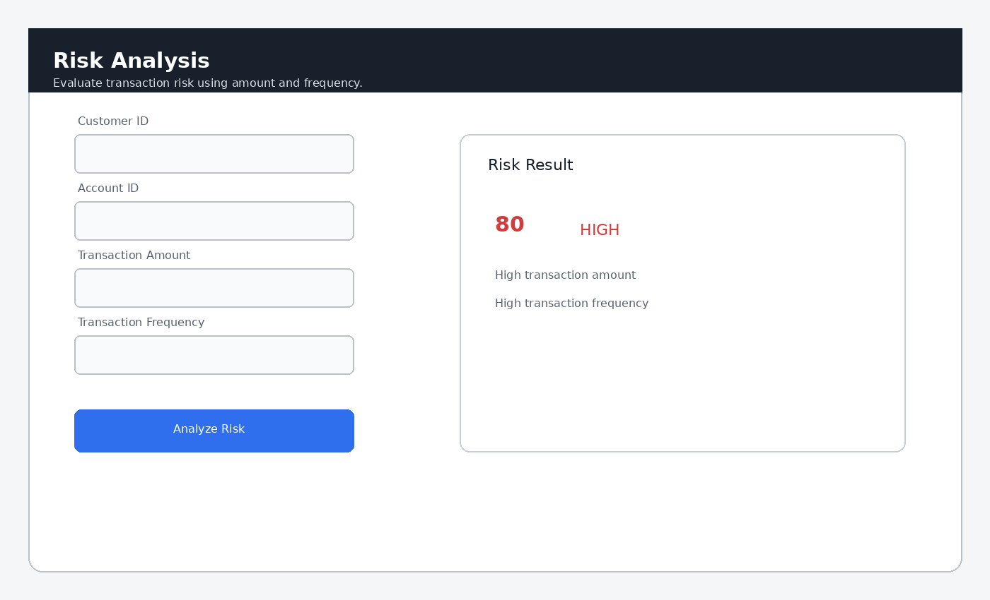
Figure 8. Risk Analysis Interface

3. EXPERIMENTS
The experiments focus on demonstrating the implemented end-to-end behavior rather than evaluating a trained predictive model. The main experimental sequence is: authenticate the user, create and retrieve customer records, create and retrieve accounts, perform deposit and withdrawal operations, retrieve transaction records, submit a risk-analysis request, verify the calculated score and risk level, and confirm that the risk document is stored in MongoDB.

3.1 Authentication Experiment
The login page sends the entered username and password to POST /login. For the configured demonstration credentials, the backend returns an access token and the JavaScript stores it in localStorage. Subsequent API calls attach the token in the Authorization header. Incorrect or missing credentials do not produce an access token.

3.2 Customer and Account Experiment
A customer is created with an ID, name, email, and phone number. The account page loads existing customers into a selection list, which reduces the chance of submitting an account with an unknown customer ID. Account creation is rejected when a referenced customer does not exist or when an account ID already exists. These behaviors correspond to the relational integrity checks implemented in main.py.

3.3 Transaction Experiment
A deposit reads the current account balance, adds the requested amount, and inserts a DEPOSIT transaction record. A withdrawal reads the current balance, rejects the request when funds are insufficient, and otherwise subtracts the amount and inserts a WITHDRAW transaction record. The resulting transaction collection can be retrieved through GET /transactions.

3.4 Risk Analysis Experiment
The risk experiment tests the two implemented indicators: transaction amount and transaction frequency. Amount above 50,000 contributes 50 points and frequency above 10 contributes 30 points. A score of 60 or more is HIGH, 30–59 is MEDIUM, and below 30 is LOW. The resulting risk document is inserted into MongoDB.
Condition | Score contribution | Indicator
amount > 50,000 | +50 | High transaction amount
frequency > 10 | +30 | High transaction frequency
score >= 60 | HIGH | High-risk classification
30 <= score < 60 | MEDIUM | Medium-risk classification
score < 30 | LOW | Low-risk classification
Table 5. Risk-Scoring Rules
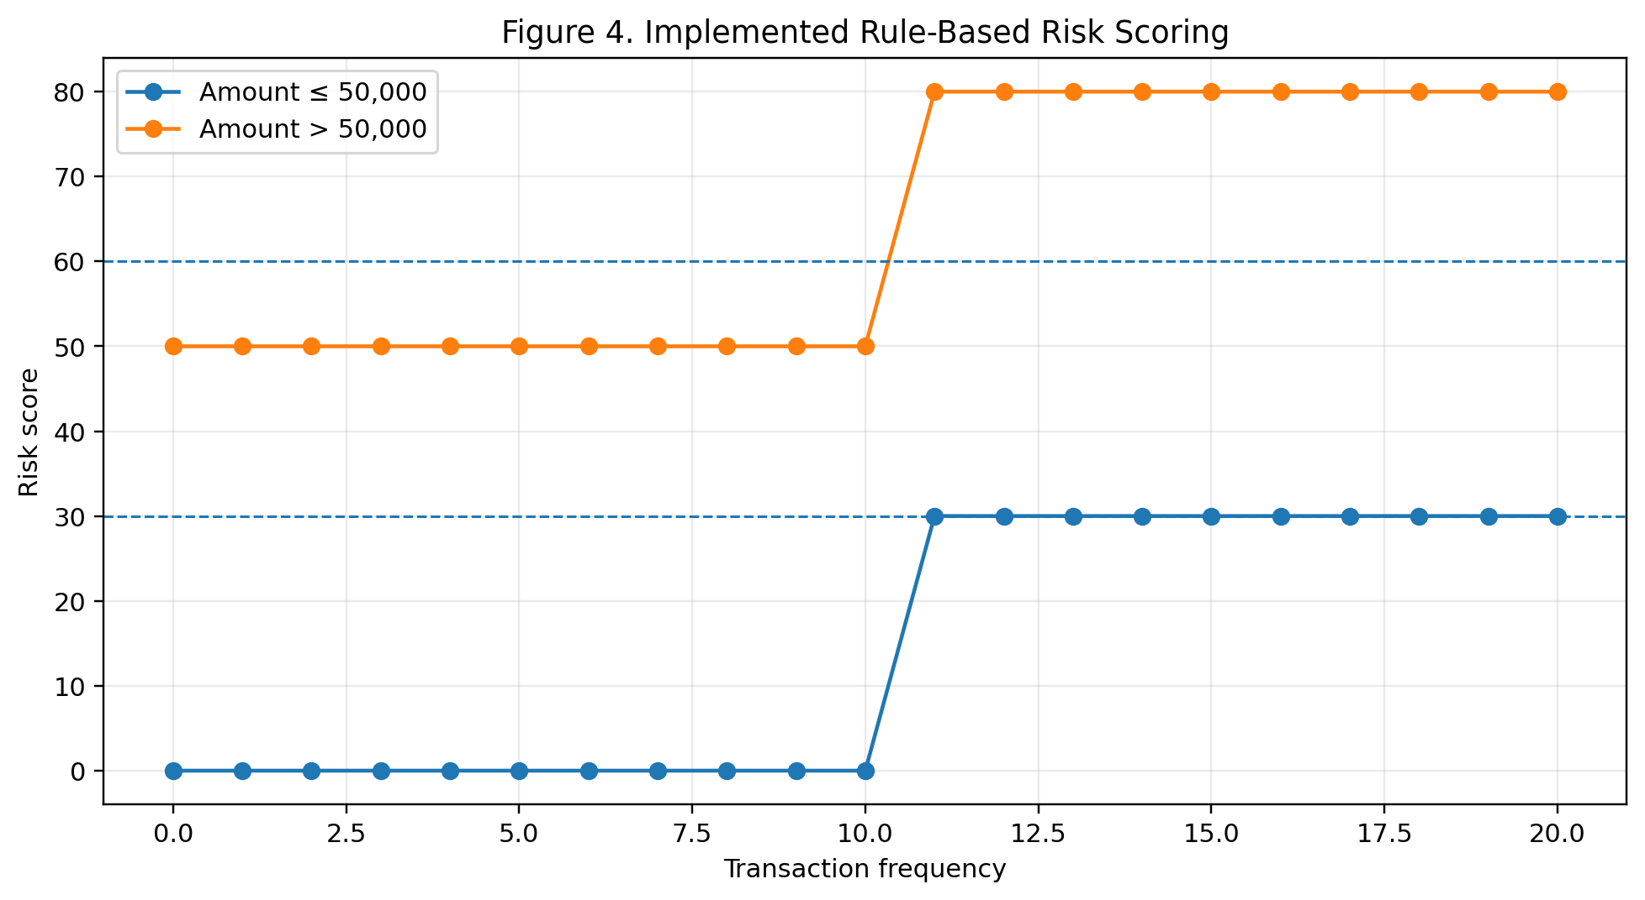
Figure 4. Implemented Rule-Based Risk Scoring
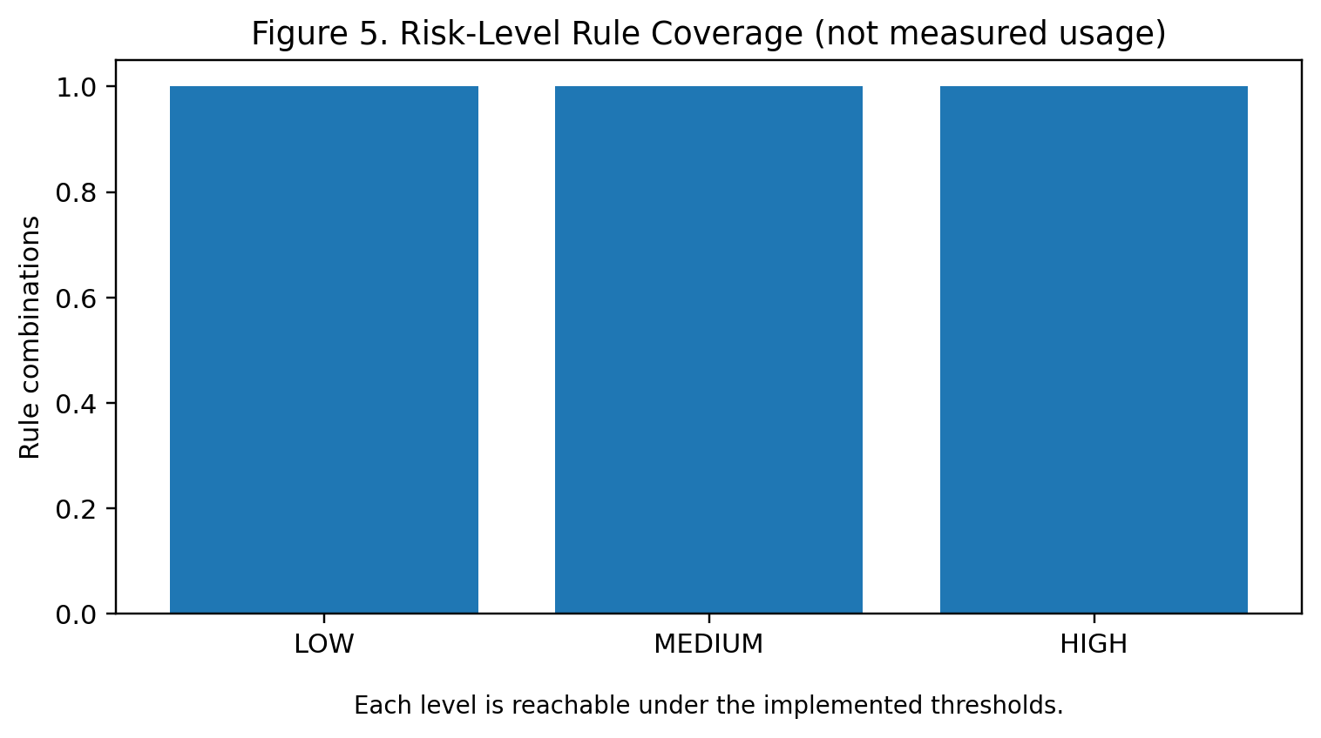
Figure 5. Risk-Level Rule Coverage (not measured usage)

4. RESULTS
The implemented prototype demonstrates a complete application path from authenticated frontend interaction to relational persistence and document-based risk storage. The dashboard, customer, account, transaction, and risk-analysis pages are connected to the FastAPI backend through JavaScript fetch calls. The backend exposes the endpoints listed in Table 4 and applies JWT verification to protected operations.
The main functional result is the successful separation of financial core data from risk-analysis documents. PostgreSQL stores the operational records required by the application, while MongoDB receives the output of the risk engine. This matches the polyglot persistence strategy presented in the project PPT and provides a clear DBMS-focused demonstration.
The risk engine produces deterministic outputs for the supplied amount and frequency. Because the current implementation is threshold-based, the result is explainable directly from the triggered indicators. The project therefore demonstrates transparent rule-based risk classification rather than statistical model accuracy. The PPT’s precision, recall, F1-score, and PR-AUC discussion is retained as an evaluation direction for future model-based risk analytics, not as measured results of the current code.
Test ID | Test scenario | Expected result | Implementation evidence
T1 | Valid admin login | JWT token returned | /login creates token
T2 | Invalid login | No token; error message | Login response returns invalid credentials message
T3 | Create customer | Customer persisted | POST /customers
T4 | Create account for unknown customer | Request rejected | Foreign-key error handled in /accounts
T5 | Deposit to valid account | Balance increases and transaction recorded | deposit() updates account and inserts transaction
T6 | Withdraw above balance | Withdrawal rejected | withdraw() checks balance
T7 | Risk amount > 50,000 | 50 points + indicator | calculate_risk()
T8 | Risk frequency > 10 | 30 points + indicator | calculate_risk()
T9 | Both thresholds triggered | 80 points and HIGH | Rule sum and level mapping
T10 | Risk result persistence | MongoDB document inserted | save_risk()
Table 6. Functional Test Cases
Area | Observed / designed outcome
Authentication | JWT bearer token protects application operations
Relational persistence | Customers, accounts and transactions use PostgreSQL
Transaction handling | Deposit and withdrawal modify balance and create transaction records
Risk analytics | Amount and frequency rules generate score, level and indicators
Document persistence | Risk result is stored in MongoDB risk_analysis collection
Frontend | Separate pages provide login, dashboard, customer, account, transaction and risk workflows
Polyglot architecture | Operational and analytical workloads are separated
Table 7. Project Results and Verification

5. CONCLUSION AND FUTURE WORK
The Financial Risk Analytics with Polyglot Data Engineering project demonstrates a secure DBMS-centered prototype in which PostgreSQL and MongoDB are used for different data workloads. PostgreSQL provides structured persistence for customer, account, and transaction information, while MongoDB provides flexible storage for risk-analysis results. FastAPI connects the databases to a REST interface, JWT provides token-based authentication, and the HTML/CSS/JavaScript frontend provides an accessible operational interface.
The current risk engine is deliberately simple and transparent. It uses transaction amount and transaction frequency thresholds to calculate a score and map the score to LOW, MEDIUM, or HIGH risk. This makes the current implementation easy to demonstrate and explain, while also providing a foundation for more advanced analytics.
The project PPT identifies several future directions: real-time Kafka streaming, explainable AI using SHAP or LIME, distributed cloud deployment, and automated compliance reporting. Additional future work can include stronger credential management, environment-based secrets instead of hard-coded demo credentials, role-specific authorization, database migration scripts, comprehensive automated tests, richer risk features, and trained models evaluated using precision, recall, F1-score, and PR-AUC on an appropriately labeled dataset.
Overall, the project addresses the central problem identified in the PPT: financial risk analytics should not be isolated from data persistence and secure application delivery. The prototype connects transaction processing, validation, polyglot storage, risk scoring, authenticated APIs, and frontend reporting into one operational workflow.

REFERENCES
- [1] Financial Risk Analytics with Polyglot Data Engineering, Project 6 presentation, 25CS1302E – DBE & DSD, Group 16, 2026.
- [2] FastAPI documentation, framework used for the REST API implementation.
- [3] PostgreSQL documentation, relational database system used for customer, account and transaction persistence.
- [4] MongoDB documentation, document database used for risk-analysis persistence.
- [5] Python-JOSE documentation, JWT implementation used by the authentication module.
- [6] Pydantic documentation, data-validation models used by the FastAPI request schemas.
- [7] Project source code: Financial-Risk-Analytics-MultiPage-v2, app and frontend modules supplied with the project.

