Server API – Built using Java 8, Maven, Google Geocoding and Distance Matrix API
GIT Instructions:
1. Change directory to your workspace folder (eg: c:/workspace)
2. “git clone https://github.com/kavithasekhar/ShopApplication.git” creates a new project folder in the workspace – ShopApplication
3. Import this project into your eclipse
Pre-requisite for successful results from server api:
Please create Google API key in Google Developer Console by choosing Server Api Key and by entering your public IP address. Configure this API key within the application (src/main/resources/application.properties) 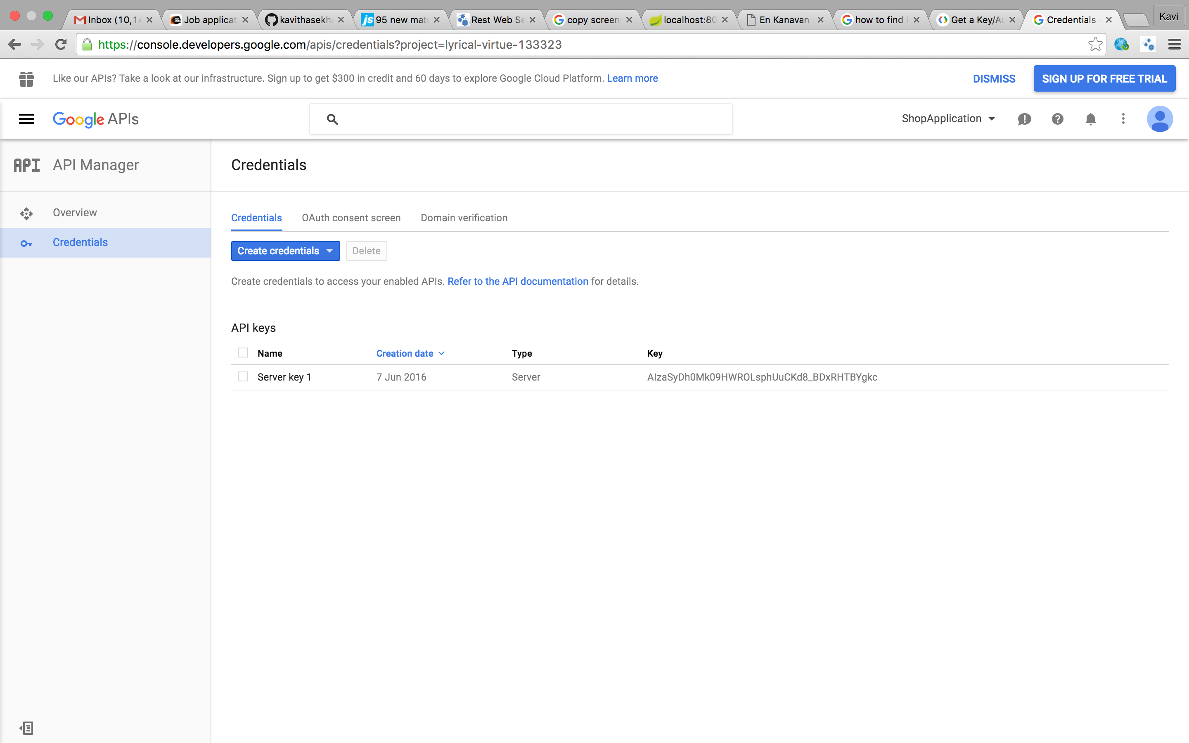

Build and Run Instructions:
1. mvn clean install => Builds the application and runs unit tests
2. mvn clean install –P integration-test => Builds the application and runs integration tests
3. Run the ApplicationRunner.java to kick start the server api

