Waterfallmodel

Waterfall Model:

- It is a traditional model.

- It is also k.a., Sequential model OR Linear model

When to go for waterfall model:

-It is suitable for simple s/w

-It is suitable for static s/w

-It is suitable when requirements are very clearly understood

Different Phases in Waterfall model:

Requirement collection:

The BA (Business Analyst) from different company will go to customer location to gather the reqts after proper feasibility study.

Feasibilty study includes:

(a) Resource availability

(b) Infrastructure OR Lab

(c) Profit

The BA will bid & get the project. Initially the reqts are in the form of CRS/BRS. After collecting the reqts they make a agreement with the customer to freeze the reqts.

Note:

Reqts freezing: means no more new reqts will be considered for development apart from the collected ones. Reqts freezing is the typical feature of waterfall model. After collecting the reqts the BA will convert CRS into SRS (Software Requirement Specification)

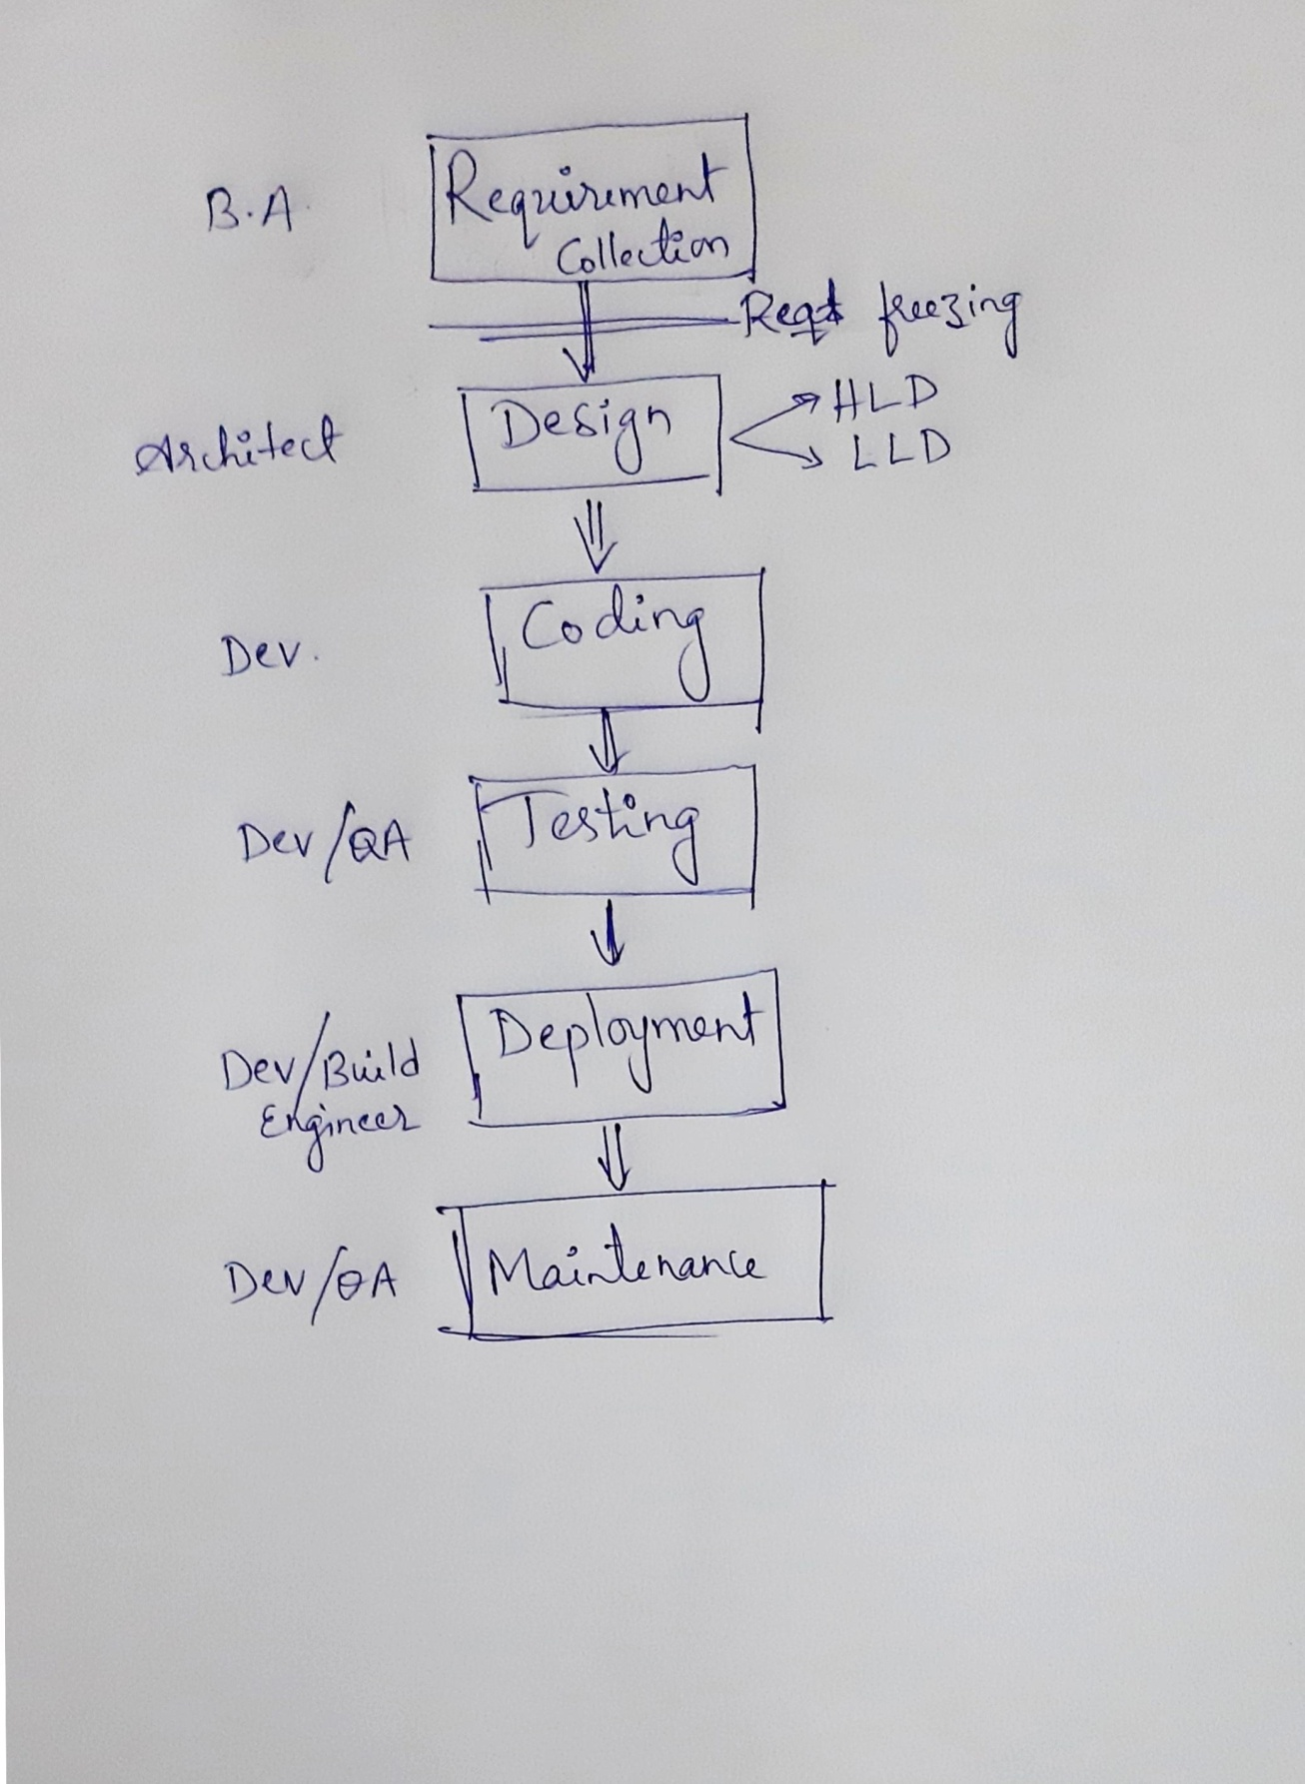

Design Phase:

Once the SRS is created, it will be shred with Architect.

The Architect/ Sr. Dev will go through the SRS & creates a Design Doc.

It is of 2 types:

1) HLD: High Level Design Doc

It contains a plan for Modules, Sub-modules, interfaces, front end and back end technologies.

2) LLD: Low Level Design Doc

It consist of controls to all the components inside the HLD

-------------------------------------------

Coding Phase:

The Dev will start converting design into actual s/w by writing the programing languages. Once all the design is converted into s/w we will move to testing phase.

-------------------------------------------------

Testing Phase:

As waterfall model is a traditional model, the testing was done by dev. Some times QA can also perform testing. During testing if you find any defects it should be informed to Dev. Once testing is completed & the s/w defect free, then it will be released to customer.

-------------------------------------------

Deployment Phase:

The deliverables will be kept in FTP machine.

The common deliverable includes:

1. Software (appServer, WebServer, DB server)

2. Release Note doc

3. Installation Guide Doc

4. Consolidated Test Execution Report

5. Consolidated Defect Report

Note:

Deliverables: It means any artifacts which is shared with the customer.

Once the delivarables are placed in FTP machine, we send out a release mail to customer. wihch includes following:

1. FTP machine name OR IP address

2. Credentials (UN/PWD)

3. Location

4. Contents

Customer will go through the release mail & install the s/w in staging environment by following Installation Guide doc. After installing the s/w customer will perform one round of testing which is k.a., User Acceptance Testing (UAT).

If UAT goes fine the same s/w will be moved to PROD environment.

--------------------------------------------

Maintenance:

As per the aggrement the company will provide support to the customer for a given period of time.

Adv of waterfall model:

1. As the reqts are freezed it is very easy to develop the s/w.

2. Less time is required

3. Less resource is required.

4. Less cost is required.

Dis-Adv of waterfall model:

1. As the reqts are freezed customer will not be satisfied.

2. Not all the phases are tested. Testing starts only after coding phase. Hence downward flow of defects will be higher.

3. The cost of fixing the defect will be much higher If the defect is found in the root system

4. Only one/few rounds of testing takes place, hence quality may not much better compare to other models.

5. It is not suitable for dynamic applications

6. It is not suitable for long term applications