**ILLINOIS INSTITUTE OF TECHNOLOGY**

**ITMT 531 – CARL R. CARLSON**

**MODULE TWO ASSIGNMENT**

**1. INFORMATION TRAIL TECHNIQUE**

**Based on the following workflow/work units, create a relational database consisting of the relation(s) needed to support each work unit complete with “Linguistic Case Analysis”. Identify the join characteristics of information trail that would be used to track progress on a customer order.**

**WORK UNIT 1:**

**Working with a Customer, the CUST-ACCT-MGR CREATES a customer purchase request in the corporate database for the items the customer wishes to purchase.**

**WORK UNIT 2:**

**A SHIPMENT-MGR FILLS a customer purchase request BY CREATING a customer delivery order with all the items requested by the customer being placed together in a delivery container.**

**WORK UNIT 3:**

**A WHSE-MGR ASSEMBLES the items, that the Shipment –Mgr has identified as being in warehouse inventory, into a delivery container for customer delivery**

**WORK UNIT 4:**

**The SHIPMENT-MGR GENERATES a “24 hour” purchase order with one of our suppliers for all items identified as not in inventory.**

**WORK UNIT 5:**

**Once we have received the “purchased” items from the supplier(s), the SHIPMENT-MGR NOTIFIES the WHSE-MGR responsible for this order to PLACE these items into the delivery container for customer delivery.**

**WORK UNIT 6:**

**Once the delivery container is filled, a delivery TRUCK DRIVER LOADS the truck and DELIVERS the delivery container to the customer. The TRUCK DRIVER OBTAINS an electronic sign-off from the customer acknowledging receipt of the items.**

**WORK UNIT 7:**

**Once the customer acknowledges receipt of the delivery container, the ACCOUNTS-MGR CLOSES OUT the order.**

**2. RAPID PROTOTYPING TECHNIQUE**

**2.1 Create an Interaction Diagram based on the following use case requirements.**

**2.2 Apply the State Assignment algorithm to the Interface Object in your Interaction Diagram.**

**2.3 Based on this event state analysis, generate the screen images that you feel would support each state and the transitions from that state**

**2.4 Based on the screen images generated in the previous step, generate a relational database to support this use case.**

***RELEASE ONE REQUIREMENTS***

**Use Case Requirements for an online new car purchasing application ( assumes that a trade in vehicle has been brought into the car dealer and a price estimate has been generated):**

**1. Log into a new car purchasing application.**

**2. Once logged on, scroll through the available cars. Identify the car you want to purchase by make, model, year, and color.**

**3. Make your selections from the group of Accessories available for this specific car**

**4. Select your Maintenance options: scheduled maintenance on selected items such as tires,**

**oil change, window wipers, etc.**

**5. Total itemized car price presented to customer with itemization of all costs determined in steps 2, 3, and 4 and with trade in price estimate obtained from dealer.**

**6. Finalize the car purchase by selecting finance options:**

**lease plan for 3 or 5 years**

**full cash payment**

**loan payment -- down payment amount and selection of 3 or 5 year**

**loan payment plan for remaining amount**

**2.1&2.2.Interaction Diagram:**

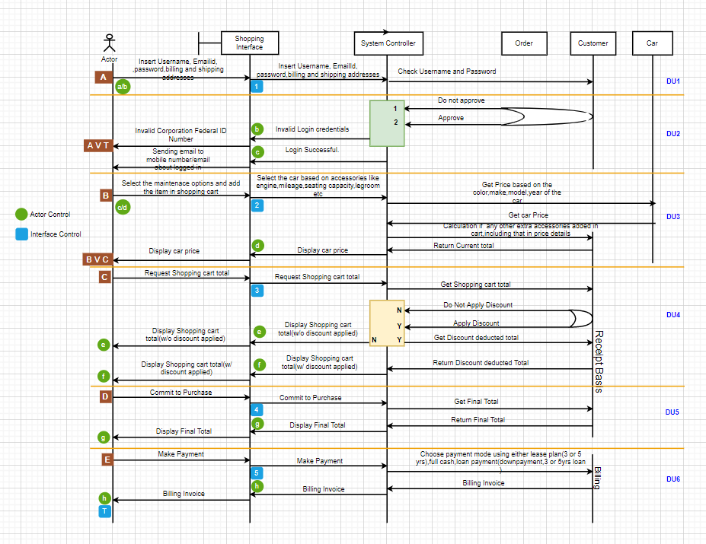

**2.3.Screen Images:**

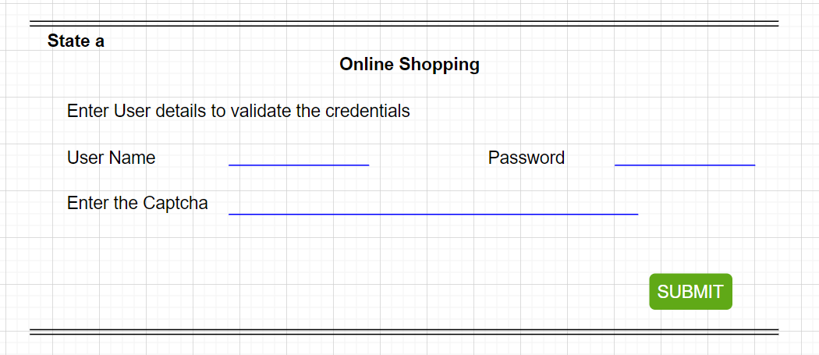

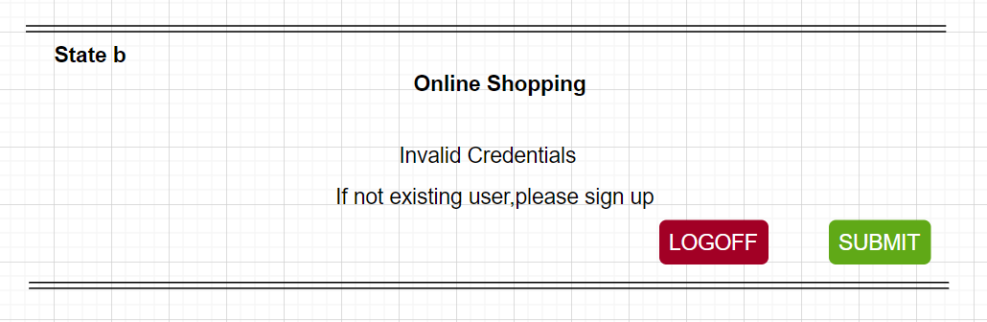

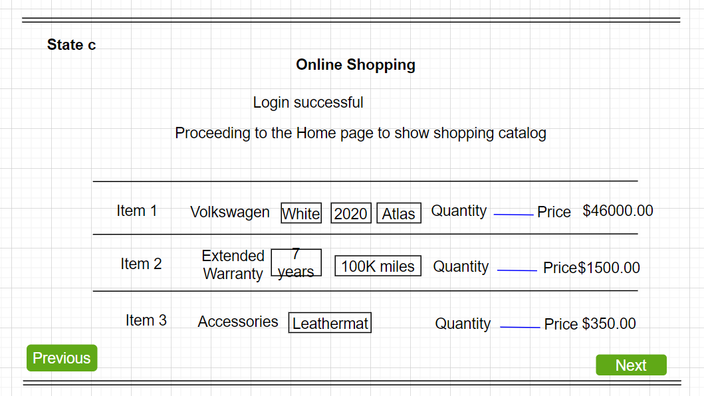

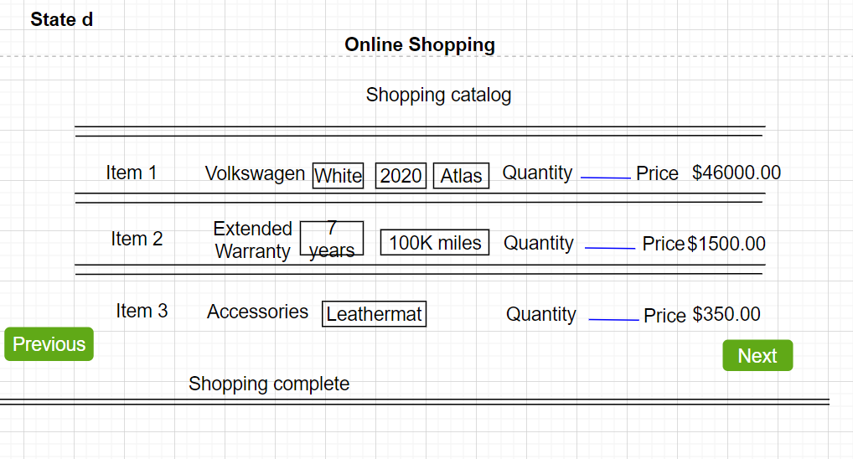

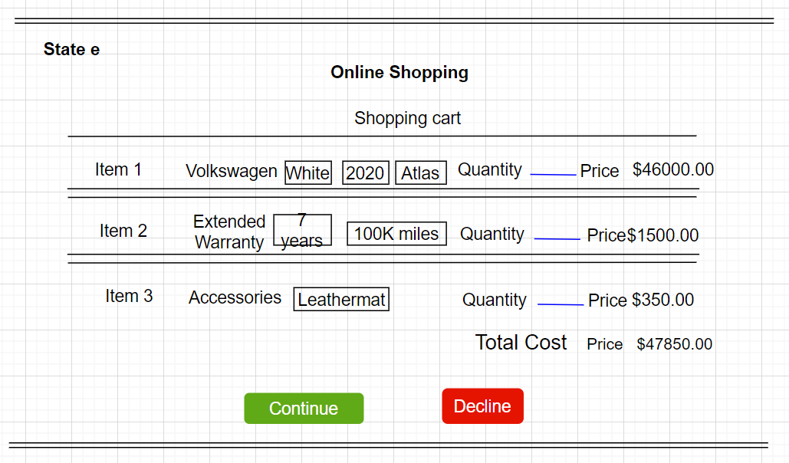

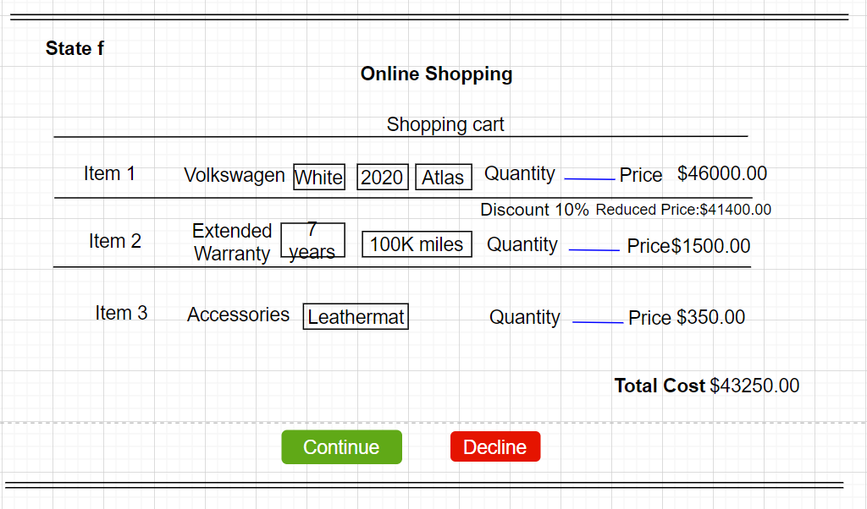

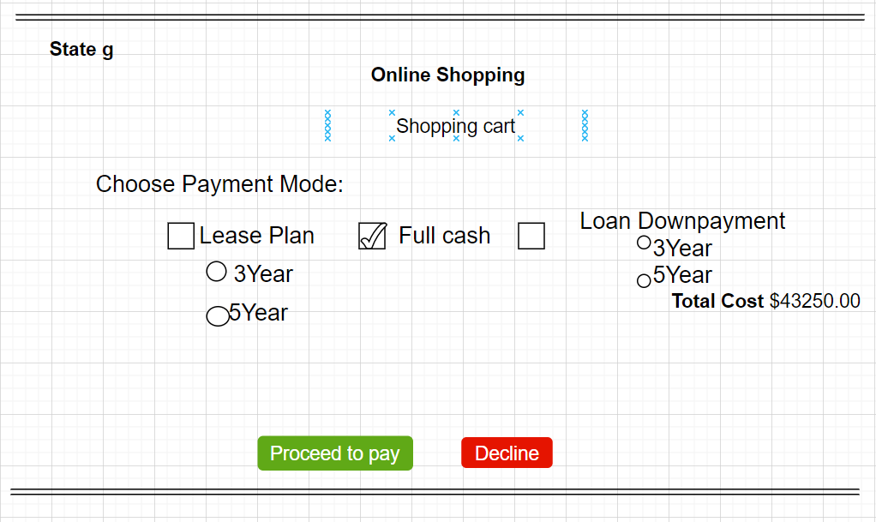

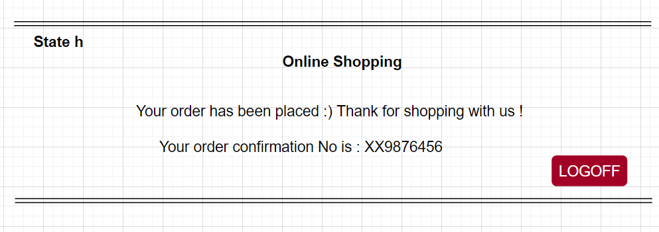

**Interface States:**

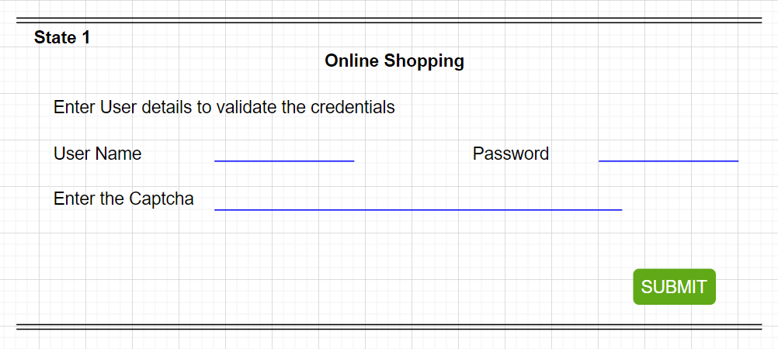

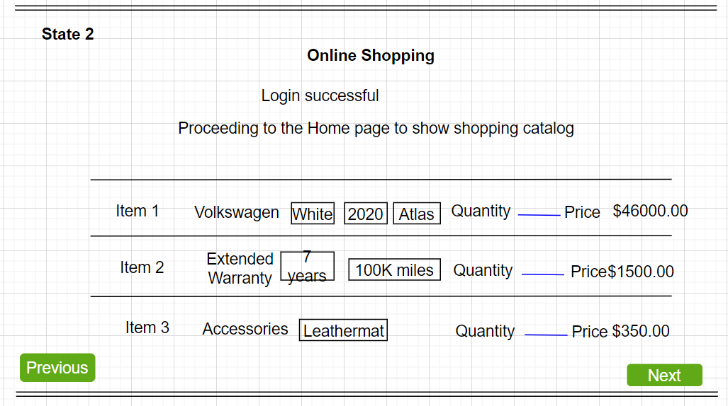

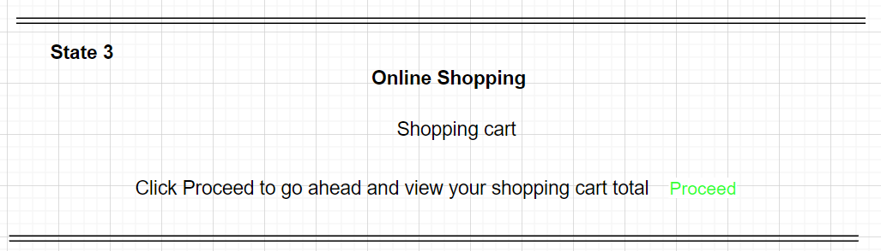

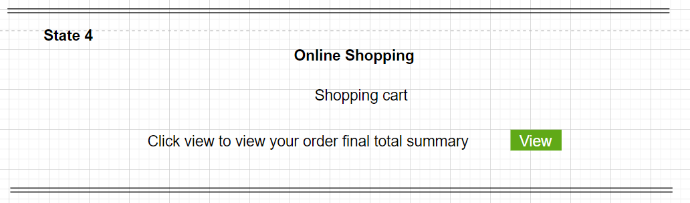

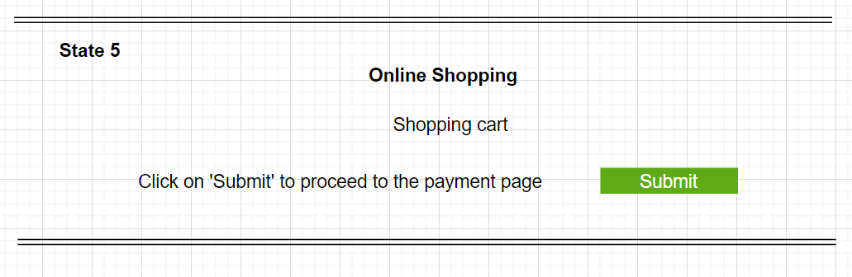

**2.4)Relational database generation:**

➢ Customer(Cust_ID, Cust_Name,Phone Number,EmailId,Billing address,Shipping address)

* Payment(Cust_ID, Payment_ID,Payment_mode,DateOfPayment)

➢ Salesperson(SalespersonID,Name,ItemId,Orderid,Cust_ID)

➢ Car(ItemID,Item Description,Brand,Model,Designed_Year,Color,Item Price,Discount availability)

➢ Order(Orderid,Cust_ID,IssueDate,Ordertotal,Billing address, Shipping address, OrderStatus, OrderItems{Itemid,Itemquantity,Itemprice,ItemDiscount})

***RELEASE TWO REQUIREMENTS***

**You need to show the changes to the previous Interaction Diagram and the Event State Analysis applied to the Interaction Diagram. All parts of the interaction diagram that remain should continue to be shown in black. Use one color (say RED) to identify those portions of the original interaction diagram that are being eliminated and another color (say GREEN) to identify those portions that have been added to the original diagram. Reapply the state assignment algorithm to the new interaction diagram. You do not need to produce either a new event based screen analysis nor a new database.**

**1. Once logged on, you have an additional option other than that described in Release One Requirement 2, 3, and 4: Several daily “Car Specials” are presented to the customer to choose from with every option described in Release One Requirements 2, 3, and 4 all bundled as part of the “package” for each “car special”.**

**2, Requirement 5 3in Release One remains the same.**

**3. Requirement 6 is limited to the “loan payment” option with a 10% down payment required.**

**Interaction Diagram:**

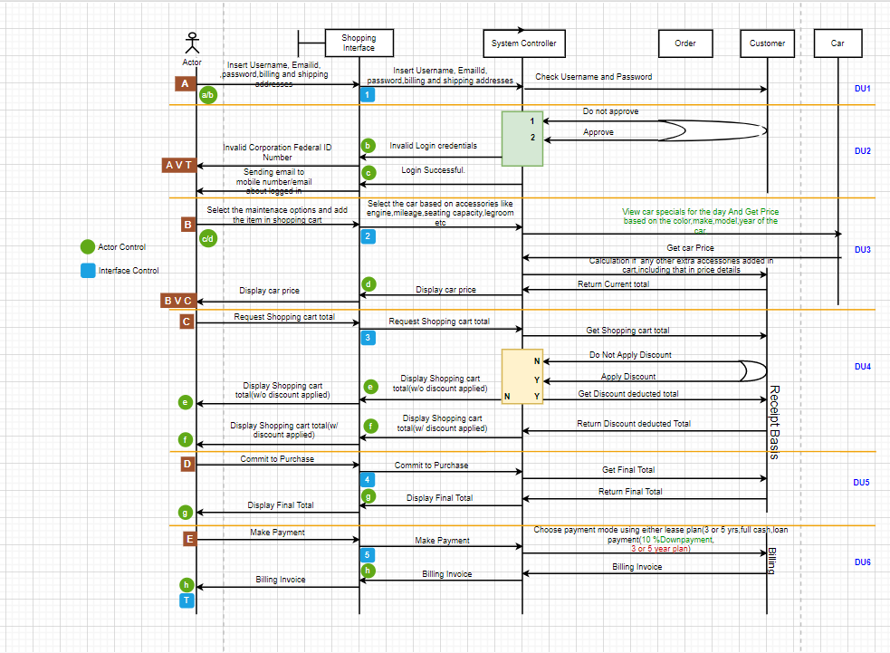

**Screen Images:**

