**INFORMATION TECHNOLOCY AND MANAGEMENT**

**HOMEWORK FOUR FALL 20202**

**DUE: December 3, 2020**

**1. Pattern Based Design**

Step 1: (Organizing Requirements) Analyze the following list of requirements and identify the ORDER (by requirements number) in which you plan to process them.

Step 2: (Pattern Identification) Based on this ORDERING, provide a pattern based design for each requirement and identify the patterns you are using.

Step 3: (Composite Pattern Based Design) Create a NER-like diagram to depict each of the patterns and identify the type of linkage being used to integrate each pattern.

R1. The inventory management system monitors the inventory level report produced daily by each warehouse It produces a composite inventory shortage list that is communicated to the central office.

R2. Employees are classified as central office employees, sales employees, warehouse employees, and account management employees.

R3. When inventory shortage lists are received by the central office, the general inventory manager decides how each shortage is to be handled, either (1) through inventory transfers from other warehouses or (2) through supplier purchases.

R4. When a sales employee receives a customer order, a sales record is created for that employee for sales bonuses and the customer order is passed on to an account management employee.

R5 When the inventory manager decides that items need to be purchased, multiple staff members are assigned to contact different suppliers to obtain price quotes on those items.

R6. When a warehouse employee returns from delivering items to a customer, an accounts manager takes the signed delivery invoice, records the completion of the sales order, and bills the customer.

R7 When a customer order is received by an account manager, he/she sends a work request to the warehouse nearest the customer and the warehouse manager assigns warehouse workers to assemble items from inventory to fill this request.

R8. Once price quotes are received from different suppliers, the inventory manager gives the go ahead to the staff member responsible for the supplier quote that was selected to issue a purchase order for the items from that supplier.

R9. Periodically, warehouse items are reviewed to determine which items are not being sold at a frequent enough rate. Then, the price on these items is discounted, a special inventory pricing list is published advertising these discounts and is sent to customers.

R10. Once a delivery bundle has been created, warehouse employees create a delivery order to delivery to the customer on a specific date.

R11. In support of the whole organization each item has information about who supplies this item, who has ordered this item, and where the item is located in the warehouse.

R12. When a shipment of items has been received from a supplier, the warehouse employee uses the inventory locator service to locate where each item is to be stored in the warehouse and proceeds to stock them there.

Step1 : ORDER OF REQUIREMENTS :

R2

R4

R7

R10

R6

R11

R12

R1

R3

R5

R8

R9

The requirements are taken in this order in such a way that first the organization level requirements explaining about the organization structure and categories of employees are taken and then followed by the requirements that explain the different processes involved at the different units of the given high level organization entity – Supply Chain Office.

Hence this model to be built by the ten-step design first concentrates on the structure of the organization followed by expanding the model for all the sub-units and processes involved in the SCO

Step2: Pattern Identification

R2. Employees are classified as central office employees, sales employees, warehouse employees, and account management employees.

Employees is the high level of different categories of employees who can be managers, sales support employees and warehouse employees. Hence this is identified to be of account-sub-account pattern -generalization because “employees” is the generalized name for the given categories of employees

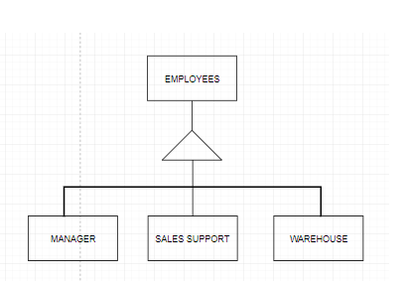

R4. When a sales employee receives a customer order, a sales record is created for that employee for sales bonuses and the customer order is passed on to an account management employee.

This requirement tells about the process that takes place when a customer places the order. Hence this is of transaction pattern – Association

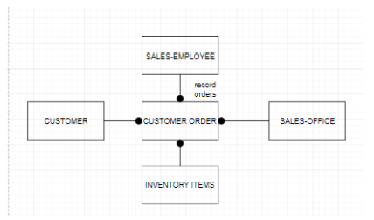

R10. Once a delivery bundle has been created, warehouse employees create a delivery order to delivery to the customer on a specific date.

This requirement tells about the process that takes place when a warehouse processes the orders and delivers the order items to customers. Hence this is of transaction pattern – Association.

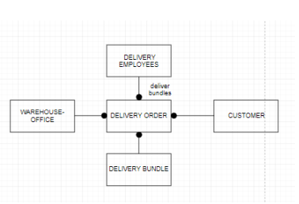

R6. When a warehouse employee returns from delivering items to a customer, an accounts manager takes the signed delivery invoice, records the completion of the sales order, and bills the customer.

This requirement tells about the process that takes place after the order is delivered to the customer. Hence this is of transaction pattern – Association.

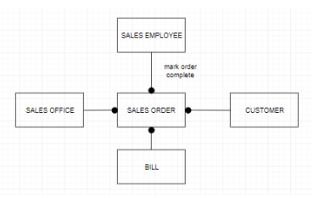

R11. In support of the whole organization each item has information about who supplies this item, who has ordered this item, and where the item is located in the warehouse.

This requirement tells about how the items list are managed and hence this is more like a directory. This is of item-line-item directory pattern- Association.

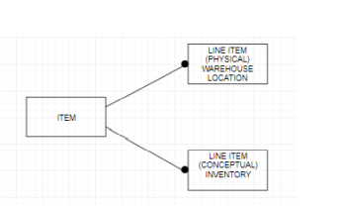

R12. When a shipment of items has been received from a supplier, the warehouse employee uses the inventory locator service to locate where each item is to be stored in the warehouse and proceeds to stock them there.

This requirement tells about the process that happens after the shipment has been received from the supplier and hence this is of transaction pattern – Association.

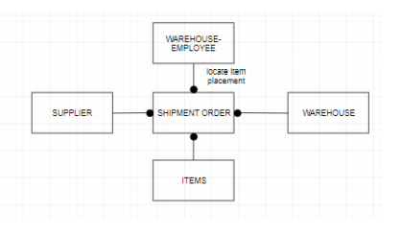

R3. When inventory shortage lists are received by the central office, the general inventory manager decides how each shortage is to be handled, either (1) through inventory transfers from other warehouses or (2) through supplier purchases.

This requirement tells about the process that happens after the shipment has been received from the supplier and hence this is of transaction pattern – Association.

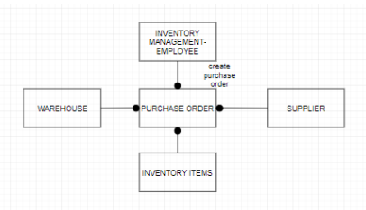

R9. Periodically, warehouse items are reviewed to determine which items are not being sold at a frequent enough rate. Then, the price on these items is discounted, a special inventory pricing list is published advertising these discounts and is sent to customers.

Here, the process of sending special inventory pricing list at significant discount is done periodically and hence it is of iterator pattern.

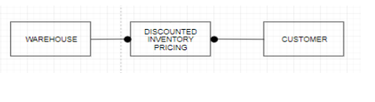

STEP3: Composite Pattern Design:

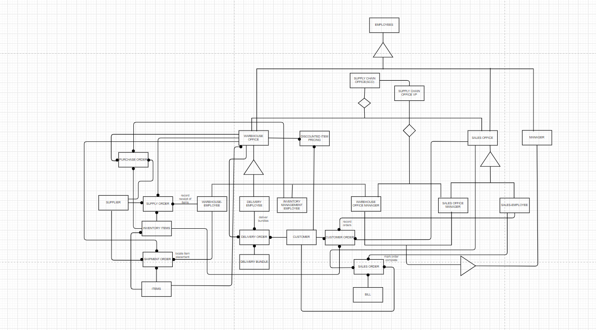

Composite diagram with individuals markup:

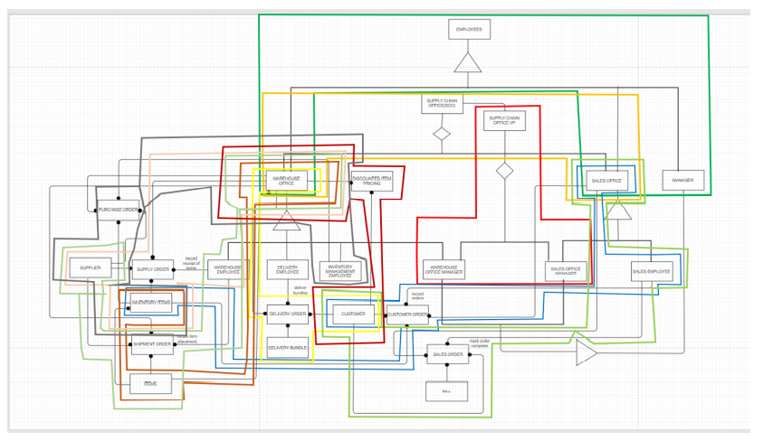

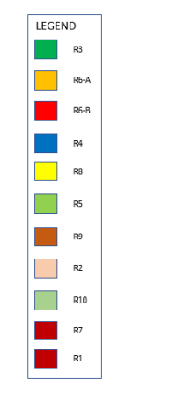

**2. OO VIEW INTEGRATION (by adapting existing techniques that you have learned)**

2.a Convert  **each** of the following OO database views into a **separate** normalized relational schema

Note that the attributes in **bold lettering “**relate to” a possible relational key.

2.b Merge the relations produced in step 1.a into a common normalized relational database using the view integration approach

2.c Using the NER cluster analysis technique, adapt it to produce an Object Oriented database

### VIEW 1 CAMPUS **(** CAMPUS**,** LOC )

COURSES ( **COURSE#,** CSE-NAME, CSE-DESCR ) STUDENTS ( **STD-ID#,**  ST-NAME, MAJOR )

OFFERINGS ( **SECTION#,** ROOM#, HOUR# )

ENROLLEES ( COURSE-GRADE )

### VIEW 2 DEPARTMENTS ( **DEPT-NAME**, ROOM#, CHAIR, PHONE# )

FACULTY ( **FAC-SS#**, PHONE#, COURSES ( **COURSE#**, ADVISOR **(STAFF-SS#,**

ROOM# ) CSE-NAME ) ROOM#)

TEACHING-LOAD ( **SECTION#,** #STUDENTS )

UG-STUDENTS ( **STD-ID#,** ST-NAME) GRAD-STUDENTS (**STD-ID#,** ST-NAME )

### VIEW 3 STUDENT-TRANSCRIPT ( **COURSE#**, COMPLETION-STATUS)

### STUDENTS ( **STD-ID#**, DEPT-MAJOR, ADDRESS )

UG-STUDENTS ( FAC-ADVISOR-SS#, GRAD-STUDENTS (STAFF-ADVISOR-SS#,

HOME-ADDRESS) GRAD-PROG-REQS)

1. – **View 1:**

In View 1 we have -

1.      CAMPUS (CAMPUS**,**LOC)

2.      COURSES (**COURSE#,** CSE-NAME, CSE-DESCR)

3.      STUDENTS (**STD-ID#**, ST-NAME, MAJOR)

4.      OFFERINGS (**SECTION#**, ROOM#, HOUR#)

5.      ENROLLEES (COURSE-GRADE)

Normalized View of above data -

We can list the views in this form after Normalizing it and by referential integrity we get –

CAMPUS (CAMPUS, LOC)

COURSES (**COURSE#**, CSE-NAME, CSE-DESCR**, CAMPUS**)

STUDENTS (**STD-ID#**, ST-NAME, MAJOR**,CAMPUS**)

OFFERINGS (**SECTION#**, ROOM#, HOUR#, **COURSE#**)

ENROLLEES (**STD-ID#, SECTION#**, COURSE-GRADE)

**View 2:**

In View 2 we have -

1.      DEPARTMENTS (**DEPT-NAME**, ROOM#, CHAIR, PHONE#)

2.      FACULTY (**FAC-SS#**, PHONE#, ROOM#)

3.      COURSES (**COURSE#**, CSE-NAME)

4.      ADVISOR (**STAFF-SS#**, ROOM#)

5.      TEACHING-LOAD (**SECTION#,** #STUDENTS)

6.      UG-STUDENTS (**STD-ID#**, ST-NAME)

7.      GRAD-STUDENTS (**STD-ID#**, ST-NAME)

Normalized View of above data:

We can list the views in this form after Normalizing it and by referential integrity we get the following results as

DEPARTMENTS (**DEPT-NAME**, ROOM#, CHAIR, PHONE#)

FACULTY (**FAC-SS#**, PHONE#, ROOM#,**DEPT-NAME**)

COURSES (**COURSE#**, CSE-NAME,**DEPT-NAME**)

ADVISOR (**STAFF-SS#**, ROOM#,**DEPT-NAME**)

TEACHING-LOAD (**SECTION#,** #STUDENTS,**FAC-SS#, COURSE#**)

UG-STUDENTS (**STD-ID#**, ST-NAME,**FAC-SS#**)

GRAD-STUDENTS (**STD-ID#**, ST-NAME,**STAFF-SS#**)

**View 3:**

The data given in View 3 is:

1.      COURSE-TRANSCRIPT (**COURSE#**, COMPLETION-STATUS)

2.      STUDENTS (**STD-ID#**, DEPT-MAJOR, ADDRESS)

3.      UG-STUDENTS (FAC-ADVISOR-SS#, HOME-ADDRESS)

4.      GRAD-STUDENTS (STAFF-ADVISOR-SS#, GRAD-PROG-REQS)

Normalized View of above data:

We can list the views in this form after Normalizing it and by referential integrity we get the following results as –

COURSE-TRANSCRIPT (**COURSE#**, COMPLETION-STATUS)

STUDENTS (**STD-ID#**, DEPT-MAJOR, ADDRESS,**COURSE#**)

UG-STUDENTS (**STD-ID#**, **COURSE#,** FAC-ADVISOR-SS#, HOME-ADDRESS)

GRAD-STUDENTS (**STD-ID#**, **COURSE#,** STAFF-ADVISOR-SS#, GRAD-PROG-REQS)

B) After merging we have Normalized Relations are as below -

**R1**CAMPUS(**CAMPUS** , LOC)

After merging COURSES relation from View1, View2 and View3 we get -

**R2**COURSES ( **COURSE#**, CSE-NAME, CSE-DESCR ,CAMPUS,DEPT-NAME,COMPLETION-STATUS)

After merging STUDENTS, UG-STUDENTS and GRAD-STUDENTS relations from View1 and View2 –

**R3** STUDENTS (**STD-ID#**, ST-NAME, MAJOR, CAMPUS, STAFF-SS#, FAC-SS#, COURSE#, DEPT-MAJOR, ADDRESS)

**R4** OFFERINGS (**SECTION#**, ROOM#, HOUR#, COURSE#)

**R5** ENROLLEES (**SECTION#, STD-ID#**, COURSE-GRADE)

**R6** DEPARTMENTS (**DEPT-NAME**, ROOM#, CHAIR, PHONE#)

**R7**FACULTY (**FAC-SS#**, DEPT-NAME)

**R8** ADVISOR (**STAFF-SS#,** DEPT-NAME)

**R9**TEACHING-LOAD (**SECTION#, FAC-SS#, COURSE#**,  STUDENTS )

**R10** UG-STUDENTS (**STD-ID#, FAC-ADVISOR-SS#**, HOME-ADDRESS)

**R11** GRAD-STUDENTS (**STD-ID#, STAFF-ADVISOR-SS#**, GRAD-PROG-REQS)

C)

