# **Rock Paper Scissor**

|  |  |  |  |
| --- | --- | --- | --- |
| First name | Last Name | Email | ‘A’ Number |
| Kavitha | Raji Subramaniyan | [krajisubramaniyan@hawk.iit.edu](mailto:krajisubramaniyan@hawk.iit.edu) | A20457276 |

Table of Contents

1.Introduction 1

2.Web Page Designing 2

3.Model Creation 2

4. Implementing the Logic 3

5.Urls.py 4

6.Invalid Login attempt 9

7.Future work 10

# 1.Introduction

Everybody wants to relive their childhood days which was memorable by playing games and spending time with family and friends.One such famous game is ‘Rock Paper Scissor’ which helps in hand movements and at the same time adding some fun time to life.In the evolution of internet,these games are made online as our friends will not be nearby us all the time.When u miss your friend and childhood days,this online game helps u stay connected and cherish the time by playing together.What if no friends?This online game lets you introduce random friends who are also like you waiting in the playroom to help them join in playing the game.

This project involves about rock paper scissor game implementation in python with Django framework and SQLite database.

# 2.Virtual Environment

The virtual environment in created and installed with appropriate Django in it.

Virtual environment🡪 djenv

Project_name🡪rps_gameproject

App_name🡪rps_app

# 3.Web Page Designing

This project has below .html files which is created with Javascript,bootstrap,CSS.These html files are located in templates folder under project(rps_gameproject) directory.

Header.html🡪The common header template is put into this file ,which is then used in other templates using {% extends header.html %} parameter.

init.html🡪This refers to the initial page of the game where it shows the game is loading

base_home.html🡪This shows the home page of the game

bregister.html🡪This shows the new user registration page

blogin.html🡪This shows the existing user login page

pick-mode.html🡪This shows the option for the user to choose how to play the game.

1.with Natasha(Computer)

2.With Random Friends in play room

3.With My Friend

rock-paper-scissor.html🡪The game page which shows rock,paper,scissor and asks user to select one out of it

includes.html🡪This shows the system choice and user choice and displays the score for each round and final winner for each set.

1 set=5 rounds

# 4.Model Creation

This project stores login details of user and their scores.So,we have two tables.

rps_app_user

rps_app_score

Defining the model in models.py file:

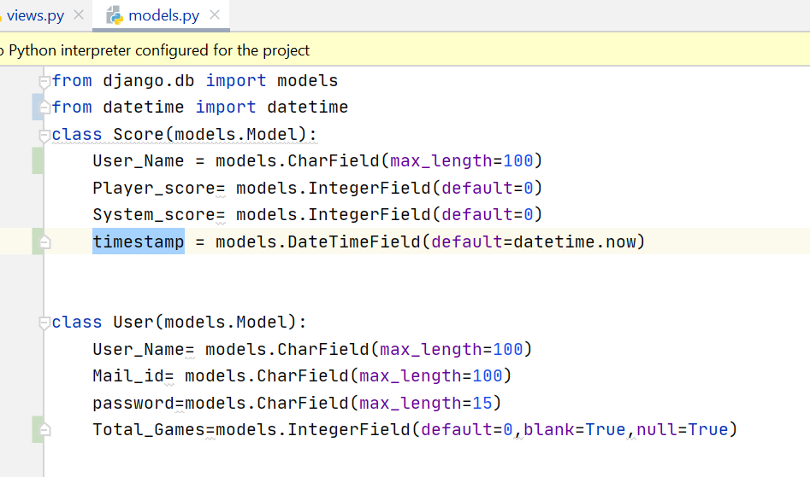

Viewing the table structure in sqlite dbshell:

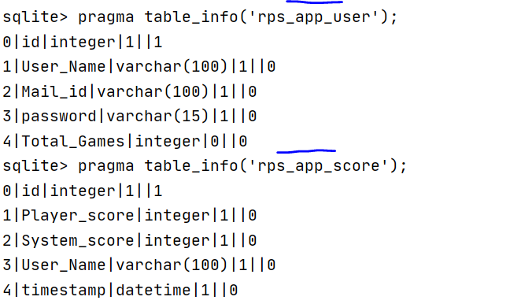

# 5. Implementing the Logic

In views.py file,first,we maintain dictionary where we give the combination of choices(userchoice-systemchoice as key and value os 0 or 1.



Next, user gives the input and system generates the input using random.choice(‘Rock’,’Paper’,’Scissor’).These two inputs are joined using ‘-‘ and then checked against the dictionary key and value is retrieved as [userpoints,systempoints].

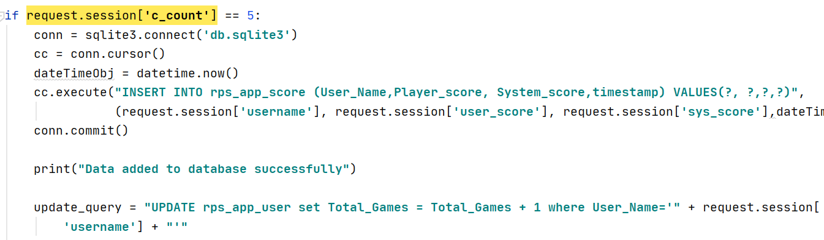

Each set consists of 5 rounds.To maintain this,we set session level parameter to make 5 rounds in one session.So,that when the next set starts,the session value is set to 0 again and then incremented for each round within session.

And at the end of every set,username,playerscore,systemscore,timestamp is inserted into rps_app_score table.

# 6.Urls.py

This file contains the path of webpages and which views to be called to perform certain actions.

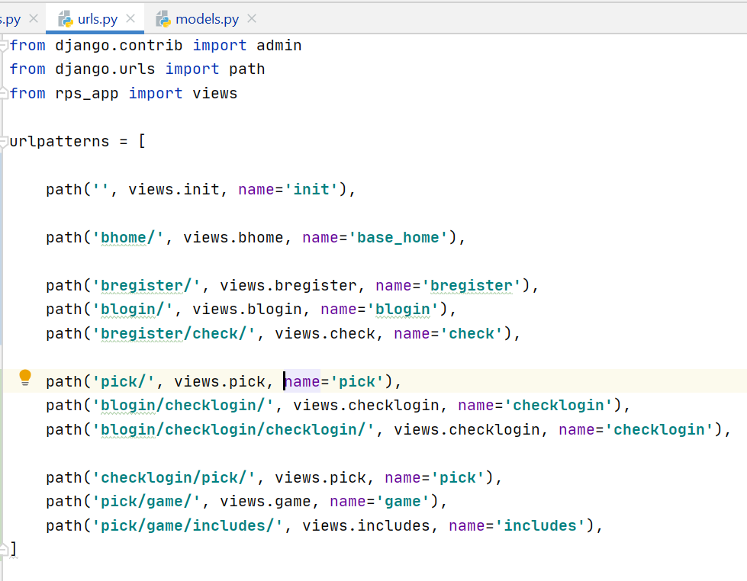

Here first parameter refers to path of webpage,second parameter refers to views.function name() to be triggered in views.py file and third parameter involves the name for each action.

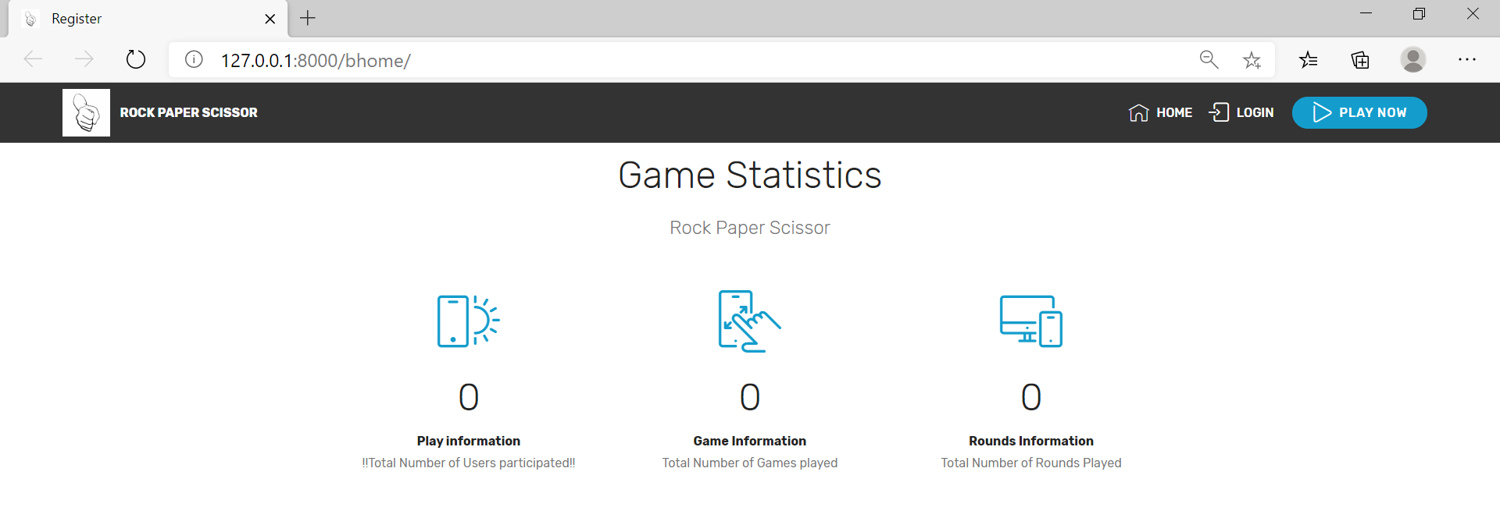

Game statistics

This bhome/ page shows total number of users,total number of games,total number of rounds played.Now,this is the first time the application is to be used,hence all these values are 0 here.

Click on the Login page in the navigation bar,to proceed to next page.

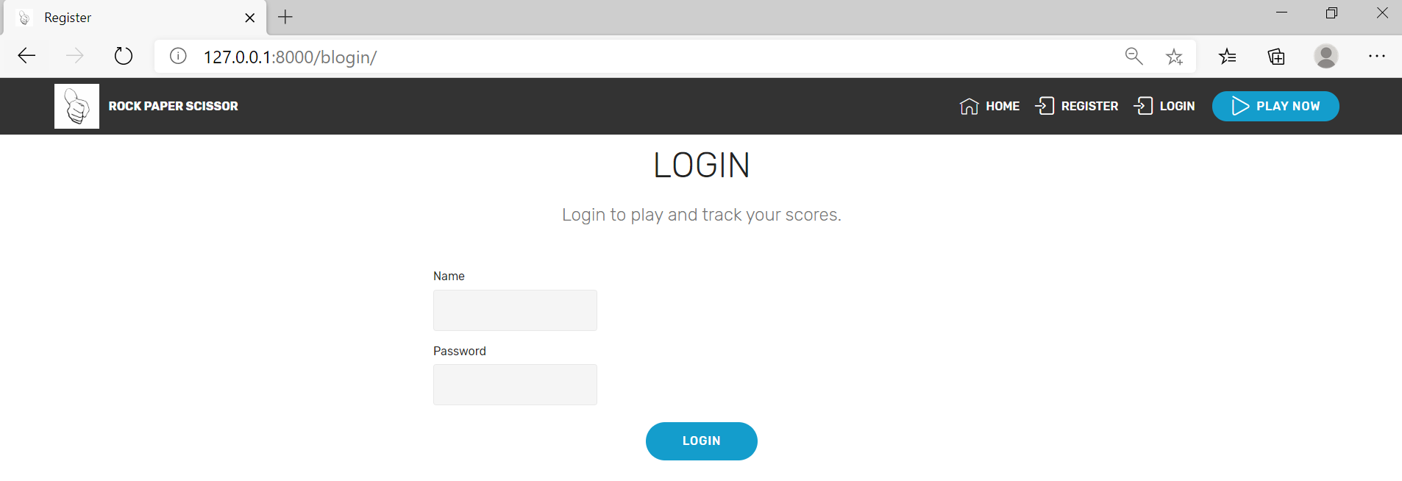

Click on the Register in navigation bar to register for new user.

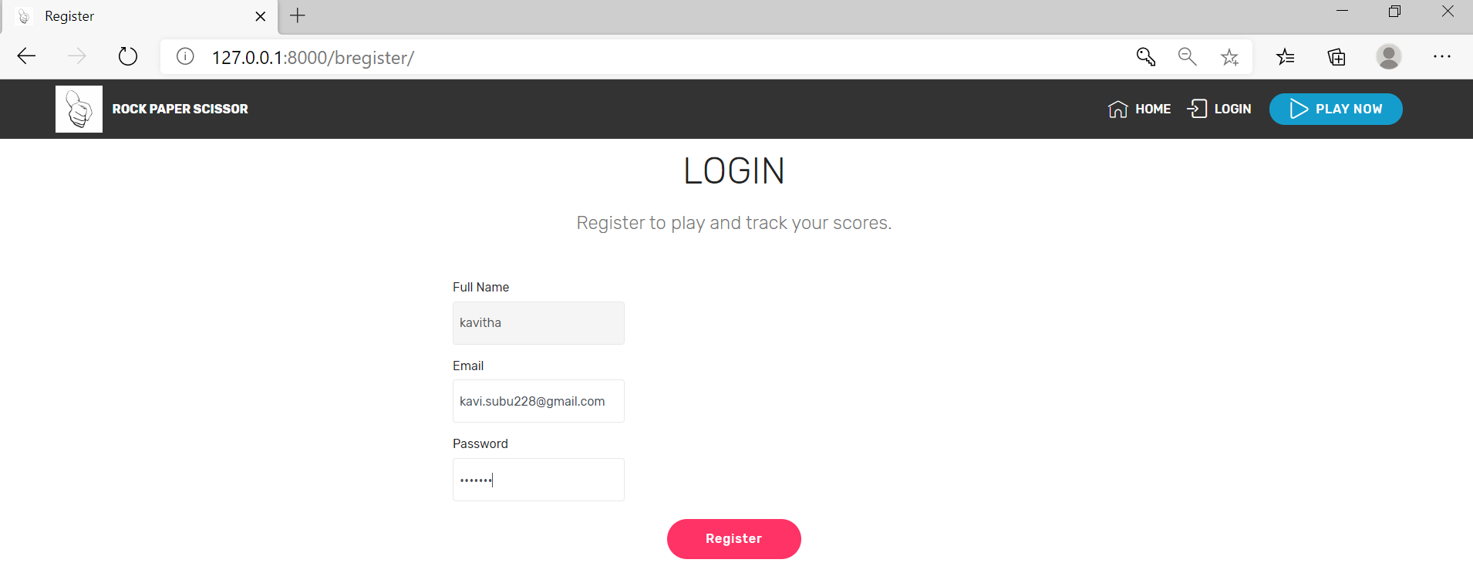

Here ,we get user name,emailid and ask them to set password.This password is masked in webpage and encrypted password is stored in database.(like below)

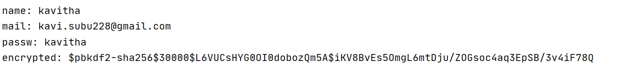

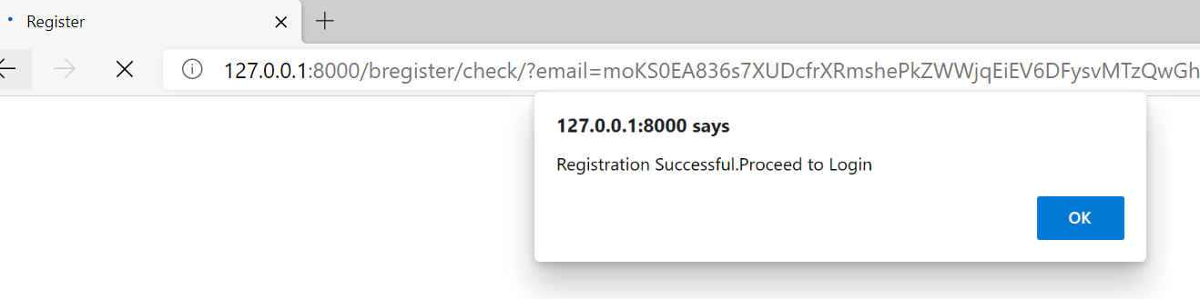

Once register button is clicked,the alert message shows.On clicking ok button,the page redirects to login page.

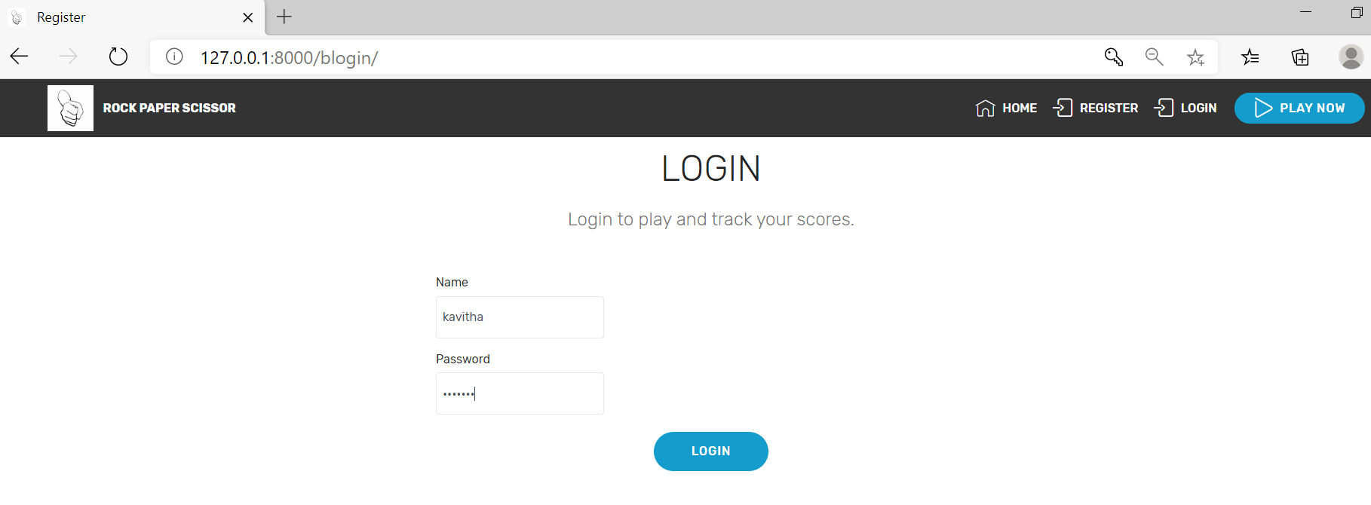

After clicking login button,the below alert window appears:

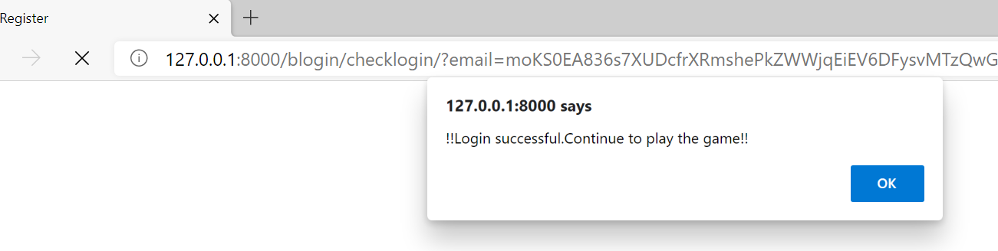

On clicking ok,we can now click play now in navigation bar to proceed to game page.

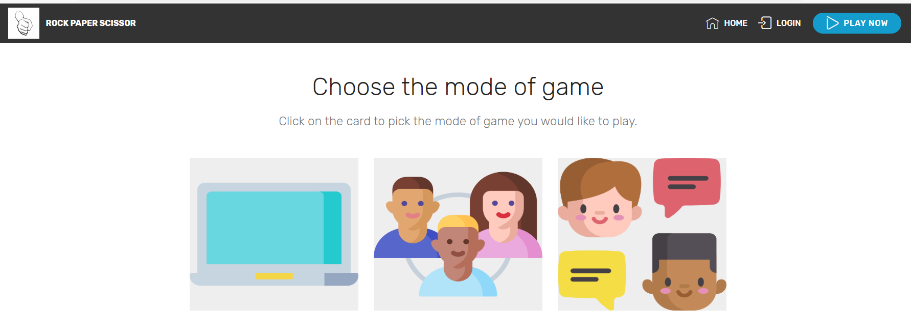

Here,we need to choose which mode we want to play and the corresponding page is redirected.

Choosing first option:With Natasha,it redirects to next page:

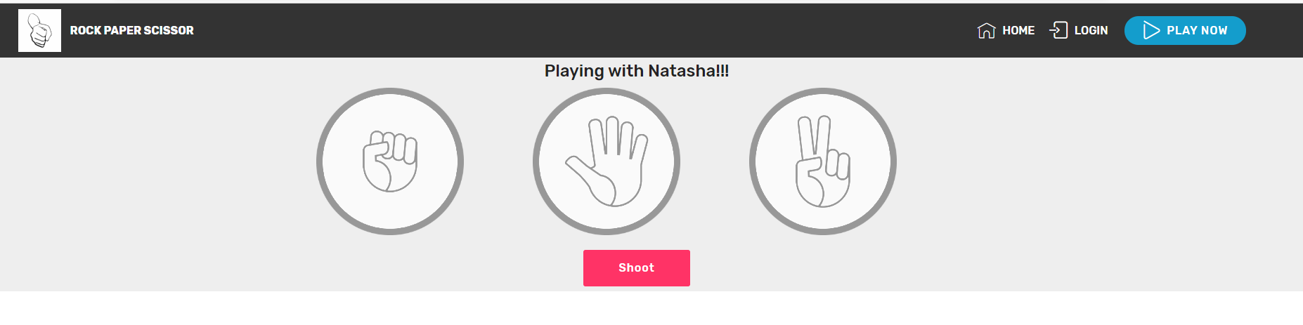

Choose rock or paper or scissor and then shoot. And the result page looks like below

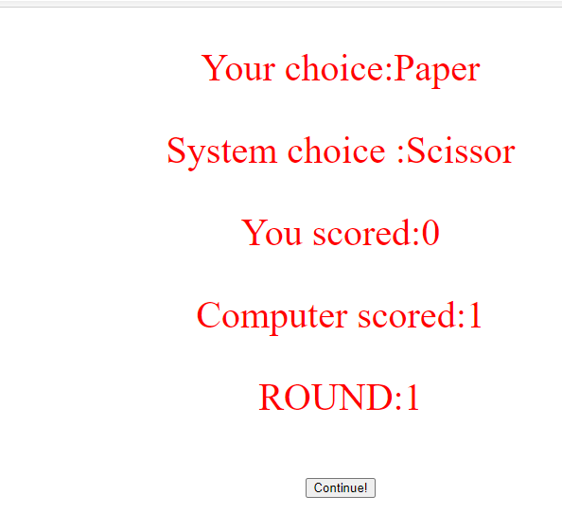

On Round-5,game gets over for that set and winner is displayed on screen and details are updated in database.

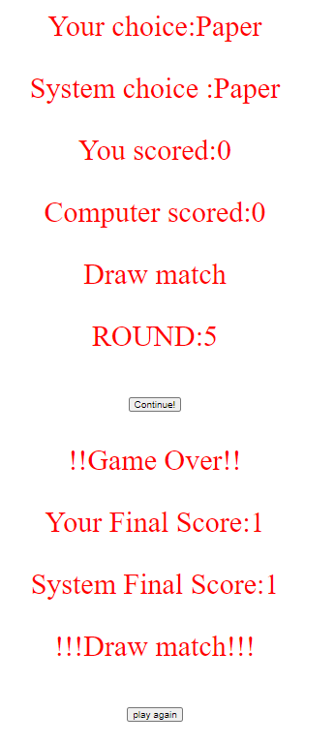

Click on play again to play next set and hence it goes on.

SQLite Database updation and insertion:

On successful completion of each set,the total_games played column in rps_app_user is updated.Since,we played one game now,its incremented from 0 to 1.



Similarly, the rps_app_score table is also inserted with player score, system score,username,timestamp.

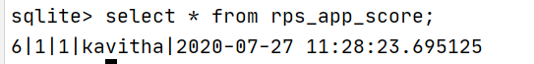

Now,on next run,the /bhome page displays:

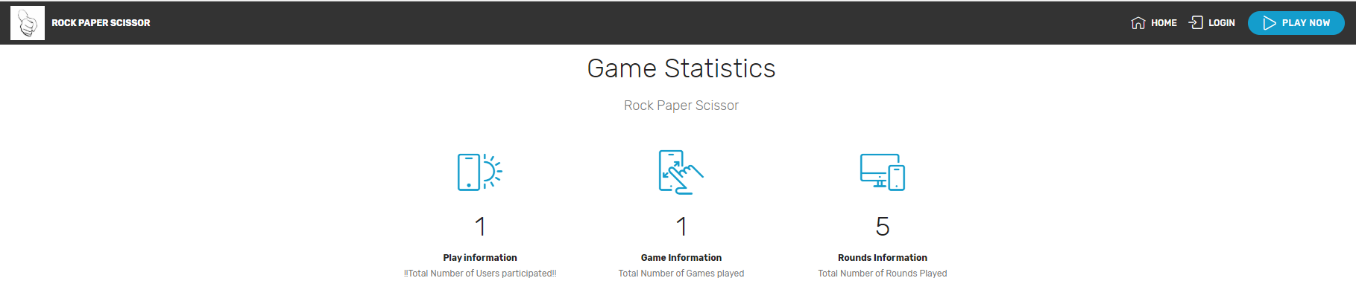

Game statistics

Play information is incremented to 1(total number of users=1(kavitha))

Game information is incremented to 1(total number of set played by Kavitha=1)

Rounds information is incremented to 5(total number of rounds in set1=5)

# 7.Invalid Login attempt

When the user tries to login,first the username and password entered is checked against the rps_app_user table in database.If the corresponsing combination is found,it says ‘Login successful’.Else,it says ‘Login unsuccessful’.

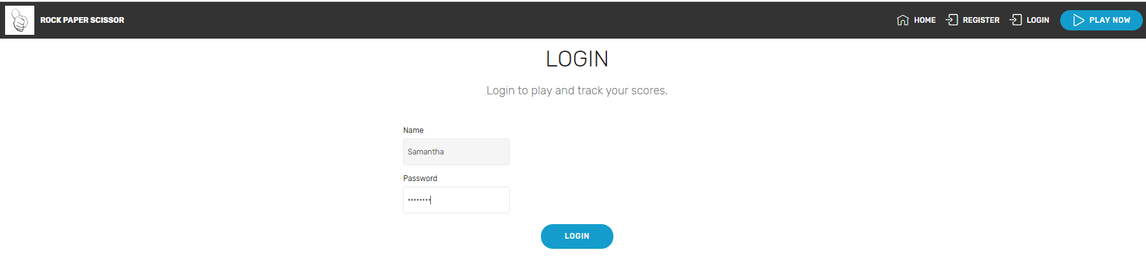

Now,when the user Samantha tries to login,it shows user does not exist alert.

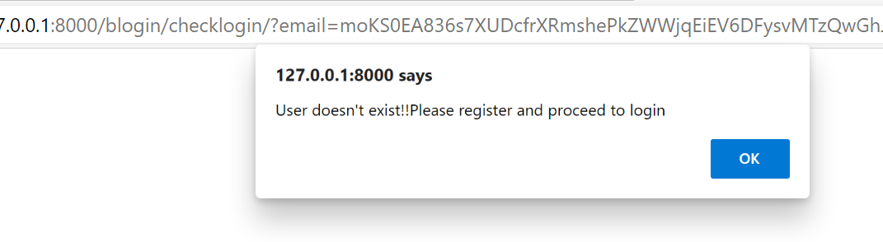

Now,lets login as Kavitha user but entering wrong password.

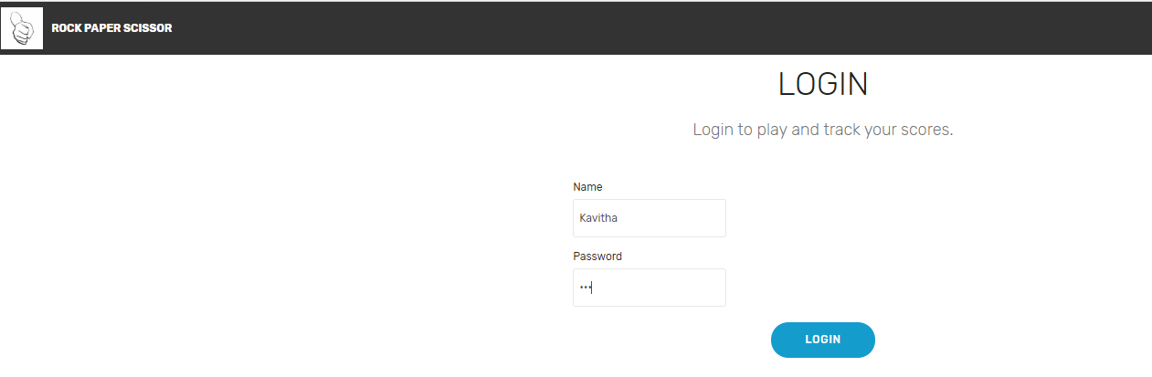

The password stored in database is for 7character length password,now am trying to enter 3 character length password.

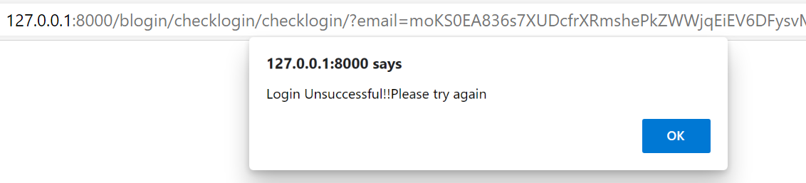

# 8.Future work

1.Build module for other two play options

2.To host this game in cloud

Video Link:

<https://drive.google.com/file/d/1Hv9eujFNt7iKk2j4BAJuYtvchVSG8B4w/view?usp=sharing>